Name: Christopher Askew-Merwin

UmichID: askchris

What dataset are you working with: comic_characters

List 3 questions that you can ask with your dataset.

Q1: Do Marvel female characters have more appearances than DC female characters?

Q2:

Q3:

List the associated null hypothesis for each question:

Q1: Marvel female characters have fewer or an equal number of appearances to DC female characters.

Q2:  
Q3:

What statistical test(s) will you use to answer each of the questions:

Q1: one- tail two-sample t-test

Q2:

Q3:

Make a visual plot showing the relationship that you will analyze statistically (e.g. boxplot for t-test or ANOVA; scatterplot for regression; table for chi-square).

Q1: 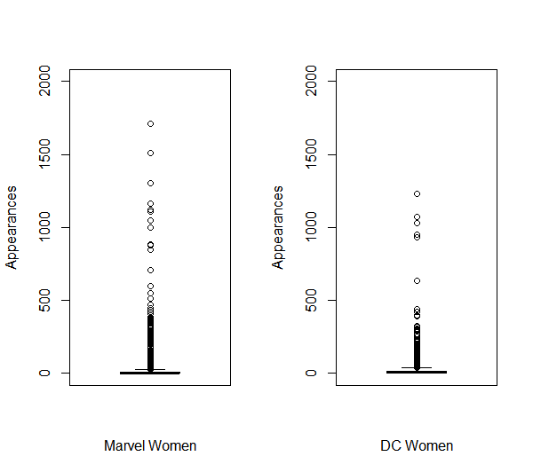

Q2:

Q3:

Do your data meet the assumptions required for the statistical test you want to run? Please state the assumptions you examined and whether or not your data meet those assumptions:

Q1: The samples are both independent both within and across the two population. Both sample sizes are larger than 30 and the ratio of variances is 1.4

Q2:

Q3:

Run the statistical test! Put your results here:

Q1: Welch Two Sample t-test

data: Marvel.women$appearances and DC.women$appearances

t = -1.0537, df = 4411.7, p-value = 0.854

alternative hypothesis: true difference in means is greater than 0

95 percent confidence interval:

-5.63425 Inf

sample estimates:

mean of x mean of y

20.28480 22.48457

Q2:

Q3:

Interpret your results!

Q1: There is no statistically significant difference in the means between the two sample sets. Therefore Marvel women characters do not have significantly more appearances than DC women characters. As such I cannot reject the null hypothesis.

Q2:

Q3: