Name: Chun Yin Anson Chang

UmichID: 8567 2113

What dataset are you working with: Drinks

List 3 questions that you can ask with your dataset.

Q1: Is there any interaction between beer consumption and spirit consumption?

Q2: Which kinds of alcohol has the strongest contribution to the total pure alcohol content?

Q3:

List the associated null hypothesis for each question:

Q1: There is no interaction between the consumption of beer and spirit.

Q2: None of them has any contribution to the total pure alcohol.  
Q3:

What statistical test(s) will you use to answer each of the questions:

Q1: Linear regression.

Q2: Linear regression x3.

Q3:

Make a visual plot showing the relationship that you will analyze statistically (e.g. boxplot for t-test or ANOVA; scatterplot for regression; table for chi-square).

Q1: 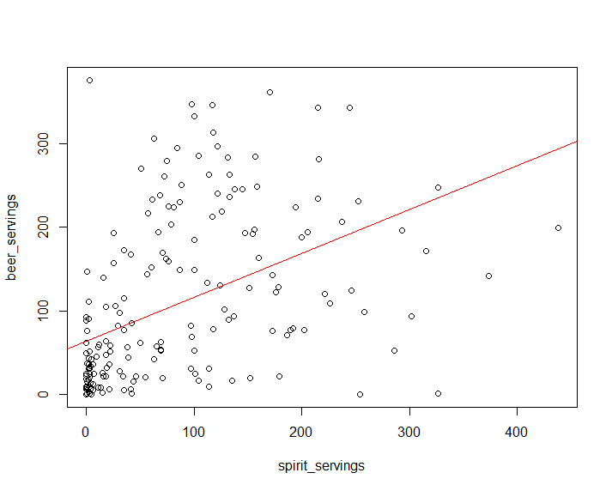

Q2: 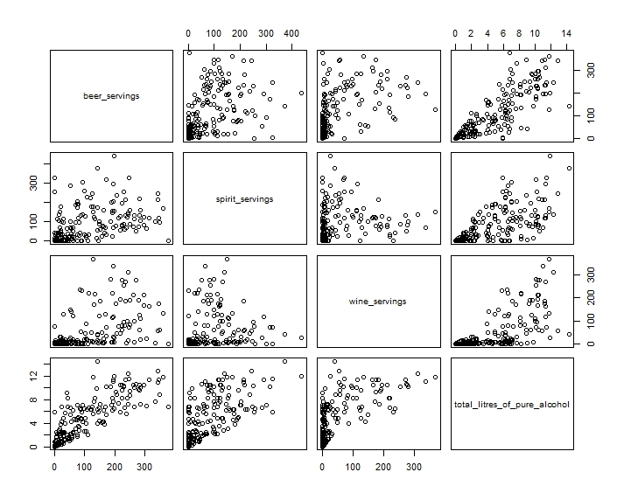



Q3:

Do your data meet the assumptions required for the statistical test you want to run? Please state the assumptions you examined and whether or not your data meet those assumptions:

Q1: There is no pattern in the residual plot. No heteroscedasticity. Histogram of residual with QQ-plot showed normal distribution. Continuous dependent and independent variables.

Q2: There is no pattern in the residual plot. No heteroscedasticity. Histogram of residual with QQ-plot showed normal distribution. Continuous dependent and independent variables.

Q3:

Run the statistical test! Put your results here:

Q1: y=0.52565x+63.58596, p-value=1.939e-11 <0.05

Q2: slope for beer > slope for spirit > slope for wine, against total litres of pure alcohol

Q3:

Interpret your results!

Q1: Reject null hypothesis, there is a significant positive correlation between beer and spirit consumption among the nations.

Q2: Beer has the biggest contribution to the total pure alcohol content, followed by spirit, wine contributes the least.

Q3: