Name: Margaret Lindman

UmichID: mlindman

What dataset are you working with**: love_actually_appearance**

List 3 questions that you can ask with your dataset.

Q1: Was there a significant difference in scene appearances between Hugh Grant and Emma Thompson?

Q2: Do Friday the 13th births differ significantly between years 2000 and 2010?

Q3:

List the associated null hypothesis for each question:

Q1: Hugh Grant and Emma Thompson do no overlap in scenes.

Q2: Fri the 13th births do not differ significantly between years 2000 and 2010.   
Q3:

What statistical test(s) will you use to answer each of the questions:

Q1: chi squared: chisq.test(love_actually_appearance$hugh_grant,love_actually_appearance$emma_thompson)

Q2: t.test(birth2000fri$births, birth2010fri$births)

Q3:

Make a visual plot showing the relationship that you will analyze statistically (e.g. boxplot for t-test or ANOVA; scatterplot for regression; table for chi-square).

Q1:

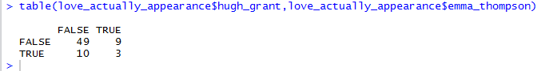

Q2:

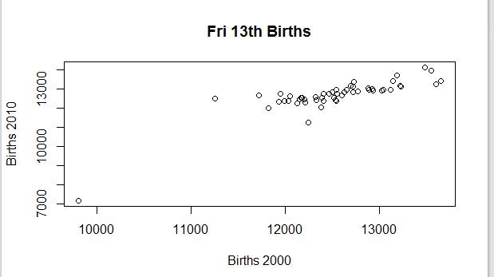

Q3:

Do your data meet the assumptions required for the statistical test you want to run? Please state the assumptions you examined and whether or not your data meet those assumptions:

Q1: adequate sample, but data are not randomly collected (data are from a scripted movie…), likewise data were not independent (because of the script)

Q2: We can assume adequate sample size, independence of data, and random data; however we cannot assume equal variance

Q3:

Run the statistical test! Put your results here:

Q1:

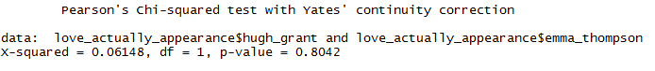

Q2: 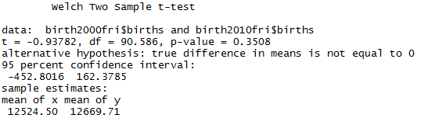

Q3:

Interpret your results!

Q1: The scene overlap of Hugh Grant and Emma Thompson is not significant throughout *Love Actually*. Based on the contingency table, they overlap in only 3 out of about 70 scenes (hence the p-value of 0.8).

Q2: Because the p-value is 0.3508, there is not a significant difference in Friday the 13th births in 2000 vs 2010.

Q3: