Name: Brittany

UmichID: szczeb

What dataset are you working with:   
murder_2015_final

bad_drivers

List 3 questions that you can ask with your dataset.

Q1: Is the murder rate in 2014 different than in 2015?

Q2: Is the murder rate in 2015 greater than the 2000 value of 15,586?

Q3:

List the associated null hypothesis for each question:

Q1: M2014 = M2015

Q2: M2015 > 15,586  
Q3:

What statistical test(s) will you use to answer each of the questions:

Q1: Two sample, two-tail t-test

Q2: One sample, one-tail t-test

Q3:

Make a visual plot showing the relationship that you will analyze statistically (e.g. boxplot for t-test or ANOVA; scatterplot for regression; table for chi-square).

Q1:

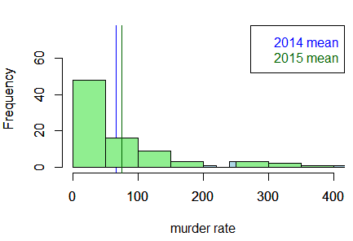

Q2: 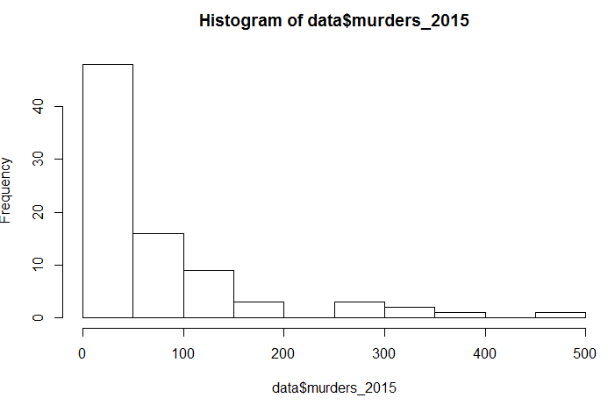

Q3:

Do your data meet the assumptions required for the statistical test you want to run? Please state the assumptions you examined and whether or not your data meet those assumptions:

Q1: Assumptions:

-Data are continuous

-Sample is randomly selected from the population

-Observations are independent

-Values are normal OR sample size is large enough (CLT)

-Equal variance between 2 populations

Q2: Assumptions:

-Data are continuous

-Sample is randomly selected from the population

-Observations are independent

-Values are normal OR sample size is large enough (CLT)

Q3:

Run the statistical test! Put your results here:

Q1: p-value = 0.4648

Q2: p-value = 2.2 x 10^(-16)

Q3:

Interpret your results!

Q1: The murder rates in 2014 are not significantly different than in 2015.

Q2: The murder rates in 2015 are significantly different from the murders in 2000

Q3: