Travel Planning Agent
Internal Assessment Task II - Agentic AI System using Modern LLM-based Tools
16010123001: Aarav Shah
16010123002: Diya Mehta
16010123003: Kabir Rao

Introduction, Abstract of problem statement
Planning a trip requires collecting information about places, costs and weather from many websites. We built an agent that takes a travel goal from the user and produces a day-wise itinerary within a budget.
Manual trip planning is slow and error-prone because budgets, prices and weather must be checked together. Our agent turns a natural-language travel goal into a budget-checked itinerary and shows every step it took.

AI framework(s) used
We used a ReAct-style agent built with LangChain, with Llama 3.3 70B accessed through the OpenRouter free API. LangChain provides the tool-calling loop and OpenRouter gives free access to an open model.

Tools integrated with agent
The agent uses three tools: web_search (Tavily search API) for places and prices, calculator for budget arithmetic, and weather_api (Open-Meteo) for the forecast. Each tool was chosen because it supplies information the LLM cannot know reliably on its own.

Part A - Agent Design (Modern View)

Goal of the agent
The goal is to produce a complete travel itinerary that respects the user's budget and dates.

Agent role
The agent acts as a travel planner that searches, compares, calculates and plans.

Tools used
web_search, calculator and weather_api as described above.

Memory type
Short-term conversational memory (the ReAct scratchpad of thoughts and observations) is kept in the context window; user preferences such as budget are stored in a JSON file between sessions.

Planning strategy
The agent follows the ReAct strategy: it reasons about the goal, calls a tool, observes the result and decides the next step until the itinerary is complete.

Part B - Implementation (Modern AI Tools)

LLM-based agent
Llama 3.3 70B was chosen because it is free on OpenRouter, supports long context and follows tool-calling instructions well.

Architecture diagram
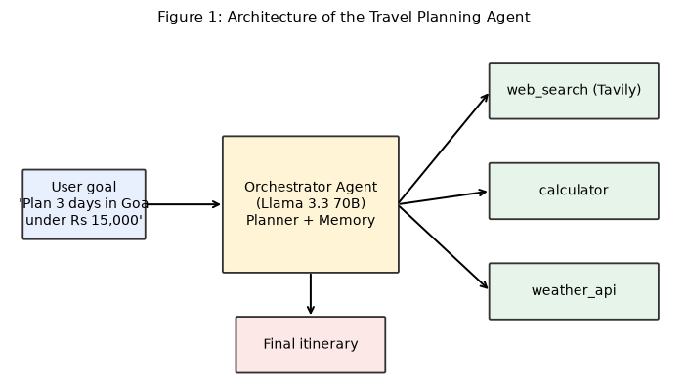
Figure 1: Architecture of the Travel Planning Agent

Tool flow diagram
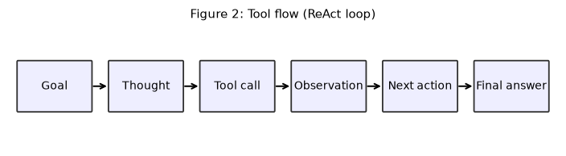
Figure 2: Tool flow (ReAct loop)

Agent interaction log
[Thought] I need hotel prices and weather first.
[Tool Call] web_search('budget hotels north goa price per night')
[Observation] 3 results: Rs 1800-2500 per night
[Tool Call] weather_api('Goa', '2026-12-10')
[Observation] Sunny, 31C
[Tool Call] calculator('3*2200 + 4500 + 2000')
[Observation] 13100
[Final Answer] Day 1: Baga beach ... total Rs 13,100

Prompts and output screenshots
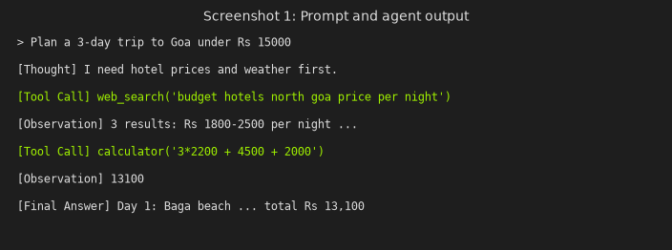
Screenshot 1: Prompt and agent output

Code repository
Code and notebook: https://github.com/example-group/travel-planning-agent

Part C - Analysis & Comparison
Classical Agent (Syllabus) | Modern Agent (This Activity)
Rule-based | LLM-driven
Static logic | Dynamic planning
No memory | Contextual memory
Single-step | Multi-step reasoning
A rule-based planner can only follow fixed if-then rules for known cities, while our agent plans dynamically and adapts when a tool returns unexpected results.

Discussion, takeaway
Tool use made the itinerary costs reliable; the main limitation is the rate limit of free APIs and occasional malformed tool calls, which we handle with retries.

Conclusion
The agent plans trips end to end with observable reasoning and verified budget calculations.

References
[1] S. Yao et al., ReAct: Synergizing Reasoning and Acting in Language Models, ICLR 2023.
[2] LangChain documentation, https://python.langchain.com

