**Feasibility Analysis**

Survey Questions

> Would you like to have an online complaint portal with the added feature of current status of your complaint?

No

Yes

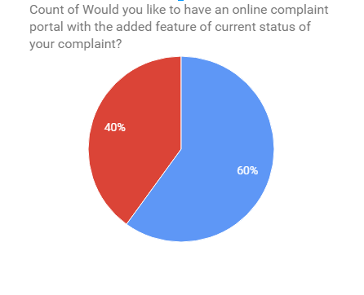

> Are you comfortable paying bills online?

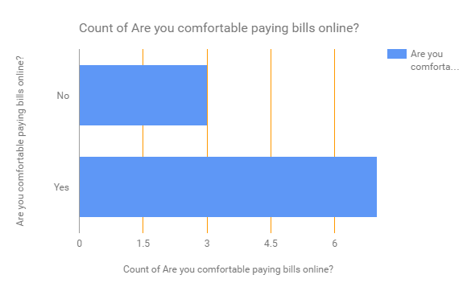

> Do you face difficulties when hiring an electrician, plumbers etc?

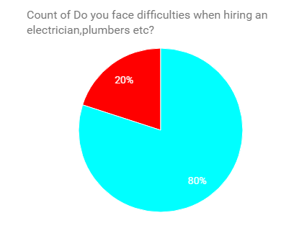

Yes

No

> Would you like a system which automatically updates you about all your society events?

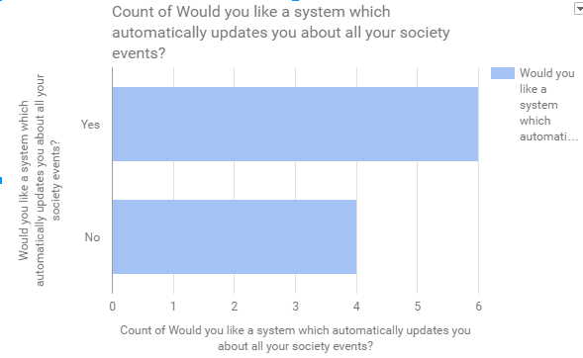

> Would you like to have an online system which will notify your security guard when you are expecting visitors?

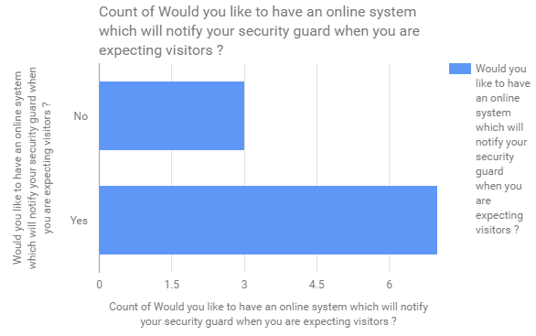

**Feasibility Analysis of the above survey:**

**>What if the system wasn’t implemented?**

* Data inconsistency.
* Consumes time and report producing is costly.
* Paying bills is a hectic task.

**>What are the current process problems?**

* Record of visitors or staff has to be kept manually.
* Apartment owners aren’t aware about the functions/events happening nearby.
* Manual payment of all the maintenance, electricity bills etc. which consumes lot of time and efforts.

**>How will the proposed system help?**

* This system will help you automatize and digitize the apartment management for better communication and make life easier.
* Automatic payment of your monthly and annual bills keeping all the accounts online.
* Ensure safety and security in your apartment.
* Better neighbour lookup.
* Update you on all the Events/news/services.

**>What will be the integration problems?**

* In some restricted environment there can be problems like slow internet or unavailability of services.
* Availability of a good and decent internet is required.
* Slow internet on the admin side leads to slower load and response time which makes the process slow.

**> Is new technology needed? What skills?**

No, new technology is not needed.

**> What facilities must be supported by the proposed system?**

* This product is a self-contained project for the home owners and societies where people from same society can share and see what, when and where are all the things happening all around the neighborhood and be updated with their surroundings.
* The product creates platform for the user to:

a) Pay bills for entities such as maintenance, electricity, taxes (home, water).

1. Interact with neighbors
2. Service functionality allows you to book electrician, plumber etc. in a single click and track the progress of the same online.
3. Complaint functionality solves the issues in and around the apartment environment
4. Visitor system to improvise general security