Lab MST

Student Name: Mehak Mehra UID: 24BAI70075
Branch: CSE - AIML Section/Group: 24AIT_KRG-1_B
Semester: 5 Date of Performance: 11/7/26
Subject Name: ADBMS Subject Code: 24CSP-310

Q1.
Solution:
SELECT D2.DEPT_NAME, EMP_NAME, SALARY
FROM EMPLOYEE AS E
JOIN
(SELECT DEPT_ID, COUNT(EMP_ID)
FROM EMPLOYEE
GROUP BY DEPT_ID
HAVING COUNT(EMP_ID)>=3) AS D
ON E.DEPT_ID = D.DEPT_ID
JOIN DEPARTMENT AS D2
ON D.DEPT_ID = D2.DEPT_ID
WHERE SALARY > (
SELECT AVG(SALARY)
FROM EMPLOYEE
WHERE DEPT_ID=D.DEPT_ID
)

Output:
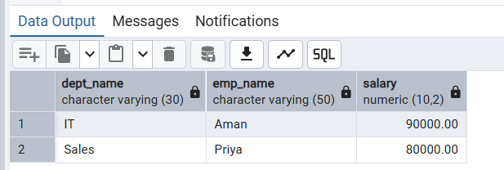
Q2.
CREATE OR REPLACE FUNCTION FN_CUSTOMER_INSERT_DELETE()
RETURNS TRIGGER
LANGUAGE PLPGSQL
AS
$$
BEGIN

IF TG_OP='INSERT' THEN
INSERT INTO CUSTOMER_AUDIT VALUES(AUDIT_ID, NEW.CUSTOMER_ID, NEW.CUSTOMER_NAME, 'ADDED', NOW());
RETURN NEW;

ELSIF TG_OP='DELETE' THEN
INSERT INTO CUSTOMER_AUDIT VALUES(AUDIT_ID, OLD.CUSTOMER_ID, OLD.CUSTOMER_NAME, 'REMOVED', NOW());
RETURN OLD;
END IF;
RETURN NULL;
END;
$$

CREATE OR REPLACE TRIGGER TRG_INSERT_DELETE
AFTER INSERT OR DELETE
ON BANK_CUSTOMER
FOR EACH ROW
EXECUTE FUNCTION FN_CUSTOMER_INSERT_DELETE()

INSERT INTO BANK_CUSTOMER VALUES
(3, 'AMAN', 50000)

DELETE FROM BANK_CUSTOMER
WHERE CUSTOMER_ID=2

