Experiment 1

Student Name: Mehak Mehra UID: 24BAI70075
Branch: CSE - AIML Section/Group: 24AIT_KRG G1
Semester: 4 Date of Performance: 9/1/26
Subject Name: DBMS Subject Code: 24CSH-298

Aim
To design and implement a Library Management System database using appropriate tables, primary keys, foreign keys, and constraints, and to perform DML operations along with DCL commands such as role creation, privilege granting, and revoking to ensure database security.

Software Requirements
- Database Management System:
  - PostgreSQL
- Database Administration Tool:
  - pgAdmin

Objectives
To gain practical experience in implementing Data Definition Language (DDL), Data Manipulation Language (DML), and Data Control Language (DCL) operations in a real database environment. This will also include implementing role-based privileges to secure data.

Problem Statement
- A Library wants to develop a Library Management System database to manage information about books, members, and book issue records efficiently. The database should be designed using appropriate tables, primary keys, foreign keys, and constraints to ensure data integrity.
- The system must support basic database operations such as inserting records, updating existing data, and deleting obsolete entries. To ensure database security.
- To ensure database security, a database role named Librarian must be created. This role should be password protected and granted SELECT, INSERT, and DELETE permissions on the required tables. The system administrator (pgAdmin) should also have the ability to revoke these permissions when required using role-based access control.

Practical/Experiment Steps
- Schema Architecture: Designed the fundamental structure by creating books and library_visitors tables. Robust data integrity was enforced using constraints such as NOT NULL, UNIQUE, and CHECK (notably restricting visitor registration to ages 18 and above).
- Relational Mapping: Established the book_issue table to serve as a transactional link, utilizing Foreign Keys to connect book records with visitor data.
- Data Seeding: Populated the database with a foundational dataset to validate the schema design and relationship logic.
- Operational Validation: Conducted stress tests on the data by performing updates and deletions to observe how the system handles referential integrity and constraints.
- Access Control Management: Implemented a security layer by creating a specific Librarian role. Access levels were meticulously defined and managed using GRANT and REVOKE commands.

Procedure
- Authenticated into the database server and established a stable connection.
- Initialized a dedicated database environment for the Library Management System.
- Executed CREATE TABLE scripts in a hierarchical order, ensuring parent tables were established before dependent transaction tables.
- Used INSERT statements to populate the system with diverse sample records for books and visitors.
- Ran complex SELECT queries to verify cross-table consistency and ensure data was stored accurately.
- Applied UPDATE and DELETE operations to confirm that the database maintains its rules (constraints) during data changes.
- Defined the Librarian role and assigned granular permissions for specific database operations.
- Validated the security model by attempting restricted actions before and after revoking permissions.
- Compiled the final SQL scripts and captured visual evidence (screenshots) of the successful command executions.

Input/Output Analysis
SQL Input Queries
CREATE TABLE BOOKS(
BOOK_ID INT PRIMARY KEY,
BOOK_NAME VARCHAR(20) NOT NULL,
AUTHOR_NAME VARCHAR(20) NOT NULL
)

SELECT * FROM BOOKS

ALTER TABLE BOOKS
ADD BOOK_COUNT INT CHECK(BOOK_COUNT>0) NOT NULL

SELECT * FROM BOOKS

INSERT INTO BOOKS VALUES(101, 'Harry Potter', 'JK Rowling', 3)
INSERT INTO BOOKS VALUES(102, '1984', 'George Orwell', 5)

SELECT * FROM BOOKS

CREATE TABLE LIBRARY_VISITORS(
USER_ID INT PRIMARY KEY,
NAME VARCHAR(20) NOT NULL,
AGE INT CHECK(AGE>=17) NOT NULL,
EMAIL VARCHAR(20) NOT NULL UNIQUE
)

SELECT * FROM LIBRARY_VISITORS

INSERT INTO LIBRARY_VISITORS(USER_ID, NAME, AGE, EMAIL)
VALUES(101, 'Vansh Sharma', 18, 'vansh12@gmail.com')

--INSERT INTO LIBRARY_VISITORS(USER_ID, NAME, AGE, EMAIL)
--VALUES(501, 'Ansh Sharma', 18, 'vansh12@gmail.com') will not work since email should be unique

DROP TABLE BOOK_ISSUE
CREATE TABLE BOOK_ISSUE(
BOOK_ISSUE_ID INT PRIMARY KEY,
USER_ID INT NOT NULL,
BOOK_ID INT NOT NULL,
FOREIGN KEY(USER_ID) REFERENCES LIBRARY_VISITORS(USER_ID), --THIS WORKS IN ORACLE
FOREIGN KEY(BOOK_ID) REFERENCES BOOKS(BOOK_ID)
)

INSERT INTO BOOK_ISSUE VALUES(10001, 501, 101)

ALTER TABLE BOOK_ISSUE
ADD ISSUE_DATE DATE

SELECT * FROM BOOK_ISSUE

INSERT INTO BOOK_ISSUE VALUES(1001, 501, 101, '2026-01-09')

UPDATE BOOK_ISSUE
SET ISSUE_DATE='2026-01-08'
WHERE BOOK_ISSUE_ID=1001

--delete or truncate
DELETE FROM BOOKS WHERE BOOK_ID=102

SELECT * FROM BOOKS

CREATE ROLE LIBRARIAN
WITH LOGIN PASSWORD 'mehak1234'

SELECT CURRENT_USER

GRANT SELECT, INSERT, DELETE, UPDATE ON BOOKS TO LIBRARIAN
GRANT SELECT, INSERT, DELETE, UPDATE ON BOOK_ISSUE TO LIBRARIAN
GRANT SELECT, INSERT, DELETE, UPDATE ON LIBRARY_VISITORS TO LIBRARIAN

REVOKE SELECT, INSERT, DELETE, UPDATE ON BOOKS, BOOK_ISSUE, LIBRARY_VISITORS FROM LIBRARIAN

Output
Table books:
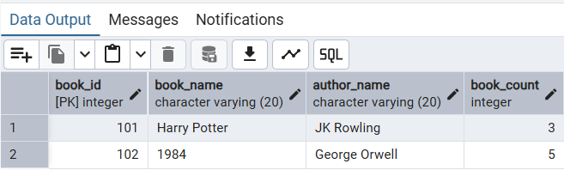

Table library_visitors:

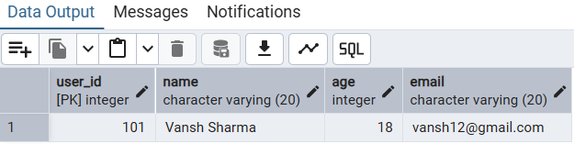

Table book_issue:
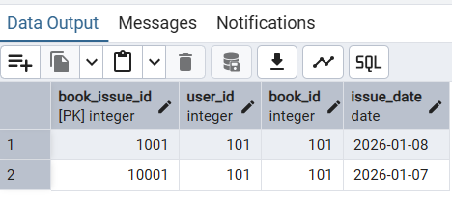

Access granted to role – librarian:
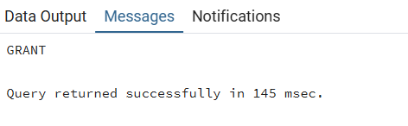

Role Librarian is able to insert and perform other queries after granting of privileges
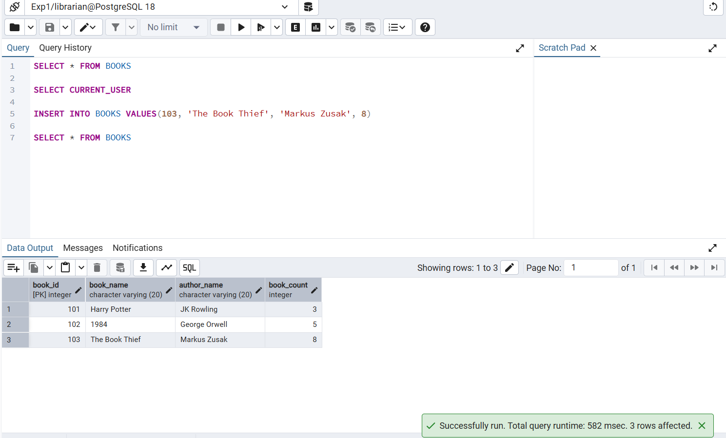

Learning Outcomes
- Gained hands-on experience to work with PostgreSQL and pgAdmin
- Writing queries to create and delete tables
- Learnt to alter tables, view tables, create roles, granting and revoking access to the roles
- Primary and foreign keys implementations and roles

