Experiment 9

Student Name: Mehak Mehra UID: 24BAI70075
Branch: CSE - AIML Section/Group: 24AIT_KRG G1
Semester: 4 Date of Performance: 17/4/26
Subject Name: DBMS Subject Code: 24CSH-298

Aim
To create and implement PL/SQL packages by developing a package specification and package body containing procedures and shared cursors, in order to achieve modular, reusable, and efficient database programming.

Software Requirements
- Database Management System:
  - Oracle Database Express Edition (Oracle XE)
  - PostgreSQL Database
- Database Administration Tool / Client Tool:
  - Oracle SQL Developer (for Oracle XE)
  - pgAdmin (for PostgreSQL)

Objectives
- To design and implement a PL/SQL package that includes procedures and shared cursors for structured and modular program development.

Problem Statement
- In enterprise applications, related database operations should be grouped together for better management and reuse.

Practical/Experiment Steps
- Modular Architecture Design: Structured the database logic into a two-part PL/SQL package consisting of a public specification and a private implementation body.
- Encapsulation of Global Assets: Defined a shared cursor within the package body to provide a centralized and reusable data source for multiple procedures.
- Procedural Logic Development: Authored specialized procedures to handle varied data retrieval tasks, including full table iteration and targeted record searching.
- Information Hiding Implementation: Enforced security and abstraction by hiding the internal cursor logic from the end-user while exposing only necessary procedure calls.
- Integration Testing: Executed the package subprograms within anonymous blocks to validate cross-procedure consistency and data accuracy.

Procedure
- Established a connection to the Oracle/PostgreSQL environment and enabled the output console for result verification.
- Created the employees table and populated it with a baseline dataset to facilitate testing.
- Drafted the Package Specification (emp_package AS) to declare the public interface of the procedures.
- Constructed the Package Body (emp_package AS BODY) to house the shared emp_cursor and the actual logic for the declared procedures.
- Implemented a FOR loop within show_employees to automatically handle the opening, fetching, and closing of the shared cursor.
- Developed the logic for get_employee to filter the shared cursor data based on a user-provided input parameter.
- Compiled both the specification and body to ensure there were no syntax errors or dependency issues.
- Invoked emp_package.show_employees to test global data retrieval and printed the formatted output.
- Called emp_package.get_employee(2) to verify the ability of the package to handle specific conditional requests using shared resources.

Input/Output Analysis
SQL Input Queries
CREATE TABLE employees (
emp_id NUMBER PRIMARY KEY,
emp_name VARCHAR2(50),
salary NUMBER
);

Output

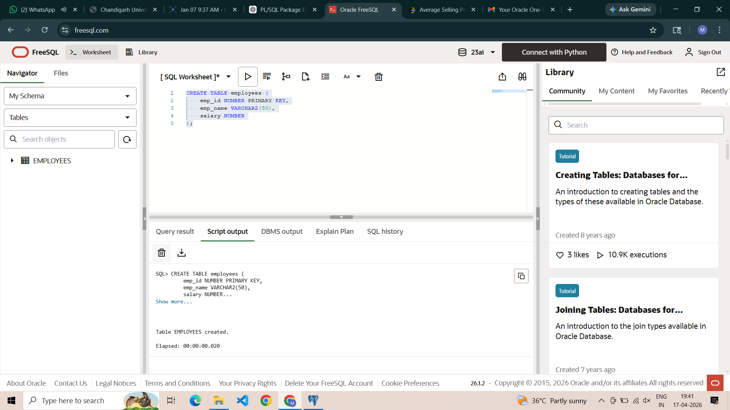

SQL Input Queries
INSERT INTO employees VALUES (1, 'Amit', 30000);
INSERT INTO employees VALUES (2, 'Riya', 40000);
INSERT INTO employees VALUES (3, 'John', 50000);

COMMIT;

Output
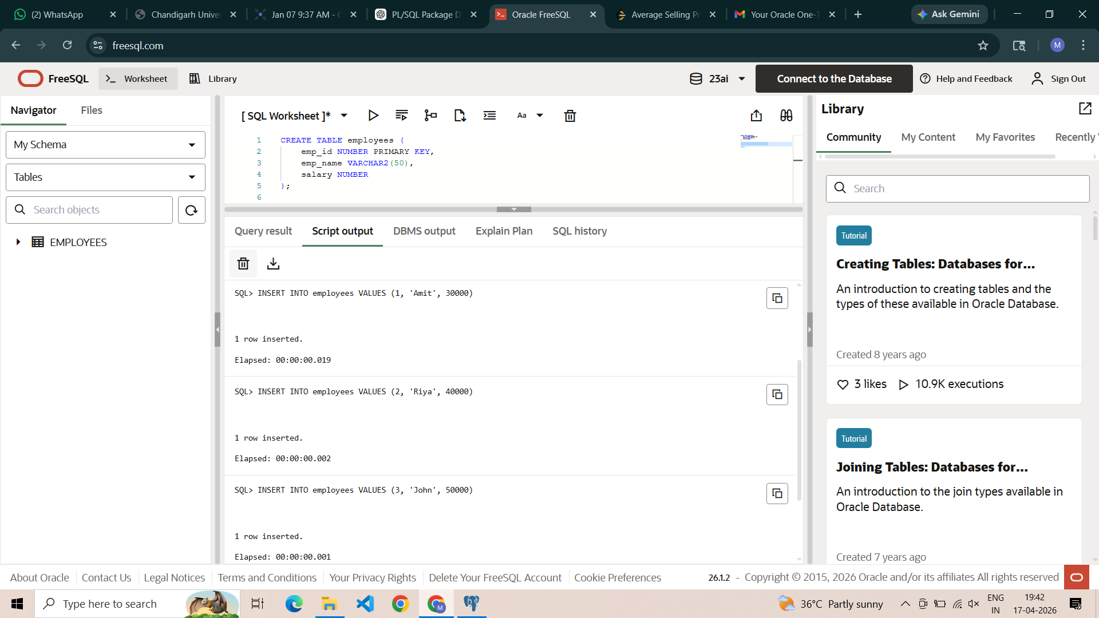
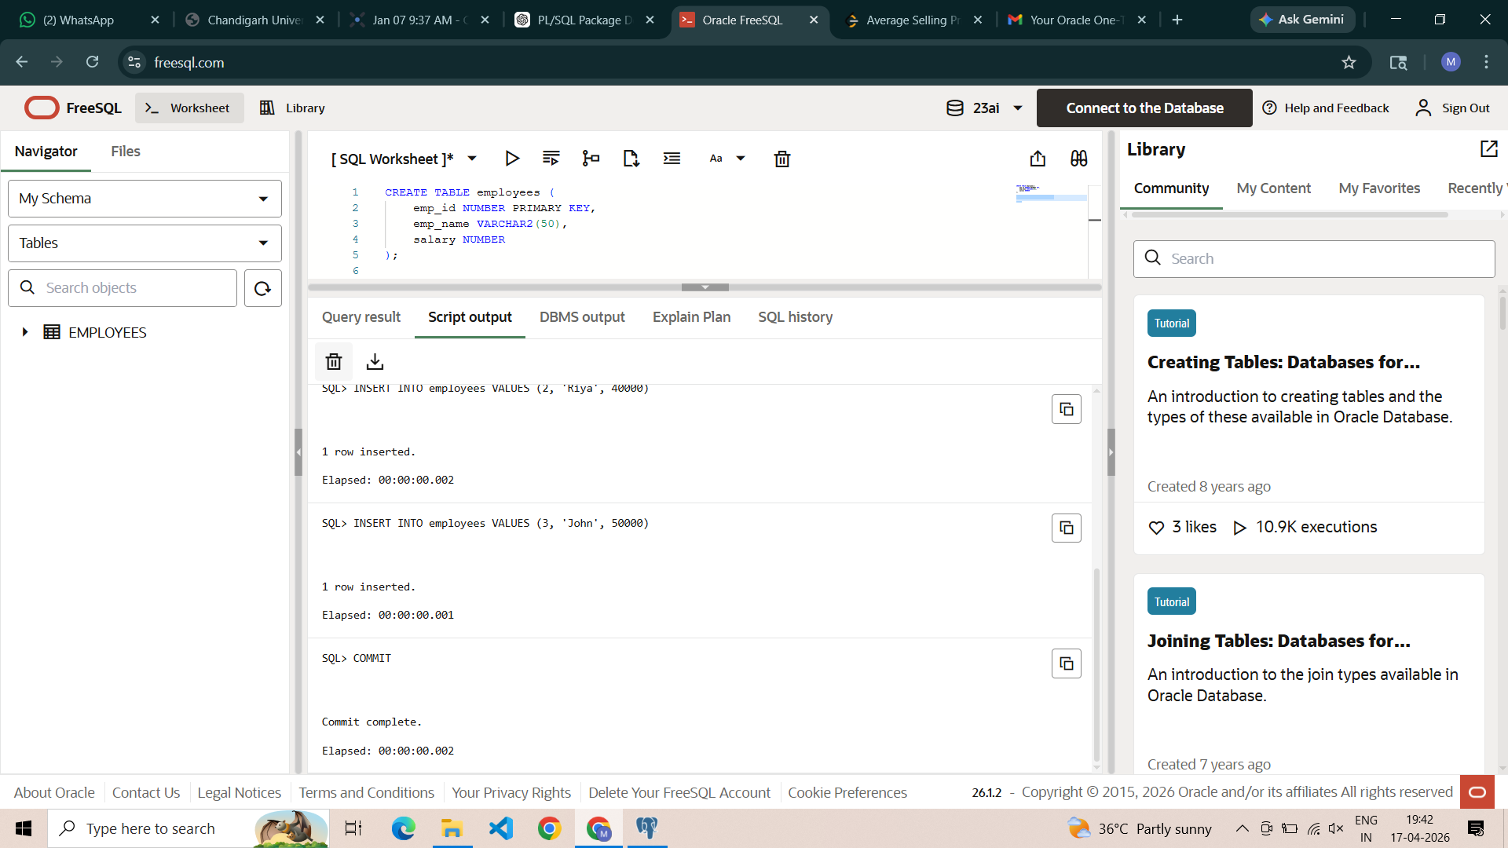

SQL Input Queries
CREATE OR REPLACE PACKAGE emp_package AS
-- Procedure to display all employee details
PROCEDURE show_employees;

-- Procedure to display employee by ID
PROCEDURE get_employee(p_id NUMBER);
END emp_package;
/

Output
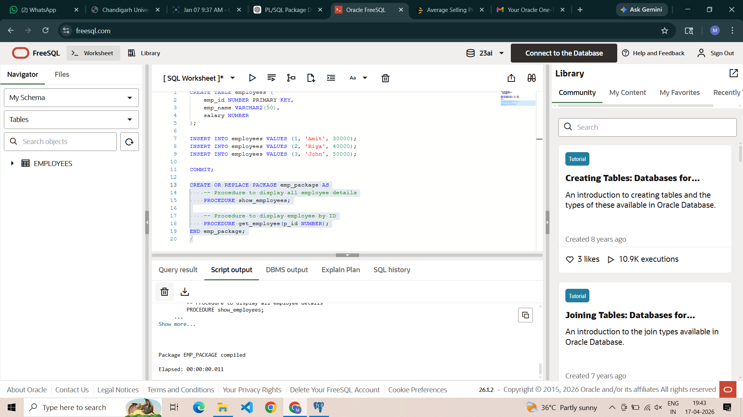

SQL Input Queries
CREATE OR REPLACE PACKAGE BODY emp_package AS

CURSOR emp_cursor IS
SELECT emp_id, emp_name, salary FROM employees;

PROCEDURE show_employees IS
BEGIN
FOR rec IN emp_cursor LOOP
DBMS_OUTPUT.PUT_LINE('ID: ' || rec.emp_id ||
' Name: ' || rec.emp_name ||
' Salary: ' || rec.salary);
END LOOP;
END;

PROCEDURE get_employee(p_id NUMBER) IS
BEGIN
FOR rec IN emp_cursor LOOP
IF rec.emp_id = p_id THEN
DBMS_OUTPUT.PUT_LINE('Employee Found -> ID: ' || rec.emp_id ||
' Name: ' || rec.emp_name ||
' Salary: ' || rec.salary);
END IF;
END LOOP;
END;

END emp_package;
/

Output
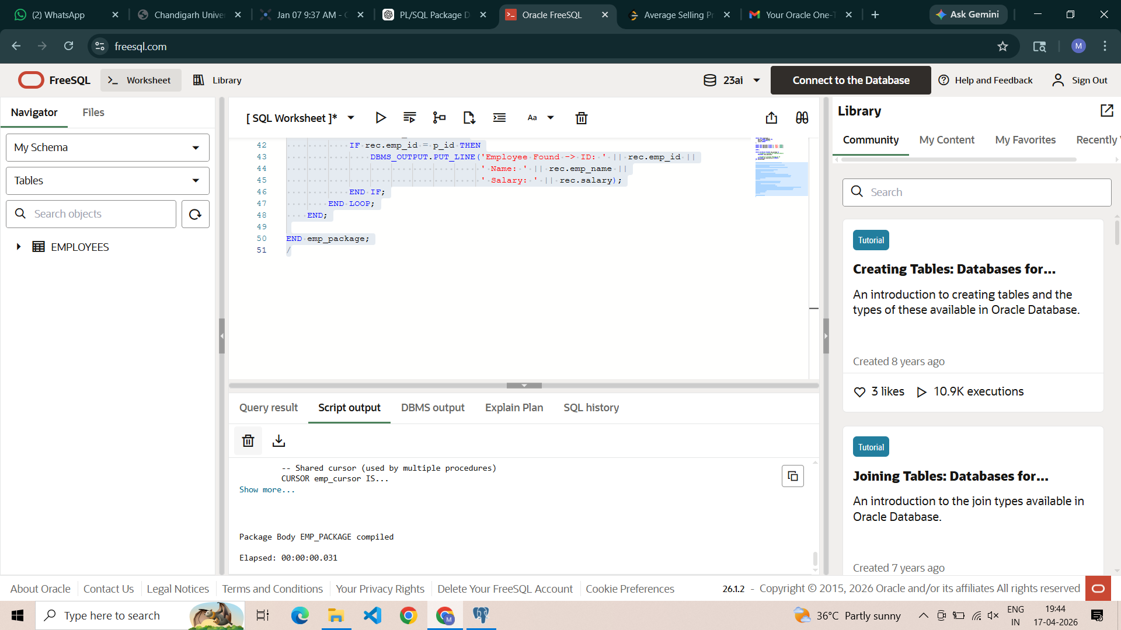

SQL Input Queries
SET SERVEROUTPUT ON;

BEGIN
emp_package.show_employees;
END;
/
CALL update_student(1, 'Rahul Verma', 22, 'Data Science');

Output
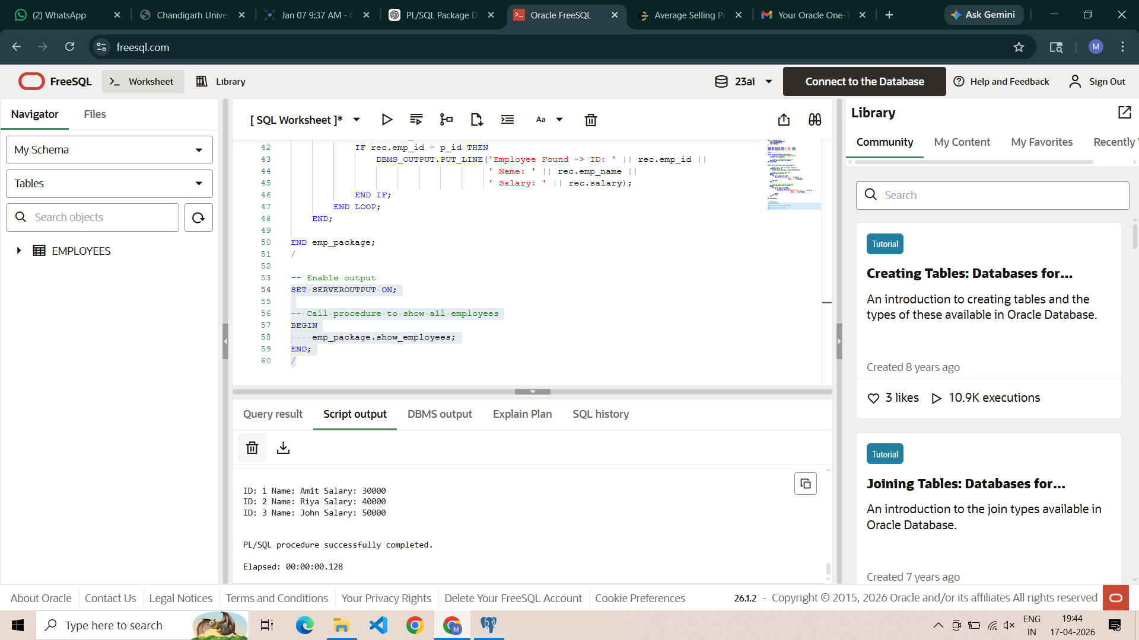

SQL Input Queries
BEGIN
emp_package.get_employee(2);
END;
/

Output
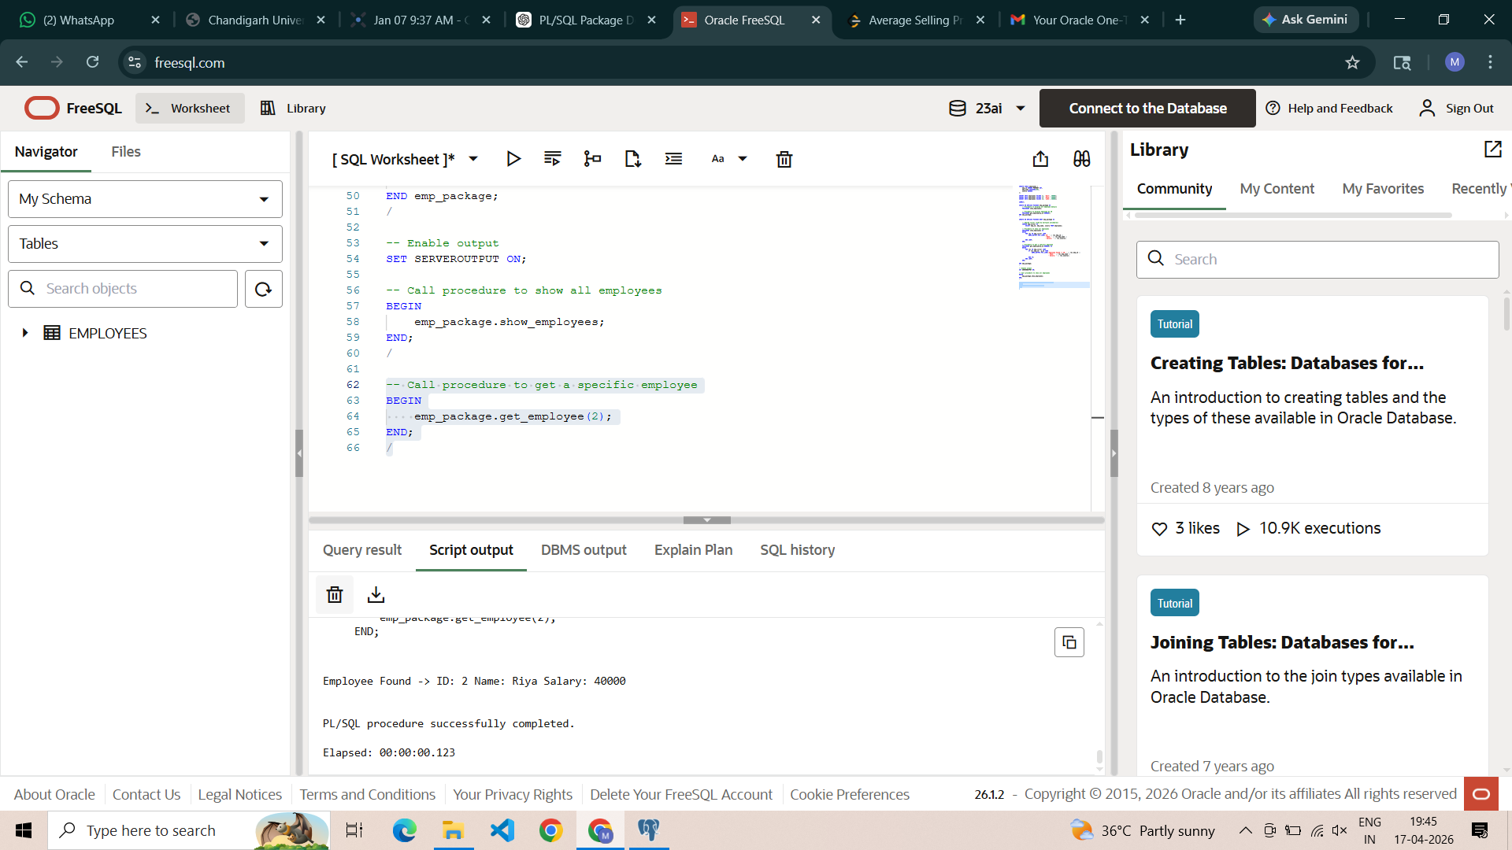

Learning Outcomes
- Package Structure Proficiency: Gained a clear understanding of the separation between the package specification (header) and the package body (implementation).
- Modular Programming Mastery: Learned to group related database operations into a single logical unit to improve maintainability and code organization.
- Shared Resource Management: Expertise in utilizing shared cursors to reduce memory overhead and ensure consistent data fetching across multiple subprograms.
- Encapsulation and Security: Understood how packages provide a layer of abstraction by hiding complex implementation details from the calling environment.

