Experiment 6

Student Name: Mehak Mehra UID: 24BAI70075
Branch: CSE - AIML Section/Group: 24AIT_KRG G1
Semester: 4 Date of Performance: 13/3/26
Subject Name: DBMS Subject Code: 24CSH-298

Aim
To understand the concept and working of cursors in PL/SQL for row-by-row data processing, and to analyse how implicit cursors, explicit cursors, and cursor attributes are used to implement business logic on multiple rows in a database table.

Software Requirements
- Database Management System:
  - Oracle Database Express Edition (Oracle XE)
  - PostgreSQL Database
- Database Administration Tool / Client Tool:
  - Oracle SQL Developer (for Oracle XE)
  - pgAdmin (for PostgreSQL)

Objectives
- To implement and analyse the use of implicit cursors, explicit cursors, and cursor attributes for processing multiple rows from a database table and applying business logic effectively.

Problem Statement
- In real-world enterprise applications, database queries often return multiple rows that need to be processed individually to apply specific business rules.

Practical/Experiment Steps
- Schema Provisioning: Created the Employees table with specific data types for IDs, names, roles, and salaries to simulate a corporate database environment.
- Implicit Cursor Analysis: Implemented an anonymous PL/SQL block to perform a single-row UPDATE operation, utilizing the internal SQL cursor to monitor DML success.
- Explicit Cursor Design: Defined a named cursor (c_engg) to fetch specific records based on the 'Engineer' role, enabling structured row-by-row processing.
- Attribute Integration: Incorporated cursor attributes such as %FOUND, %NOTFOUND, %ROWCOUNT, and %ISOPEN to programmatically control the execution flow.
- Business Logic Application: Developed logic to apply salary increments and format record-specific output, demonstrating how enterprise rules are applied to individual data rows.

Procedure
- Logged into the database environment and ensured SERVEROUTPUT was enabled to capture procedural messages.
- Executed the CREATE TABLE and INSERT scripts to establish the foundational employee dataset.
- Initiated a PL/SQL block using an implicit cursor to update a specific employee’s salary and verified the change using SQL%ROWCOUNT.
- Declared an explicit cursor in a separate block, specifically targeting employees with the ‘Engineer’ role.
- Opened the explicit cursor and used the %ISOPEN attribute to confirm the cursor was successfully initialized in memory.
- Implemented a LOOP structure to sequentially FETCH data from the active set into local variables (v_name, v_role).
- Used the %NOTFOUND attribute as an exit condition to terminate the loop once all relevant records were processed.
- Monitored the %ROWCOUNT attribute to display a dynamic count for each record retrieved during the iteration.
- Closed the cursor explicitly to release system resources and verified the closure using the NOT c_engg%ISOPEN condition.

Input/Output Analysis
SQL Input Queries
CREATE TABLE Employees(
emp_id NUMBER PRIMARY KEY,
name VARCHAR(20),
role VARCHAR(20),
salary NUMBER
);

Output

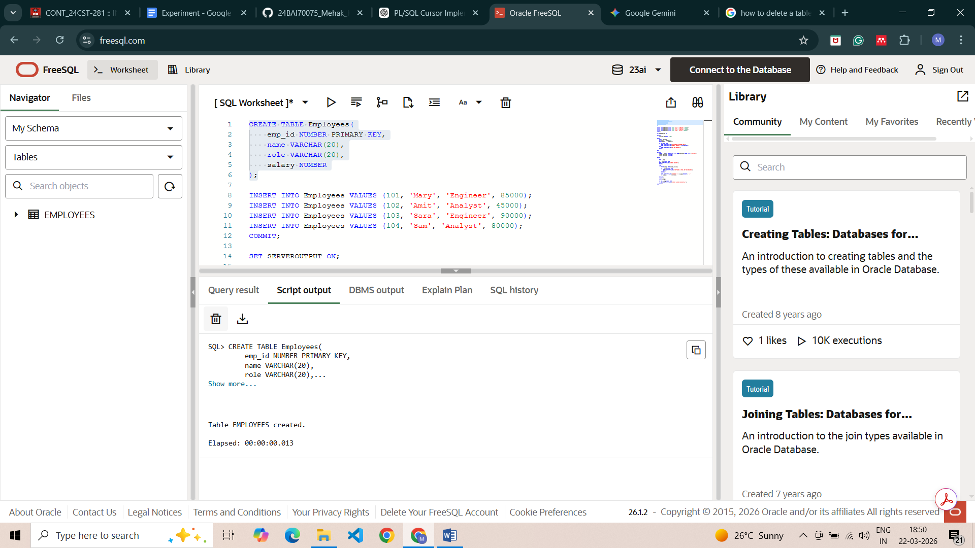

SQL Input Queries
INSERT INTO Employees VALUES (101, 'Mary', 'Engineer', 85000);
INSERT INTO Employees VALUES (102, 'Amit', 'Analyst', 45000);
INSERT INTO Employees VALUES (103, 'Sara', 'Engineer', 90000);
INSERT INTO Employees VALUES (104, 'Sam', 'Analyst', 80000);
COMMIT;

Output
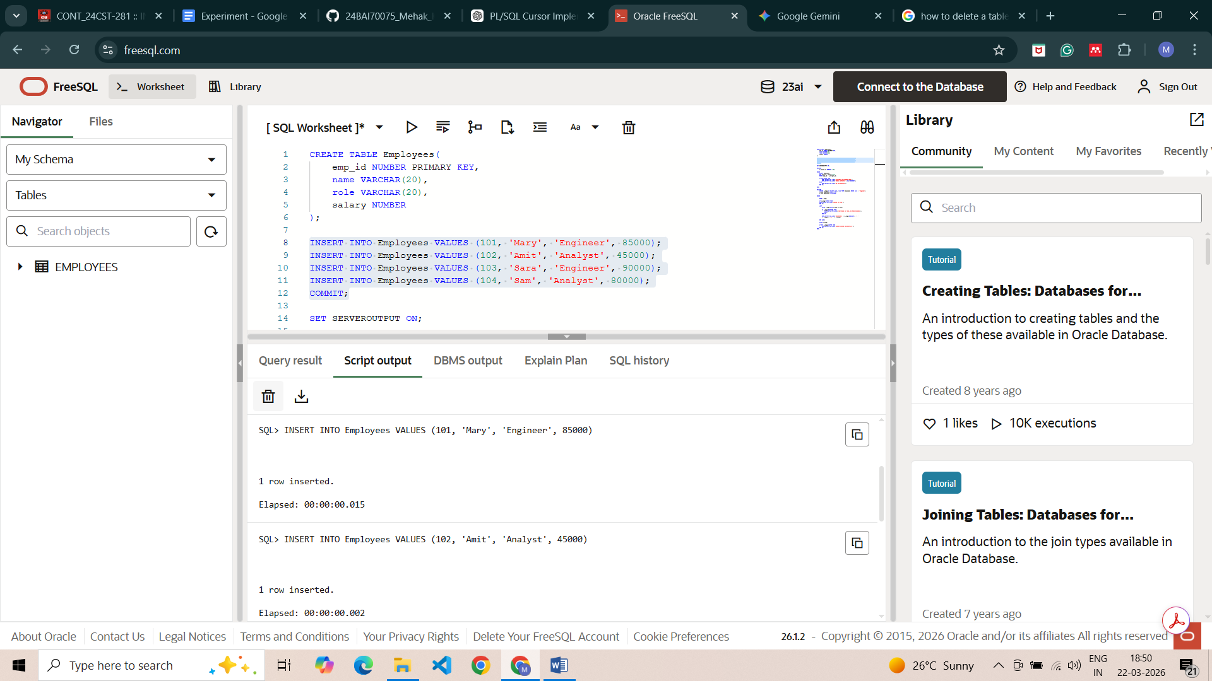
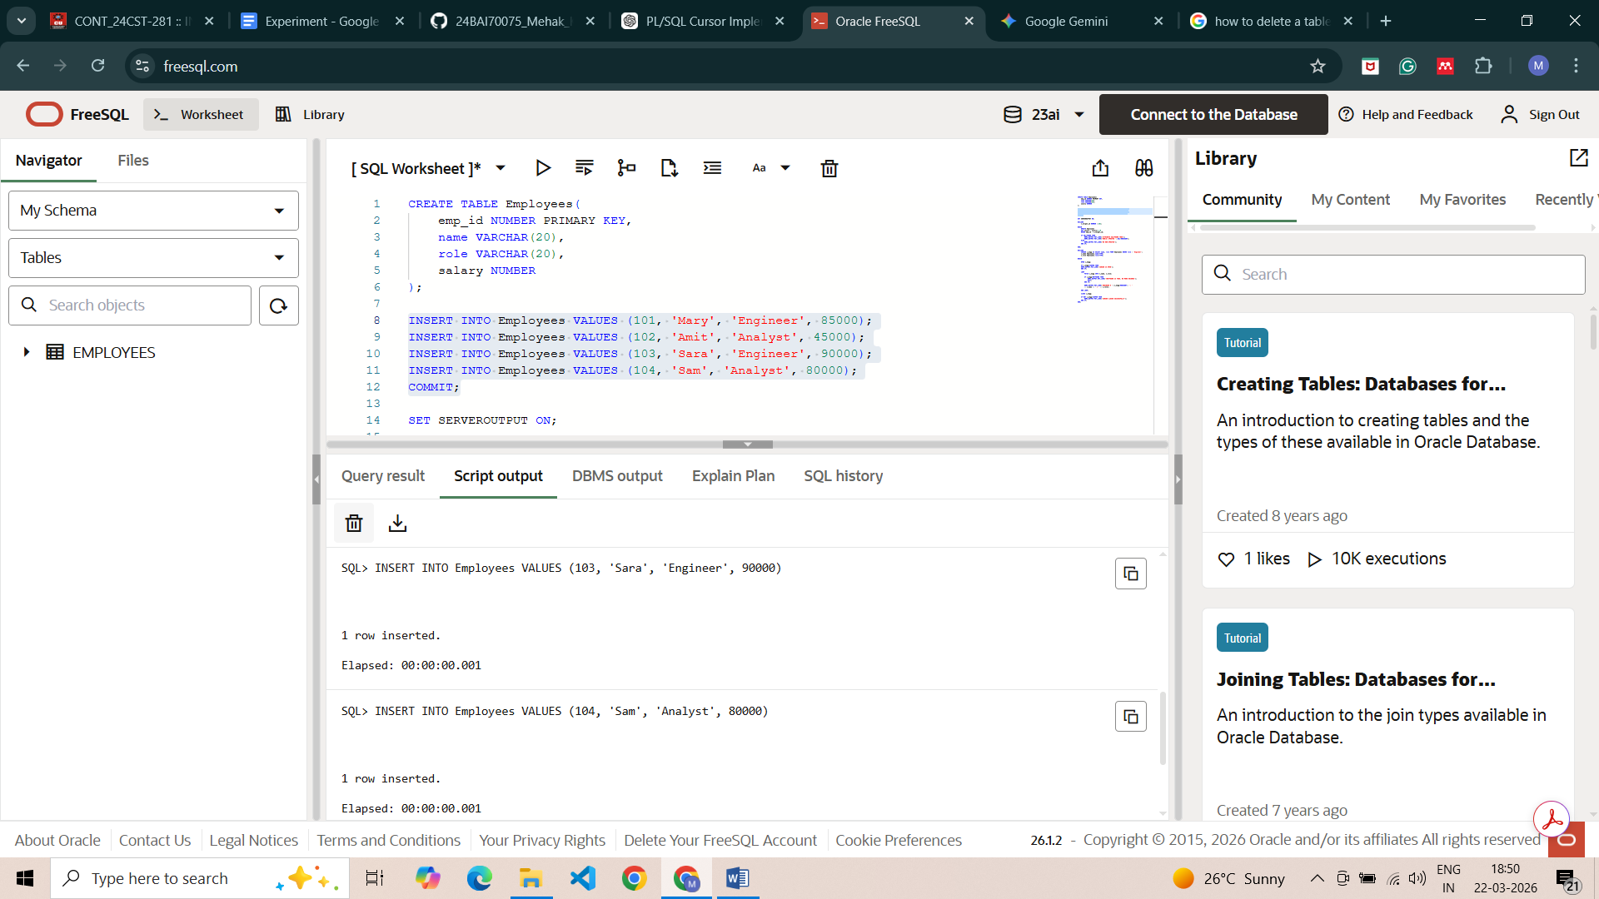

SQL Input Queries
SET SERVEROUTPUT ON;

DECLARE
v_target_id NUMBER :=101;

BEGIN
UPDATE Employees
SET salary = salary*1.10
WHERE emp_id = v_target_id;

IF SQL%FOUND THEN
DBMS_OUTPUT.PUT_LINE('ATTRIBUTE SQL%FOUND TRUE');
DBMS_OUTPUT.PUT_LINE('ROW(S) UPDATED '||SQL%ROWCOUNT);
ELSE
DBMS_OUTPUT.PUT_LINE('NO ROW UPDATED');
END IF;

END;

Output
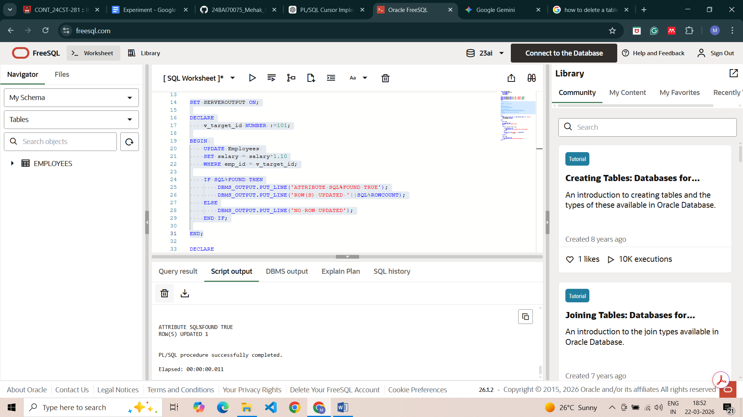

SQL Input Queries
DECLARE
CURSOR c_engg IS SELECT name, role FROM Employees WHERE role = 'Engineer';
v_name Employees.name%TYPE;
v_role Employees.role%TYPE;

BEGIN

OPEN c_engg;

IF c_engg%ISOPEN THEN
DBMS_OUTPUT.PUT_LINE('CURSOR IS OPEN');
END IF;

LOOP
FETCH c_engg INTO v_name, v_role;

IF c_engg%NOTFOUND THEN
DBMS_OUTPUT.PUT_LINE('%NOTFOUND IS TRUE, NO MORE RECORDS');
EXIT;
END IF;

DBMS_OUTPUT.PUT_LINE('ENGINEER # '||c_engg%ROWCOUNT|| ': '
|| v_name || ' | ' || v_role);

END LOOP;

CLOSE c_engg;

IF NOT c_engg%ISOPEN THEN
DBMS_OUTPUT.PUT_LINE('CURSOR CLOSED SUCCESSFULLY');
END IF;
END;

Output
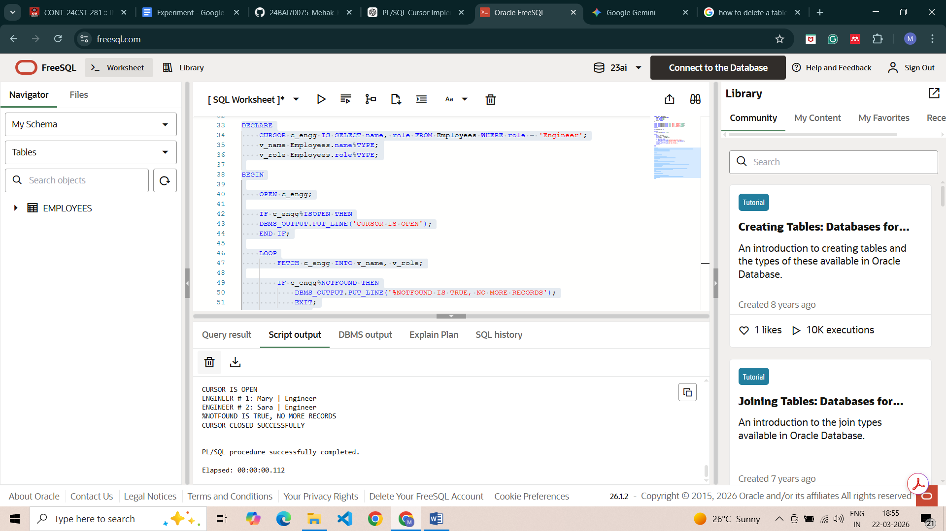

Learning Outcomes
- Gained proficiency in differentiating between implicit cursors for DML and explicit cursors for multi-row queries.
- Learnt using %FOUND, %NOTFOUND, and %ROWCOUNT to manage loop iterations and verify operation success.
- Understanding the importance of the OPEN, FETCH, and CLOSE lifecycle to ensure efficient memory management.
- Ability to develop PL/SQL programs that apply complex business logic to individual records within a larger dataset.

