**FINANCIAL RISK ANALYSIS**

**(APPLE INC. 2012-2021)**

**Overview**

This project involves the analysis of Apple Inc.'s historic financial data to assess financial risks and trends. Utilizing Excel, SQL, and Power BI, the analysis aims to provide comprehensive insights into financial performance, risk factors, and strategic opportunities.

**Key Financial Risk Indicators**

Key financial risk indicators help assess the financial health and stability of an organization. These indicators provide insights into potential risks and help in making informed decisions. Here are some essential financial risk indicators:

**1. Liquidity Ratios**

These measure the ability of an organization to meet its short-term obligations.

* **Current Ratio**:

Current Ratio = Current Assets/Current Liabilities

* **Quick Ratio (Acid-Test Ratio)**:

Quick Ratio = (Cash and Cash Equivalents + Short-Term Investments + Accounts Receivable)/Current Liabilities

**2. Solvency Ratios**

These assess the ability to meet long-term obligations and the overall financial stability of the company.

* **Debt to Equity Ratio**:

Debt to Equity Ratio= Total Debt/Total Equity

**3. Cash Flow Risk Indicators**

These evaluate the stability and reliability of cash flows.

* **Operating Cash Flow Ratio**:

Operating Cash Flow Ratio = Operating Cash Flow/Current Liabilities ​

**OBSERVATION**

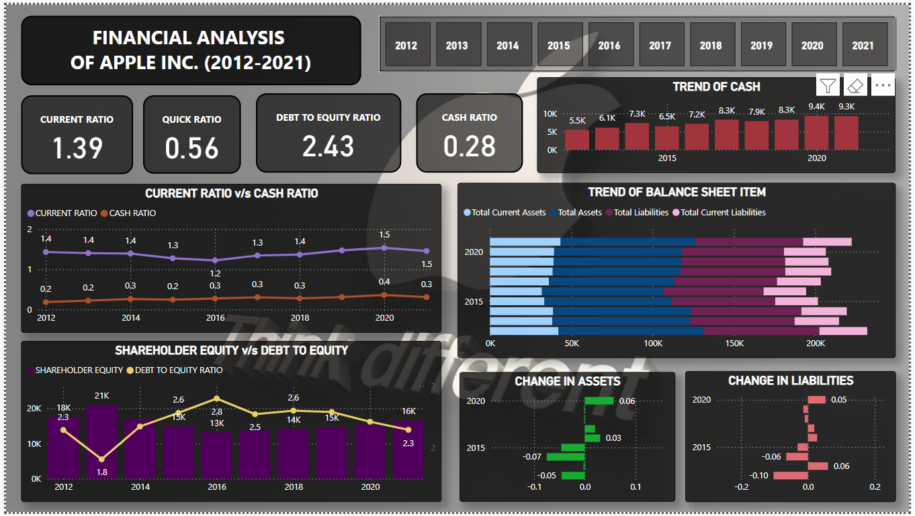

* As observed in CURRENT RATIO with a positive value the amount of Current Assets is more than the Current Liabilities which shows a low-risk indication.
* Similarly, in QUICK RATIO with a positive value indicates a low financial risk.
* But in DEBT-TO-EQUITY RATIO the positive value indicates more amount of DEBT than EQUITY which is a **high-risk indication**.
* In CASH RATIO positive value is a low-risk indicator as it indicates more amount Cash than Current Liabilities.

**High Financial Leverage and Risk**

Having more debt than equity is considered a high-risk indication. This situation indicates high financial leverage, which can lead to increased financial risk.

1. **Increased Financial Obligations**:

* High levels of debt mean higher interest payments, which can strain cash flows, especially if revenues or profits decline.
* Debt must be repaid according to a schedule, which can be a burden if the company faces financial difficulties.

1. **Financial Flexibility**:

* Companies with significant debt have less flexibility to makeover in adverse conditions.
* High debt levels can make it harder or more expensive to raise additional capital.

1. **Risk of Insolvency**:

* If a company cannot meet its debt payments, it risks default or bankruptcy, especially if economic conditions worsen.

**Predictive Insights**

Due to High Debt-to-Equity Ratio following are the predictive situations that can be faced by the company:

1. Risk of Financial Distress
2. Impact on Profit Margins
3. Credit Risk and Cost of Borrowing
4. Operational Flexibility
5. Liquidity and Cash Flow Pressures

**CONCLUSION**

While debt can provide growth opportunities and leverage, excessive debt relative to equity increases financial risk and can lead to significant challenges for a company. Effective debt management and maintaining a healthy balance between debt and equity are crucial for long-term financial stability and risk mitigation.