**Predictive Maintenance for Industrial Equipment**

**Using IoT Data**

**Introduction**

The Predictive Maintenance model for industrial equipment which utilizes IoT data is designed to forecast potential equipment failures before they occur, enhancing operational efficiency and minimizing downtime.

Leveraging real-time sensor data from machinery, the model processes and analyzes critical parameters like voltage, rotation, pressure, vibration, and more. It applies machine learning techniques to predict the likelihood of equipment failure, enabling proactive maintenance.

In addition to predictive analysis, the model incorporates anomaly detection and real-time monitoring, allowing for immediate identification of irregular behavior. This system provides businesses with cost savings by optimizing maintenance schedules, reducing unplanned downtime, and improving overall equipment life cycle management.

**Dashboard (created in Power BI)**

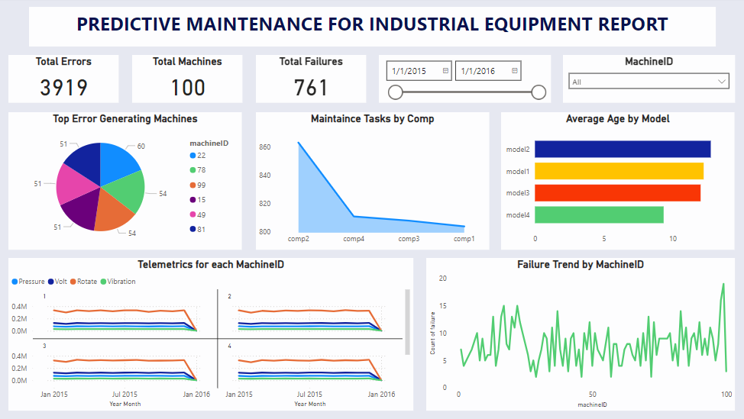

**Imports and Setup:**

* Includes various libraries such as NumPy, pandas, matplotlib, plotly, TensorFlow, and statsmodels, indicating the use of machine learning and time series analysis for predictive modelling.
* Libraries like ARIMA suggest that time-series forecasting techniques are explored, while LSTM (Long Short-Term Memory) and other deep learning models are employed.

**Data Collection**

Used IoT sensors data from industrial equipment which includes equipment's telemetry and features, such as voltage, rotation, pressure, and vibration, machine ID’s respective to their errorID, model and age of the machine, failures of the machine, and maintenance of the machines are tracked over time for each machine.

**Data Loading and Preprocessing:**

* **Telemetry Data**: Contains features like datetime, machineID, volt, rotate, pressure, and vibration. These features are vital for monitoring machine health.
* **Failure and Error Data**: Separate datasets for machine failures and errors. These are loaded alongside the telemetry data.
* **Datetime Parsing**: Dates and times in the data are converted into datetime objects to facilitate time-series analysis and synchronization across the different datasets.
* **Machine-wise Data Separation**: Data is separated for individual machines, indicating machine-specific analysis for predictive maintenance.

**Modeling & Prediction Approaches:**

* **ARIMA (Auto Regressive Integrated Moving Average)**: This model is mentioned for time-series forecasting, likely used to predict sensor measurements (e.g., volt, pressure) over time. ARIMA is traditionally used to forecast trends based on past data.
* **LSTM (Long Short-Term Memory)**: The presence of LSTM layers, a type of recurrent neural network, suggests that the model aims to capture long-term dependencies in time-series data, which is crucial for predicting machine failures or anomalies.
* **Anomaly Detection**: Not explicitly mentioned in the extracted content, but the combination of LSTM with telemetry data typically indicates anomaly detection for identifying unusual machine behavior prior to failure.

**Failure Prediction & Anomaly Detection:**

* Telemetry data (volt, rotation, pressure, vibration) is likely used to predict failure events.
* The models are built to flag abnormal sensor readings that could lead to equipment failure. The ARIMA and LSTM models may work in tandem to detect trends and sudden changes (anomalies).

**Real-Time Monitoring:**

Real-time monitoring and forecasting are likely part of the system’s design, where new telemetry data is fed into the model to continuously predict failures and alert operators.

**Cost-Benefit Analysis:**

The notebook likely includes a cost-benefit analysis based on the predicted failures and anomalies detected. By predicting equipment failure in advance, companies can minimize downtime, reduce repair costs, and increase equipment longevity.

**Key Insights and Model Summary:**

* **Input Data**: Includes telemetry data and failure/error data related to industrial equipment.
* **Time-Series Modeling**: ARIMA is used for short-term prediction, while LSTM is implemented to detect anomalies over longer periods.
* **Failure Prediction**: The system predicts failures based on historical trends in telemetry data. It learns from past failures and anomalies to predict future issues.
* **Anomaly Detection**: Detects unusual patterns in voltage, rotation, pressure, and vibration data to warn about potential equipment malfunction