N17

## one_way_anova

(3.46342327748778, 0.031513596310710636)

## t_test

t_statistic p_value  
pre_diabetes vs no_diabetes 1.756018 0.079270  
diabetes vs no_diabetes 2.311373 0.020923

## tukey_hsd

Multiple Comparison of Means - Tukey HSD, FWER=0.05   
==============================================================  
 group1 group2 meandiff p-adj lower upper reject  
--------------------------------------------------------------  
 diabetes no_diabetes -0.0197 0.0643 -0.0403 0.0009 False  
 diabetes pre_diabetes 0.0007 0.9985 -0.0331 0.0346 False  
no_diabetes pre_diabetes 0.0205 0.2322 -0.0089 0.0498 False  
--------------------------------------------------------------

## covariance_analysis

sum_sq df F PR(>F)  
C(no_diabetes) 0.086272 1.0 4.391968 0.036236  
C(pre_diabetes) 0.000014 1.0 0.000720 0.978594  
C(diabetes) 0.000383 1.0 0.019501 0.888955  
Age 0.451150 1.0 22.967366 0.000002  
Residual 38.598670 1965.0 NaN NaN

## interaction_analysis

sum_sq df F PR(>F)  
C(no_diabetes) 0.002033 1.0 0.103439 0.747775  
C(pre_diabetes) 0.003084 1.0 0.156926 0.692046  
C(diabetes) 0.000383 1.0 0.019493 0.888977  
Age 0.451150 1.0 22.958423 0.000002  
C(diabetes):Age 0.004615 1.0 0.234828 0.628021  
Residual 38.594055 1964.0 NaN NaN

## interaction_analysis2

dfn dfd F PR(>F)  
diabetes 1.0 1827.0 0.434073 0.510080  
pre_diabetes 1.0 1837.0 0.548373 0.459078

## chi_square_test

condition chi2 p_value dof  
0 no_diabetes 5.945014 0.014759 1  
1 pre_diabetes 1.126961 0.288424 1  
2 diabetes 3.397261 0.065305 1

## relative_risk_analysis

condition relative_risk ci p_value  
0 no_diabetes 0.016032 0.010712 4.707742e-90  
1 pre_diabetes 0.037594 0.015394 2.962226e-13  
2 diabetes 0.036789 0.020156 2.739759e-27

## odds_ratio_analysis

condition odds_ratio ci p_value  
0 no_diabetes 2.310185 1.543508 0.012626  
1 pre_diabetes 0.518374 0.212268 0.196901  
2 diabetes 0.483603 0.264950 0.047810

## relative_risk_by_age

age_group condition relative_risk p_value confidence_interval  
6 18-40 No Diabetes 0.000000 1.000000 0.000000  
7 18-40 Pre-Diabetes inf 1.000000 NaN  
8 18-40 Diabetes inf 1.000000 NaN  
3 40-60 No Diabetes 5.571429 0.283553 0.783170  
4 40-60 Pre-Diabetes 0.055449 0.105463 0.007553  
5 40-60 Diabetes inf 1.000000 NaN  
0 60+ No Diabetes 1.343464 0.382002 0.878570  
1 60+ Pre-Diabetes 0.922757 0.782792 0.339735  
2 60+ Diabetes 0.730354 0.431284 0.399023

## visualize_tukey_results

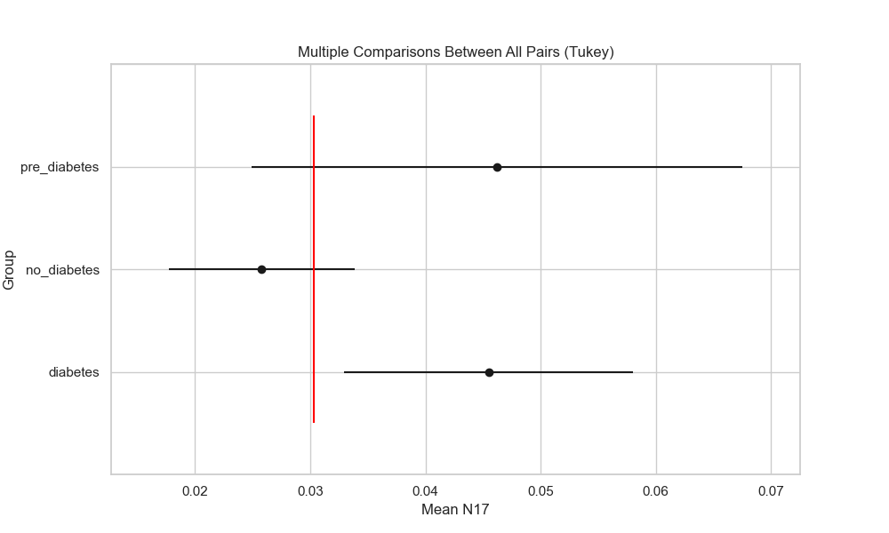

## plot_interaction_analysis

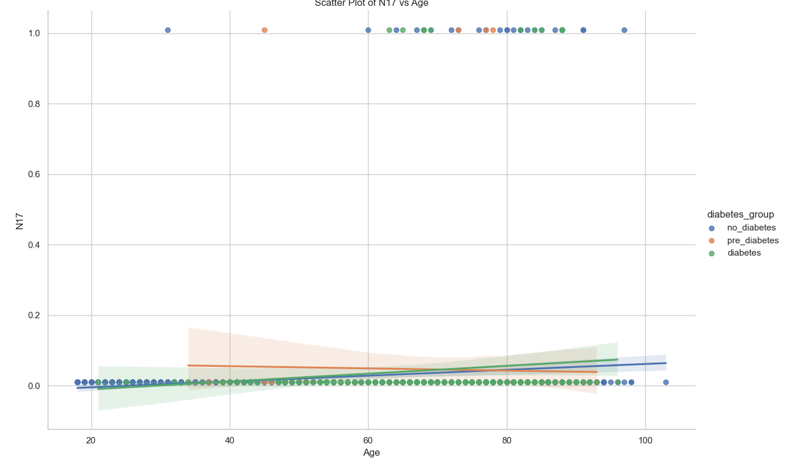

## visualize_chi_square_results

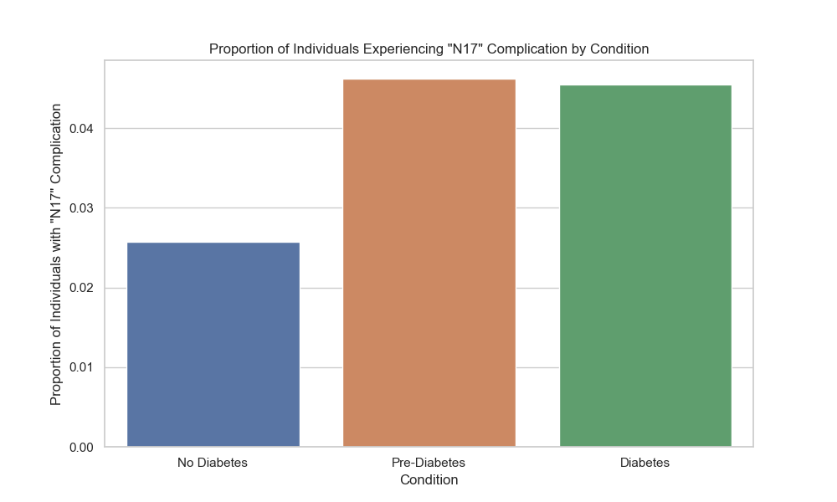

## visualize_relative_risk_results

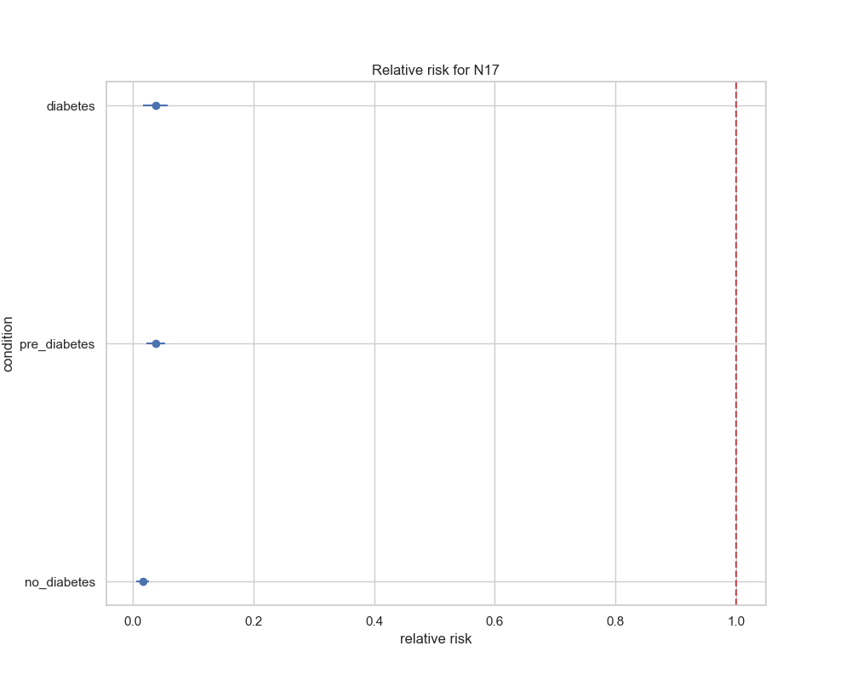

## visualize_odds_ratio_results

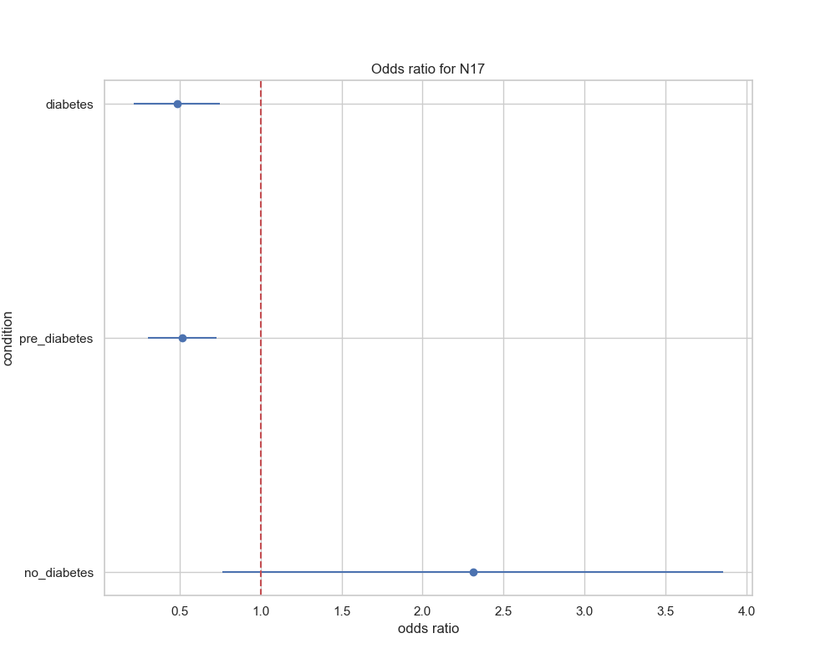

## visualize_relative_risk_by_age_results

