T84

## one_way_anova

(2.6423095847201137, 0.07144947915880548)

## t_test

t_statistic p_value  
pre_diabetes vs no_diabetes -2.274008 0.023093  
diabetes vs no_diabetes 0.217763 0.827638

## tukey_hsd

Multiple Comparison of Means - Tukey HSD, FWER=0.05   
==============================================================  
 group1 group2 meandiff p-adj lower upper reject  
--------------------------------------------------------------  
 diabetes no_diabetes -0.0025 0.9723 -0.029 0.0239 False  
 diabetes pre_diabetes -0.0387 0.0926 -0.0822 0.0048 False  
no_diabetes pre_diabetes -0.0362 0.0641 -0.0739 0.0016 False  
--------------------------------------------------------------

## covariance_analysis

sum_sq df F PR(>F)  
C(no_diabetes) 0.314843 1.0 9.587568 0.001987  
C(pre_diabetes) 0.077810 1.0 2.369471 0.123890  
C(diabetes) 0.121959 1.0 3.713873 0.054106  
Age 0.018570 1.0 0.565482 0.452150  
Residual 64.528091 1965.0 NaN NaN

## interaction_analysis

sum_sq df F PR(>F)  
C(no_diabetes) 0.174619 1.0 5.319027 0.021197  
C(pre_diabetes) 0.000019 1.0 0.000568 0.980982  
C(diabetes) 0.121959 1.0 3.714952 0.054071  
Age 0.018570 1.0 0.565647 0.452084  
C(diabetes):Age 0.051569 1.0 1.570829 0.210236  
Residual 64.476522 1964.0 NaN NaN

## interaction_analysis2

dfn dfd F PR(>F)  
diabetes 1.0 1827.0 5.204662 0.022641  
pre_diabetes 1.0 1837.0 0.142634 0.705720

## chi_square_test

condition chi2 p_value dof  
0 no_diabetes 0.662069 0.415830 1  
1 pre_diabetes 4.173600 0.041058 1  
2 diabetes 0.105453 0.745381 1

## relative_risk_analysis

condition relative_risk ci p_value  
0 no_diabetes 0.037517 0.028663 1.431133e-126  
1 pre_diabetes 0.000000 0.000000 NaN  
2 diabetes 0.040268 0.022612 5.171448e-28

## odds_ratio_analysis

condition odds_ratio ci p_value  
0 no_diabetes 0.733611 0.560476 0.377007  
1 pre_diabetes inf NaN 0.012768  
2 diabetes 0.851517 0.478161 0.608907

## relative_risk_by_age

age_group condition relative_risk p_value confidence_interval  
6 18-40 No Diabetes 0.000000 1.000000 0.000000  
7 18-40 Pre-Diabetes inf 1.000000 NaN  
8 18-40 Diabetes inf 1.000000 NaN  
3 40-60 No Diabetes 0.000000 0.089191 0.000000  
4 40-60 Pre-Diabetes inf 0.615903 NaN  
5 40-60 Diabetes inf 0.397503 NaN  
0 60+ No Diabetes 0.861518 0.733185 0.586325  
1 60+ Pre-Diabetes inf 0.026774 NaN  
2 60+ Diabetes 0.693211 0.337155 0.388128

## visualize_tukey_results

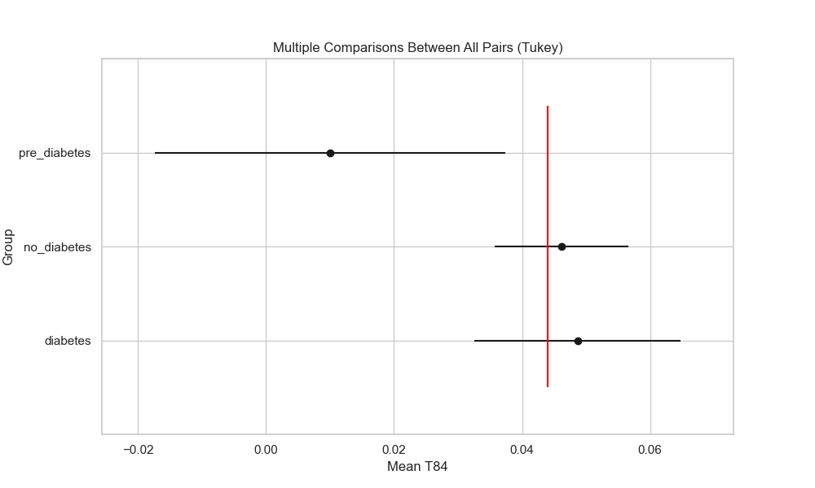

## plot_interaction_analysis

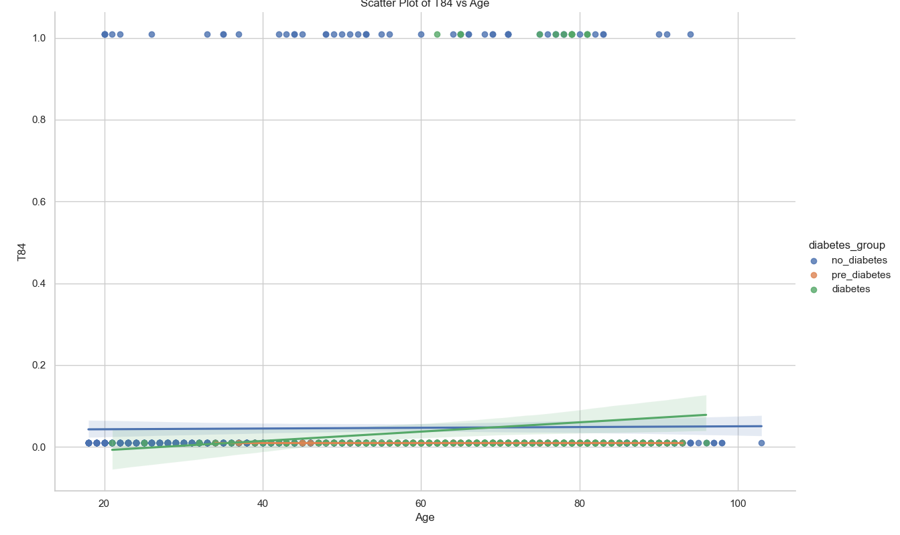

## visualize_chi_square_results

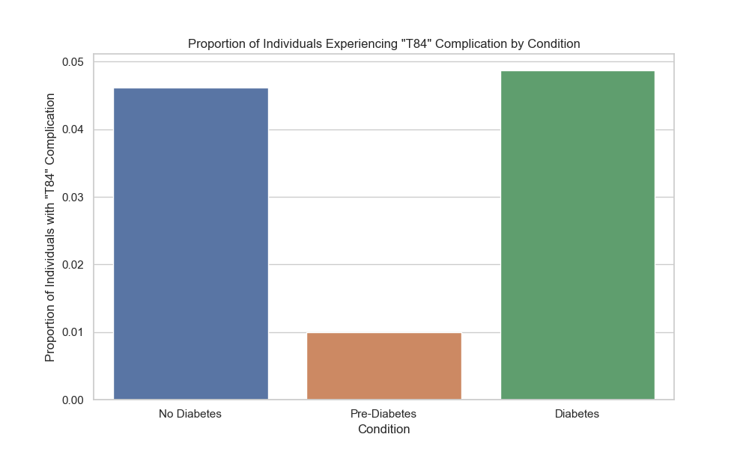

## visualize_relative_risk_results

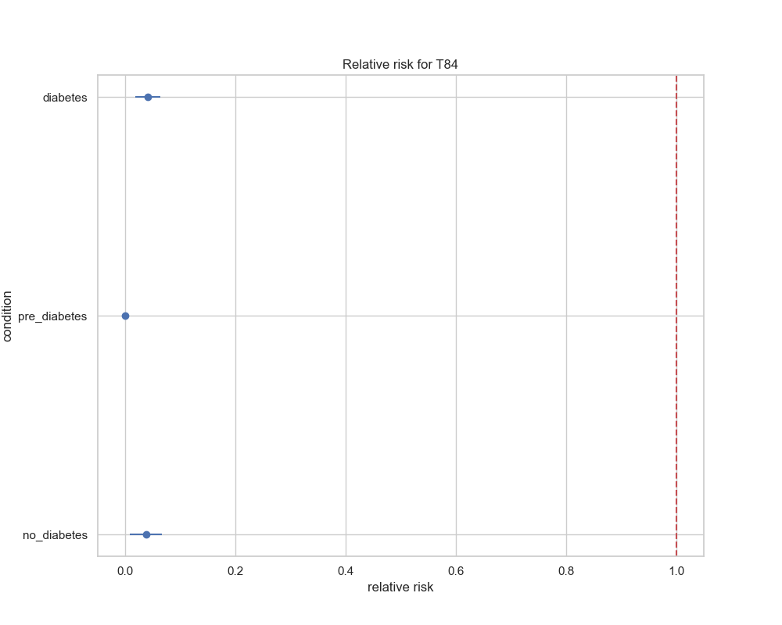

## visualize_odds_ratio_results

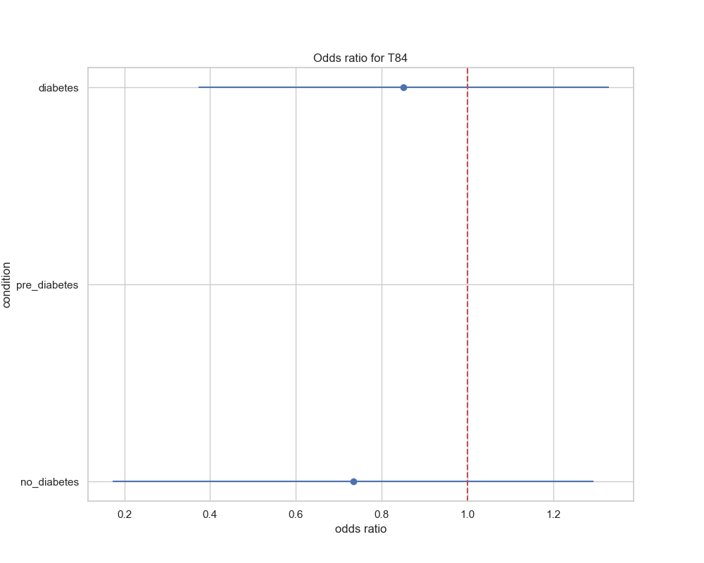

## visualize_relative_risk_by_age_results

