TOD

## one_way_anova

(0.8980365004751797, 0.40753578189714934)

## t_test

t_statistic p_value  
pre_diabetes vs no_diabetes 1.185860 0.235848  
diabetes vs no_diabetes 0.845129 0.398149

## tukey_hsd

Multiple Comparison of Means - Tukey HSD, FWER=0.05   
==============================================================  
 group1 group2 meandiff p-adj lower upper reject  
--------------------------------------------------------------  
 diabetes no_diabetes -0.0056 0.6906 -0.0217 0.0104 False  
 diabetes pre_diabetes 0.0056 0.8716 -0.0207 0.032 False  
no_diabetes pre_diabetes 0.0112 0.4836 -0.0117 0.0341 False  
--------------------------------------------------------------

## covariance_analysis

sum_sq df F PR(>F)  
C(no_diabetes) 0.005993 1.0 0.500211 0.479491  
C(pre_diabetes) 0.001539 1.0 0.128435 0.720099  
C(diabetes) 0.003424 1.0 0.285826 0.592969  
Age 0.144405 1.0 12.053463 0.000528  
Residual 23.541422 1965.0 NaN NaN

## interaction_analysis

sum_sq df F PR(>F)  
C(no_diabetes) 0.007536 1.0 0.629158 0.427760  
C(pre_diabetes) 0.014774 1.0 1.233375 0.266888  
C(diabetes) 0.003424 1.0 0.285867 0.592942  
Age 0.144405 1.0 12.055211 0.000528  
C(diabetes):Age 0.015393 1.0 1.285069 0.257097  
Residual 23.526029 1964.0 NaN NaN

## interaction_analysis2

dfn dfd F PR(>F)  
diabetes 1.0 1827.0 0.247071 0.619205  
pre_diabetes 1.0 1837.0 0.370256 0.542940

## chi_square_test

condition chi2 p_value dof  
0 no_diabetes 0.998130 0.317764 1  
1 pre_diabetes 0.432981 0.510530 1  
2 diabetes 0.165497 0.684145 1

## relative_risk_analysis

condition relative_risk ci p_value  
0 no_diabetes 0.010631 0.006496 2.291005e-73  
1 pre_diabetes 0.022222 0.007078 3.485672e-11  
2 diabetes 0.016393 0.006775 3.834600e-20

## odds_ratio_analysis

condition odds_ratio ci p_value  
0 no_diabetes 1.710227 1.045022 0.222302  
1 pre_diabetes 0.522099 0.166296 0.234170  
2 diabetes 0.706707 0.292054 0.569195

## relative_risk_by_age

age_group condition relative_risk p_value confidence_interval  
3 40-60 No Diabetes 0.000000 1.000000 0.000000  
4 40-60 Pre-Diabetes inf 1.000000 NaN  
5 40-60 Diabetes inf 1.000000 NaN  
0 60+ No Diabetes 1.204013 0.649817 0.695485  
1 60+ Pre-Diabetes 0.666667 0.461612 0.211491  
2 60+ Diabetes 1.000772 1.000000 0.412829

## visualize_tukey_results

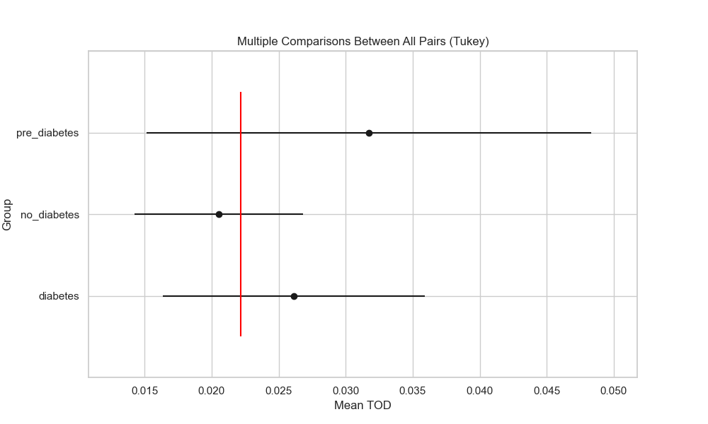

## plot_interaction_analysis

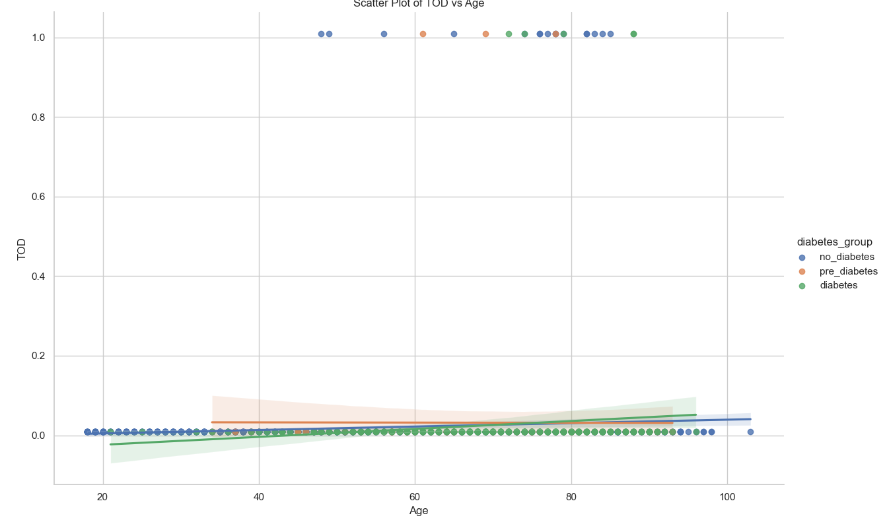

## visualize_chi_square_results

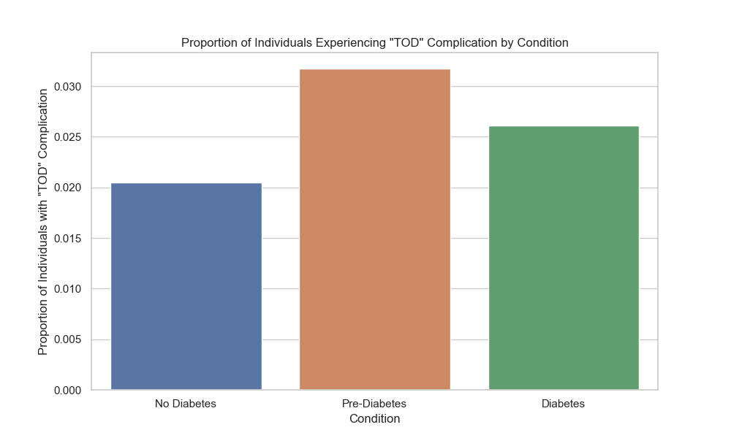

## visualize_relative_risk_results

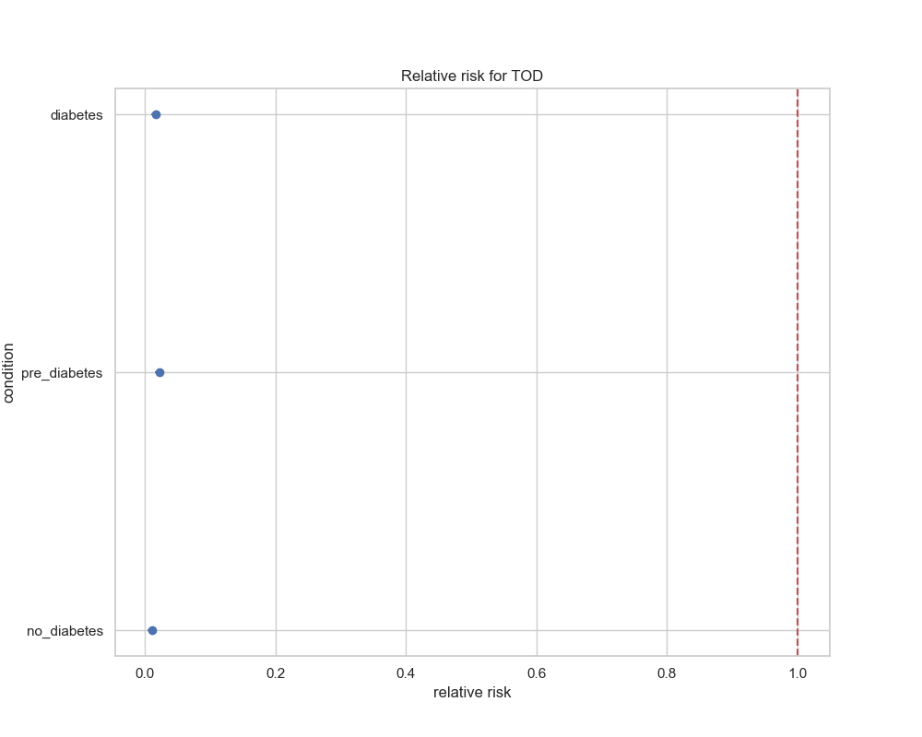

## visualize_odds_ratio_results

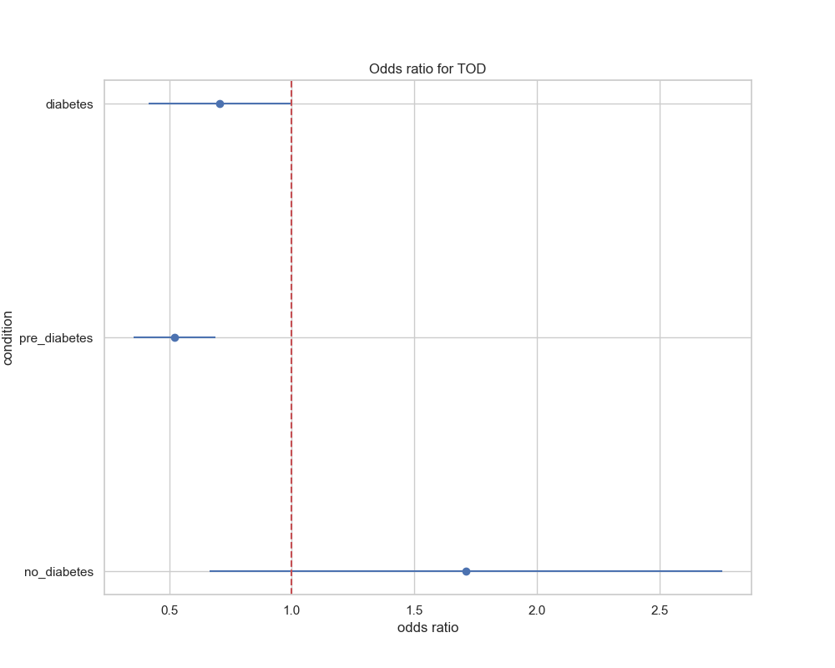

## visualize_relative_risk_by_age_results

