U69

## one_way_anova

(1.2641029604024445, 0.2827220948316846)

## t_test

t_statistic p_value  
pre_diabetes vs no_diabetes -1.171685 0.241492  
diabetes vs no_diabetes 0.967288 0.333528

## tukey_hsd

Multiple Comparison of Means - Tukey HSD, FWER=0.05   
==============================================================  
 group1 group2 meandiff p-adj lower upper reject  
--------------------------------------------------------------  
 diabetes no_diabetes -0.0063 0.5751 -0.0209 0.0084 False  
 diabetes pre_diabetes -0.0161 0.2582 -0.0402 0.0079 False  
no_diabetes pre_diabetes -0.0099 0.5104 -0.0308 0.011 False  
--------------------------------------------------------------

## covariance_analysis

sum_sq df F PR(>F)  
C(no_diabetes) 0.014269 1.0 1.421173 0.233354  
C(pre_diabetes) 0.016635 1.0 1.656786 0.198189  
C(diabetes) 0.016056 1.0 1.599149 0.206174  
Age 0.041906 1.0 4.173665 0.041190  
Residual 19.729520 1965.0 NaN NaN

## interaction_analysis

sum_sq df F PR(>F)  
C(no_diabetes) 0.001720 1.0 0.171242 0.679056  
C(pre_diabetes) 0.006784 1.0 0.675280 0.411317  
C(diabetes) 0.016056 1.0 1.598336 0.206289  
Age 0.041906 1.0 4.171543 0.041242  
C(diabetes):Age 0.000007 1.0 0.000745 0.978230  
Residual 19.729513 1964.0 NaN NaN

## interaction_analysis2

dfn dfd F PR(>F)  
diabetes 1.0 1827.0 2.917099 0.087815  
pre_diabetes 1.0 1837.0 0.000051 0.994281

## chi_square_test

condition chi2 p_value dof  
0 no_diabetes 0.000000 1.000000 1  
1 pre_diabetes 0.630199 0.427282 1  
2 diabetes 0.695220 0.404394 1

## relative_risk_analysis

condition relative_risk ci p_value  
0 no_diabetes 0.009960 0.005990 6.840429e-71  
1 pre_diabetes 0.000000 0.000000 NaN  
2 diabetes 0.016393 0.006775 3.834600e-20

## odds_ratio_analysis

condition odds_ratio ci p_value  
0 no_diabetes 1.133183 0.681442 0.790399  
1 pre_diabetes inf NaN 0.392685  
2 diabetes 0.556569 0.230008 0.227470

## relative_risk_by_age

age_group condition relative_risk p_value confidence_interval  
6 18-40 No Diabetes 0.000000 1.000000 0.000000  
7 18-40 Pre-Diabetes inf 1.000000 NaN  
8 18-40 Diabetes inf 1.000000 NaN  
3 40-60 No Diabetes 0.000000 1.000000 0.000000  
4 40-60 Pre-Diabetes inf 1.000000 NaN  
5 40-60 Diabetes inf 1.000000 NaN  
0 60+ No Diabetes 0.974138 1.000000 0.521758  
1 60+ Pre-Diabetes inf 0.386931 NaN  
2 60+ Diabetes 0.620690 0.368715 0.256041

## visualize_tukey_results

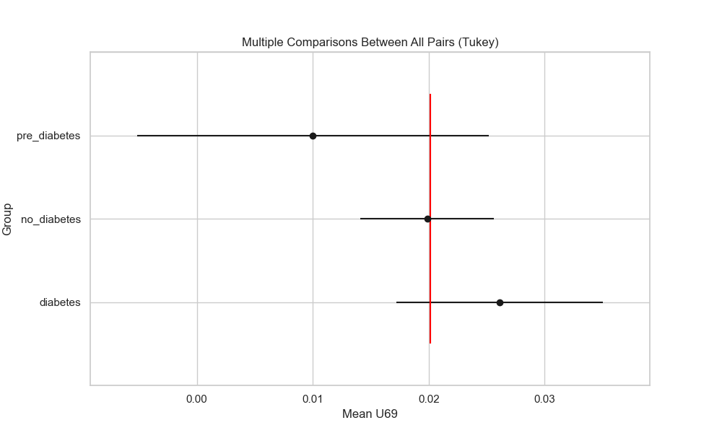

## plot_interaction_analysis

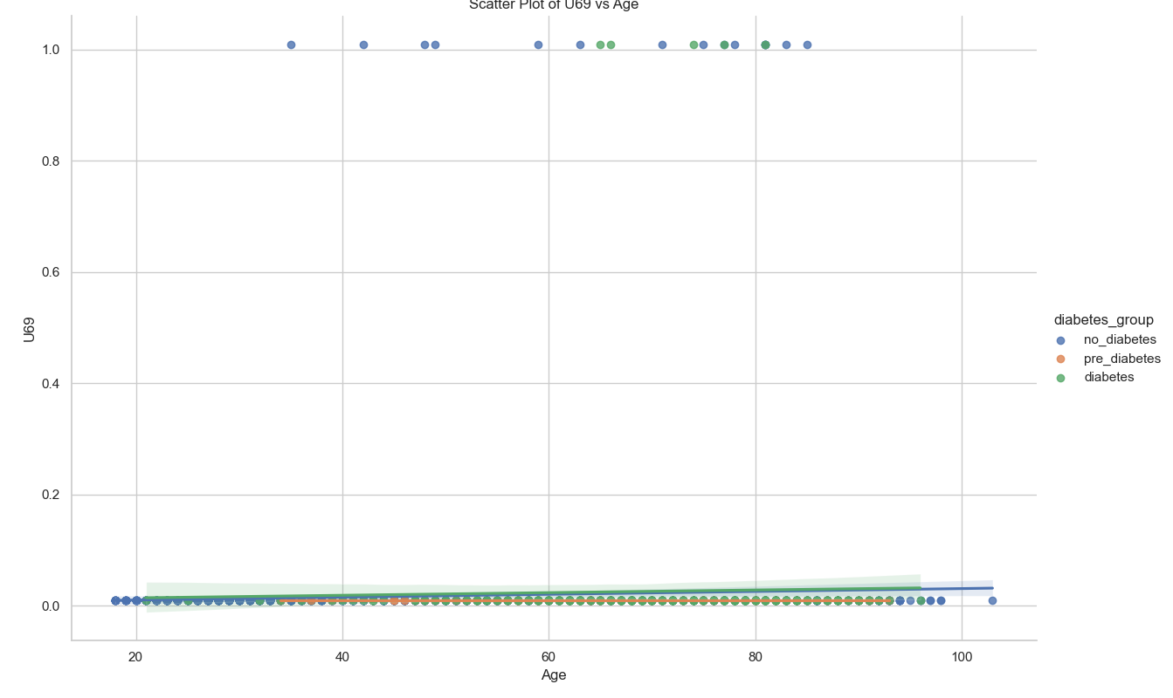

## visualize_chi_square_results

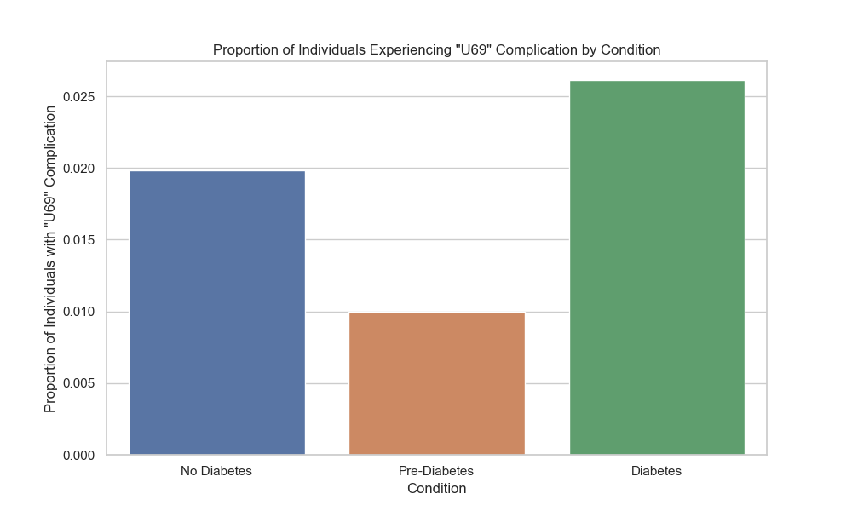

## visualize_relative_risk_results

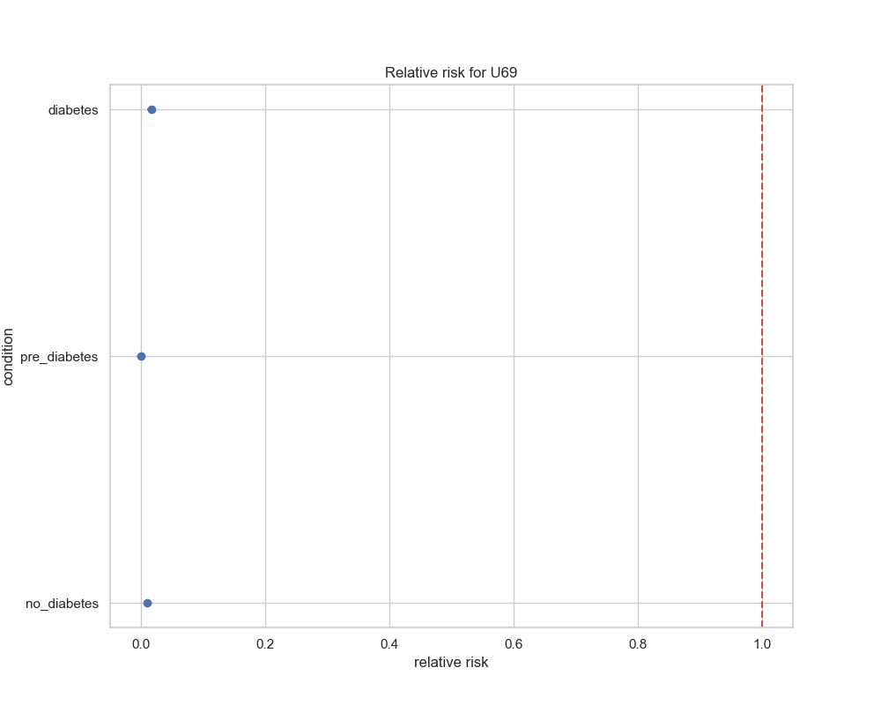

## visualize_odds_ratio_results

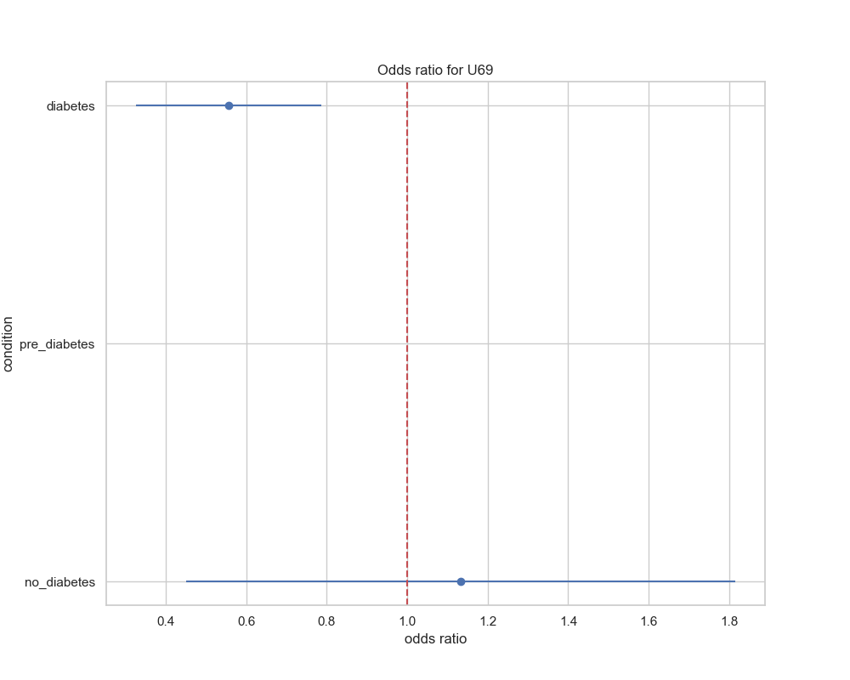

## visualize_relative_risk_by_age_results

