Fall

## one_way_anova

(0.5230749166852501, 0.5929190671787293)

## t_test

t_statistic p_value  
pre_diabetes vs no_diabetes -0.726222 0.467992  
diabetes vs no_diabetes 0.531399 0.595346

## tukey_hsd

Multiple Comparison of Means - Tukey HSD, FWER=0.05   
==============================================================  
 group1 group2 meandiff p-adj lower upper reject  
--------------------------------------------------------------  
 diabetes no_diabetes -0.0106 0.846 -0.0555 0.0344 False  
 diabetes pre_diabetes -0.0237 0.5666 -0.0784 0.031 False  
no_diabetes pre_diabetes -0.0131 0.7618 -0.0571 0.0308 False  
--------------------------------------------------------------

## covariance_analysis

sum_sq df F PR(>F)  
C(no_diabetes) 0.003846 1.0 0.101597 0.750014  
C(pre_diabetes) 0.097127 1.0 2.565825 0.109632  
C(diabetes) 0.001891 1.0 0.049958 0.823200  
Age 0.434580 1.0 11.480422 0.000741  
Residual 27.368437 723.0 NaN NaN

## interaction_analysis

sum_sq df F PR(>F)  
C(no_diabetes) 0.011929 1.0 0.314789 0.574930  
C(pre_diabetes) 0.008896 1.0 0.234767 0.628158  
C(diabetes) 0.001891 1.0 0.049904 0.823294  
Age 0.434580 1.0 11.468074 0.000746  
C(diabetes):Age 0.008426 1.0 0.222358 0.637391  
Residual 27.360011 722.0 NaN NaN

## interaction_analysis2

dfn dfd F PR(>F)  
diabetes 1.0 592.0 1.052675 0.305311  
pre_diabetes 1.0 591.0 0.039203 0.843115

## chi_square_test

condition chi2 p_value dof  
0 no_diabetes 0.000000 1.000000 1  
1 pre_diabetes 0.392241 0.531124 1  
2 diabetes 0.251606 0.615946 1

## relative_risk_analysis

condition relative_risk ci p_value  
0 no_diabetes 0.042254 0.026366 8.613046e-40  
1 pre_diabetes 0.028169 0.010428 9.571320e-13  
2 diabetes 0.053846 0.025170 2.540453e-14

## odds_ratio_analysis

condition odds_ratio ci p_value  
0 no_diabetes 0.957108 0.597222 1.000000  
1 pre_diabetes 1.596223 0.590935 0.484284  
2 diabetes 0.719316 0.336239 0.467380

## relative_risk_by_age

age_group condition relative_risk p_value confidence_interval  
3 40-60 No Diabetes 0.339726 0.419222 0.138951  
4 40-60 Pre-Diabetes inf 0.602938 NaN  
5 40-60 Diabetes 0.969697 1.000000 0.132506  
0 60+ No Diabetes 0.769231 0.668110 0.438033  
1 60+ Pre-Diabetes 1.559701 0.616056 0.572632  
2 60+ Diabetes 0.958647 1.000000 0.419528

## visualize_tukey_results

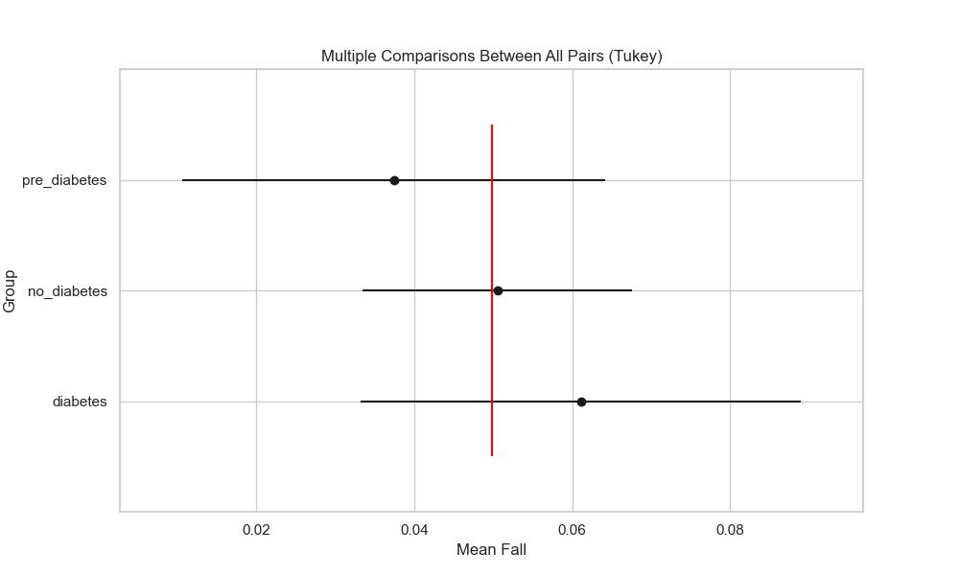

## plot_interaction_analysis

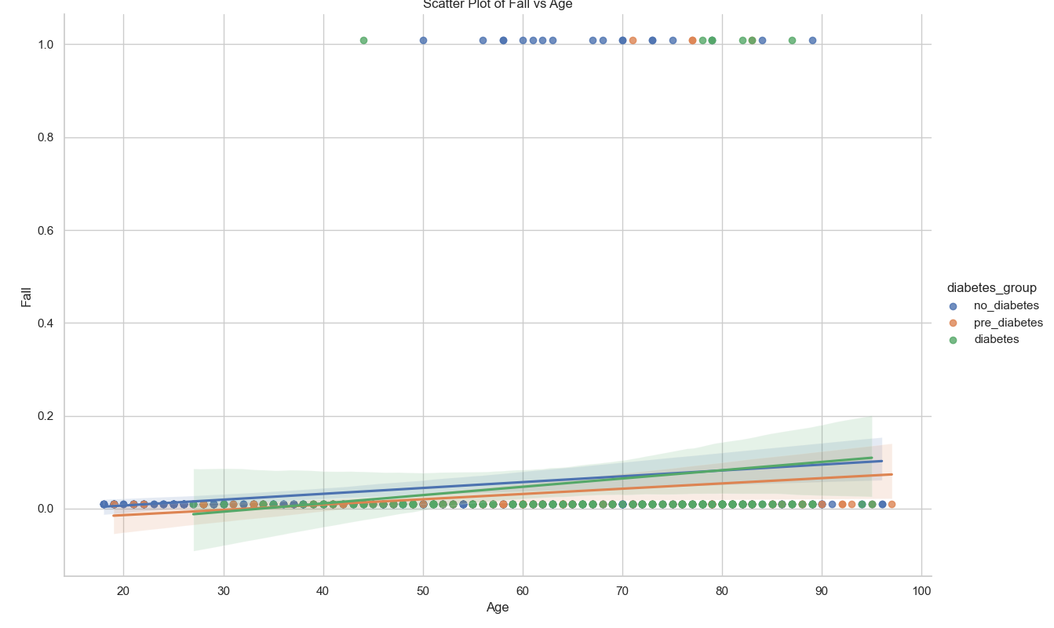

## visualize_chi_square_results

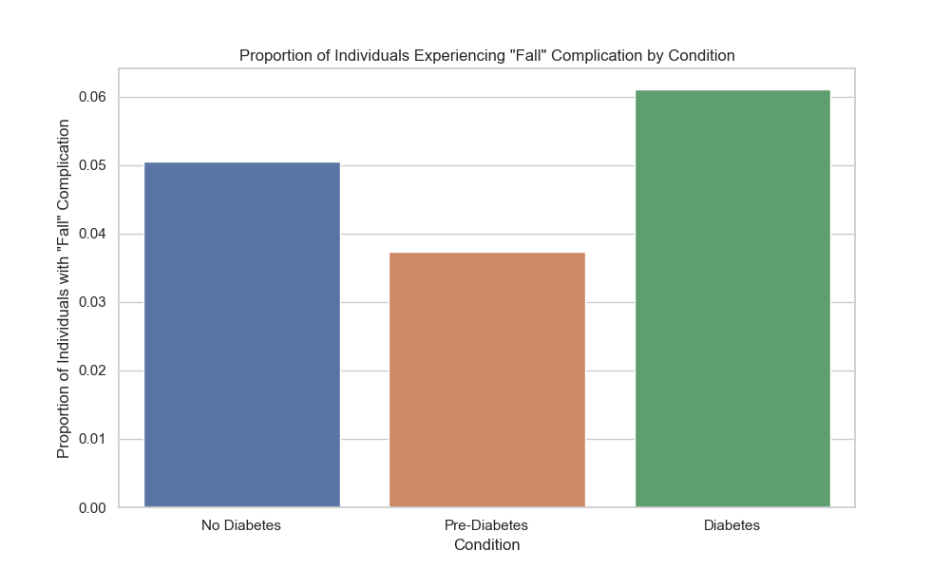

## visualize_relative_risk_results

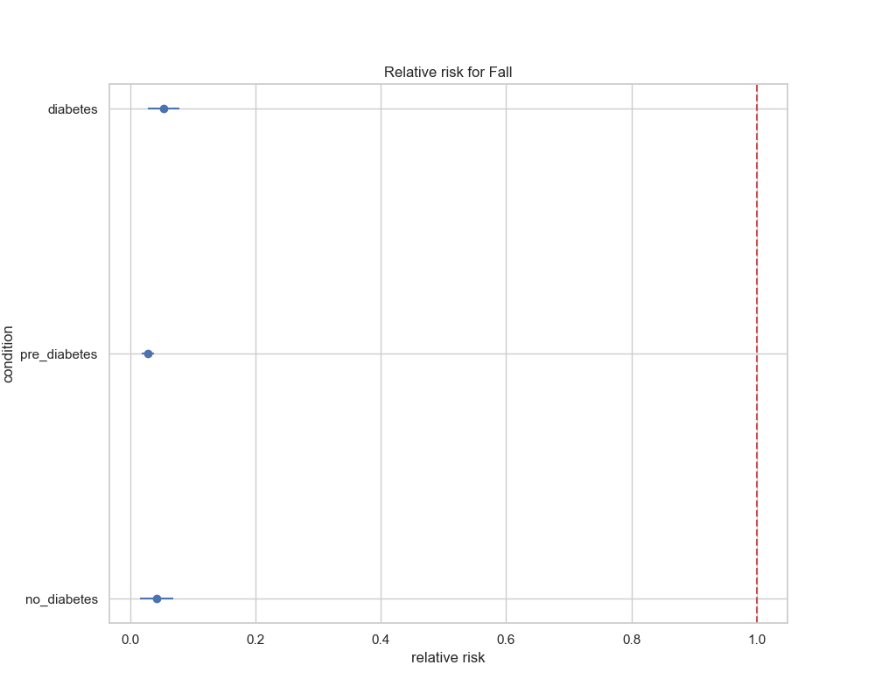

## visualize_odds_ratio_results

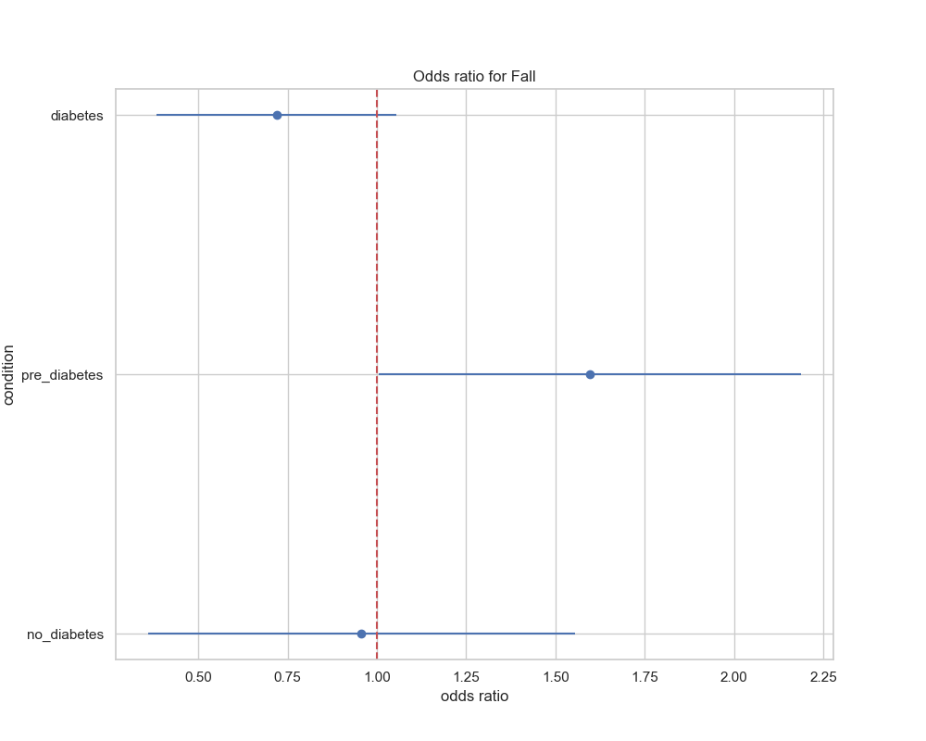

## visualize_relative_risk_by_age_results

