I21

## one_way_anova

(0.31809501926653655, 0.7276352812843677)

## t_test

t_statistic p_value  
pre_diabetes vs no_diabetes -0.573109 0.566790  
diabetes vs no_diabetes -0.555149 0.579007

## tukey_hsd

Multiple Comparison of Means - Tukey HSD, FWER=0.05   
==============================================================  
 group1 group2 meandiff p-adj lower upper reject  
--------------------------------------------------------------  
 diabetes no_diabetes 0.0023 0.8088 -0.0063 0.0108 False  
 diabetes pre_diabetes 0.0 1.0 -0.0104 0.0104 False  
no_diabetes pre_diabetes -0.0023 0.8003 -0.0106 0.0061 False  
--------------------------------------------------------------

## covariance_analysis

sum_sq df F PR(>F)  
C(no_diabetes) 0.004872 1.0 3.539210 0.060336  
C(pre_diabetes) 0.000003 1.0 0.002471 0.960366  
C(diabetes) 0.000003 1.0 0.001860 0.965613  
Age 0.002484 1.0 1.804267 0.179619  
Residual 0.995264 723.0 NaN NaN

## interaction_analysis

sum_sq df F PR(>F)  
C(no_diabetes) 0.000138 1.0 0.100299 0.751563  
C(pre_diabetes) 0.000216 1.0 0.156419 0.692592  
C(diabetes) 0.000003 1.0 0.001858 0.965631  
Age 0.002484 1.0 1.802410 0.179843  
C(diabetes):Age 0.000352 1.0 0.255790 0.613182  
Residual 0.994912 722.0 NaN NaN

## interaction_analysis2

dfn dfd F PR(>F)  
diabetes 1.0 592.0 1.228742 0.268102  
pre_diabetes 1.0 591.0 2.088496 0.148942

## chi_square_test

condition chi2 p_value dof  
0 no_diabetes 0.0 1.0 1  
1 pre_diabetes 0.0 1.0 1  
2 diabetes 0.0 1.0 1

## relative_risk_analysis

condition relative_risk ci p_value  
0 no_diabetes 0.002257 0.000317 5.762947e-10  
1 pre_diabetes 0.000000 0.000000 NaN  
2 diabetes 0.000000 0.000000 NaN

## odds_ratio_analysis

condition odds_ratio ci p_value  
0 no_diabetes 0.0 0.0 1.0  
1 pre_diabetes inf NaN 1.0  
2 diabetes inf NaN 1.0

## relative_risk_by_age

age_group condition relative_risk p_value confidence_interval  
0 60+ No Diabetes 0.0 1.0 0.0  
1 60+ Pre-Diabetes inf 1.0 NaN  
2 60+ Diabetes inf 1.0 NaN

## visualize_tukey_results

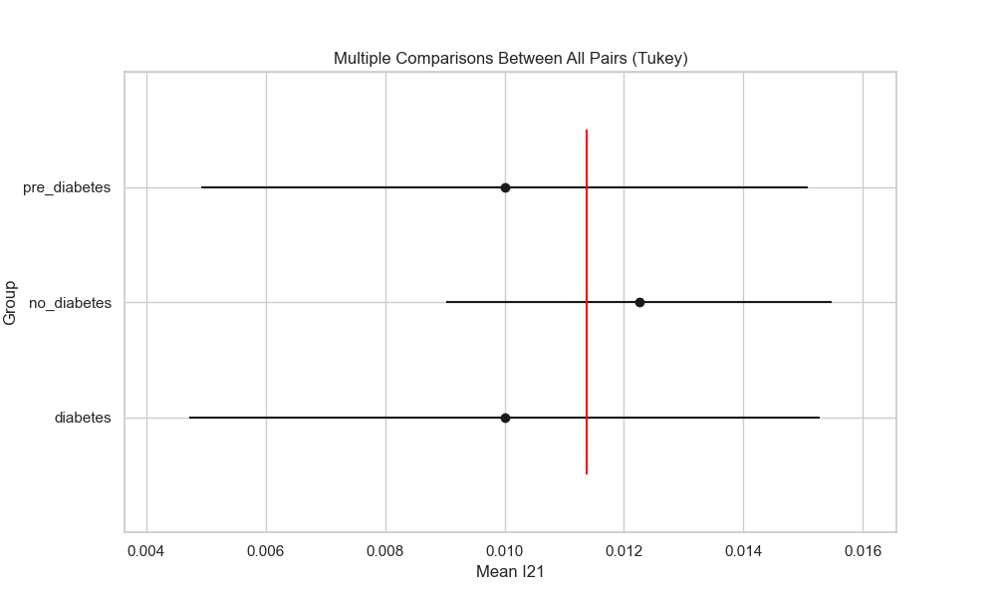

## plot_interaction_analysis

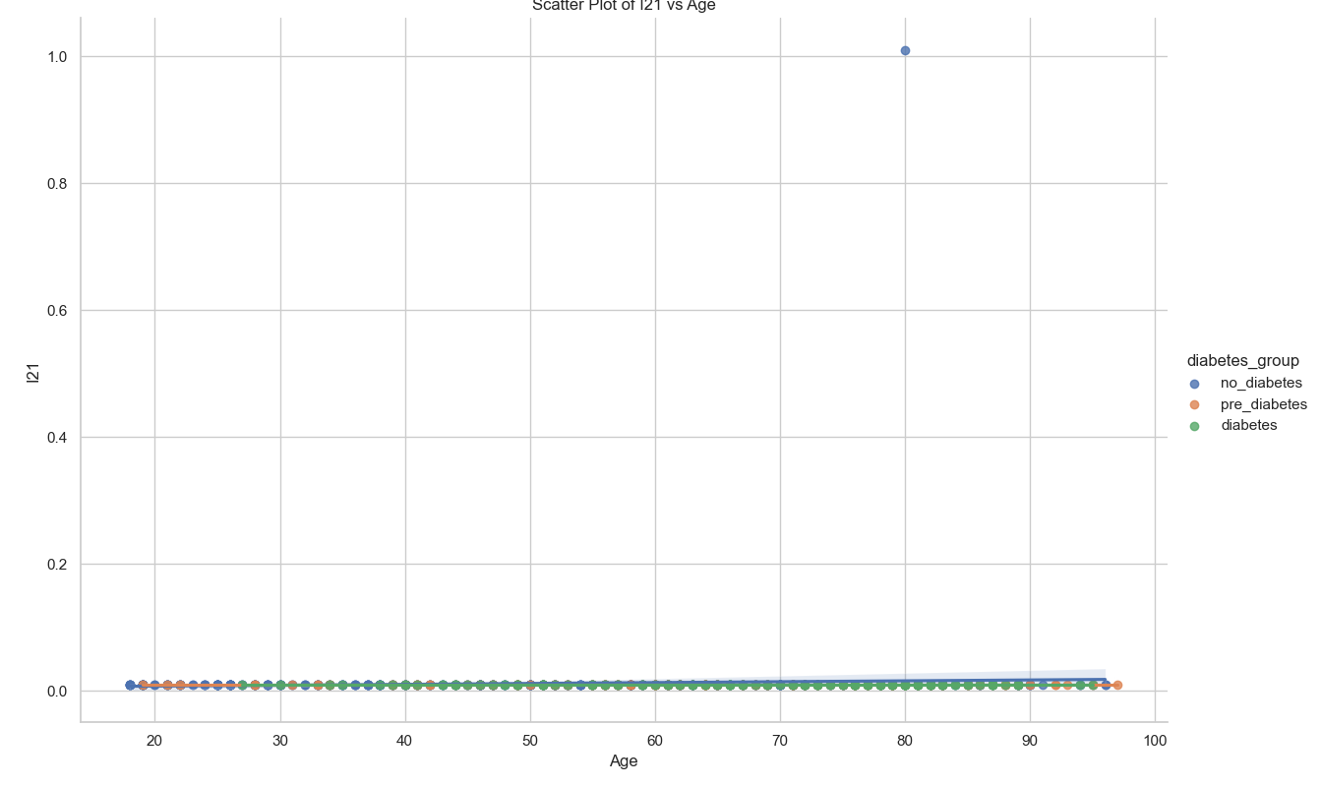

## visualize_chi_square_results

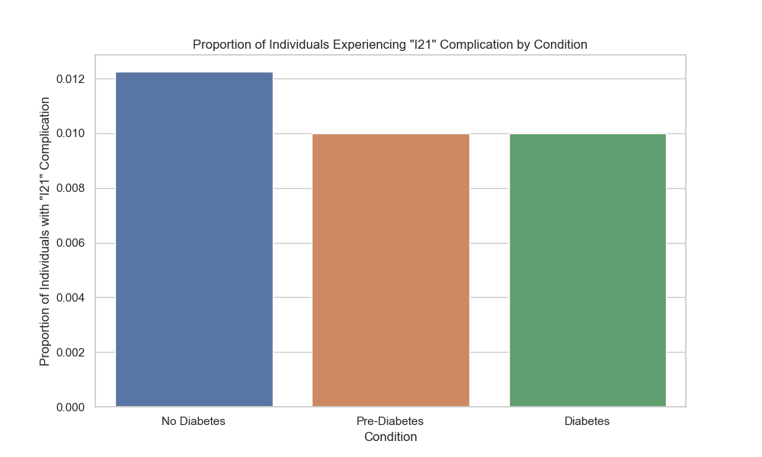

## visualize_relative_risk_results

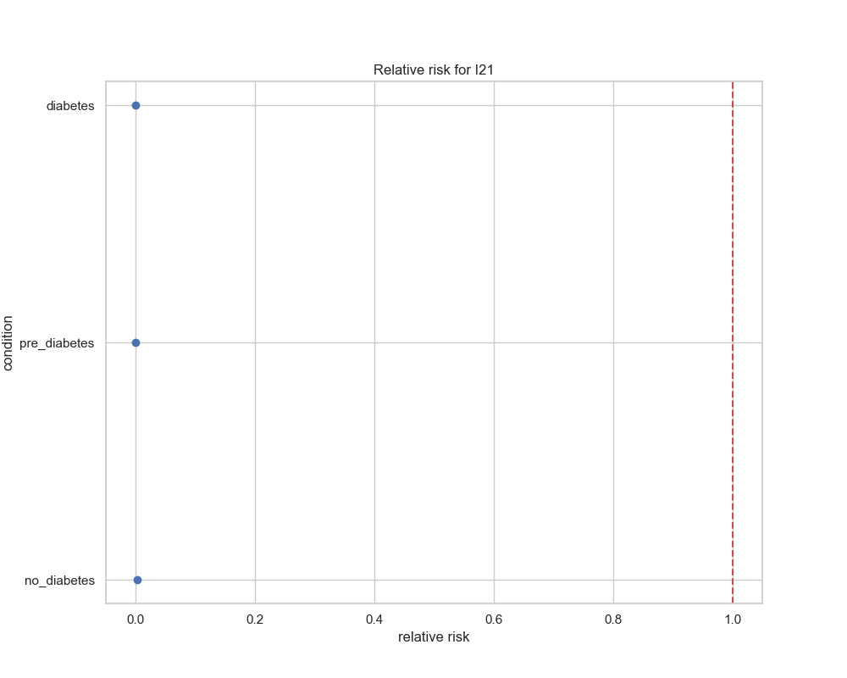

## visualize_odds_ratio_results

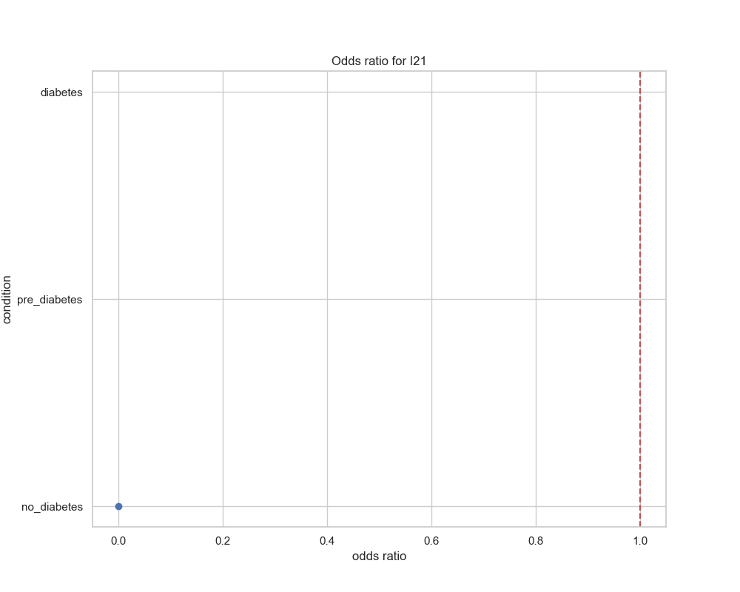

## visualize_relative_risk_by_age_results

