INTENSIV

## one_way_anova

(3.746942910153029, 0.024048467532678093)

## t_test

t_statistic p_value  
pre_diabetes vs no_diabetes -2.595849 0.009671  
diabetes vs no_diabetes -1.354127 0.176224

## tukey_hsd

Multiple Comparison of Means - Tukey HSD, FWER=0.05   
===============================================================  
 group1 group2 meandiff p-adj lower upper reject  
---------------------------------------------------------------  
 diabetes no_diabetes 0.0545 0.3409 -0.0369 0.146 False  
 diabetes pre_diabetes -0.045 0.6084 -0.1563 0.0662 False  
no_diabetes pre_diabetes -0.0996 0.0243 -0.1888 -0.0103 True  
---------------------------------------------------------------

## covariance_analysis

sum_sq df F PR(>F)  
C(no_diabetes) 1.990572 1.0 12.930456 0.000345  
C(pre_diabetes) 0.838493 1.0 5.446720 0.019878  
C(diabetes) 0.186975 1.0 1.214559 0.270798  
Age 3.588729 1.0 23.311842 0.000002  
Residual 111.301856 723.0 NaN NaN

## interaction_analysis

sum_sq df F PR(>F)  
C(no_diabetes) 0.445286 1.0 2.888733 0.089632  
C(pre_diabetes) 0.180942 1.0 1.173835 0.278976  
C(diabetes) 0.186975 1.0 1.212972 0.271111  
Age 3.588729 1.0 23.281383 0.000002  
C(diabetes):Age 0.008532 1.0 0.055353 0.814064  
Residual 111.293324 722.0 NaN NaN

## interaction_analysis2

dfn dfd F PR(>F)  
diabetes 1.0 592.0 13.449835 0.000267  
pre_diabetes 1.0 591.0 6.145323 0.013454

## chi_square_test

condition chi2 p_value dof  
0 no_diabetes 6.071548 0.013738 1  
1 pre_diabetes 4.967108 0.025834 1  
2 diabetes 0.449428 0.502607 1

## relative_risk_analysis

condition relative_risk ci p_value  
0 no_diabetes 0.298246 0.239080 3.934949e-27  
1 pre_diabetes 0.149606 0.092379 5.671478e-15  
2 diabetes 0.212389 0.136716 2.724899e-12

## odds_ratio_analysis

condition odds_ratio ci p_value  
0 no_diabetes 0.600735 0.481562 0.010307  
1 pre_diabetes 1.851012 1.142962 0.020211  
2 diabetes 1.214730 0.781925 0.477656

## relative_risk_by_age

age_group condition relative_risk p_value confidence_interval  
6 18-40 No Diabetes 0.000000 0.222316 0.000000  
7 18-40 Pre-Diabetes inf 0.615694 NaN  
8 18-40 Diabetes inf 1.000000 NaN  
3 40-60 No Diabetes 0.402797 0.030049 0.271220  
4 40-60 Pre-Diabetes 2.131200 0.194096 0.836333  
5 40-60 Diabetes 2.087121 0.242547 0.733741  
0 60+ No Diabetes 0.545927 0.015453 0.399131  
1 60+ Pre-Diabetes 1.971024 0.034082 1.115899  
2 60+ Diabetes 1.225234 0.577482 0.748689

## visualize_tukey_results

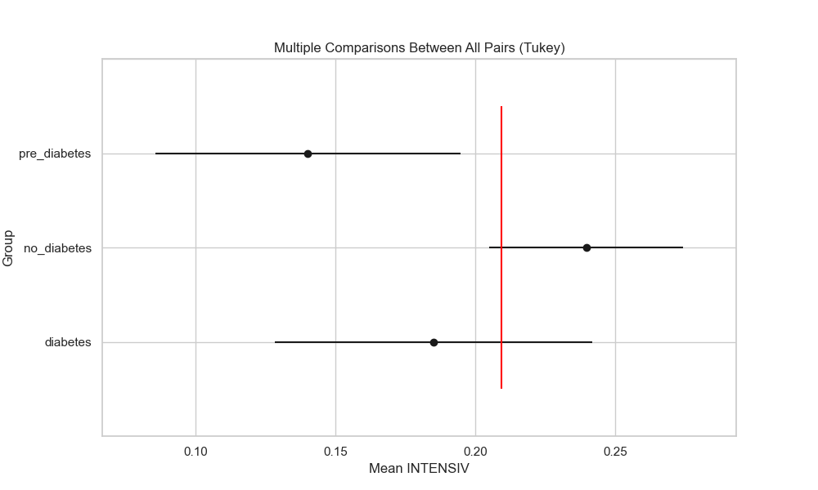

## plot_interaction_analysis

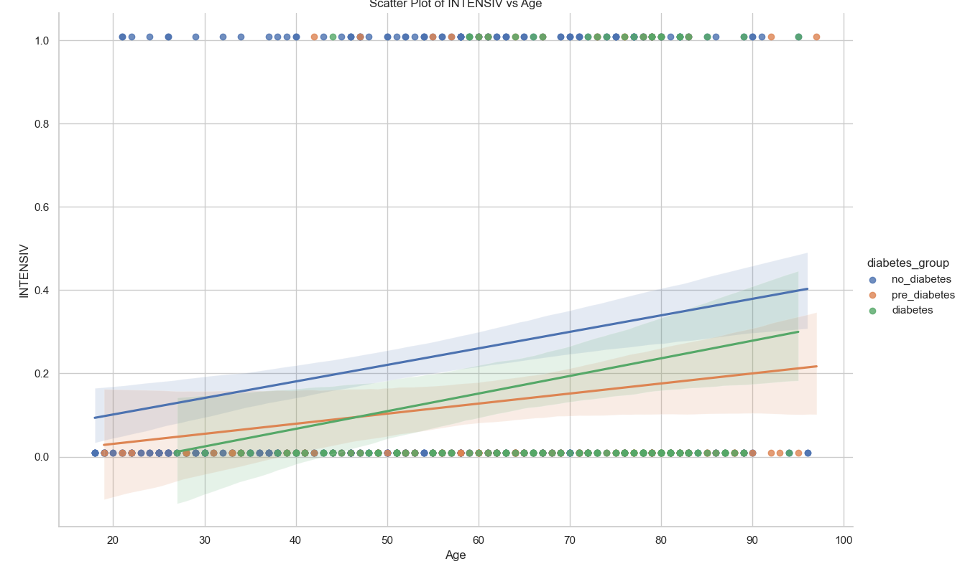

## visualize_chi_square_results

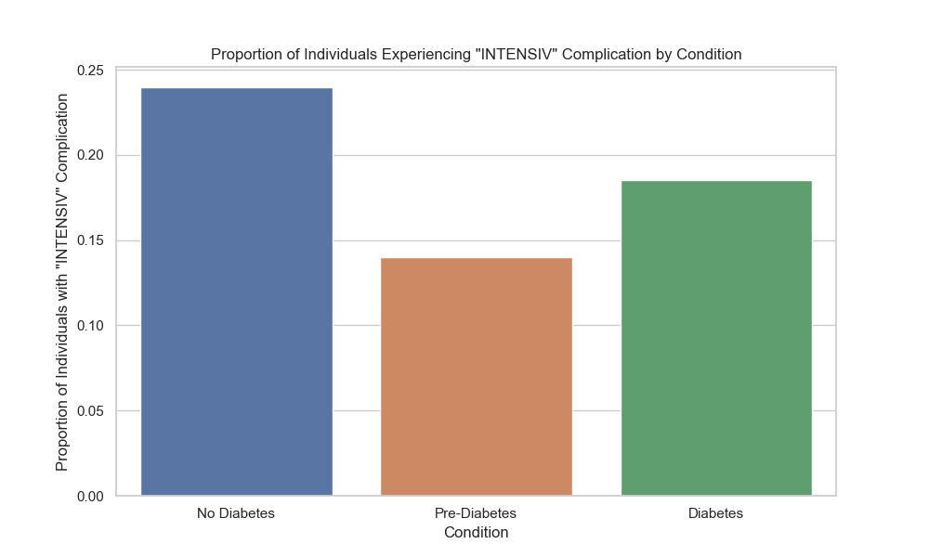

## visualize_relative_risk_results

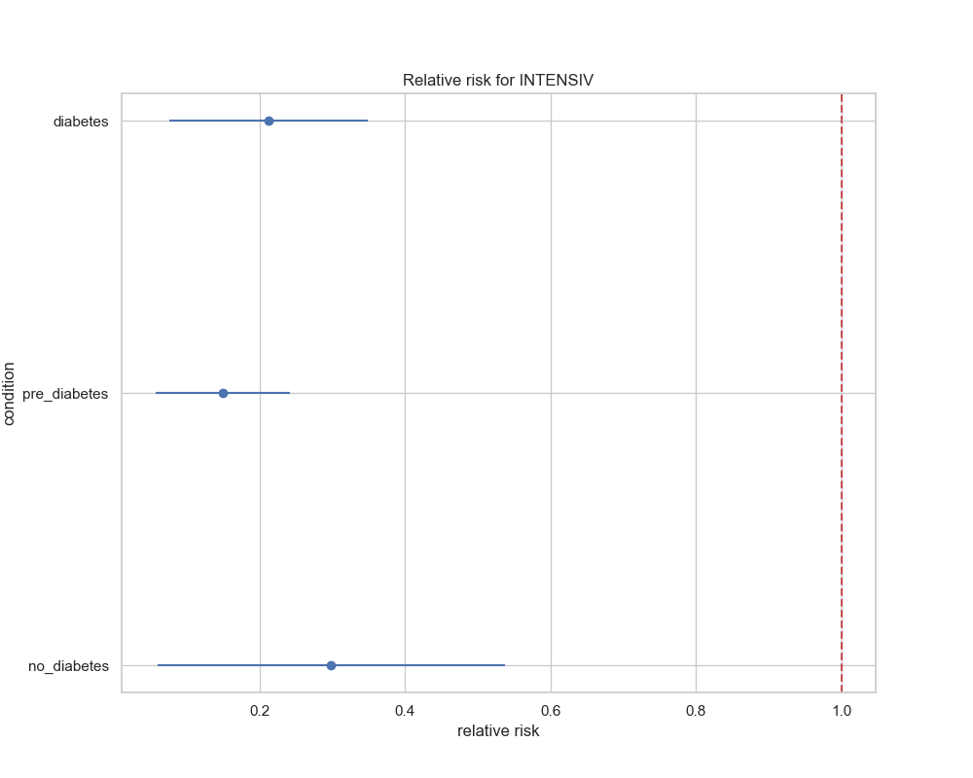

## visualize_odds_ratio_results

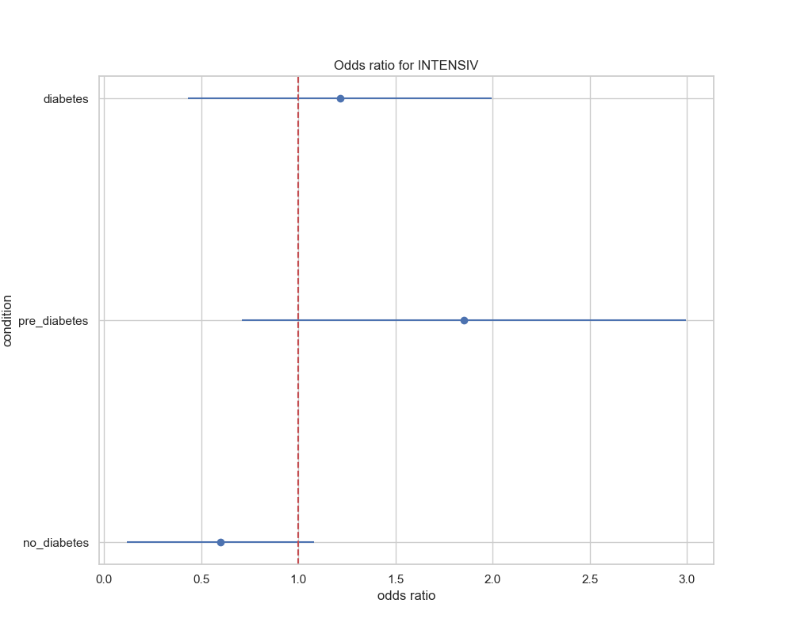

## visualize_relative_risk_by_age_results

