Length of Stay

## one_way_anova

(0.9804963262174998, 0.37562241493259874)

## t_test

t_statistic p_value  
pre_diabetes vs no_diabetes -1.192965 0.233364  
diabetes vs no_diabetes -0.916063 0.360015

## tukey_hsd

Multiple Comparison of Means - Tukey HSD, FWER=0.05   
==============================================================  
 group1 group2 meandiff p-adj lower upper reject  
--------------------------------------------------------------  
 diabetes no_diabetes 0.8009 0.6264 -1.2386 2.8403 False  
 diabetes pre_diabetes -0.2548 0.9685 -2.737 2.2274 False  
no_diabetes pre_diabetes -1.0557 0.4269 -3.0465 0.9352 False  
--------------------------------------------------------------

## covariance_analysis

sum_sq df F PR(>F)  
C(no_diabetes) 2868.129942 1.0 36.732559 2.180621e-09  
C(pre_diabetes) 180.216994 1.0 2.308065 1.291413e-01  
C(diabetes) 199.693709 1.0 2.557507 1.102085e-01  
Age 708.767816 1.0 9.077293 2.678384e-03  
Residual 56452.858037 723.0 NaN NaN

## interaction_analysis

sum_sq df F PR(>F)  
C(no_diabetes) 508.678231 1.0 6.505730 0.010958  
C(pre_diabetes) 60.076626 1.0 0.768349 0.381020  
C(diabetes) 199.693709 1.0 2.553979 0.110454  
Age 708.767816 1.0 9.064772 0.002697  
C(diabetes):Age 0.209645 1.0 0.002681 0.958718  
Residual 56452.648392 722.0 NaN NaN

## interaction_analysis2

dfn dfd F PR(>F)  
diabetes 1.0 592.0 2.293735 0.130431  
pre_diabetes 1.0 591.0 1.855286 0.173689

## chi_square_test

condition chi2 p_value dof  
0 no_diabetes 64.301417 0.047453 47  
1 pre_diabetes 64.222865 0.048109 47  
2 diabetes 41.792422 0.687531 47

## relative_risk_analysis

condition relative_risk ci p_value  
0 no_diabetes 1.076923 0.738343 0.350188  
1 pre_diabetes 3.333333 1.582604 0.000768  
2 diabetes 1.562500 0.834262 0.081664

## odds_ratio_analysis

condition odds_ratio ci p_value  
0 no_diabetes 0.714938 0.593385 0.031987  
1 pre_diabetes 1.537114 1.095458 0.025383  
2 diabetes 1.080547 0.769942 0.703309

## relative_risk_by_age

age_group condition relative_risk p_value confidence_interval  
6 18-40 No Diabetes 0.794643 0.795721 0.537455  
7 18-40 Pre-Diabetes 1.298246 1.000000 0.357295  
8 18-40 Diabetes 1.151515 1.000000 0.232416  
3 40-60 No Diabetes 0.313679 0.000230 0.221602  
4 40-60 Pre-Diabetes 3.256962 0.002607 1.596812  
5 40-60 Diabetes 1.863636 0.130015 0.903721  
0 60+ No Diabetes 0.704751 0.100438 0.530357  
1 60+ Pre-Diabetes 1.426923 0.151667 0.943673  
2 60+ Diabetes 1.125352 0.638117 0.753698

## visualize_tukey_results

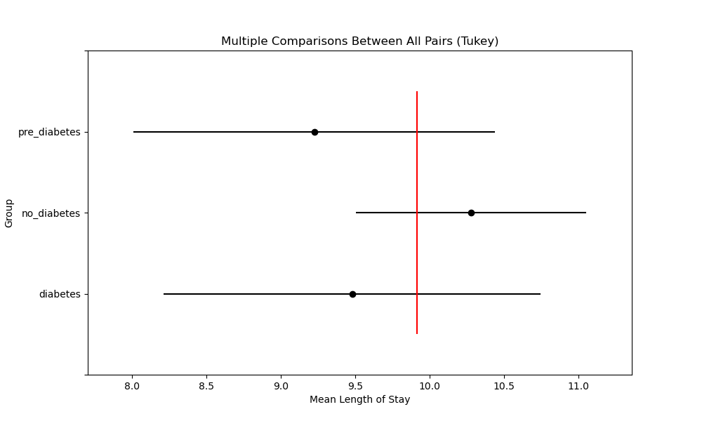

## plot_interaction_analysis

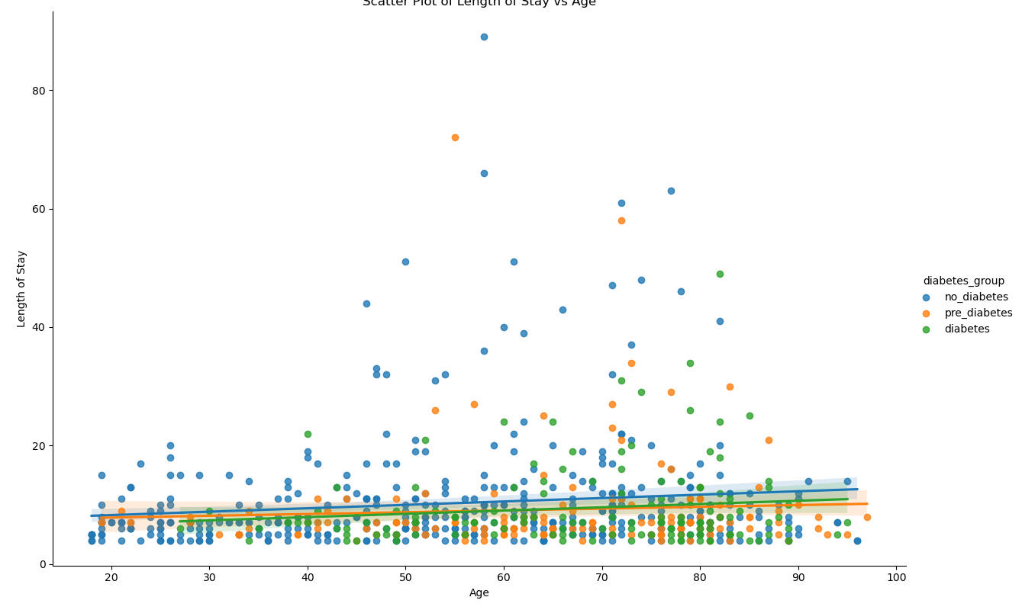

## visualize_chi_square_results

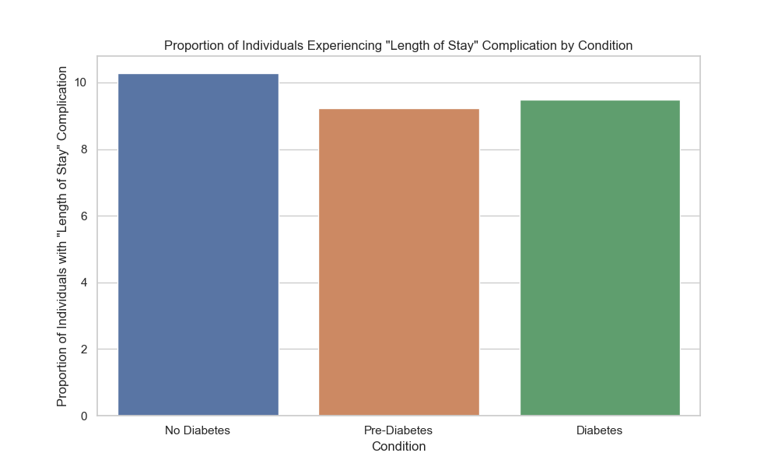

## visualize_relative_risk_results

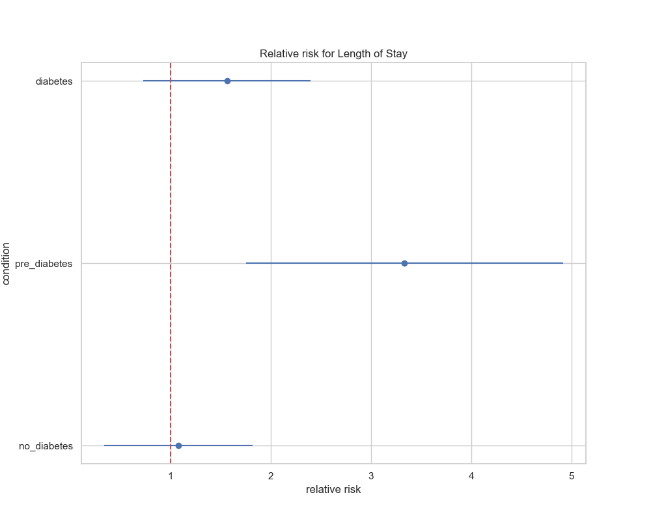

## visualize_odds_ratio_results

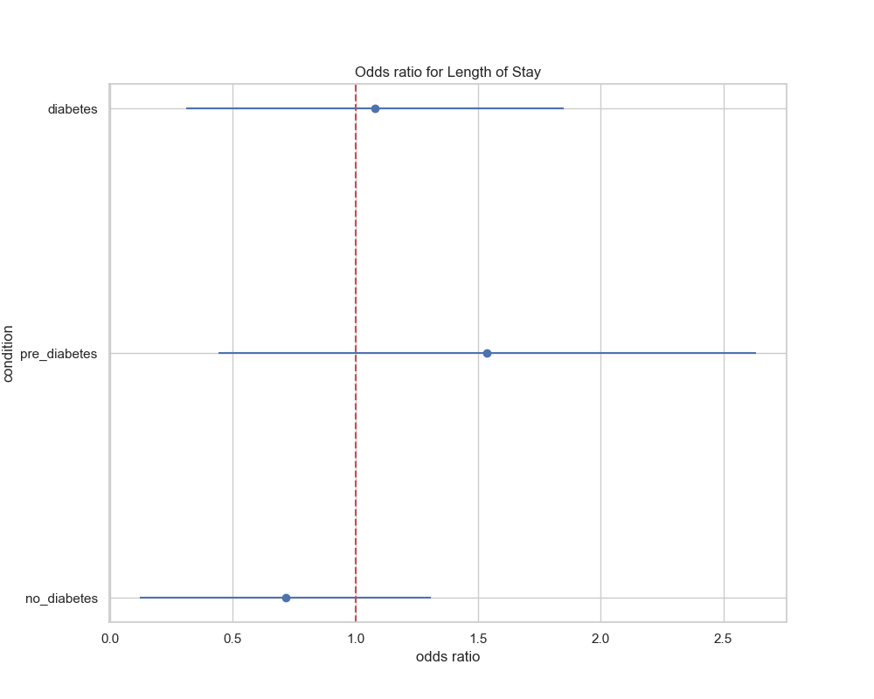

## visualize_relative_risk_by_age_results

