N17

## one_way_anova

(0.46107882290541075, 0.6307880083345768)

## t_test

t_statistic p_value  
pre_diabetes vs no_diabetes 0.195724 0.844894  
diabetes vs no_diabetes -0.887178 0.375351

## tukey_hsd

Multiple Comparison of Means - Tukey HSD, FWER=0.05   
==============================================================  
 group1 group2 meandiff p-adj lower upper reject  
--------------------------------------------------------------  
 diabetes no_diabetes 0.0107 0.666 -0.0186 0.04 False  
 diabetes pre_diabetes 0.0132 0.6576 -0.0224 0.0489 False  
no_diabetes pre_diabetes 0.0025 0.9765 -0.0261 0.0311 False  
--------------------------------------------------------------

## covariance_analysis

sum_sq df F PR(>F)  
C(no_diabetes) 0.008462 1.0 0.522851 0.469862  
C(pre_diabetes) 0.000182 1.0 0.011266 0.915501  
C(diabetes) 0.029788 1.0 1.840549 0.175310  
Age 0.085725 1.0 5.296847 0.021648  
Residual 11.701187 723.0 NaN NaN

## interaction_analysis

sum_sq df F PR(>F)  
C(no_diabetes) 0.000003 1.0 0.000193 0.988922  
C(pre_diabetes) 0.000848 1.0 0.052324 0.819133  
C(diabetes) 0.029788 1.0 1.838304 0.175574  
Age 0.085725 1.0 5.290384 0.021728  
C(diabetes):Age 0.001910 1.0 0.117851 0.731477  
Residual 11.699278 722.0 NaN NaN

## interaction_analysis2

dfn dfd F PR(>F)  
diabetes 1.0 592.0 0.021207 0.884266  
pre_diabetes 1.0 591.0 1.220878 0.269638

## chi_square_test

condition chi2 p_value dof  
0 no_diabetes 0.010452 0.918569 1  
1 pre_diabetes 0.004285 0.947805 1  
2 diabetes 0.321151 0.570917 1

## relative_risk_analysis

condition relative_risk ci p_value  
0 no_diabetes 0.018349 0.009118 1.899186e-29  
1 pre_diabetes 0.020979 0.006687 1.748914e-11  
2 diabetes 0.007353 0.001028 4.922974e-07

## odds_ratio_analysis

condition odds_ratio ci p_value  
0 no_diabetes 0.781362 0.388292 0.773800  
1 pre_diabetes 0.750000 0.239052 0.715274  
2 diabetes 2.583765 0.361350 0.707421

## relative_risk_by_age

age_group condition relative_risk p_value confidence_interval  
3 40-60 No Diabetes 0.869863 1.000000 0.215199  
4 40-60 Pre-Diabetes 0.500000 0.493689 0.068738  
5 40-60 Diabetes inf 1.000000 NaN  
0 60+ No Diabetes 0.500000 0.502668 0.221757  
1 60+ Pre-Diabetes 1.125000 1.000000 0.277084  
2 60+ Diabetes 2.763636 0.458709 0.385311

## visualize_tukey_results

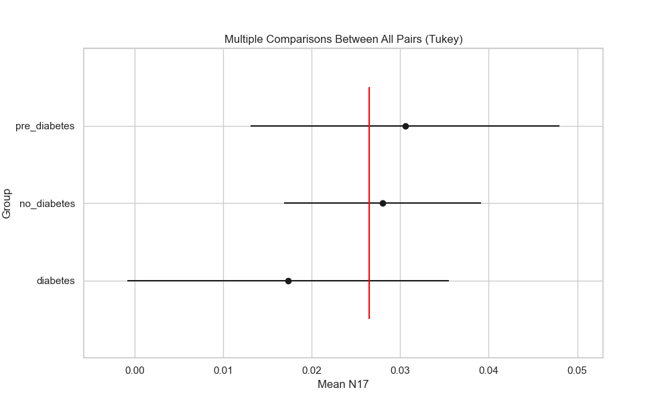

## plot_interaction_analysis

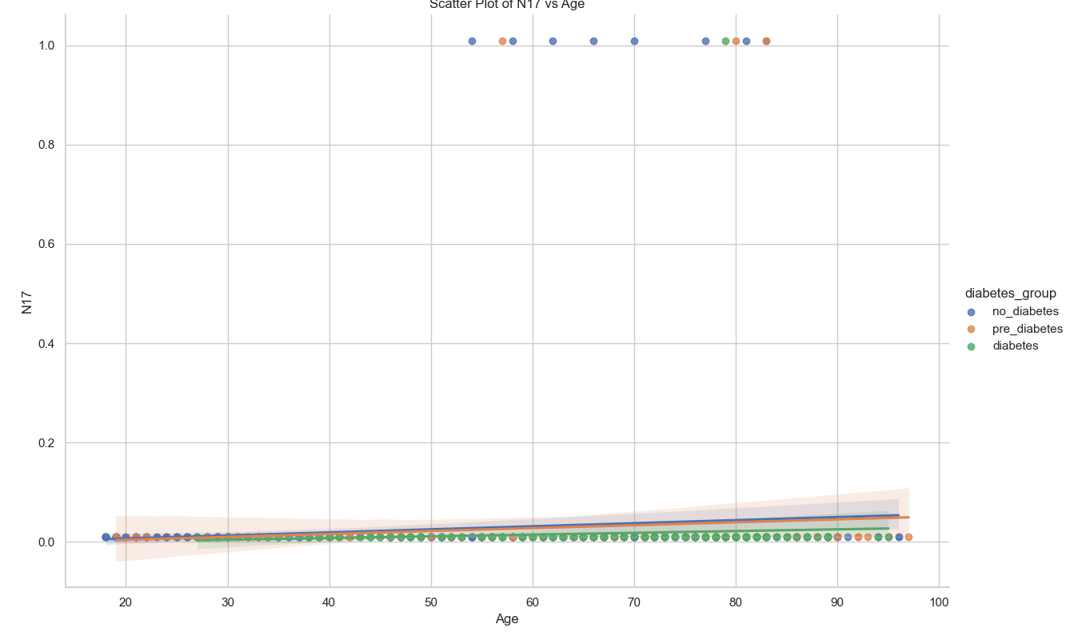

## visualize_chi_square_results

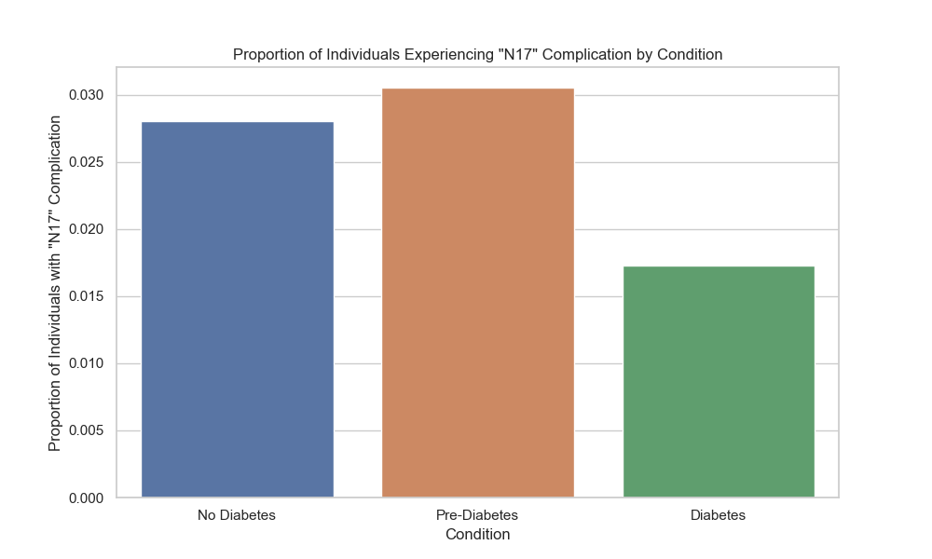

## visualize_relative_risk_results

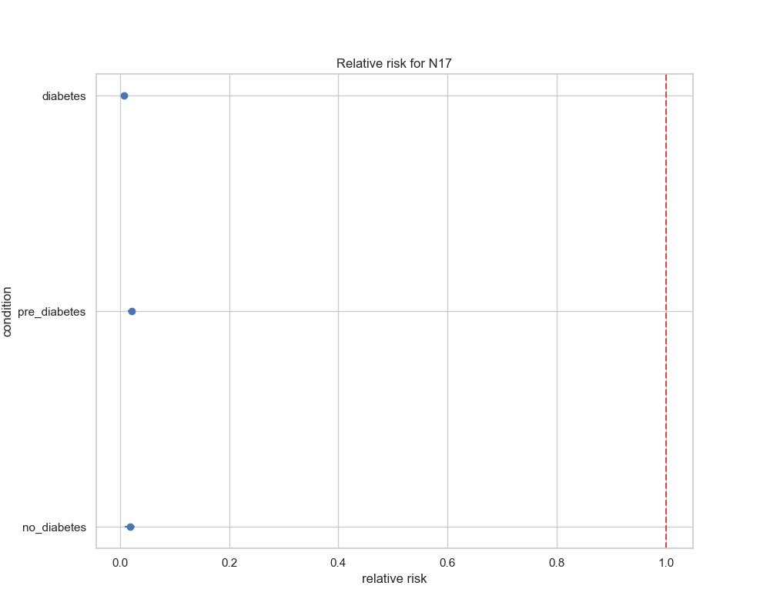

## visualize_odds_ratio_results

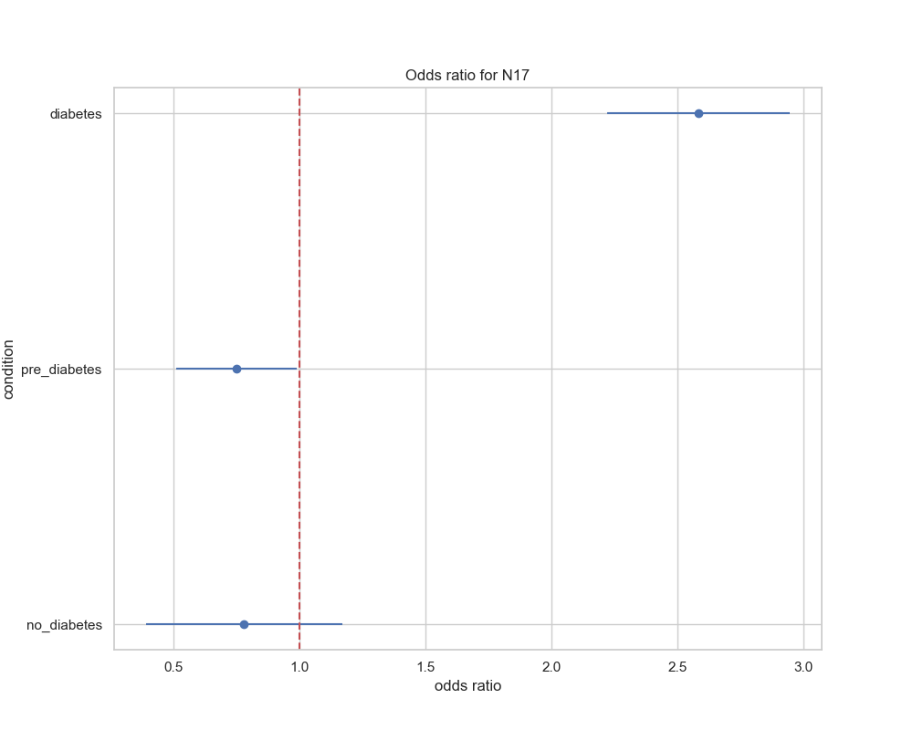

## visualize_relative_risk_by_age_results

