T81

## one_way_anova

(1.2940459153376842, 0.2747926428919189)

## t_test

t_statistic p_value  
pre_diabetes vs no_diabetes -1.026727 0.304971  
diabetes vs no_diabetes -1.362705 0.173505

## tukey_hsd

Multiple Comparison of Means - Tukey HSD, FWER=0.05   
==============================================================  
 group1 group2 meandiff p-adj lower upper reject  
--------------------------------------------------------------  
 diabetes no_diabetes 0.0237 0.3339 -0.0156 0.063 False  
 diabetes pre_diabetes 0.0059 0.9541 -0.0419 0.0538 False  
no_diabetes pre_diabetes -0.0177 0.5236 -0.0561 0.0207 False  
--------------------------------------------------------------

## covariance_analysis

sum_sq df F PR(>F)  
C(no_diabetes) 0.214042 1.0 7.279696 0.007137  
C(pre_diabetes) 0.004625 1.0 0.157313 0.691760  
C(diabetes) 0.000082 1.0 0.002778 0.957978  
Age 0.000168 1.0 0.005726 0.939703  
Residual 21.258090 723.0 NaN NaN

## interaction_analysis

sum_sq df F PR(>F)  
C(no_diabetes) 0.057816 1.0 1.963920 0.161524  
C(pre_diabetes) 0.006808 1.0 0.231241 0.630751  
C(diabetes) 0.000082 1.0 0.002775 0.958004  
Age 0.000168 1.0 0.005719 0.939741  
C(diabetes):Age 0.002921 1.0 0.099229 0.752848  
Residual 21.255169 722.0 NaN NaN

## interaction_analysis2

dfn dfd F PR(>F)  
diabetes 1.0 592.0 0.945502 0.331264  
pre_diabetes 1.0 591.0 2.086990 0.149088

## chi_square_test

condition chi2 p_value dof  
0 no_diabetes 1.850924 0.173676 1  
1 pre_diabetes 0.246205 0.619760 1  
2 diabetes 0.830186 0.362219 1

## relative_risk_analysis

condition relative_risk ci p_value  
0 no_diabetes 0.039813 0.024519 3.909555e-39  
1 pre_diabetes 0.020979 0.006687 1.748914e-11  
2 diabetes 0.014815 0.003667 1.677546e-09

## odds_ratio_analysis

condition odds_ratio ci p_value  
0 no_diabetes 0.451756 0.278220 0.125746  
1 pre_diabetes 1.611507 0.513644 0.593463  
2 diabetes 2.368421 0.586309 0.403026

## relative_risk_by_age

age_group condition relative_risk p_value confidence_interval  
6 18-40 No Diabetes 0.000000 1.000000 0.000000  
7 18-40 Pre-Diabetes inf 1.000000 NaN  
8 18-40 Diabetes inf 1.000000 NaN  
3 40-60 No Diabetes 0.339726 0.419222 0.138951  
4 40-60 Pre-Diabetes 1.273885 1.000000 0.175128  
5 40-60 Diabetes inf 0.592110 NaN  
0 60+ No Diabetes 0.571429 0.542910 0.268643  
1 60+ Pre-Diabetes 1.456835 1.000000 0.358814  
2 60+ Diabetes 1.543796 0.736896 0.380478

## visualize_tukey_results

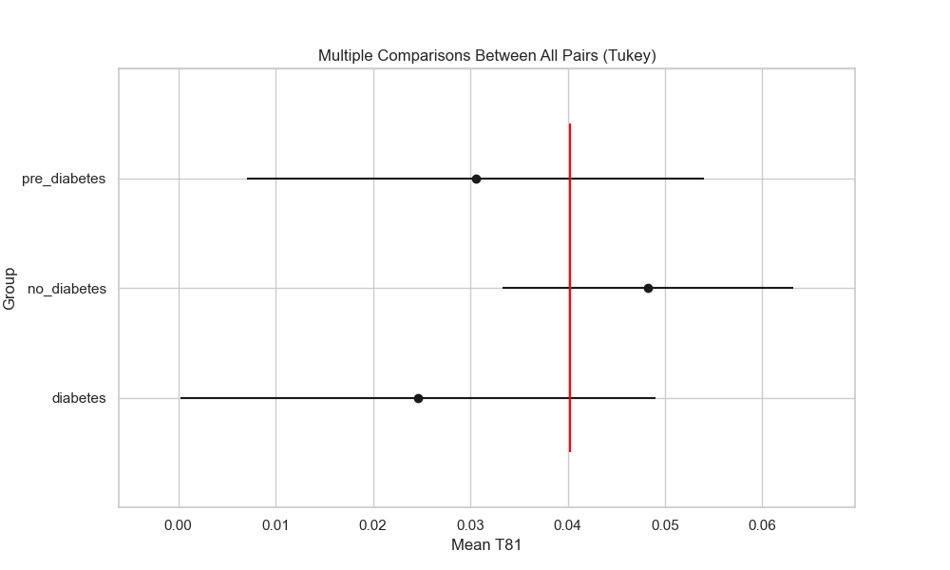

## plot_interaction_analysis

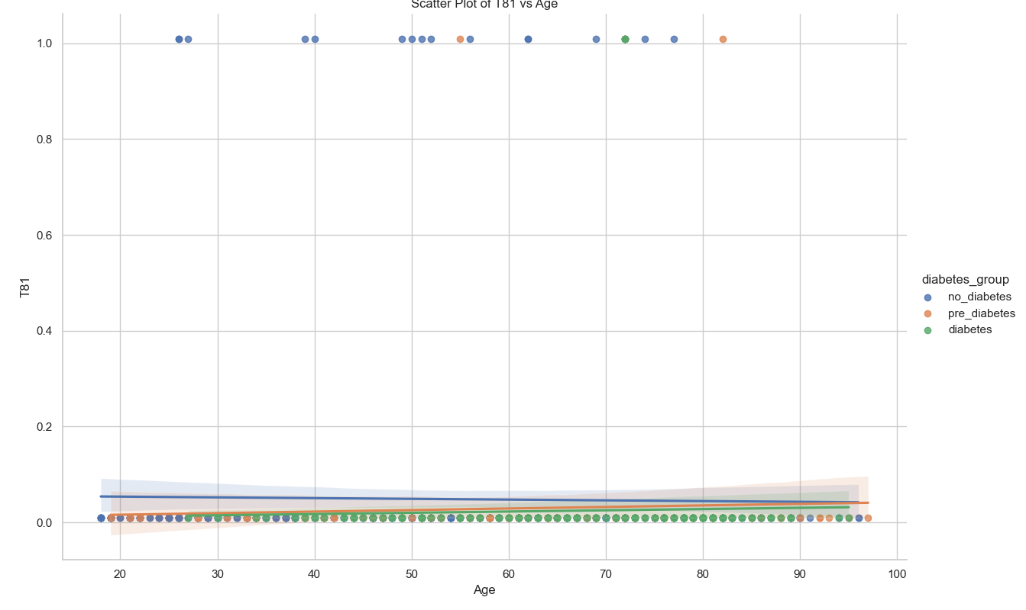

## visualize_chi_square_results

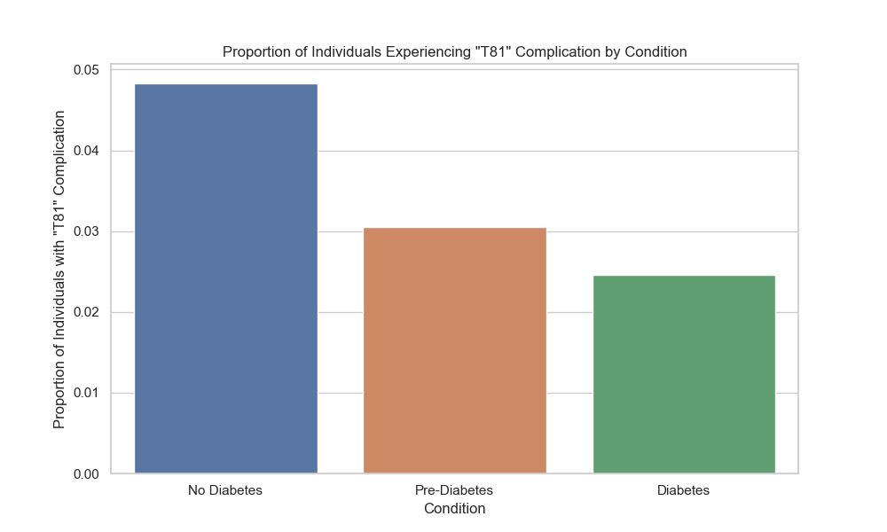

## visualize_relative_risk_results

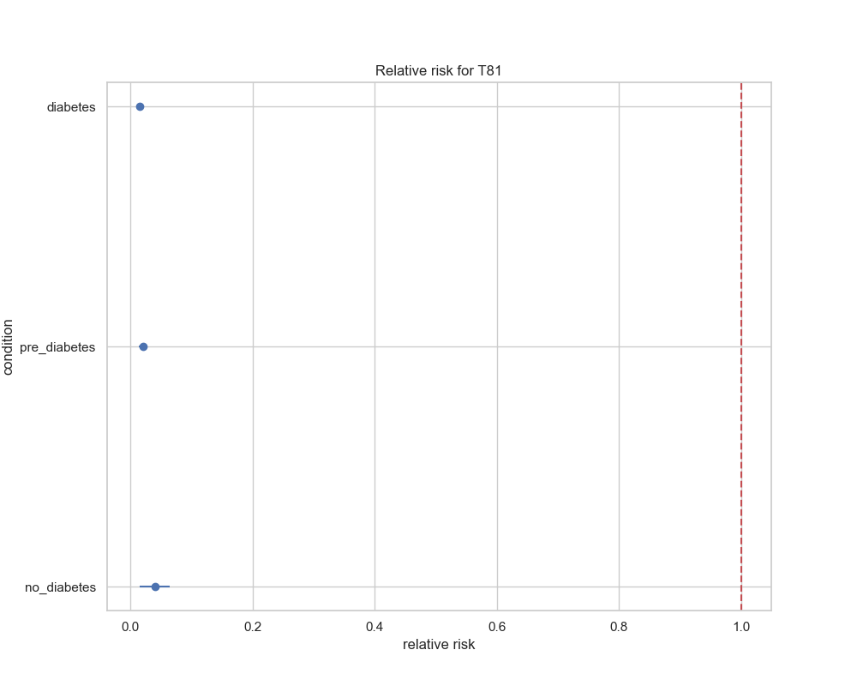

## visualize_odds_ratio_results

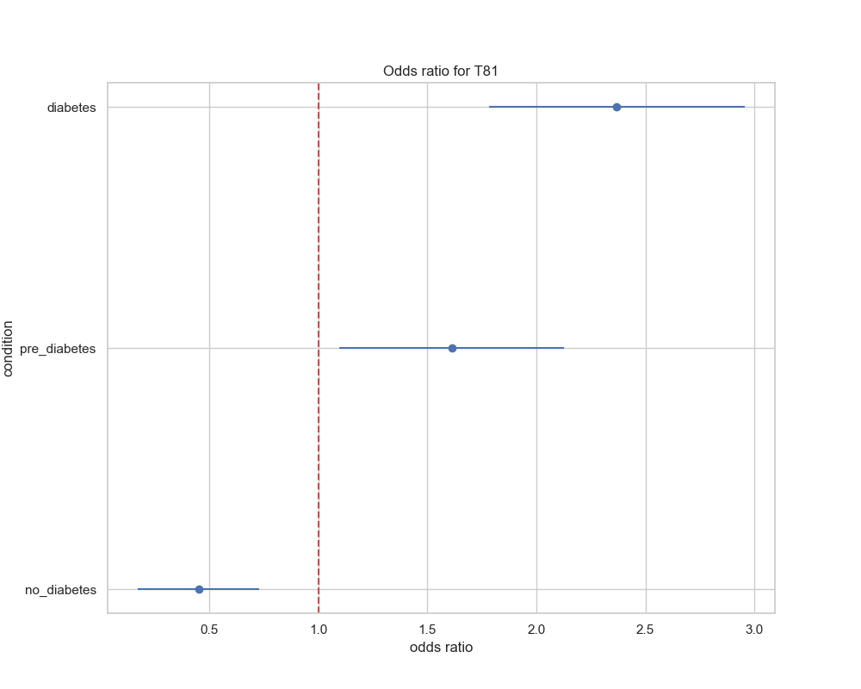

## visualize_relative_risk_by_age_results

