T84

## one_way_anova

(4.109334332773446, 0.016803210939315943)

## t_test

t_statistic p_value  
pre_diabetes vs no_diabetes -2.332261 0.020024  
diabetes vs no_diabetes -1.746247 0.081298

## tukey_hsd

Multiple Comparison of Means - Tukey HSD, FWER=0.05   
===============================================================  
 group1 group2 meandiff p-adj lower upper reject  
---------------------------------------------------------------  
 diabetes no_diabetes 0.0287 0.1249 -0.0058 0.0633 False  
 diabetes pre_diabetes -0.0073 0.9125 -0.0494 0.0348 False  
no_diabetes pre_diabetes -0.036 0.033 -0.0698 -0.0023 True  
---------------------------------------------------------------

## covariance_analysis

sum_sq df F PR(>F)  
C(no_diabetes) 0.189158 1.0 8.418549 0.003827  
C(pre_diabetes) 0.093937 1.0 4.180722 0.041248  
C(diabetes) 0.051615 1.0 2.297158 0.130048  
Age 0.170903 1.0 7.606121 0.005964  
Residual 16.245221 723.0 NaN NaN

## interaction_analysis

sum_sq df F PR(>F)  
C(no_diabetes) 0.013227 1.0 0.588026 0.443434  
C(pre_diabetes) 0.051838 1.0 2.304597 0.129429  
C(diabetes) 0.051615 1.0 2.294695 0.130254  
Age 0.170903 1.0 7.597967 0.005991  
C(diabetes):Age 0.005059 1.0 0.224930 0.635452  
Residual 16.240161 722.0 NaN NaN

## interaction_analysis2

dfn dfd F PR(>F)  
diabetes 1.0 592.0 13.156649 0.000311  
pre_diabetes 1.0 591.0 8.784945 0.003160

## chi_square_test

condition chi2 p_value dof  
0 no_diabetes 6.635297 0.009998 1  
1 pre_diabetes 3.186802 0.074235 1  
2 diabetes 1.143001 0.285019 1

## relative_risk_analysis

condition relative_risk ci p_value  
0 no_diabetes 0.037383 0.022695 2.052426e-38  
1 pre_diabetes 0.000000 0.000000 NaN  
2 diabetes 0.007353 0.001028 4.922974e-07

## odds_ratio_analysis

condition odds_ratio ci p_value  
0 no_diabetes 0.094858 0.057588 0.004163  
1 pre_diabetes inf NaN 0.031428  
2 diabetes 3.790941 0.530178 0.220247

## relative_risk_by_age

age_group condition relative_risk p_value confidence_interval  
6 18-40 No Diabetes 0.000000 1.000000 0.000000  
7 18-40 Pre-Diabetes inf 1.000000 NaN  
8 18-40 Diabetes inf 1.000000 NaN  
3 40-60 No Diabetes 0.000000 0.534410 0.000000  
4 40-60 Pre-Diabetes inf 1.000000 NaN  
5 40-60 Diabetes inf 1.000000 NaN  
0 60+ No Diabetes 0.079768 0.002947 0.044464  
1 60+ Pre-Diabetes inf 0.044005 NaN  
2 60+ Diabetes 4.206642 0.198122 0.586497

## visualize_tukey_results

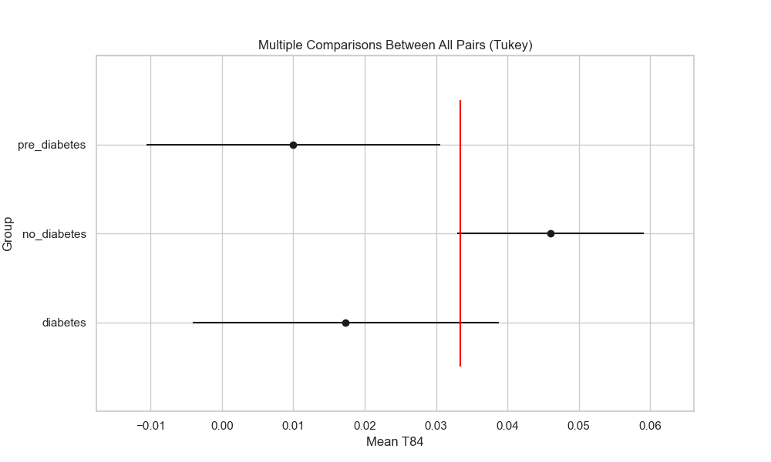

## plot_interaction_analysis

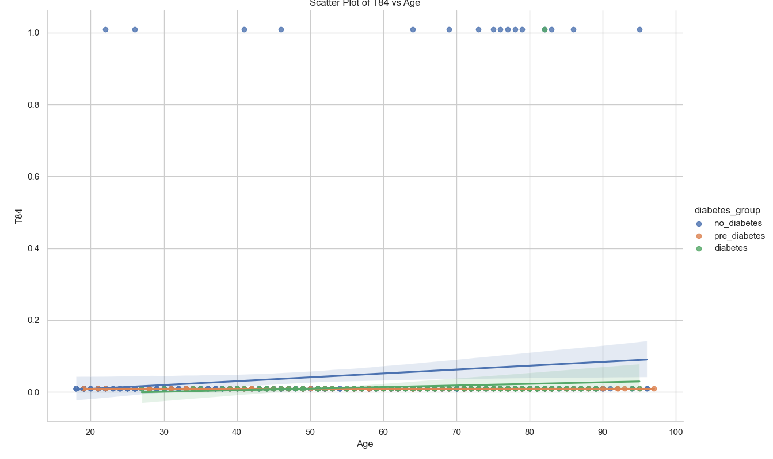

## visualize_chi_square_results

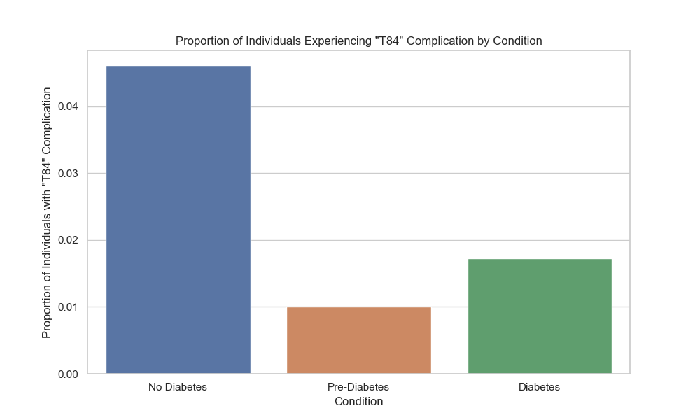

## visualize_relative_risk_results

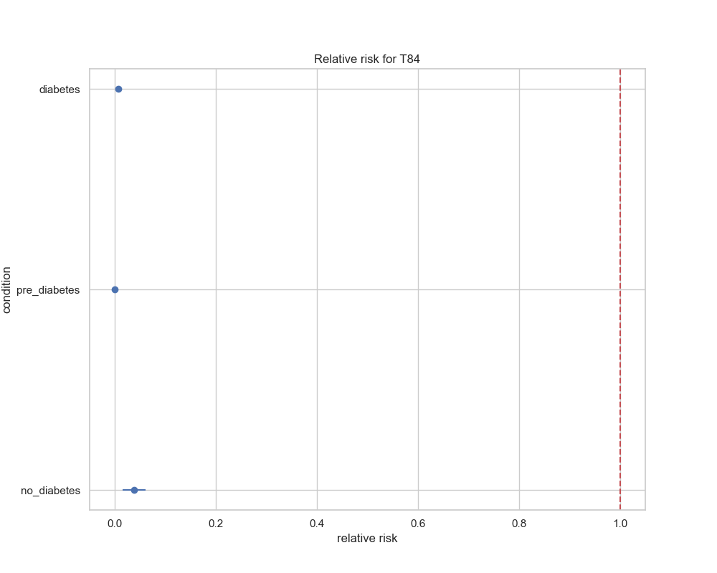

## visualize_odds_ratio_results

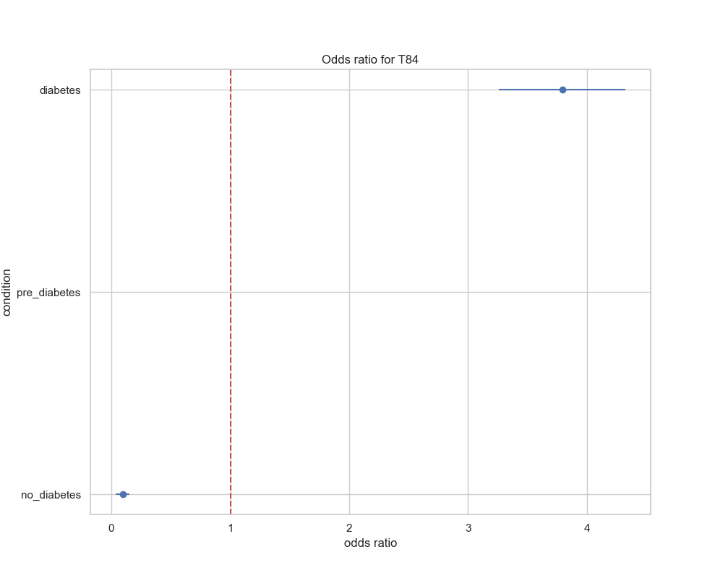

## visualize_relative_risk_by_age_results

