TOD

## one_way_anova

(1.0303050016944557, 0.3574207647988519)

## t_test

t_statistic p_value  
pre_diabetes vs no_diabetes -1.330839 0.183758  
diabetes vs no_diabetes -0.703101 0.482275

## tukey_hsd

Multiple Comparison of Means - Tukey HSD, FWER=0.05   
==============================================================  
 group1 group2 meandiff p-adj lower upper reject  
--------------------------------------------------------------  
 diabetes no_diabetes 0.0102 0.7294 -0.0214 0.0417 False  
 diabetes pre_diabetes -0.0077 0.8837 -0.0462 0.0307 False  
no_diabetes pre_diabetes -0.0179 0.3592 -0.0487 0.0129 False  
--------------------------------------------------------------

## covariance_analysis

sum_sq df F PR(>F)  
C(no_diabetes) 0.033947 1.0 1.817329 0.178054  
C(pre_diabetes) 0.054862 1.0 2.936990 0.087001  
C(diabetes) 0.023785 1.0 1.273322 0.259519  
Age 0.186076 1.0 9.961448 0.001665  
Residual 13.505355 723.0 NaN NaN

## interaction_analysis

sum_sq df F PR(>F)  
C(no_diabetes) 0.006768 1.0 0.361837 0.547677  
C(pre_diabetes) 0.015116 1.0 0.808112 0.368979  
C(diabetes) 0.023785 1.0 1.271565 0.259848  
Age 0.186076 1.0 9.947703 0.001677  
C(diabetes):Age 0.000045 1.0 0.002408 0.960877  
Residual 13.505310 722.0 NaN NaN

## interaction_analysis2

dfn dfd F PR(>F)  
diabetes 1.0 592.0 3.351329 0.067653  
pre_diabetes 1.0 591.0 4.740166 0.029861

## chi_square_test

condition chi2 p_value dof  
0 no_diabetes 1.164645 0.280504 1  
1 pre_diabetes 0.780601 0.376957 1  
2 diabetes 0.009101 0.923999 1

## relative_risk_analysis

condition relative_risk ci p_value  
0 no_diabetes 0.025404 0.013964 1.241839e-33  
1 pre_diabetes 0.006897 0.000965 3.530818e-07  
2 diabetes 0.014815 0.003667 1.677546e-09

## odds_ratio_analysis

condition odds_ratio ci p_value  
0 no_diabetes 0.421753 0.231831 0.268285  
1 pre_diabetes 3.318662 0.464335 0.322613  
2 diabetes 1.401384 0.346916 1.000000

## relative_risk_by_age

age_group condition relative_risk p_value confidence_interval  
3 40-60 No Diabetes 0.000000 0.534410 0.000000  
4 40-60 Pre-Diabetes inf 1.000000 NaN  
5 40-60 Diabetes inf 1.000000 NaN  
0 60+ No Diabetes 0.327928 0.139730 0.167924  
1 60+ Pre-Diabetes 3.626812 0.307414 0.505428  
2 60+ Diabetes 1.721612 0.737849 0.424302

## visualize_tukey_results

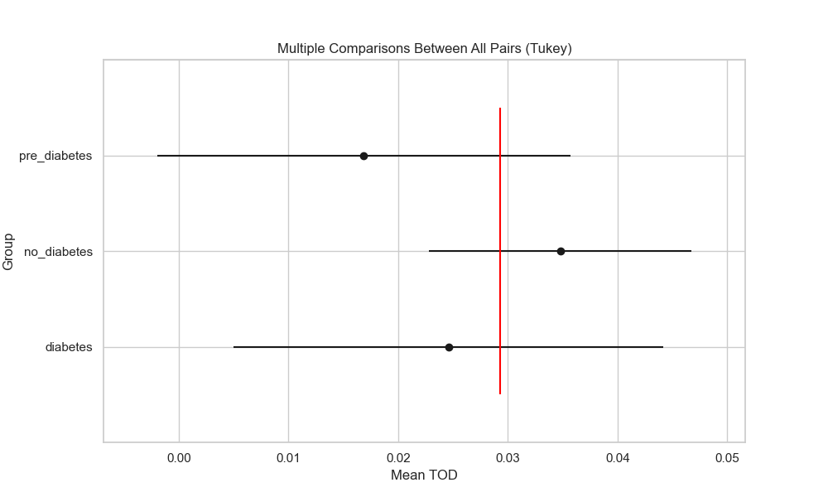

## plot_interaction_analysis

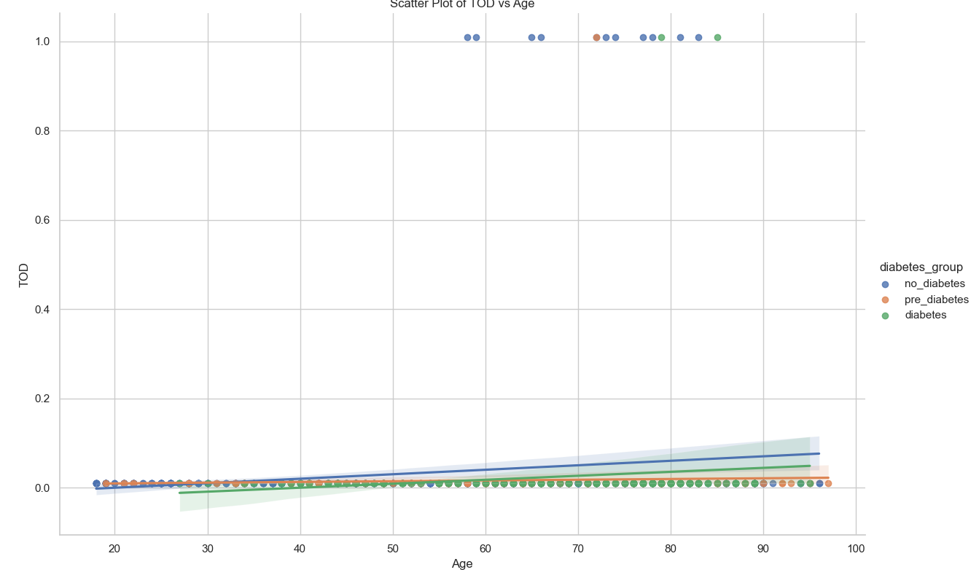

## visualize_chi_square_results

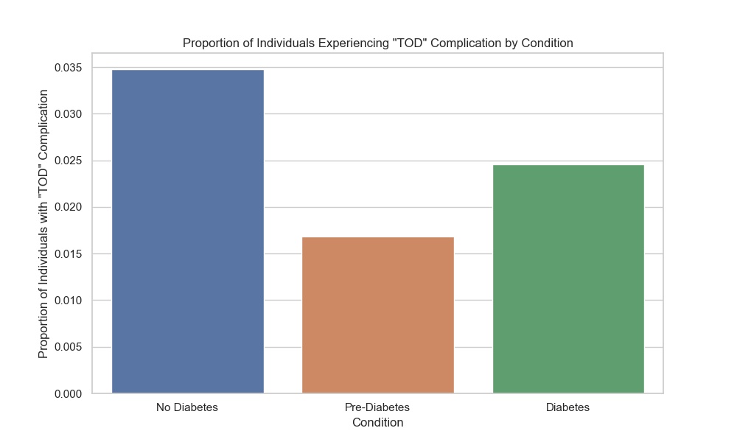

## visualize_relative_risk_results

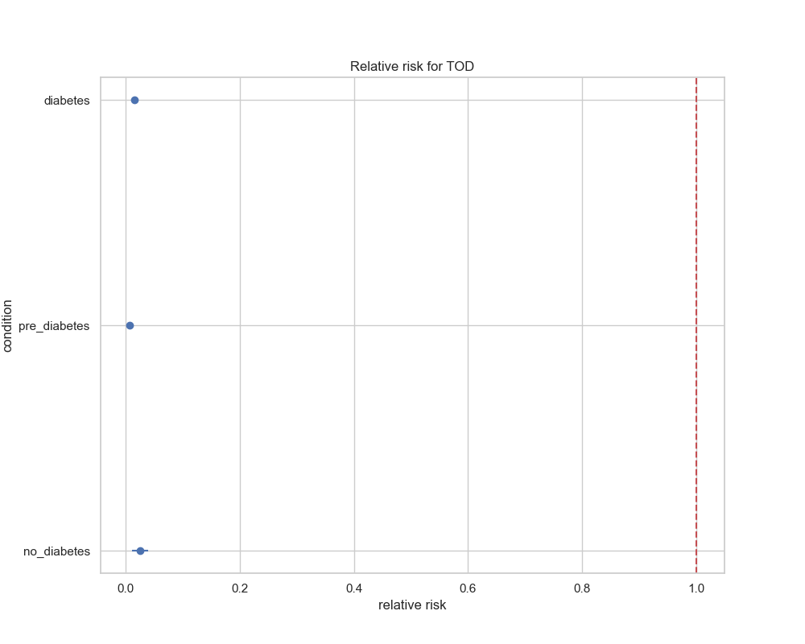

## visualize_odds_ratio_results

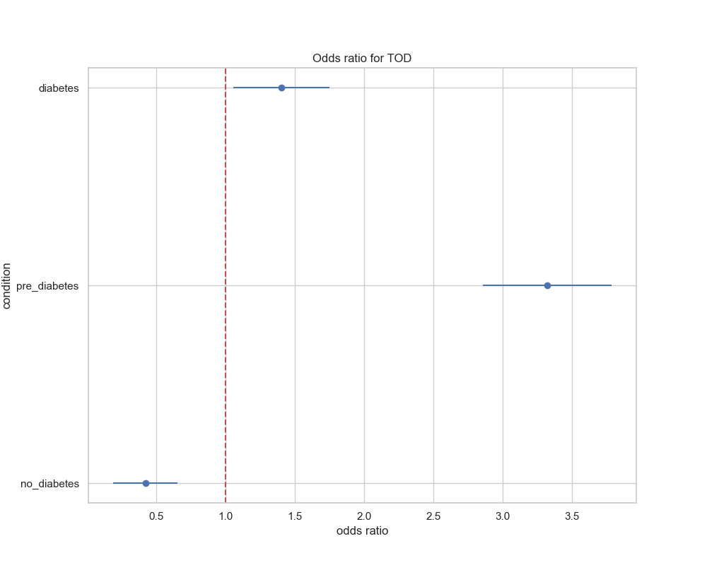

## visualize_relative_risk_by_age_results

