U69

## one_way_anova

(0.6534560747374301, 0.5205512161196733)

## t_test

t_statistic p_value  
pre_diabetes vs no_diabetes -1.150119 0.250562  
diabetes vs no_diabetes -0.189077 0.850099

## tukey_hsd

Multiple Comparison of Means - Tukey HSD, FWER=0.05   
==============================================================  
 group1 group2 meandiff p-adj lower upper reject  
--------------------------------------------------------------  
 diabetes no_diabetes 0.0017 0.9757 -0.0173 0.0207 False  
 diabetes pre_diabetes -0.0073 0.7388 -0.0304 0.0158 False  
no_diabetes pre_diabetes -0.009 0.489 -0.0275 0.0095 False  
--------------------------------------------------------------

## covariance_analysis

sum_sq df F PR(>F)  
C(no_diabetes) 0.013069 1.0 1.911632 0.167209  
C(pre_diabetes) 0.005941 1.0 0.868963 0.351554  
C(diabetes) 0.000105 1.0 0.015349 0.901436  
Age 0.014005 1.0 2.048665 0.152772  
Residual 4.942659 723.0 NaN NaN

## interaction_analysis

sum_sq df F PR(>F)  
C(no_diabetes) 0.010019 1.0 1.464561 0.226602  
C(pre_diabetes) 0.000039 1.0 0.005632 0.940200  
C(diabetes) 0.000105 1.0 0.015338 0.901471  
Age 0.014005 1.0 2.047226 0.152916  
C(diabetes):Age 0.003368 1.0 0.492285 0.483136  
Residual 4.939292 722.0 NaN NaN

## interaction_analysis2

dfn dfd F PR(>F)  
diabetes 1.0 592.0 1.923237 0.166022  
pre_diabetes 1.0 591.0 0.900220 0.343110

## chi_square_test

condition chi2 p_value dof  
0 no_diabetes 0.168767 0.681210 1  
1 pre_diabetes 0.318894 0.572273 1  
2 diabetes 0.000000 1.000000 1

## relative_risk_analysis

condition relative_risk ci p_value  
0 no_diabetes 0.009091 0.003397 4.043136e-21  
1 pre_diabetes 0.000000 0.000000 NaN  
2 diabetes 0.007353 0.001028 4.922974e-07

## odds_ratio_analysis

condition odds_ratio ci p_value  
0 no_diabetes 0.390071 0.145751 0.653615  
1 pre_diabetes inf NaN 0.588995  
2 diabetes 0.928328 0.129830 1.000000

## relative_risk_by_age

age_group condition relative_risk p_value confidence_interval  
3 40-60 No Diabetes 0.000000 1.000000 0.000000  
4 40-60 Pre-Diabetes inf 1.000000 NaN  
5 40-60 Diabetes inf 1.000000 NaN  
0 60+ No Diabetes 0.335116 0.623055 0.107114  
1 60+ Pre-Diabetes inf 0.576083 NaN  
2 60+ Diabetes 1.017857 1.000000 0.141911

## visualize_tukey_results

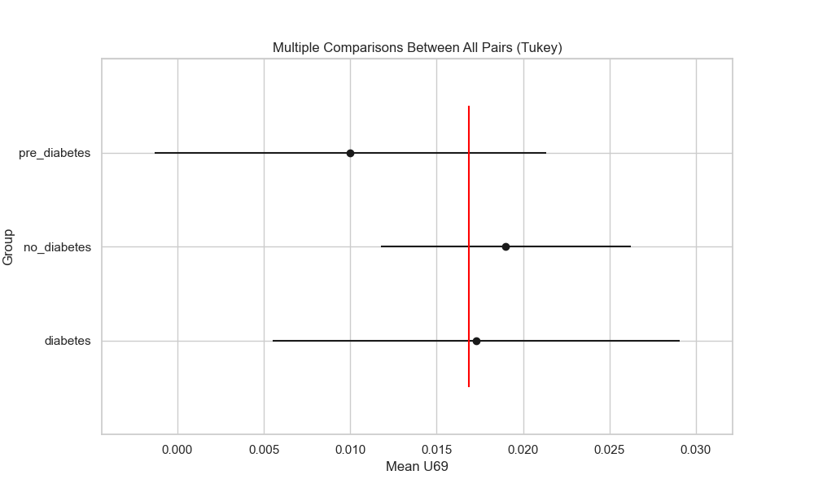

## plot_interaction_analysis

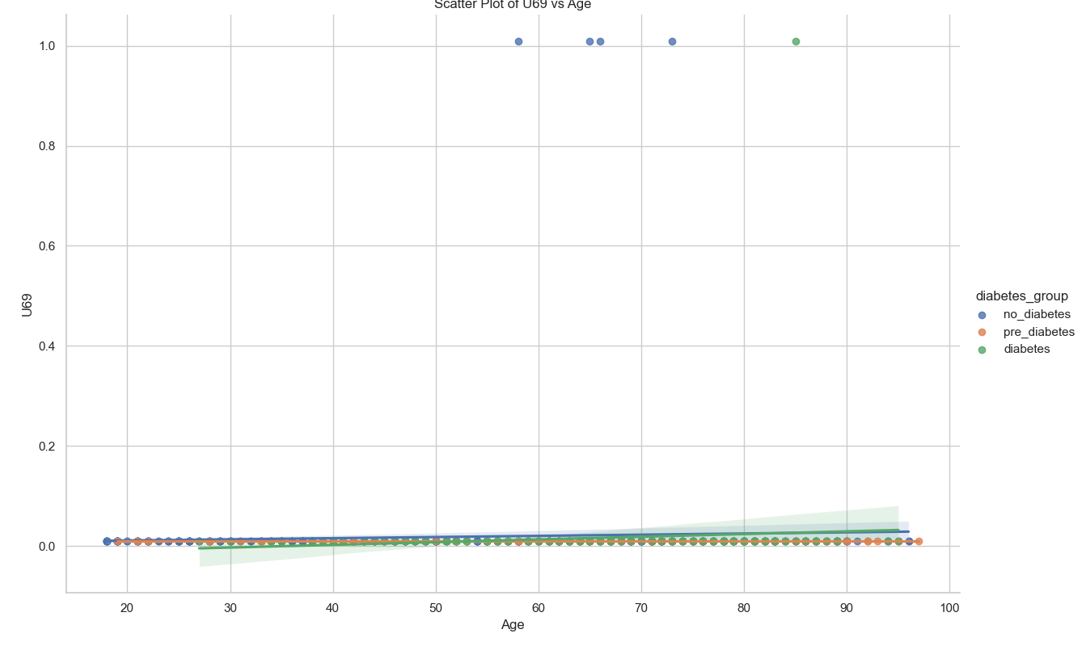

## visualize_chi_square_results

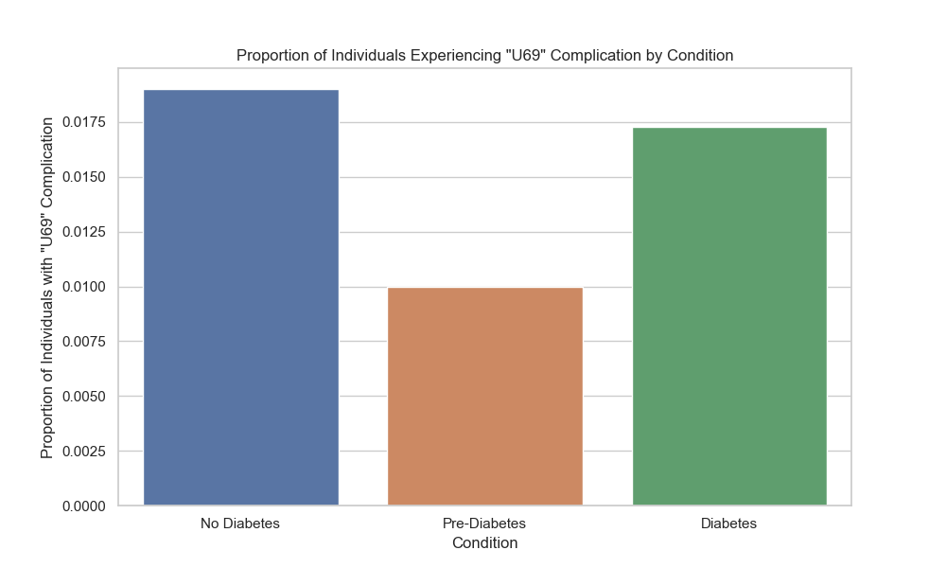

## visualize_relative_risk_results

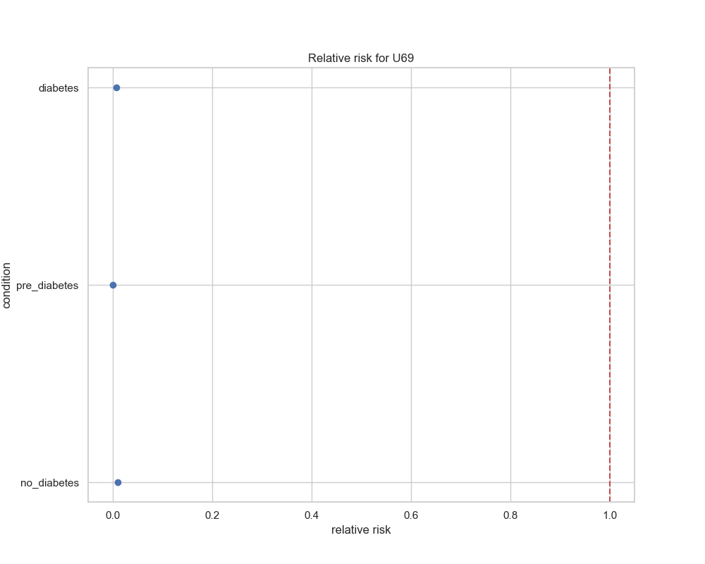

## visualize_odds_ratio_results

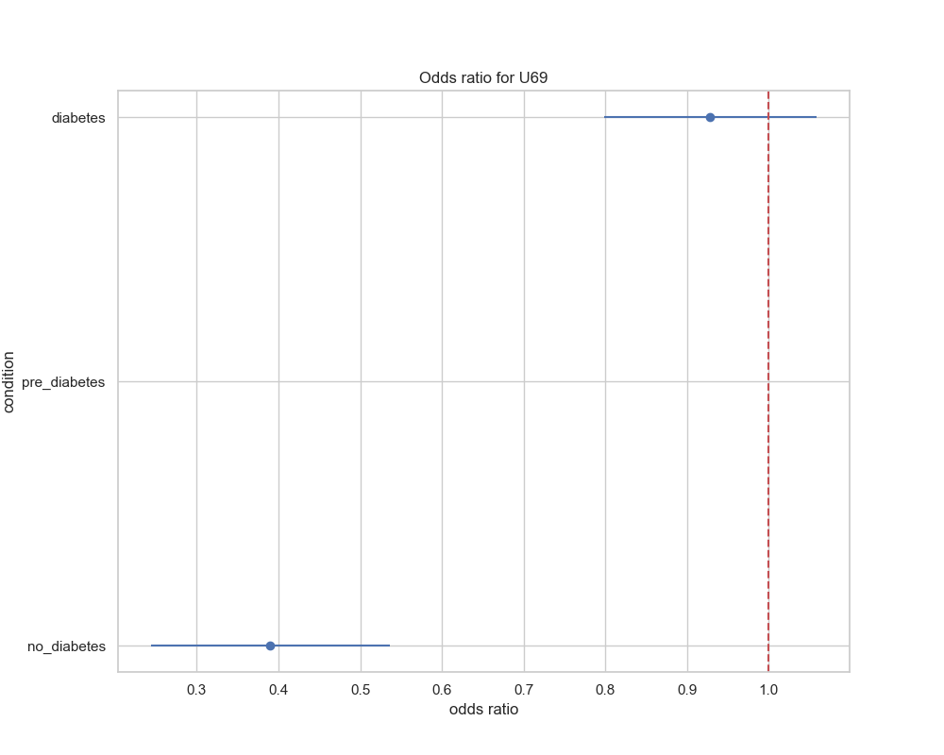

## visualize_relative_risk_by_age_results

