Fall

## one_way_anova

(1.4643342192622864, 0.23153759978231395)

## t_test

t_statistic p_value  
pre_diabetes vs no_diabetes -0.555115 0.578905  
diabetes vs no_diabetes 1.514273 0.130175

## tukey_hsd

Multiple Comparison of Means - Tukey HSD, FWER=0.05   
==============================================================  
 group1 group2 meandiff p-adj lower upper reject  
--------------------------------------------------------------  
 diabetes no_diabetes -0.0246 0.2753 -0.0623 0.013 False  
 diabetes pre_diabetes -0.0343 0.2765 -0.0869 0.0183 False  
no_diabetes pre_diabetes -0.0097 0.8532 -0.052 0.0326 False  
--------------------------------------------------------------

## covariance_analysis

sum_sq df F PR(>F)  
C(no_diabetes) 0.011188 1.0 0.229682 6.318241e-01  
C(pre_diabetes) 0.177769 1.0 3.649425 5.626495e-02  
C(diabetes) 0.000176 1.0 0.003611 9.520910e-01  
Age 1.493078 1.0 30.651394 3.596536e-08  
Residual 78.912761 1620.0 NaN NaN

## interaction_analysis

sum_sq df F PR(>F)  
C(no_diabetes) 0.017135 1.0 0.351690 5.532407e-01  
C(pre_diabetes) 0.006443 1.0 0.132232 7.161761e-01  
C(diabetes) 0.000176 1.0 0.003610 9.520961e-01  
Age 1.493078 1.0 30.644867 3.608764e-08  
C(diabetes):Age 0.031916 1.0 0.655066 4.184263e-01  
Residual 78.880845 1619.0 NaN NaN

## interaction_analysis2

dfn dfd F PR(>F)  
diabetes 1.0 1487.0 1.244325 0.264819  
pre_diabetes 1.0 1494.0 0.667353 0.414106

## chi_square_test

condition chi2 p_value dof  
0 no_diabetes 0.403132 0.525476 1  
1 pre_diabetes 0.335191 0.562618 1  
2 diabetes 2.145101 0.143026 1

## relative_risk_analysis

condition relative_risk ci p_value  
0 no_diabetes 0.052541 0.040615 1.035193e-111  
1 pre_diabetes 0.041916 0.019678 1.000719e-16  
2 diabetes 0.080569 0.049155 8.429676e-24

## odds_ratio_analysis

condition odds_ratio ci p_value  
0 no_diabetes 1.208431 0.934136 0.440194  
1 pre_diabetes 1.356310 0.636739 0.588334  
2 diabetes 0.635542 0.387741 0.109079

## relative_risk_by_age

age_group condition relative_risk p_value confidence_interval  
6 18-40 No Diabetes 0.000000 1.000000 0.000000  
7 18-40 Pre-Diabetes inf 1.000000 NaN  
8 18-40 Diabetes inf 1.000000 NaN  
3 40-60 No Diabetes 0.215686 0.139687 0.132523  
4 40-60 Pre-Diabetes inf 0.249417 NaN  
5 40-60 Diabetes 1.725888 1.000000 0.237267  
0 60+ No Diabetes 1.069065 0.787161 0.780846  
1 60+ Pre-Diabetes 1.287564 0.703456 0.599491  
2 60+ Diabetes 0.785994 0.427497 0.470413

## visualize_tukey_results

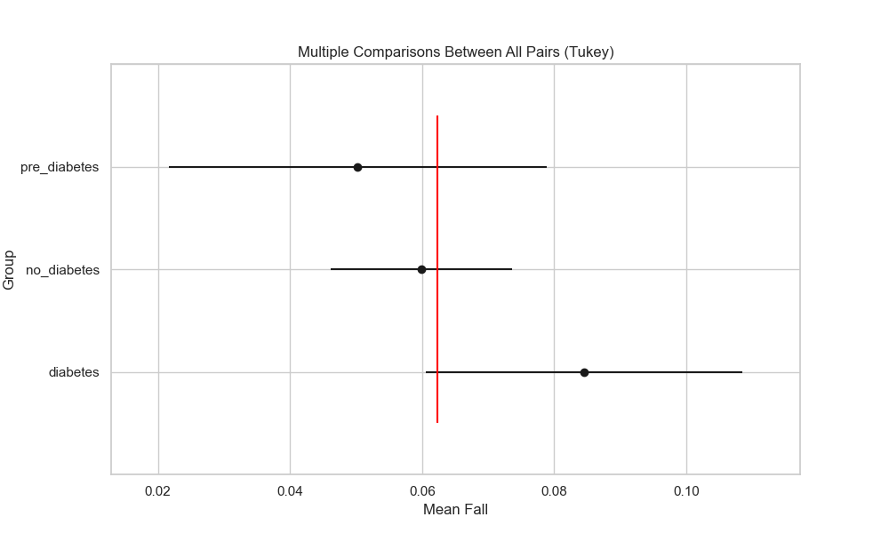

## plot_interaction_analysis

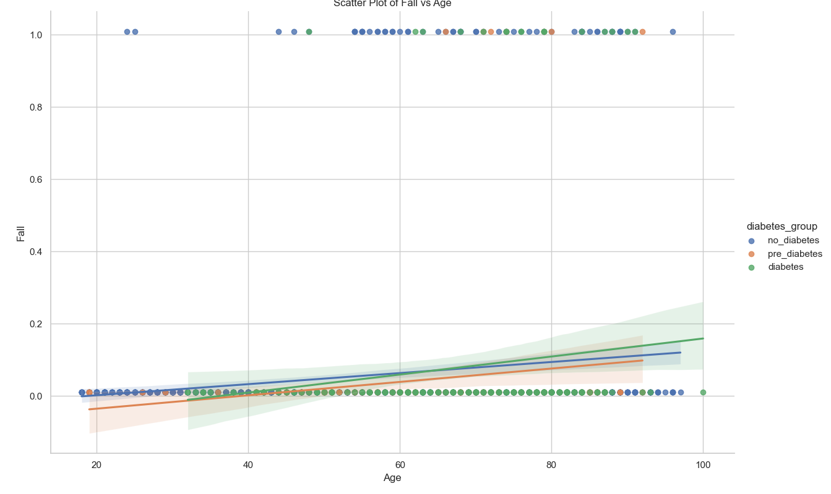

## visualize_chi_square_results

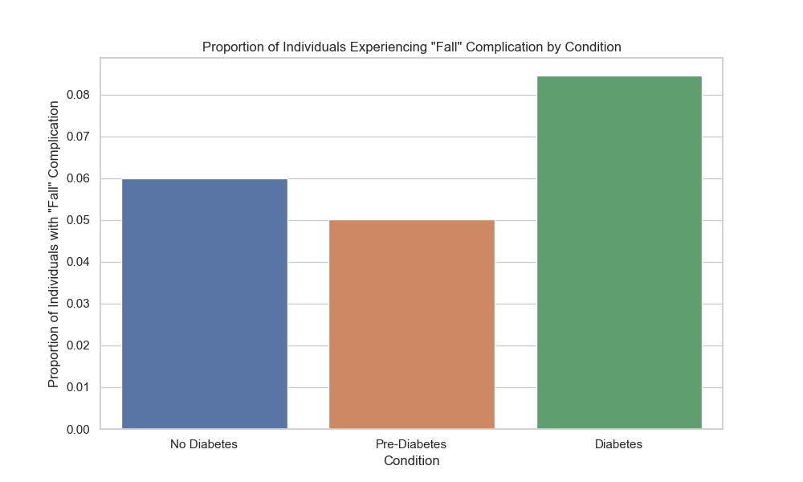

## visualize_relative_risk_results

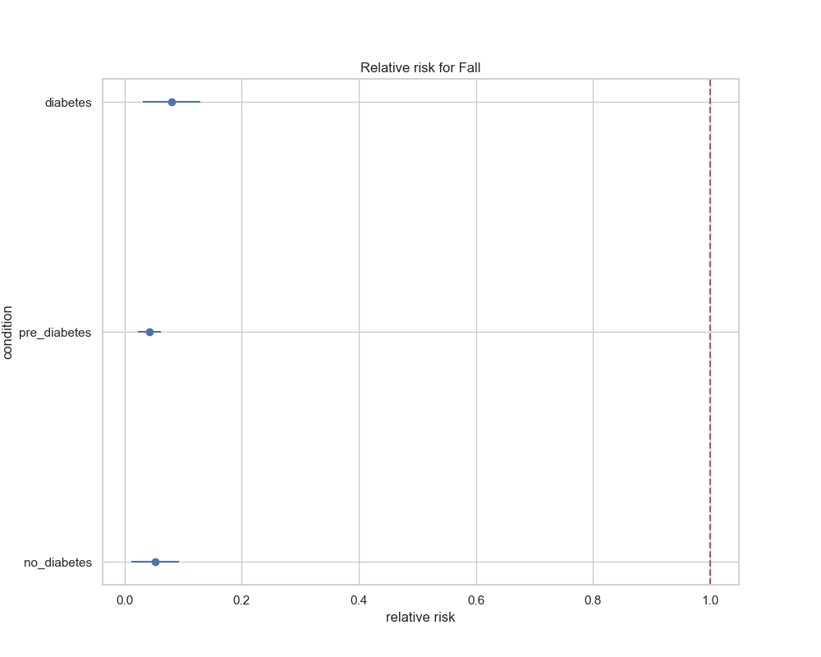

## visualize_odds_ratio_results

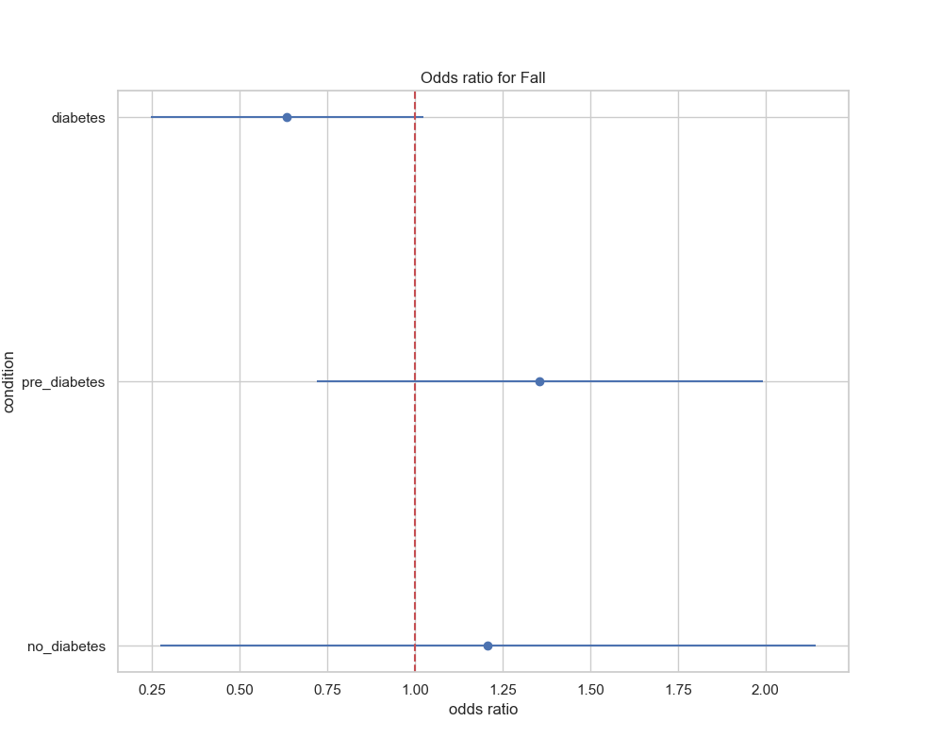

## visualize_relative_risk_by_age_results

