I21

## one_way_anova

(0.9115171930965795, 0.4021198844865027)

## t_test

t_statistic p_value  
pre_diabetes vs no_diabetes -0.844896 0.398314  
diabetes vs no_diabetes 0.935638 0.349616

## tukey_hsd

Multiple Comparison of Means - Tukey HSD, FWER=0.05   
==============================================================  
 group1 group2 meandiff p-adj lower upper reject  
--------------------------------------------------------------  
 diabetes no_diabetes -0.0047 0.5833 -0.0158 0.0064 False  
 diabetes pre_diabetes -0.0088 0.3788 -0.0242 0.0067 False  
no_diabetes pre_diabetes -0.0041 0.7212 -0.0165 0.0084 False  
--------------------------------------------------------------

## covariance_analysis

sum_sq df F PR(>F)  
C(no_diabetes) 0.002144 1.0 0.500249 0.479493  
C(pre_diabetes) 0.003979 1.0 0.928645 0.335359  
C(diabetes) 0.004263 1.0 0.994847 0.318710  
Age 0.020237 1.0 4.722664 0.029912  
Residual 6.941761 1620.0 NaN NaN

## interaction_analysis

sum_sq df F PR(>F)  
C(no_diabetes) 0.016026 1.0 3.745116 0.053136  
C(pre_diabetes) 0.004142 1.0 0.968055 0.325313  
C(diabetes) 0.004263 1.0 0.996226 0.318375  
Age 0.020237 1.0 4.729211 0.029799  
C(diabetes):Age 0.013889 1.0 3.245718 0.071796  
Residual 6.927872 1619.0 NaN NaN

## interaction_analysis2

dfn dfd F PR(>F)  
diabetes 1.0 1487.0 1.490623 0.222313  
pre_diabetes 1.0 1494.0 0.093529 0.759780

## chi_square_test

condition chi2 p_value dof  
0 no_diabetes 0.000000 1.000000 1  
1 pre_diabetes 0.093737 0.759479 1  
2 diabetes 0.318065 0.572773 1

## relative_risk_analysis

condition relative_risk ci p_value  
0 no_diabetes 0.004108 0.001707 7.300093e-35  
1 pre_diabetes 0.000000 0.000000 NaN  
2 diabetes 0.008850 0.002200 1.405478e-11

## odds_ratio_analysis

condition odds_ratio ci p_value  
0 no_diabetes 1.217000 0.505639 0.685273  
1 pre_diabetes inf NaN 1.000000  
2 diabetes 0.406183 0.100966 0.256551

## relative_risk_by_age

age_group condition relative_risk p_value confidence_interval  
3 40-60 No Diabetes 0.000000 1.000000 0.000000  
4 40-60 Pre-Diabetes inf 1.000000 NaN  
5 40-60 Diabetes inf 1.000000 NaN  
0 60+ No Diabetes 0.970990 1.000000 0.363179  
1 60+ Pre-Diabetes inf 1.000000 NaN  
2 60+ Diabetes 0.520468 0.609661 0.129161

## visualize_tukey_results

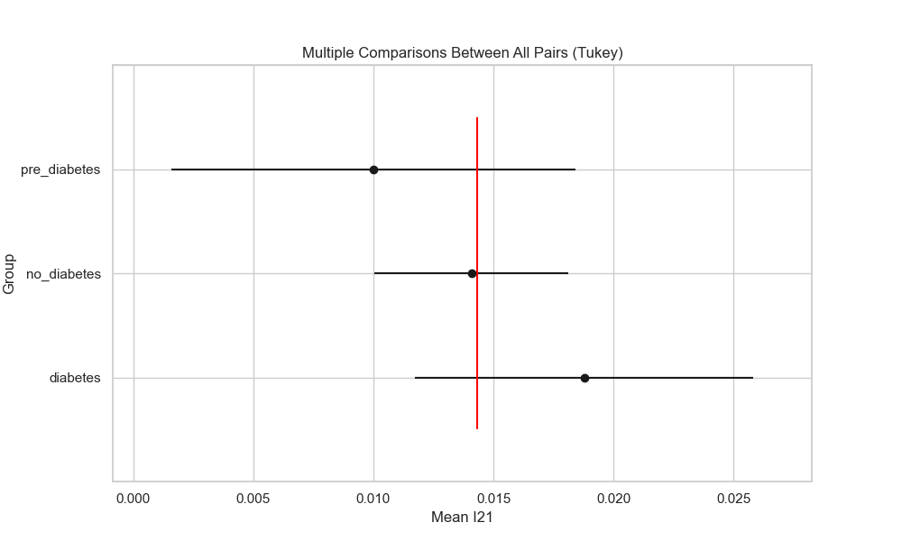

## plot_interaction_analysis

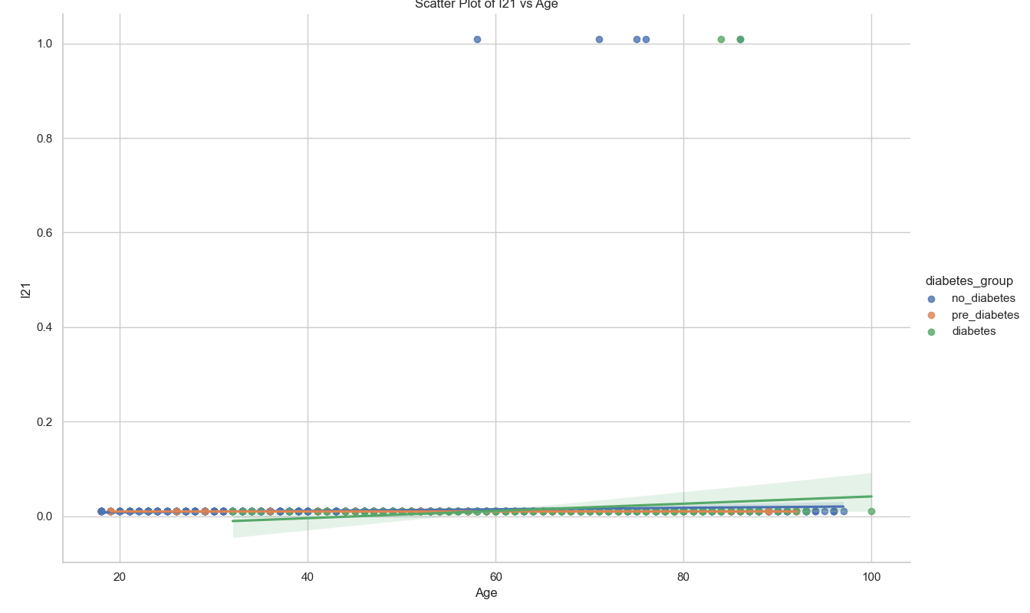

## visualize_chi_square_results

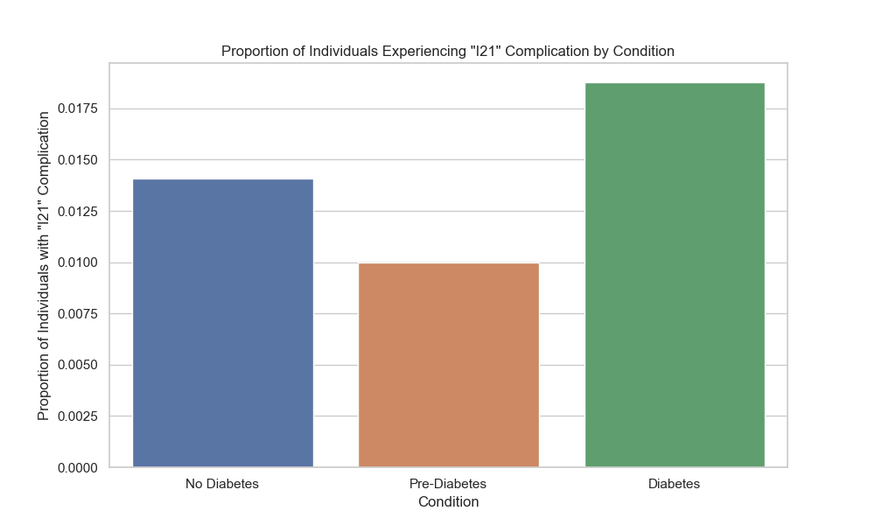

## visualize_relative_risk_results

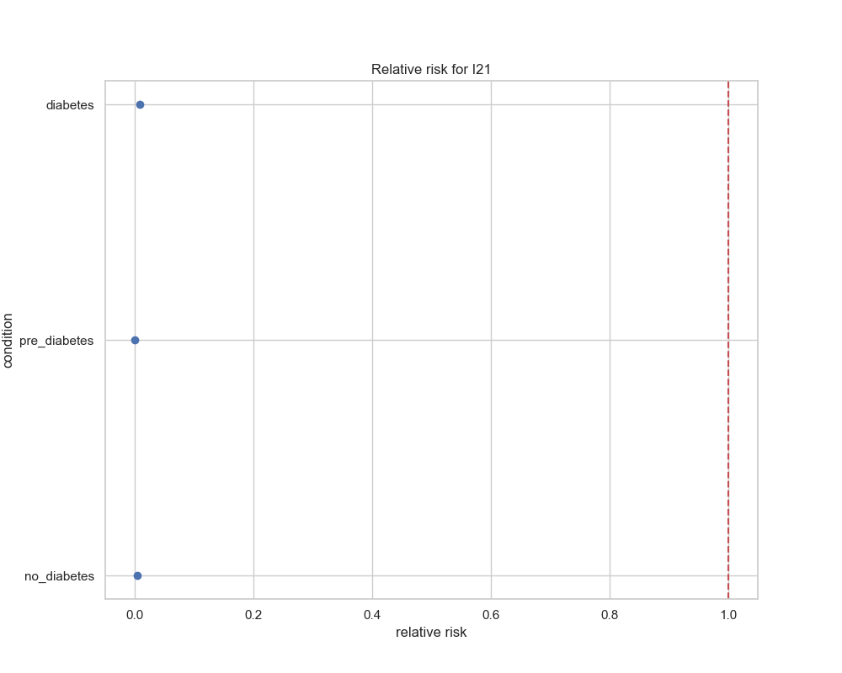

## visualize_odds_ratio_results

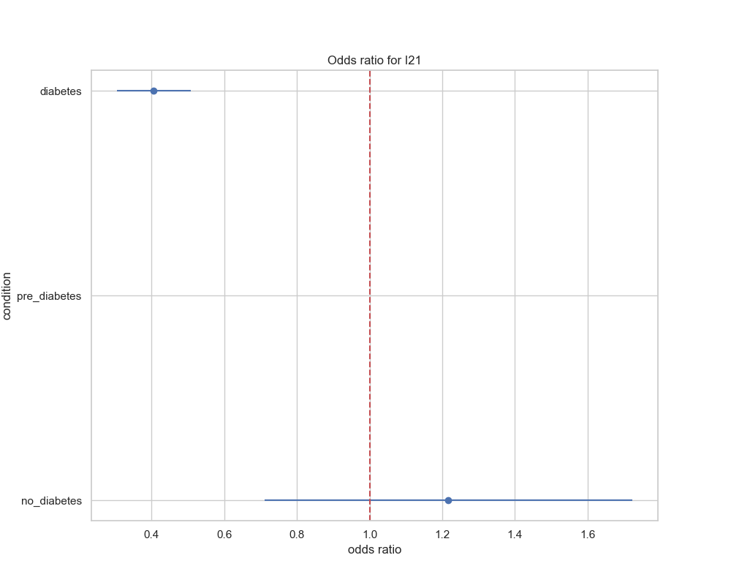

## visualize_relative_risk_by_age_results

