INTENSIV

## one_way_anova

(3.15687361398527, 0.04282036093459741)

## t_test

t_statistic p_value  
pre_diabetes vs no_diabetes -0.350940 0.725687  
diabetes vs no_diabetes 2.407163 0.016201

## tukey_hsd

Multiple Comparison of Means - Tukey HSD, FWER=0.05   
===============================================================  
 group1 group2 meandiff p-adj lower upper reject  
---------------------------------------------------------------  
 diabetes no_diabetes -0.0723 0.0418 -0.1425 -0.0021 True  
 diabetes pre_diabetes -0.0839 0.1102 -0.1819 0.014 False  
no_diabetes pre_diabetes -0.0116 0.9363 -0.0905 0.0673 False  
---------------------------------------------------------------

## covariance_analysis

sum_sq df F PR(>F)  
C(no_diabetes) 0.091594 1.0 0.543174 4.612272e-01  
C(pre_diabetes) 0.191544 1.0 1.135894 2.866804e-01  
C(diabetes) 0.497617 1.0 2.950975 8.601685e-02  
Age 5.932331 1.0 35.179961 3.667465e-09  
Residual 273.177588 1620.0 NaN NaN

## interaction_analysis

sum_sq df F PR(>F)  
C(no_diabetes) 0.238919 1.0 1.416832 2.341000e-01  
C(pre_diabetes) 0.010870 1.0 0.064462 7.996106e-01  
C(diabetes) 0.497617 1.0 2.950963 8.601763e-02  
Age 5.932331 1.0 35.179814 3.668181e-09  
C(diabetes):Age 0.167487 1.0 0.993229 3.191035e-01  
Residual 273.010101 1619.0 NaN NaN

## interaction_analysis2

dfn dfd F PR(>F)  
diabetes 1.0 1487.0 0.895513 0.344141  
pre_diabetes 1.0 1494.0 1.895021 0.168843

## chi_square_test

condition chi2 p_value dof  
0 no_diabetes 2.067123 0.150505 1  
1 pre_diabetes 0.351943 0.553015 1  
2 diabetes 5.761593 0.016380 1

## relative_risk_analysis

condition relative_risk ci p_value  
0 no_diabetes 0.270270 0.235668 1.769542e-78  
1 pre_diabetes 0.251799 0.173810 1.522366e-13  
2 diabetes 0.398773 0.299129 1.838587e-10

## odds_ratio_analysis

condition odds_ratio ci p_value  
0 no_diabetes 1.225166 1.068312 0.145959  
1 pre_diabetes 1.147302 0.791954 0.562277  
2 diabetes 0.671907 0.504013 0.015875

## relative_risk_by_age

age_group condition relative_risk p_value confidence_interval  
6 18-40 No Diabetes 0.538462 1.000000 0.384313  
7 18-40 Pre-Diabetes inf 1.000000 NaN  
8 18-40 Diabetes 0.906977 1.000000 0.109193  
3 40-60 No Diabetes 0.698662 0.348284 0.531350  
4 40-60 Pre-Diabetes 1.326162 0.692342 0.598770  
5 40-60 Diabetes 1.452632 0.657151 0.570047  
0 60+ No Diabetes 1.089078 0.633392 0.907074  
1 60+ Pre-Diabetes 1.266088 0.374043 0.827025  
2 60+ Diabetes 0.765486 0.138509 0.560760

## visualize_tukey_results

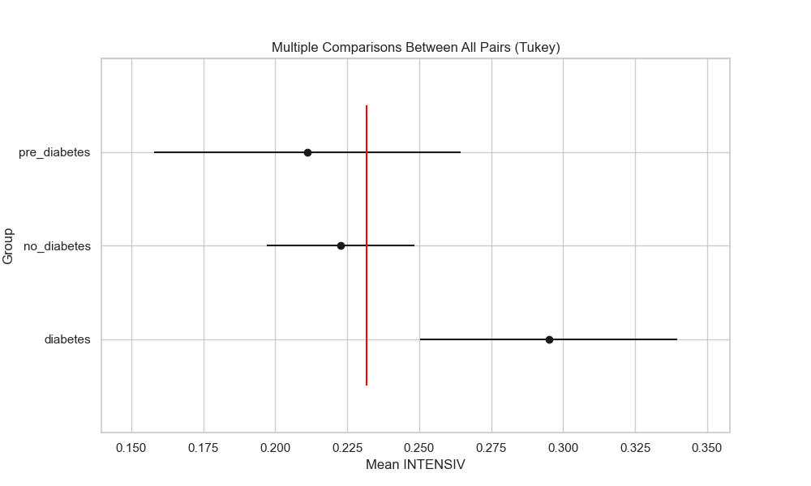

## plot_interaction_analysis

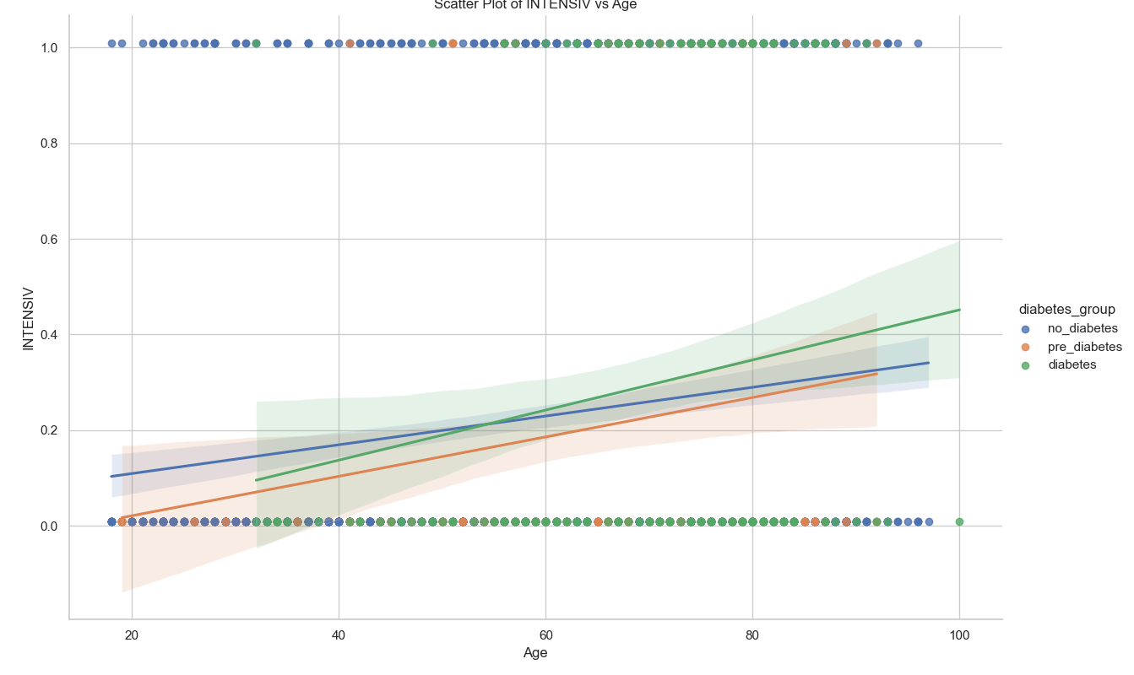

## visualize_chi_square_results

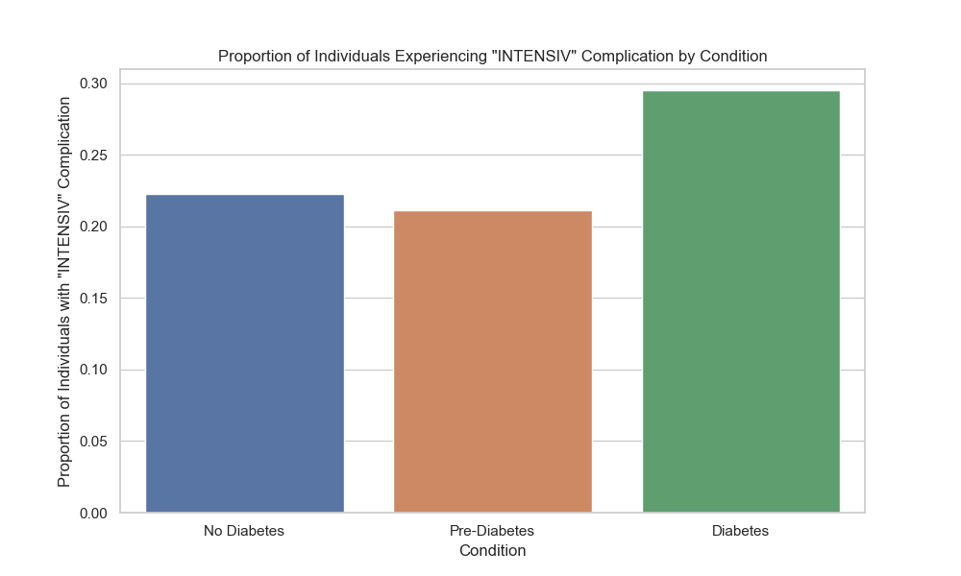

## visualize_relative_risk_results

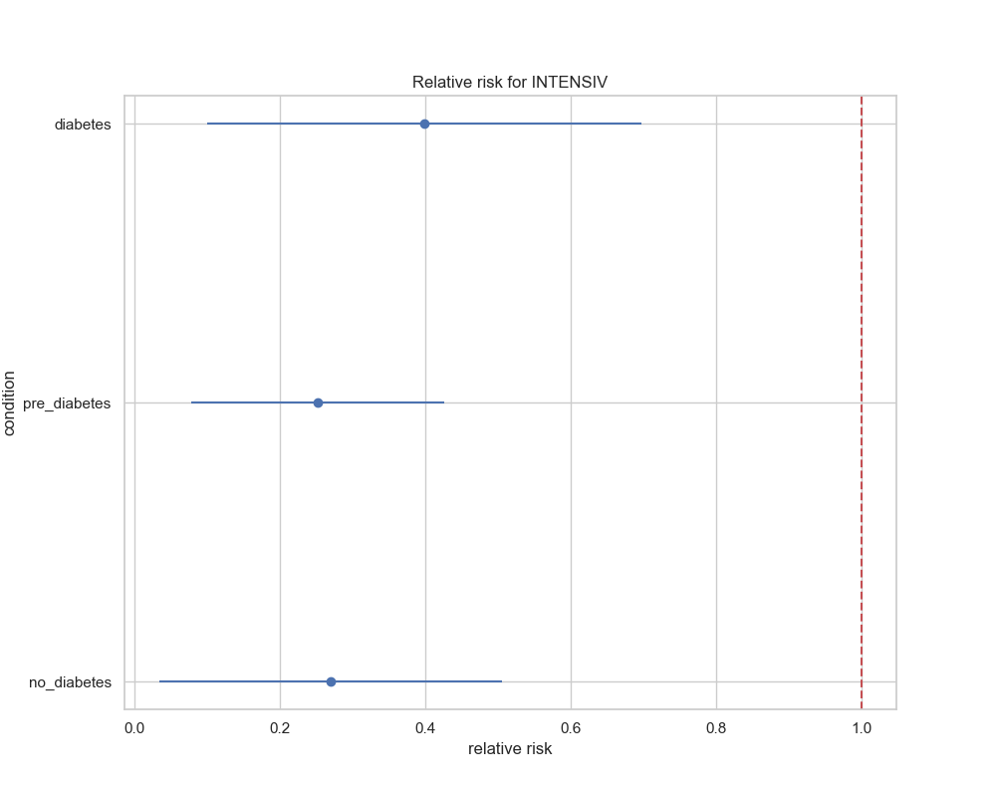

## visualize_odds_ratio_results

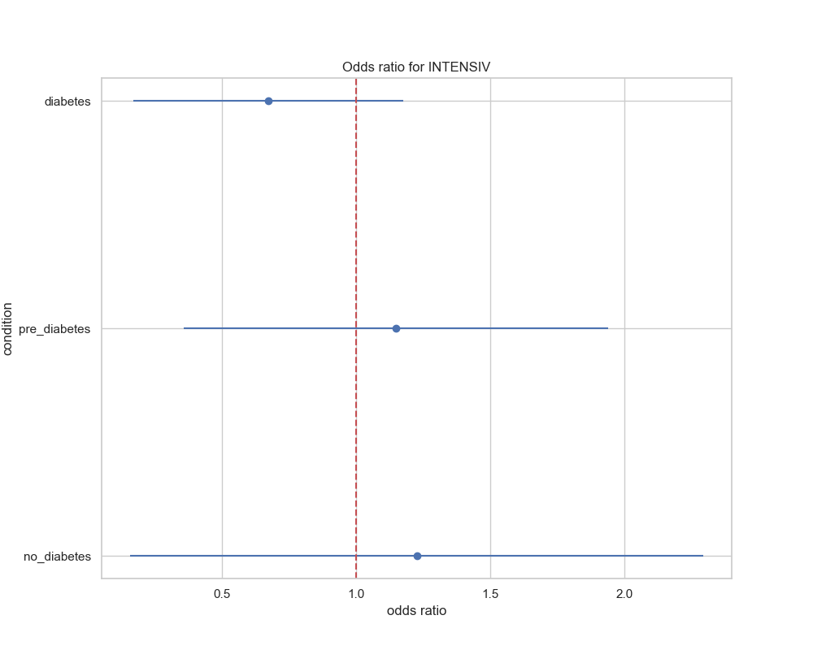

## visualize_relative_risk_by_age_results

