Length of Stay

## one_way_anova

(1696.1217694096001, 0.0)

## t_test

t_statistic p_value  
pre_diabetes vs no_diabetes 53.479249 0.000000e+00  
diabetes vs no_diabetes -34.933000 1.958167e-194

## tukey_hsd

Multiple Comparison of Means - Tukey HSD, FWER=0.05   
==============================================================  
 group1 group2 meandiff p-adj lower upper reject  
--------------------------------------------------------------  
 diabetes no_diabetes -0.0 1.0 -0.3769 0.3769 False  
 diabetes pre_diabetes 10.408 0.0 9.8821 10.934 True  
no_diabetes pre_diabetes 10.408 0.0 9.9847 10.8314 True  
--------------------------------------------------------------

## covariance_analysis

sum_sq df F PR(>F)  
C(no_diabetes) 5308.355656 1.0 1070.123555 1.226134e-180  
C(pre_diabetes) 15073.977254 1.0 3038.797545 0.000000e+00  
C(diabetes) 1728.105803 1.0 348.372801 1.419433e-70  
Age 6.006990 1.0 1.210963 2.713050e-01  
Residual 8036.021746 1620.0 NaN NaN

## interaction_analysis

sum_sq df F PR(>F)  
C(no_diabetes) 606.910737 1.0 122.279719 1.873995e-27  
C(pre_diabetes) 4560.405459 1.0 918.825563 3.096822e-160  
C(diabetes) 1728.105803 1.0 348.176890 1.552798e-70  
Age 6.006990 1.0 1.210282 2.714399e-01  
C(diabetes):Age 0.441617 1.0 0.088977 7.655206e-01  
Residual 8035.580129 1619.0 NaN NaN

## interaction_analysis2

dfn dfd F PR(>F)  
diabetes 1.0 1487.0 2.852815e+03 0.0  
pre_diabetes 1.0 1494.0 3.004882e-26 1.0

## chi_square_test

condition chi2 p_value dof  
0 no_diabetes 592.396418 4.643688e-109 25  
1 pre_diabetes 1624.000000 0.000000e+00 25  
2 diabetes 31.828539 1.630333e-01 25

## relative_risk_analysis

condition relative_risk ci p_value  
0 no_diabetes 0.0 0.0 NaN  
1 pre_diabetes inf NaN NaN  
2 diabetes 0.0 0.0 NaN

## odds_ratio_analysis

condition odds_ratio ci p_value  
0 no_diabetes inf NaN 2.399372e-121  
1 pre_diabetes 0.0 0.0 2.200058e-239  
2 diabetes inf NaN 1.631788e-12

## relative_risk_by_age

age_group condition relative_risk p_value confidence_interval  
6 18-40 No Diabetes inf 1.645007e-09 NaN  
7 18-40 Pre-Diabetes 0.0 9.586286e-13 0.0  
8 18-40 Diabetes inf 1.000000e+00 NaN  
3 40-60 No Diabetes inf 1.472635e-43 NaN  
4 40-60 Pre-Diabetes 0.0 1.936745e-70 0.0  
5 40-60 Diabetes inf 8.776790e-03 NaN  
0 60+ No Diabetes inf 2.071475e-62 NaN  
1 60+ Pre-Diabetes 0.0 9.346410e-147 0.0  
2 60+ Diabetes inf 5.946386e-13 NaN

## visualize_tukey_results

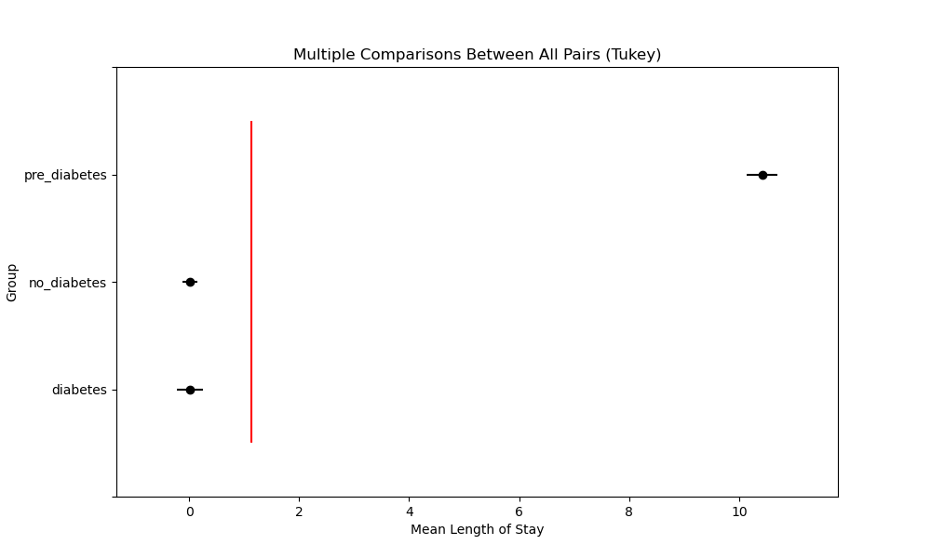

## plot_interaction_analysis

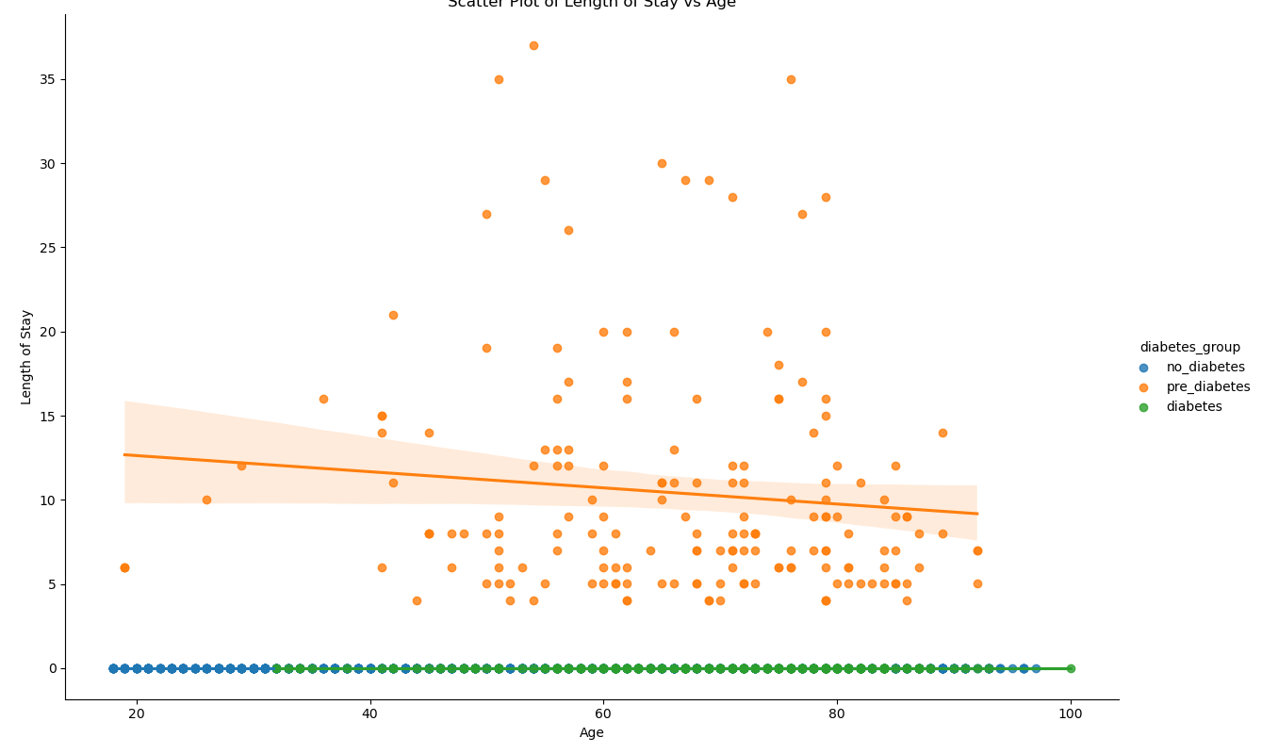

## visualize_chi_square_results

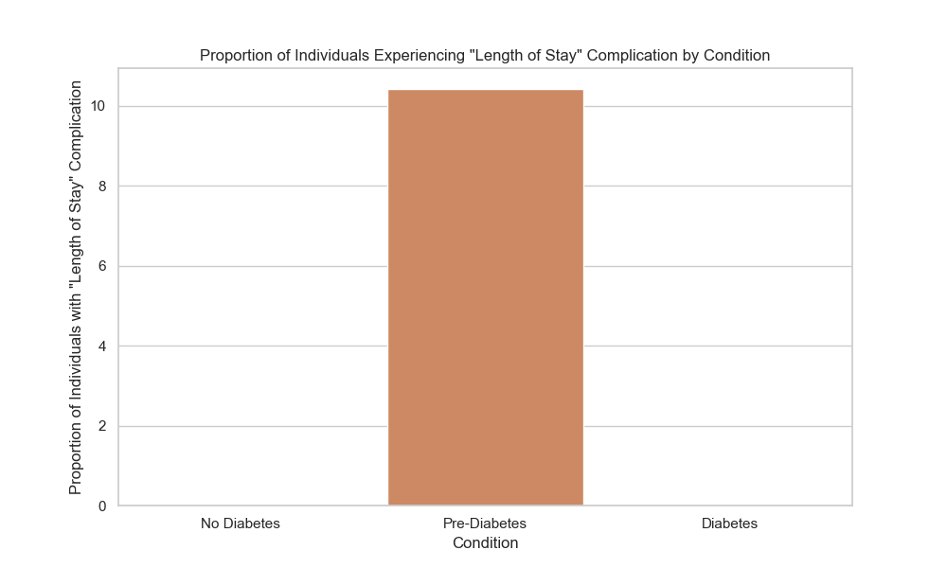

## visualize_relative_risk_results

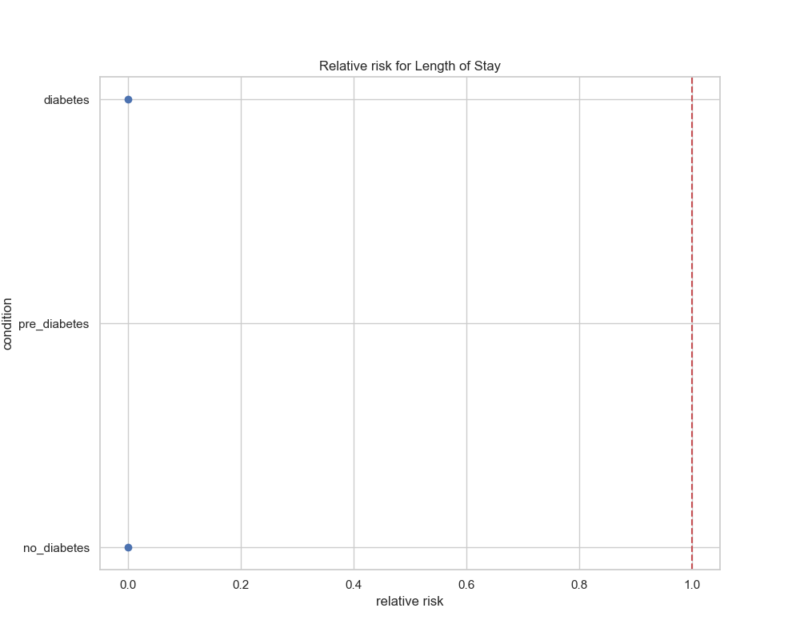

## visualize_odds_ratio_results

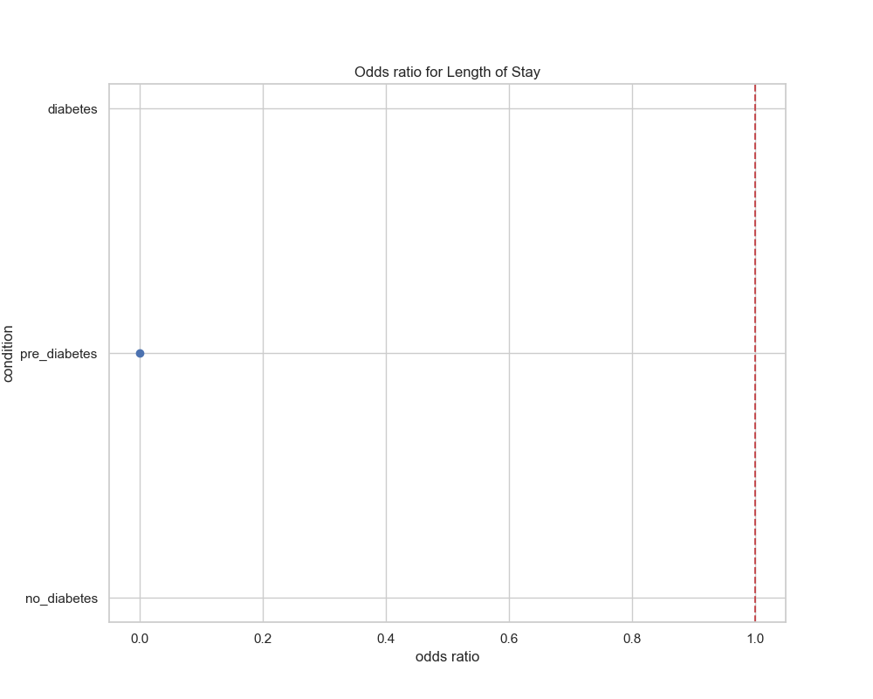

## visualize_relative_risk_by_age_results

