N17

## one_way_anova

(10.295664403684896, 3.604217453752248e-05)

## t_test

t_statistic p_value  
pre_diabetes vs no_diabetes -1.743308 0.081500  
diabetes vs no_diabetes 3.827755 0.000135

## tukey_hsd

Multiple Comparison of Means - Tukey HSD, FWER=0.05   
===============================================================  
 group1 group2 meandiff p-adj lower upper reject  
---------------------------------------------------------------  
 diabetes no_diabetes -0.0511 0.0002 -0.081 -0.0212 True  
 diabetes pre_diabetes -0.0732 0.0001 -0.1149 -0.0315 True  
no_diabetes pre_diabetes -0.0221 0.2717 -0.0557 0.0115 False  
---------------------------------------------------------------

## covariance_analysis

sum_sq df F PR(>F)  
C(no_diabetes) 0.025097 1.0 0.809532 0.368392  
C(pre_diabetes) 0.293832 1.0 9.477700 0.002115  
C(diabetes) 0.332603 1.0 10.728285 0.001077  
Age 0.403298 1.0 13.008585 0.000319  
Residual 50.223913 1620.0 NaN NaN

## interaction_analysis

sum_sq df F PR(>F)  
C(no_diabetes) 0.024916 1.0 0.804007 0.370031  
C(pre_diabetes) 0.011146 1.0 0.359677 0.548770  
C(diabetes) 0.332603 1.0 10.732659 0.001075  
Age 0.403298 1.0 13.013888 0.000319  
C(diabetes):Age 0.051456 1.0 1.660409 0.197732  
Residual 50.172457 1619.0 NaN NaN

## interaction_analysis2

dfn dfd F PR(>F)  
diabetes 1.0 1487.0 4.166674 0.041403  
pre_diabetes 1.0 1494.0 8.520375 0.003565

## chi_square_test

condition chi2 p_value dof  
0 no_diabetes 3.031522 0.081661 1  
1 pre_diabetes 3.559954 0.059189 1  
2 diabetes 16.353291 0.000053 1

## relative_risk_analysis

condition relative_risk ci p_value  
0 no_diabetes 0.028620 0.020352 4.437402e-93  
1 pre_diabetes 0.005780 0.000810 1.384981e-07  
2 diabetes 0.085714 0.052967 7.381002e-24

## odds_ratio_analysis

condition odds_ratio ci p_value  
0 no_diabetes 1.733374 1.232646 0.073496  
1 pre_diabetes 6.434907 0.901331 0.038026  
2 diabetes 0.300024 0.185398 0.000155

## relative_risk_by_age

age_group condition relative_risk p_value confidence_interval  
6 18-40 No Diabetes 0.000000 1.000000 0.000000  
7 18-40 Pre-Diabetes inf 1.000000 NaN  
8 18-40 Diabetes inf 1.000000 NaN  
3 40-60 No Diabetes 0.374194 0.472598 0.199564  
4 40-60 Pre-Diabetes inf 0.626096 NaN  
5 40-60 Diabetes 0.997506 1.000000 0.137132  
0 60+ No Diabetes 1.627502 0.170444 1.062814  
1 60+ Pre-Diabetes 6.226891 0.051225 0.869650  
2 60+ Diabetes 0.331623 0.002026 0.201233

## visualize_tukey_results

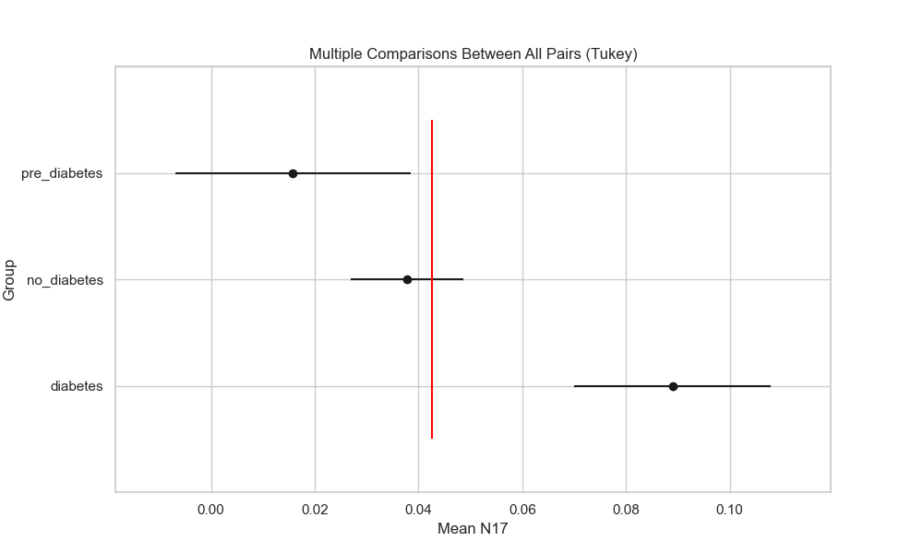

## plot_interaction_analysis

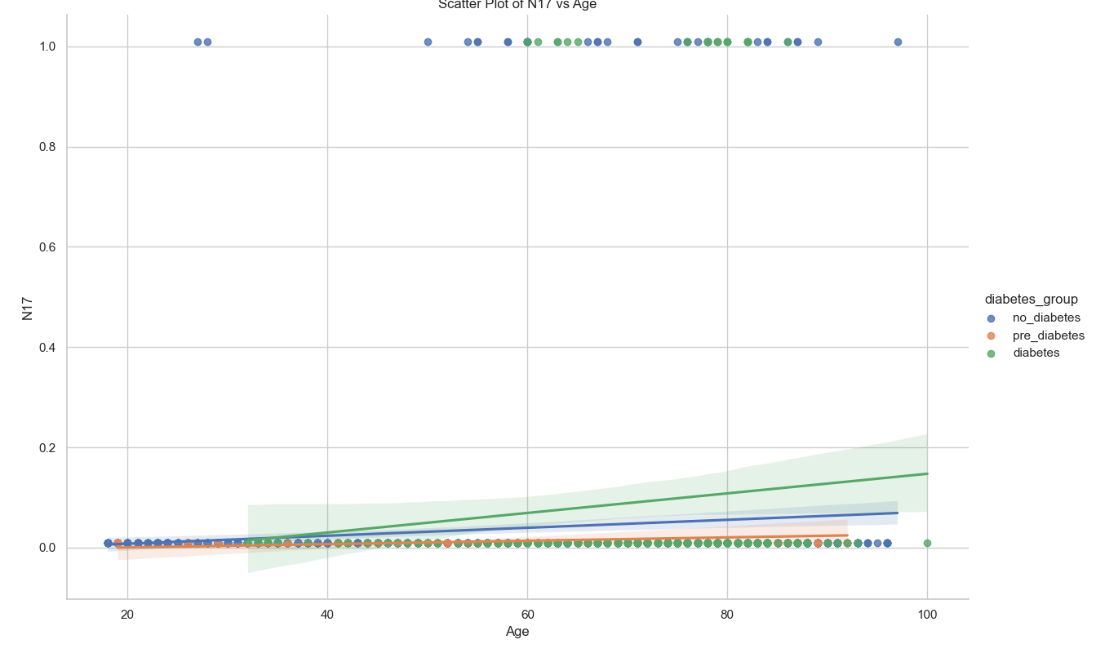

## visualize_chi_square_results

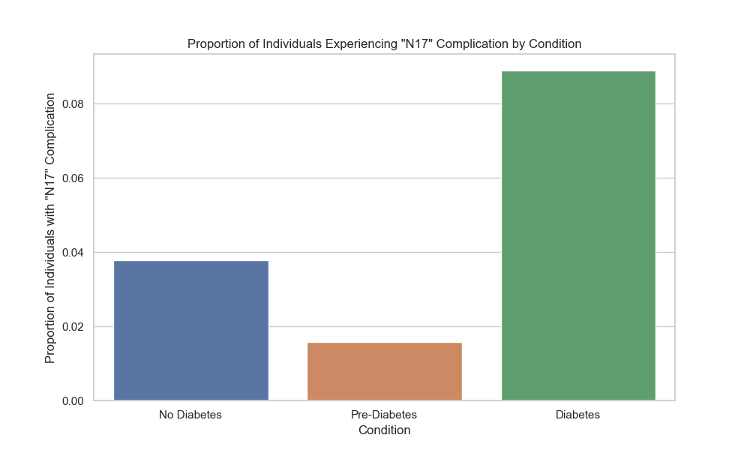

## visualize_relative_risk_results

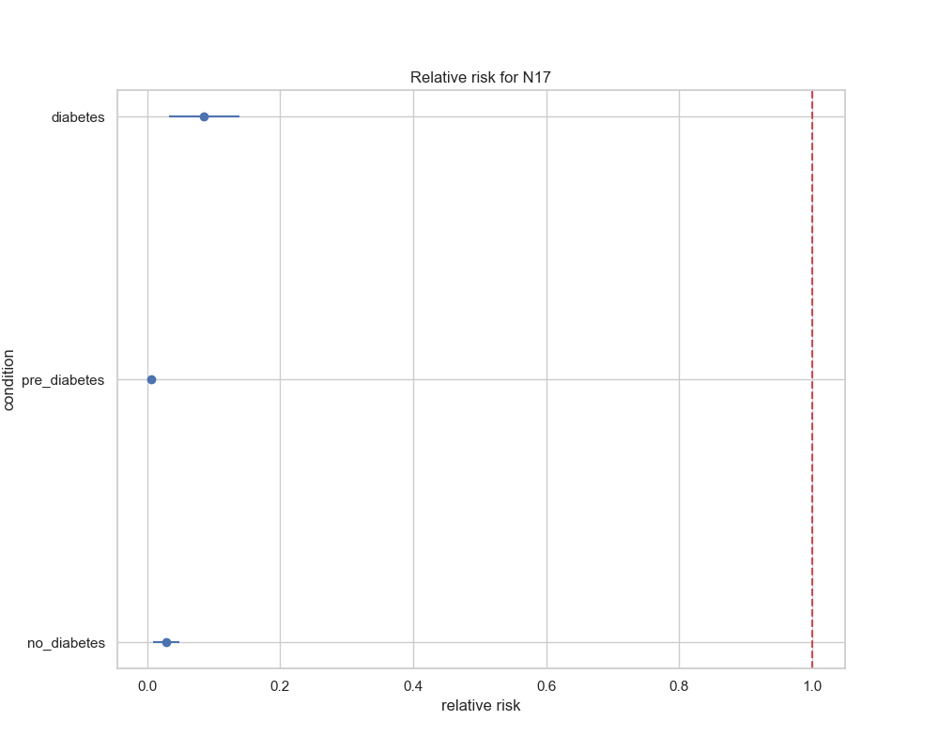

## visualize_odds_ratio_results

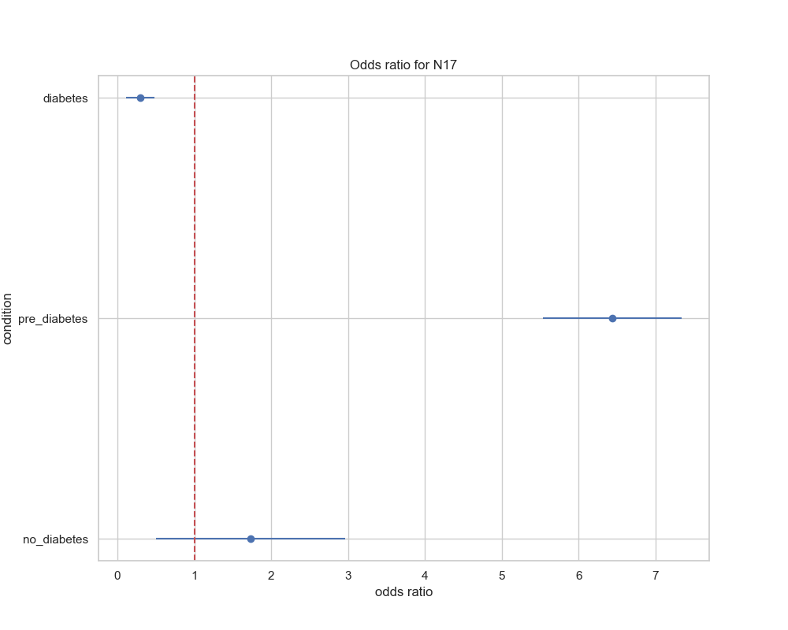

## visualize_relative_risk_by_age_results

