T81

## one_way_anova

(1.1760461037948489, 0.30875916751638716)

## t_test

t_statistic p_value  
pre_diabetes vs no_diabetes 1.531299 0.125922  
diabetes vs no_diabetes 0.384803 0.700440

## tukey_hsd

Multiple Comparison of Means - Tukey HSD, FWER=0.05   
==============================================================  
 group1 group2 meandiff p-adj lower upper reject  
--------------------------------------------------------------  
 diabetes no_diabetes -0.0054 0.926 -0.0393 0.0285 False  
 diabetes pre_diabetes 0.0194 0.6024 -0.0279 0.0667 False  
no_diabetes pre_diabetes 0.0248 0.2794 -0.0133 0.0628 False  
--------------------------------------------------------------

## covariance_analysis

sum_sq df F PR(>F)  
C(no_diabetes) 0.006831 1.0 0.170153 0.680031  
C(pre_diabetes) 0.166766 1.0 4.153781 0.041704  
C(diabetes) 0.009991 1.0 0.248849 0.617954  
Age 0.018396 1.0 0.458203 0.498562  
Residual 65.039913 1620.0 NaN NaN

## interaction_analysis

sum_sq df F PR(>F)  
C(no_diabetes) 0.000269 1.0 0.006686 0.934842  
C(pre_diabetes) 0.033313 1.0 0.829260 0.362622  
C(diabetes) 0.009991 1.0 0.248704 0.618057  
Age 0.018396 1.0 0.457936 0.498687  
C(diabetes):Age 0.002306 1.0 0.057404 0.810678  
Residual 65.037607 1619.0 NaN NaN

## interaction_analysis2

dfn dfd F PR(>F)  
diabetes 1.0 1487.0 3.879716 0.049058  
pre_diabetes 1.0 1494.0 0.199261 0.655383

## chi_square_test

condition chi2 p_value dof  
0 no_diabetes 1.108357 0.292439 1  
1 pre_diabetes 1.657644 0.197922 1  
2 diabetes 0.000000 1.000000 1

## relative_risk_analysis

condition relative_risk ci p_value  
0 no_diabetes 0.040000 0.029884 3.860861e-104  
1 pre_diabetes 0.067485 0.036647 2.488369e-18  
2 diabetes 0.045872 0.024337 7.884350e-22

## odds_ratio_analysis

condition odds_ratio ci p_value  
0 no_diabetes 1.377953 1.029473 0.250629  
1 pre_diabetes 0.606343 0.329271 0.157180  
2 diabetes 0.944993 0.501361 0.858435

## relative_risk_by_age

age_group condition relative_risk p_value confidence_interval  
6 18-40 No Diabetes 3.380952 0.297999 1.597255  
7 18-40 Pre-Diabetes inf 1.000000 NaN  
8 18-40 Diabetes 0.144828 0.171859 0.017436  
3 40-60 No Diabetes 1.216507 0.620290 0.766369  
4 40-60 Pre-Diabetes 0.506596 0.196561 0.201678  
5 40-60 Diabetes 2.480620 0.716134 0.341024  
0 60+ No Diabetes 1.309609 0.468475 0.847020  
1 60+ Pre-Diabetes 0.727670 0.448259 0.319887  
2 60+ Diabetes 0.878215 0.831174 0.432251

## visualize_tukey_results

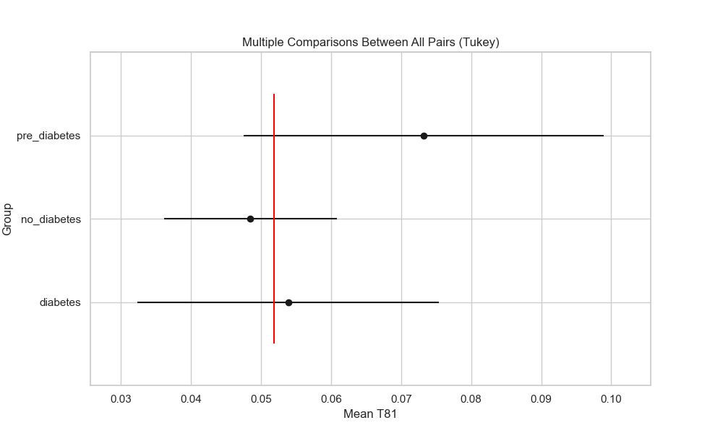

## plot_interaction_analysis

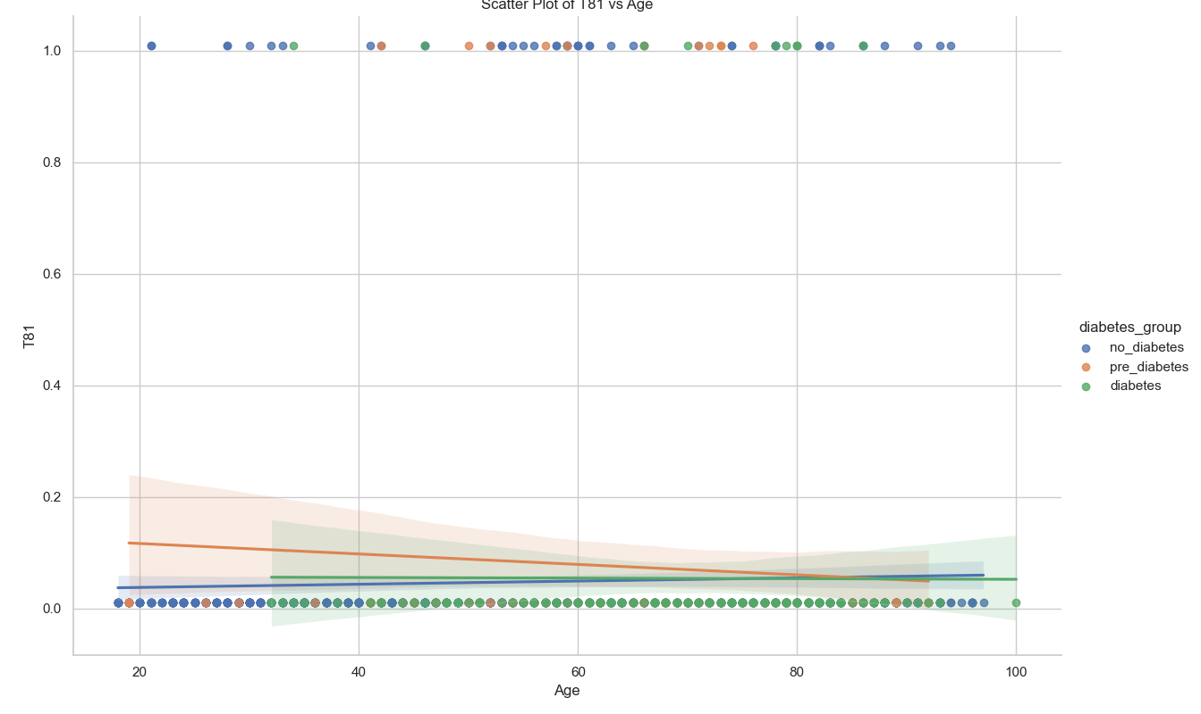

## visualize_chi_square_results

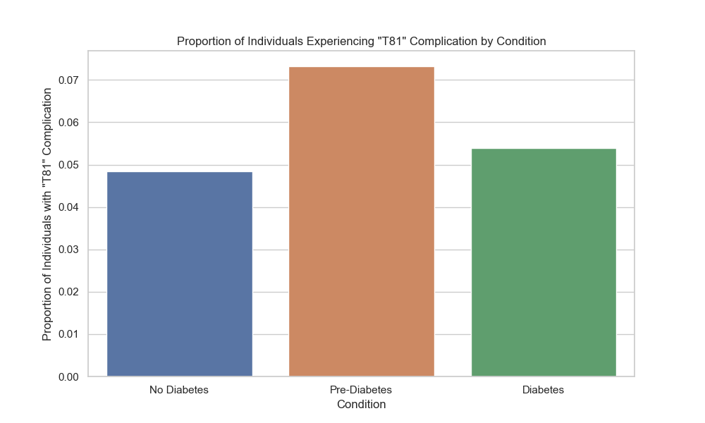

## visualize_relative_risk_results

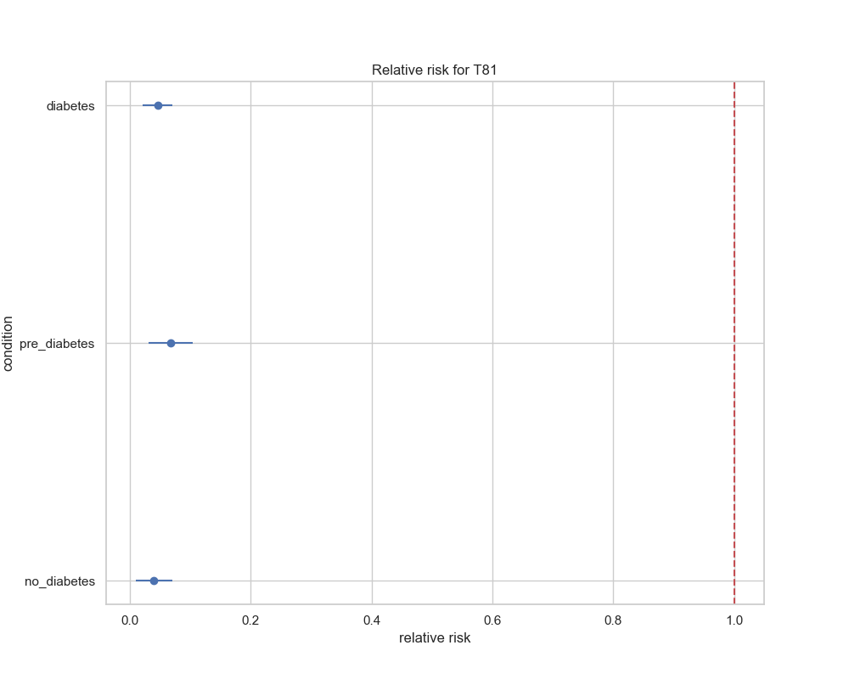

## visualize_odds_ratio_results

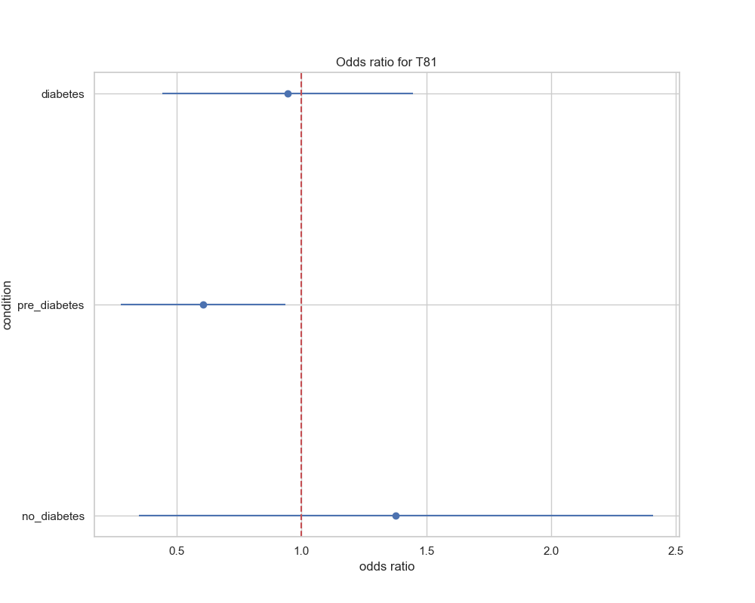

## visualize_relative_risk_by_age_results

