T84

## one_way_anova

(0.5024151843142112, 0.6051617330528427)

## t_test

t_statistic p_value  
pre_diabetes vs no_diabetes -0.070851 0.943526  
diabetes vs no_diabetes -1.002623 0.316210

## tukey_hsd

Multiple Comparison of Means - Tukey HSD, FWER=0.05   
==============================================================  
 group1 group2 meandiff p-adj lower upper reject  
--------------------------------------------------------------  
 diabetes no_diabetes 0.0092 0.5769 -0.0124 0.0309 False  
 diabetes pre_diabetes 0.0085 0.7881 -0.0217 0.0387 False  
no_diabetes pre_diabetes -0.0008 0.997 -0.0251 0.0236 False  
--------------------------------------------------------------

## covariance_analysis

sum_sq df F PR(>F)  
C(no_diabetes) 0.110637 1.0 6.763061 0.009391  
C(pre_diabetes) 0.041140 1.0 2.514825 0.112975  
C(diabetes) 0.008160 1.0 0.498794 0.480132  
Age 0.033167 1.0 2.027433 0.154674  
Residual 26.501493 1620.0 NaN NaN

## interaction_analysis

sum_sq df F PR(>F)  
C(no_diabetes) 0.025763 1.0 1.573999 0.209808  
C(pre_diabetes) 0.022808 1.0 1.393496 0.237989  
C(diabetes) 0.008160 1.0 0.498529 0.480249  
Age 0.033167 1.0 2.026359 0.154783  
C(diabetes):Age 0.002321 1.0 0.141830 0.706518  
Residual 26.499172 1619.0 NaN NaN

## interaction_analysis2

dfn dfd F PR(>F)  
diabetes 1.0 1487.0 0.010774 0.917343  
pre_diabetes 1.0 1494.0 0.190438 0.662615

## chi_square_test

condition chi2 p_value dof  
0 no_diabetes 0.283222 0.594597 1  
1 pre_diabetes 0.000000 1.000000 1  
2 diabetes 0.519852 0.470905 1

## relative_risk_analysis

condition relative_risk ci p_value  
0 no_diabetes 0.018333 0.012026 2.027412e-77  
1 pre_diabetes 0.017544 0.005603 1.931034e-12  
2 diabetes 0.008850 0.002200 1.405478e-11

## odds_ratio_analysis

condition odds_ratio ci p_value  
0 no_diabetes 0.686970 0.450615 0.652564  
1 pre_diabetes 0.959327 0.306361 1.000000  
2 diabetes 2.060540 0.512193 0.413430

## relative_risk_by_age

age_group condition relative_risk p_value confidence_interval  
6 18-40 No Diabetes 2.947917 0.328830 1.459977  
7 18-40 Pre-Diabetes 0.137931 0.166264 0.016115  
8 18-40 Diabetes inf 1.000000 NaN  
3 40-60 No Diabetes 0.951613 1.000000 0.355191  
4 40-60 Pre-Diabetes 0.526582 0.465575 0.072798  
5 40-60 Diabetes inf 1.000000 NaN  
0 60+ No Diabetes 0.578425 0.559390 0.309523  
1 60+ Pre-Diabetes 1.846154 1.000000 0.257835  
2 60+ Diabetes 1.446086 1.000000 0.358865

## visualize_tukey_results

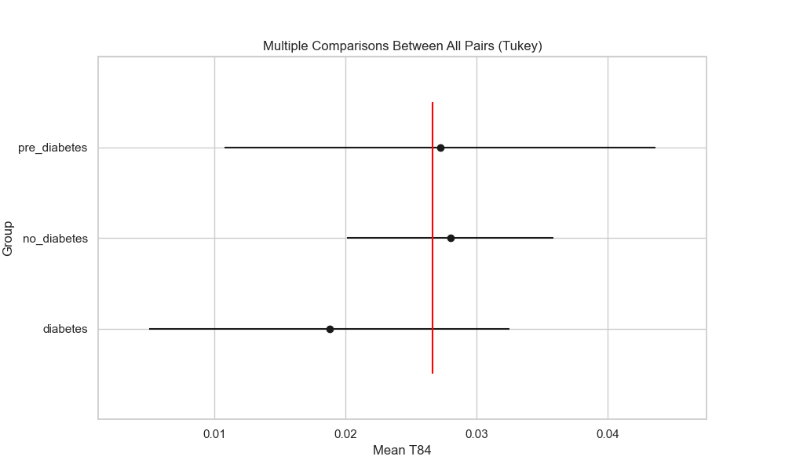

## plot_interaction_analysis

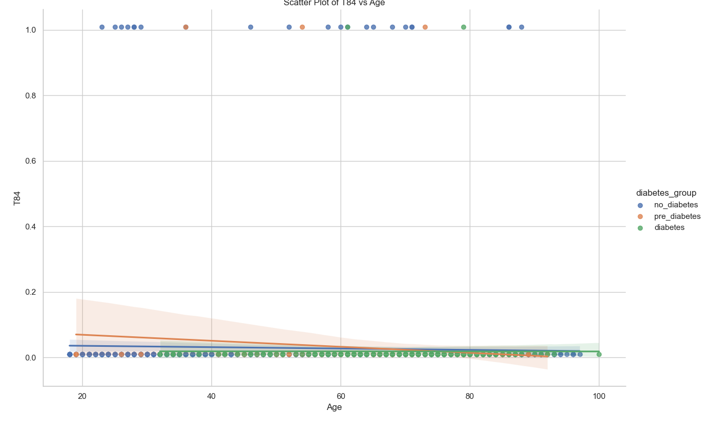

## visualize_chi_square_results

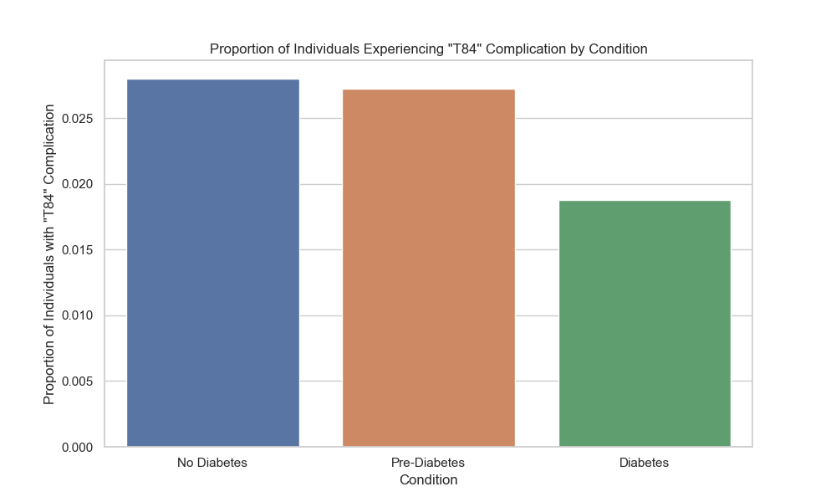

## visualize_relative_risk_results

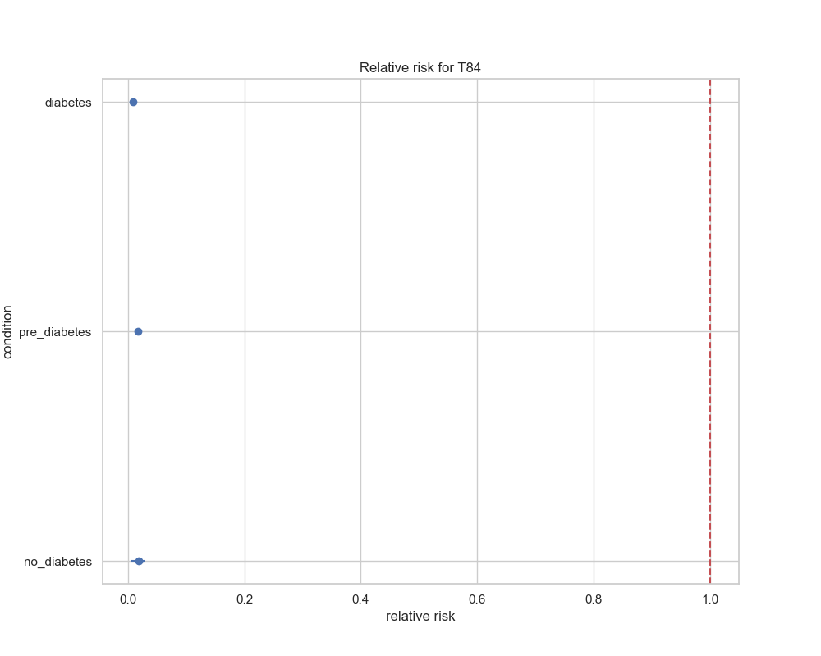

## visualize_odds_ratio_results

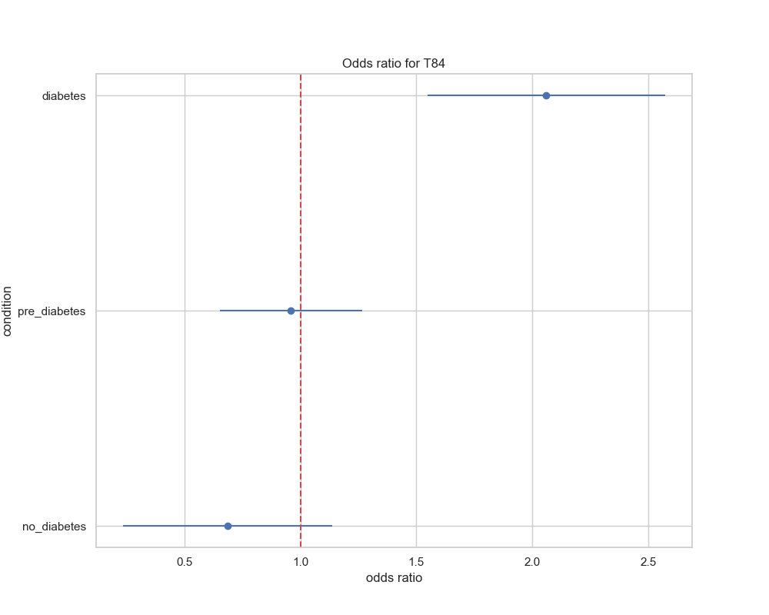

## visualize_relative_risk_by_age_results

