TOD

## one_way_anova

(0.11305435281558858, 0.8931091575009511)

## t_test

t_statistic p_value  
pre_diabetes vs no_diabetes 0.207233 0.835858  
diabetes vs no_diabetes 0.457008 0.647734

## tukey_hsd

Multiple Comparison of Means - Tukey HSD, FWER=0.05   
==============================================================  
 group1 group2 meandiff p-adj lower upper reject  
--------------------------------------------------------------  
 diabetes no_diabetes -0.0033 0.8925 -0.0206 0.0139 False  
 diabetes pre_diabetes -0.0017 0.9856 -0.0257 0.0224 False  
no_diabetes pre_diabetes 0.0017 0.9776 -0.0177 0.021 False  
--------------------------------------------------------------

## covariance_analysis

sum_sq df F PR(>F)  
C(no_diabetes) 0.000105 1.0 0.010157 0.919735  
C(pre_diabetes) 0.001375 1.0 0.133317 0.715065  
C(diabetes) 0.001661 1.0 0.161025 0.688268  
Age 0.109964 1.0 10.660925 0.001117  
Residual 16.709734 1620.0 NaN NaN

## interaction_analysis

sum_sq df F PR(>F)  
C(no_diabetes) 0.008930 1.0 0.865713 0.352284  
C(pre_diabetes) 0.010301 1.0 0.998646 0.317788  
C(diabetes) 0.001661 1.0 0.161016 0.688276  
Age 0.109964 1.0 10.660342 0.001117  
C(diabetes):Age 0.009402 1.0 0.911466 0.339868  
Residual 16.700333 1619.0 NaN NaN

## interaction_analysis2

dfn dfd F PR(>F)  
diabetes 1.0 1487.0 1.514718 0.218615  
pre_diabetes 1.0 1494.0 0.003360 0.953784

## chi_square_test

condition chi2 p_value dof  
0 no_diabetes 0.027188 0.869032 1  
1 pre_diabetes 0.000000 1.000000 1  
2 diabetes 0.006323 0.936620 1

## relative_risk_analysis

condition relative_risk ci p_value  
0 no_diabetes 0.009917 0.005616 3.026706e-57  
1 pre_diabetes 0.011628 0.002885 1.887110e-10  
2 diabetes 0.013333 0.004268 5.481528e-14

## odds_ratio_analysis

condition odds_ratio ci p_value  
0 no_diabetes 1.269941 0.719196 0.584596  
1 pre_diabetes 0.898955 0.223027 0.702596  
2 diabetes 0.759768 0.243206 0.721688

## relative_risk_by_age

age_group condition relative_risk p_value confidence_interval  
3 40-60 No Diabetes 3.838710 0.373045 0.539253  
4 40-60 Pre-Diabetes inf 1.000000 NaN  
5 40-60 Diabetes 0.097561 0.173371 0.013412  
0 60+ No Diabetes 0.702281 0.784150 0.386691  
1 60+ Pre-Diabetes 0.992568 1.000000 0.245226  
2 60+ Diabetes 1.714074 0.748373 0.425370

## visualize_tukey_results

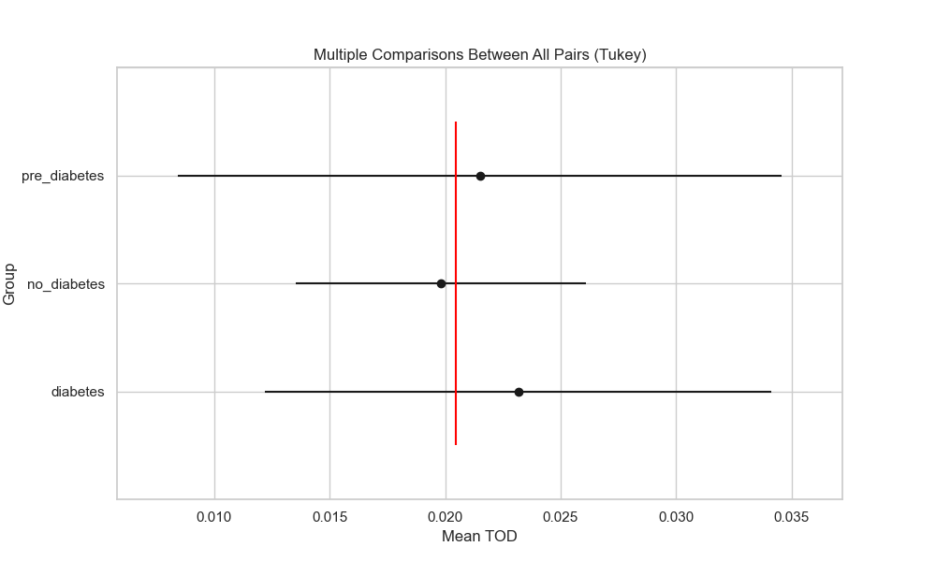

## plot_interaction_analysis

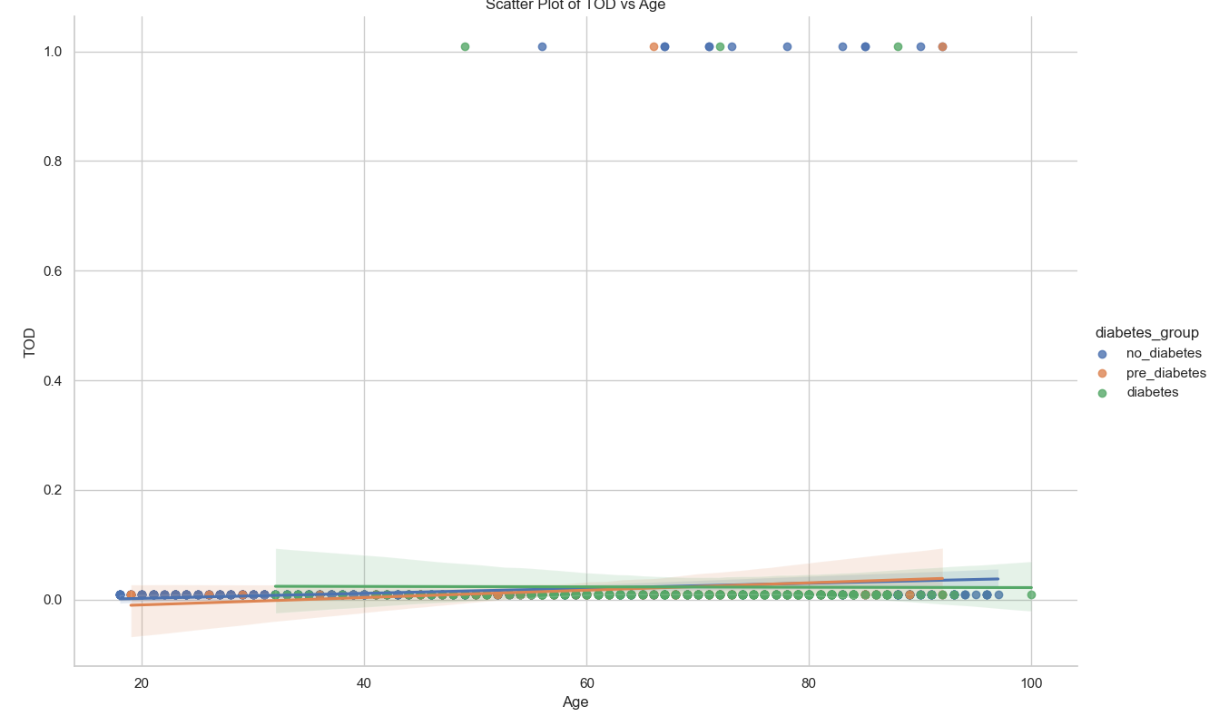

## visualize_chi_square_results

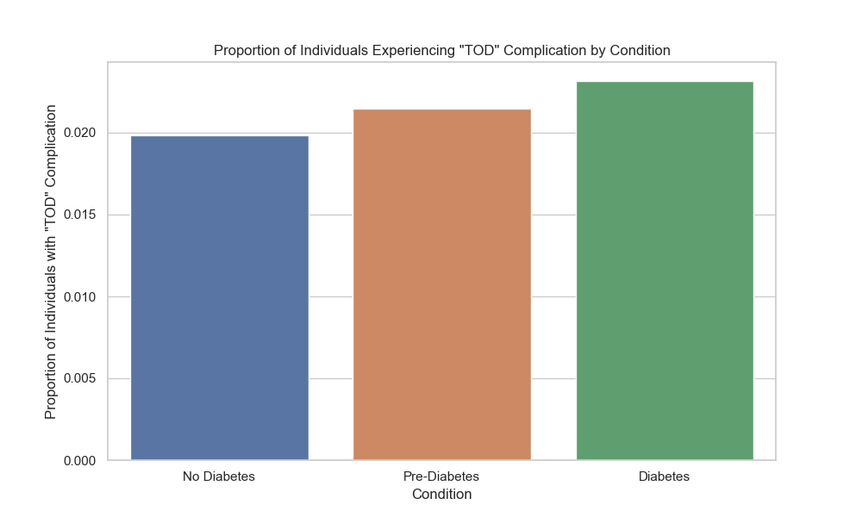

## visualize_relative_risk_results

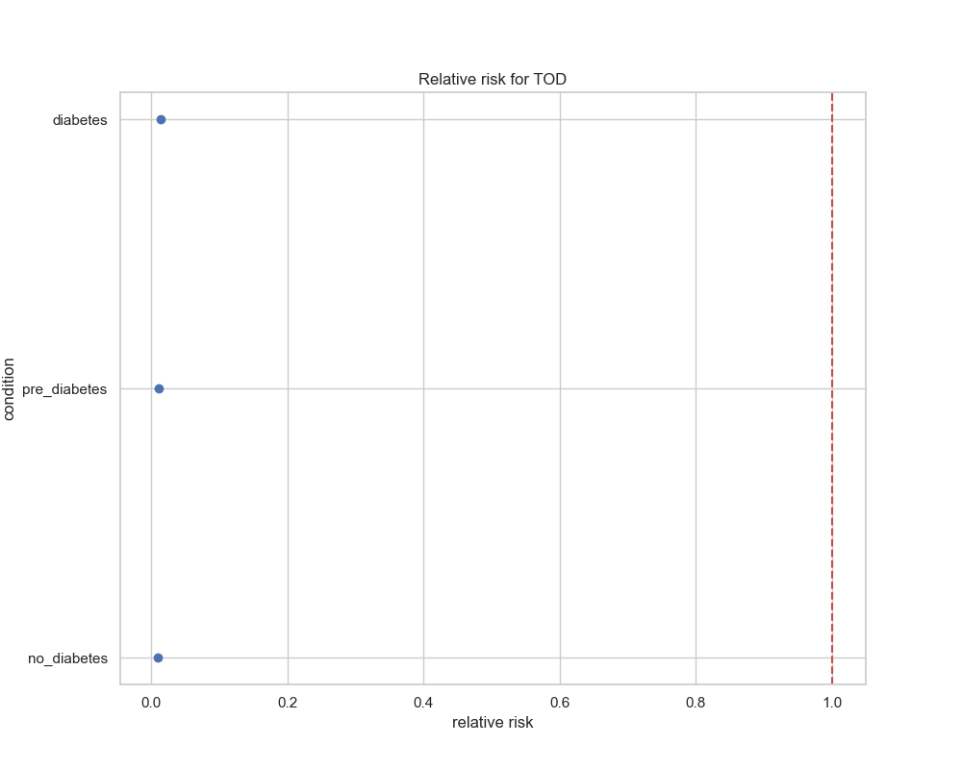

## visualize_odds_ratio_results

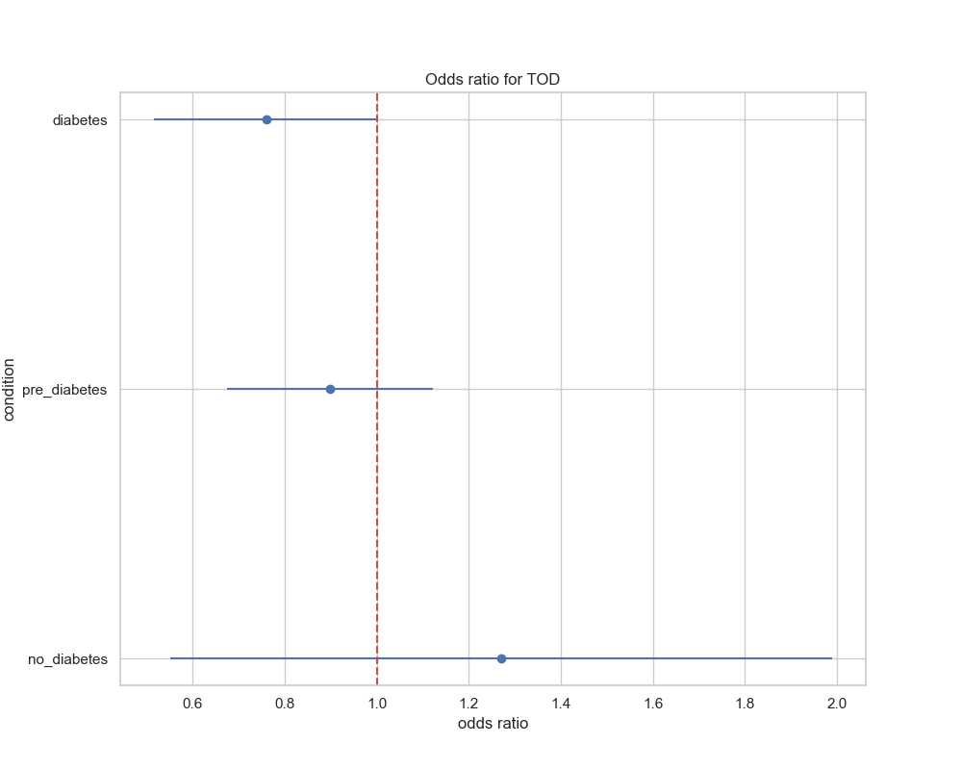

## visualize_relative_risk_by_age_results

