U69

## one_way_anova

(0.8863021257522719, 0.4123767598216167)

## t_test

t_statistic p_value  
pre_diabetes vs no_diabetes -0.434809 0.663769  
diabetes vs no_diabetes 1.170016 0.242187

## tukey_hsd

Multiple Comparison of Means - Tukey HSD, FWER=0.05   
==============================================================  
 group1 group2 meandiff p-adj lower upper reject  
--------------------------------------------------------------  
 diabetes no_diabetes -0.0085 0.4543 -0.0253 0.0082 False  
 diabetes pre_diabetes -0.0118 0.4616 -0.0351 0.0115 False  
no_diabetes pre_diabetes -0.0033 0.913 -0.022 0.0155 False  
--------------------------------------------------------------

## covariance_analysis

sum_sq df F PR(>F)  
C(no_diabetes) 0.003443 1.0 0.352763 0.552636  
C(pre_diabetes) 0.001426 1.0 0.146062 0.702377  
C(diabetes) 0.020857 1.0 2.136772 0.143998  
Age 0.012304 1.0 1.260507 0.261721  
Residual 15.812756 1620.0 NaN NaN

## interaction_analysis

sum_sq df F PR(>F)  
C(no_diabetes) 0.000890 1.0 0.091108 0.762813  
C(pre_diabetes) 0.004281 1.0 0.438351 0.508014  
C(diabetes) 0.020857 1.0 2.135840 0.144086  
Age 0.012304 1.0 1.259957 0.261826  
C(diabetes):Age 0.002861 1.0 0.292977 0.588394  
Residual 15.809895 1619.0 NaN NaN

## interaction_analysis2

dfn dfd F PR(>F)  
diabetes 1.0 1487.0 0.260824 0.609630  
pre_diabetes 1.0 1494.0 0.848517 0.357121

## chi_square_test

condition chi2 p_value dof  
0 no_diabetes 0.098603 0.753512 1  
1 pre_diabetes 0.030299 0.861815 1  
2 diabetes 0.822082 0.364572 1

## relative_risk_analysis

condition relative_risk ci p_value  
0 no_diabetes 0.009083 0.005017 1.228740e-54  
1 pre_diabetes 0.005780 0.000810 1.384981e-07  
2 diabetes 0.017857 0.006644 7.330270e-16

## odds_ratio_analysis

condition odds_ratio ci p_value  
0 no_diabetes 1.386535 0.765810 0.562608  
1 pre_diabetes 1.808362 0.253295 1.000000  
2 diabetes 0.485549 0.180655 0.264438

## relative_risk_by_age

age_group condition relative_risk p_value confidence_interval  
6 18-40 No Diabetes 0.000000 1.000000 0.000000  
7 18-40 Pre-Diabetes inf 1.000000 NaN  
8 18-40 Diabetes inf 1.000000 NaN  
3 40-60 No Diabetes 1.913978 0.504009 0.476824  
4 40-60 Pre-Diabetes inf 1.000000 NaN  
5 40-60 Diabetes 0.195599 0.248686 0.026890  
0 60+ No Diabetes 1.111438 1.000000 0.527446  
1 60+ Pre-Diabetes 1.534320 1.000000 0.214284  
2 60+ Diabetes 0.694118 0.706317 0.221740

## visualize_tukey_results

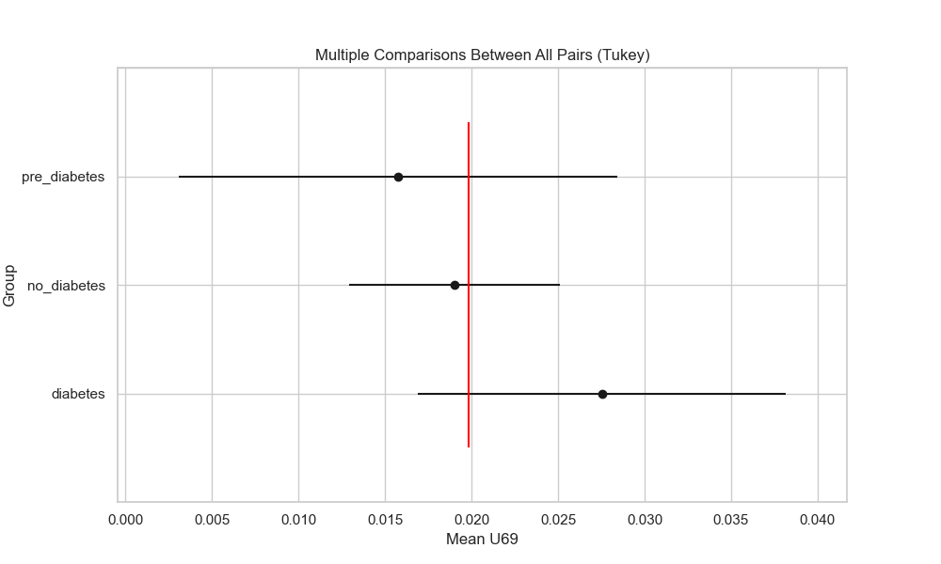

## plot_interaction_analysis

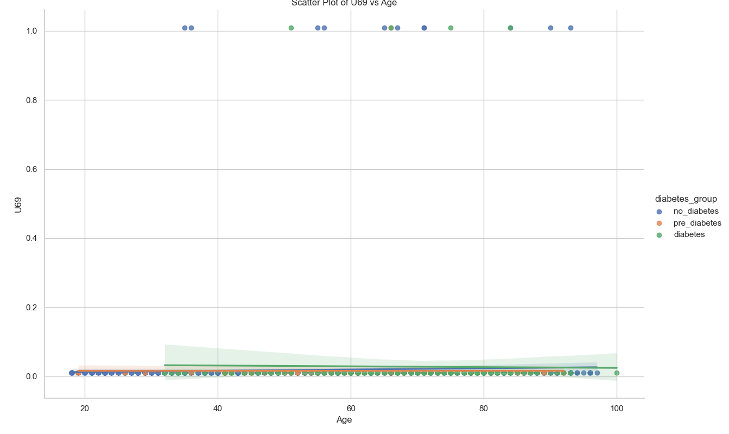

## visualize_chi_square_results

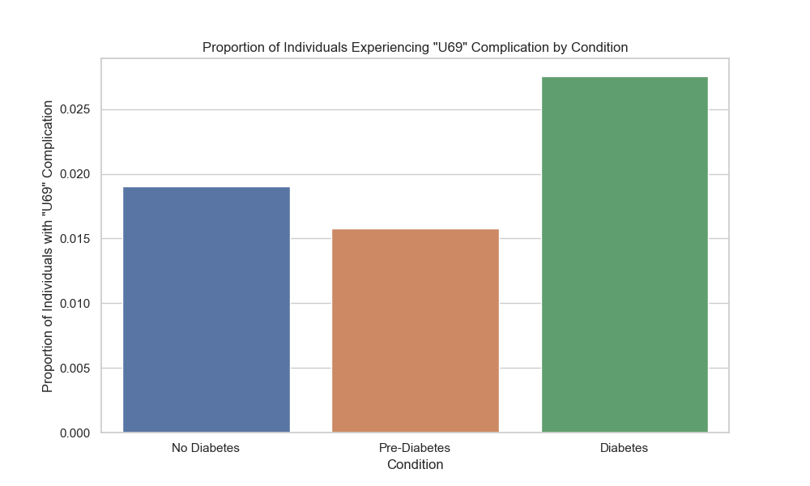

## visualize_relative_risk_results

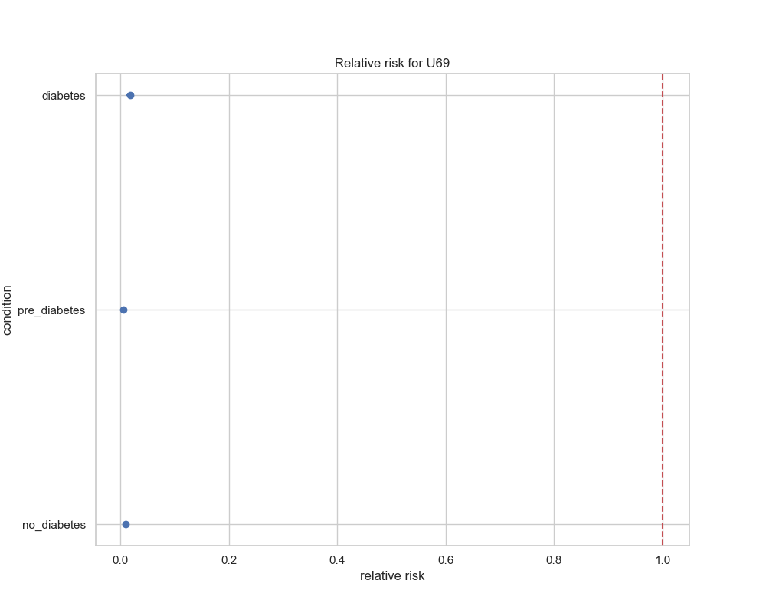

## visualize_odds_ratio_results

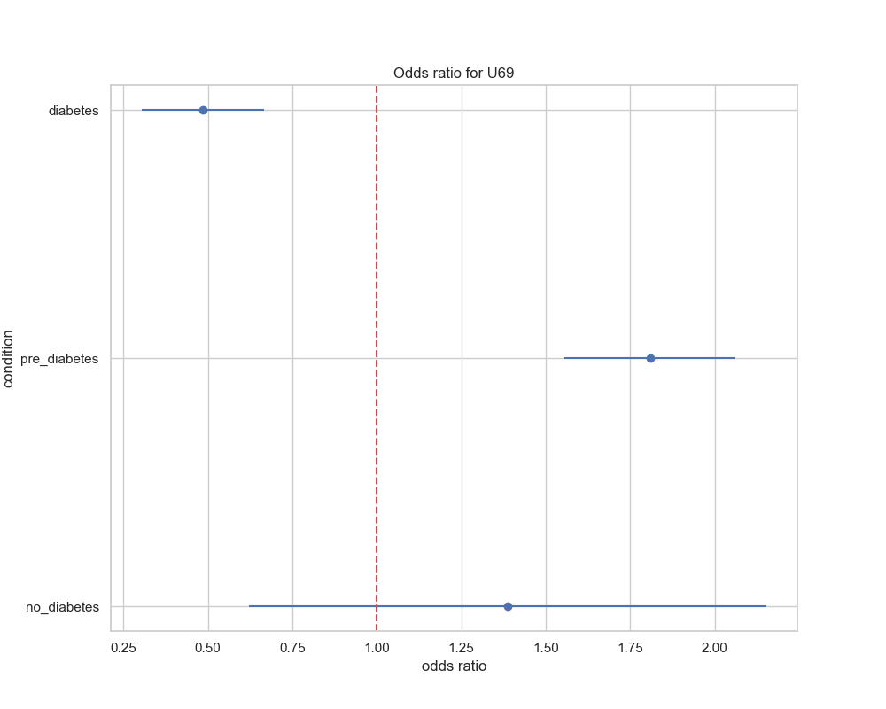

## visualize_relative_risk_by_age_results

