## one_way_anova

(4.82574790276262, 0.008115810254152204)

## t_test

t_statistic p_value  
pre_diabetes vs no_diabetes 2.022218 0.043314  
diabetes vs no_diabetes 2.725927 0.006473

## tukey_hsd

Multiple Comparison of Means - Tukey HSD, FWER=0.05   
===============================================================  
 group1 group2 meandiff p-adj lower upper reject  
---------------------------------------------------------------  
 diabetes no_diabetes -0.0323 0.0214 -0.0608 -0.0038 True  
 diabetes pre_diabetes 0.0007 0.9993 -0.046 0.0474 False  
no_diabetes pre_diabetes 0.033 0.1371 -0.0076 0.0736 False  
---------------------------------------------------------------

## covariance_analysis

sum_sq df F PR(>F)  
C(no_diabetes) 0.271295 1.0 7.245741 7.167223e-03  
C(pre_diabetes) 0.000031 1.0 0.000830 9.770127e-01  
C(diabetes) 0.000456 1.0 0.012181 9.121306e-01  
Age 0.970519 1.0 25.920568 3.897258e-07  
Residual 73.573635 1965.0 NaN NaN

## interaction_analysis

sum_sq df F PR(>F)  
C(no_diabetes) 0.008189 1.0 0.218635 6.401336e-01  
C(pre_diabetes) 0.007906 1.0 0.211072 6.459795e-01  
C(diabetes) 0.000456 1.0 0.012176 9.121458e-01  
Age 0.970519 1.0 25.911570 3.915407e-07  
C(diabetes):Age 0.011907 1.0 0.317913 5.729287e-01  
Residual 73.561727 1964.0 NaN NaN

## interaction_analysis2

dfn dfd F PR(>F)  
diabetes 1.0 1827.0 1.318136 0.251077  
pre_diabetes 1.0 1837.0 1.336032 0.247885

## chi_square_test

condition chi2 p_value dof  
0 no_diabetes 8.782065 0.003042 1  
1 pre_diabetes 1.884536 0.169819 1  
2 diabetes 5.245366 0.022005 1

## relative_risk_analysis

condition relative_risk ci p_value  
0 no_diabetes 0.033288 0.025043 1.030113e-121  
1 pre_diabetes 0.069767 0.035497 5.685542e-15  
2 diabetes 0.068966 0.043837 3.030091e-31

## odds_ratio_analysis

condition odds_ratio ci p_value  
0 no_diabetes 2.079197 1.564185 0.003453  
1 pre_diabetes 0.561294 0.285579 0.112728  
2 diabetes 0.525297 0.333900 0.024722

## relative_risk_by_age

age_group condition relative_risk p_value confidence_interval  
6 18-40 No Diabetes 0.000000 1.000000 0.000000  
7 18-40 Pre-Diabetes inf 1.000000 NaN  
8 18-40 Diabetes inf 1.000000 NaN  
3 40-60 No Diabetes 2.108232 0.387517 1.048029  
4 40-60 Pre-Diabetes 0.564202 0.461066 0.076857  
5 40-60 Diabetes 0.486735 0.299528 0.118618  
0 60+ No Diabetes 1.398959 0.217526 1.004492  
1 60+ Pre-Diabetes 0.756952 0.514446 0.368094  
2 60+ Diabetes 0.768717 0.361797 0.475810

## visualize_tukey_results

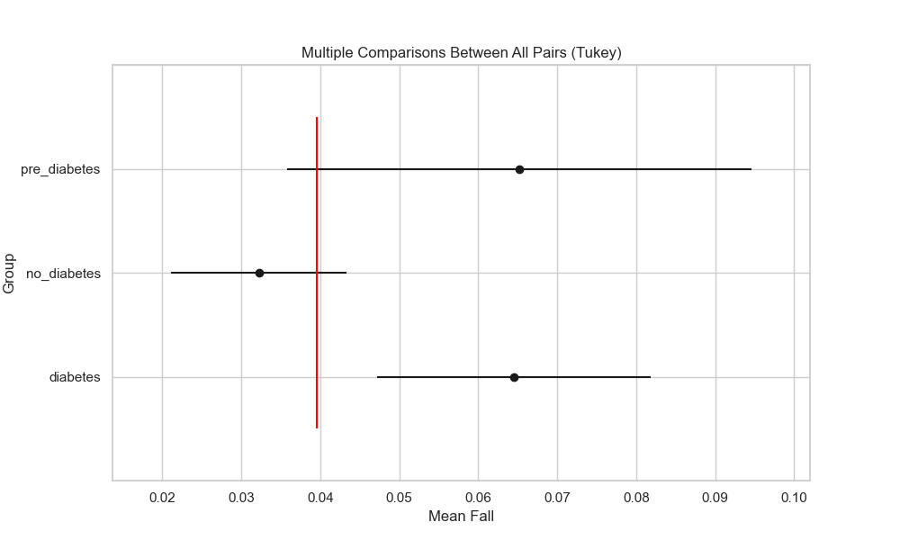

## plot_interaction_analysis

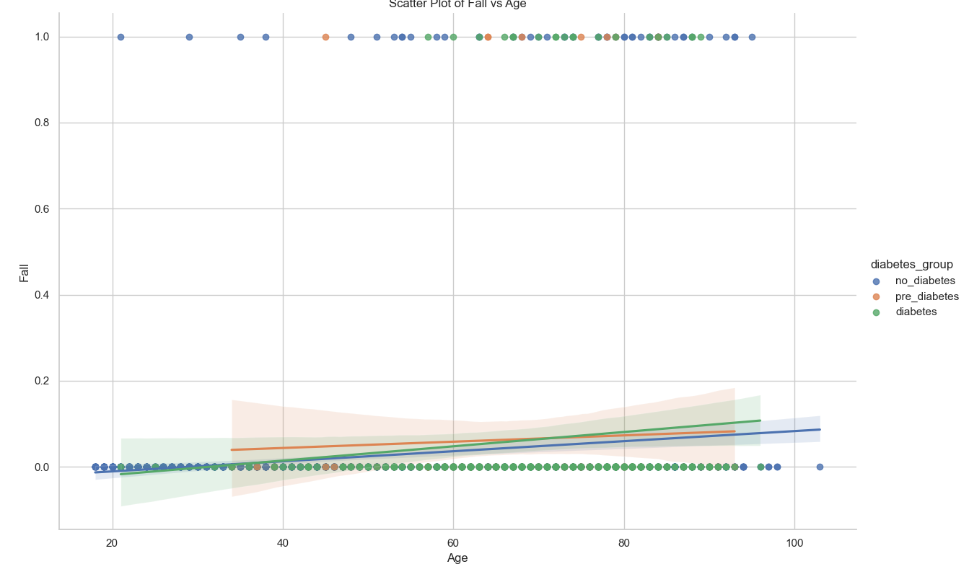

## visualize_chi_square_results

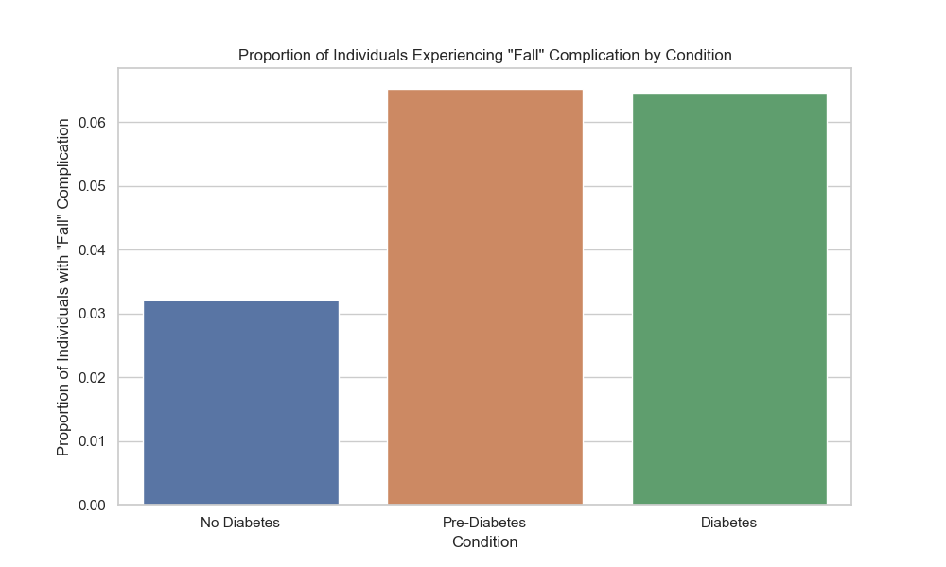

## visualize_relative_risk_results

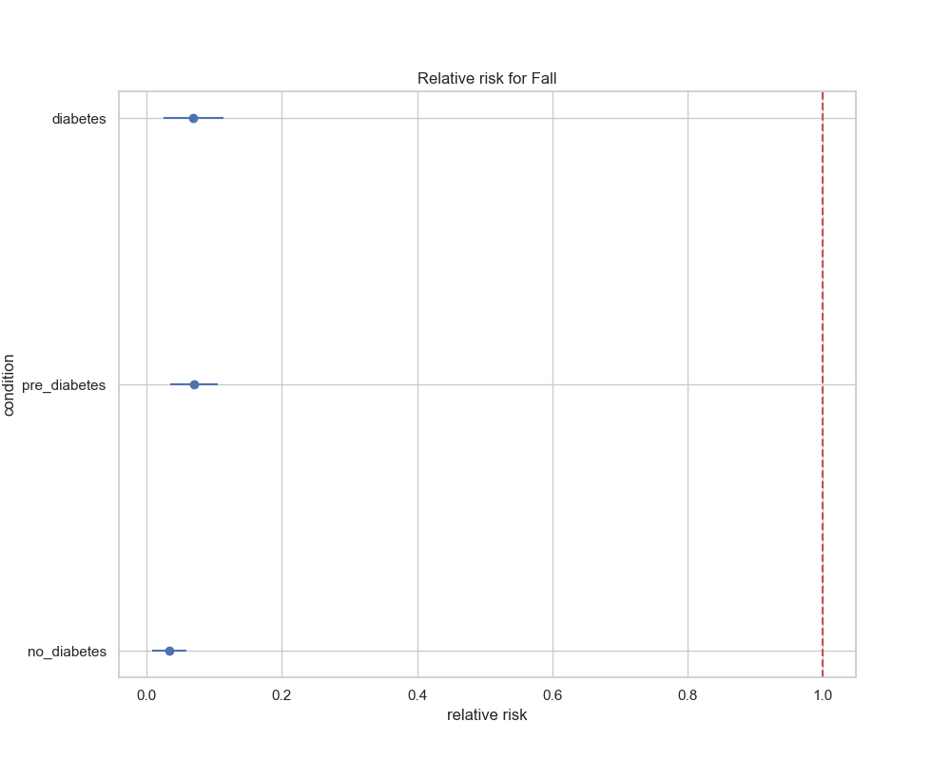

## visualize_odds_ratio_results

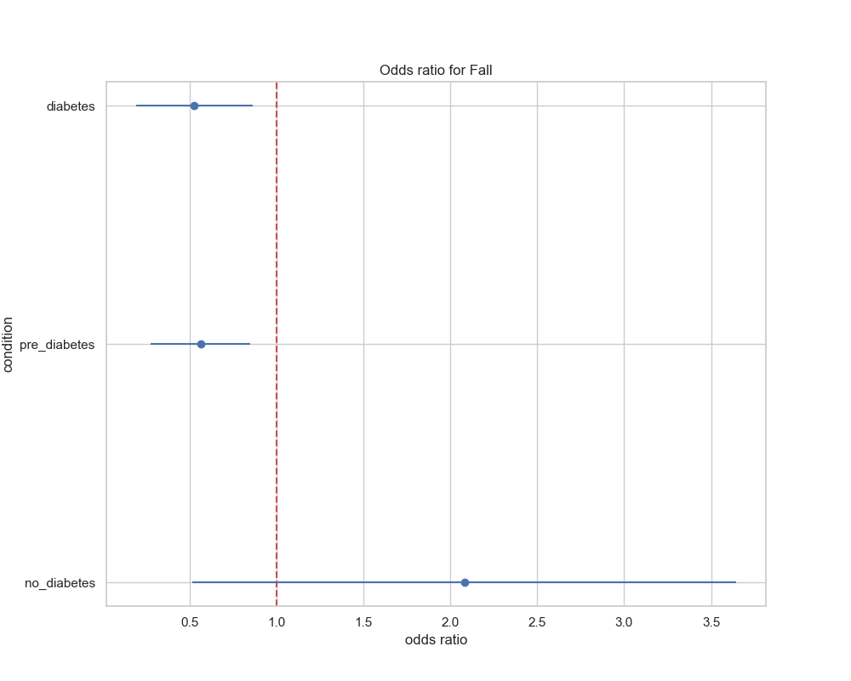

## visualize_relative_risk_by_age_results

