## one_way_anova

(1.7575940709061484, 0.1727301617005915)

## t_test

t_statistic p_value  
pre_diabetes vs no_diabetes 1.784491 0.074527  
diabetes vs no_diabetes 1.009346 0.312942

## tukey_hsd

Multiple Comparison of Means - Tukey HSD, FWER=0.05   
==============================================================  
 group1 group2 meandiff p-adj lower upper reject  
--------------------------------------------------------------  
 diabetes no_diabetes -0.0057 0.6046 -0.0196 0.0082 False  
 diabetes pre_diabetes 0.0088 0.6357 -0.014 0.0317 False  
no_diabetes pre_diabetes 0.0145 0.1999 -0.0053 0.0344 False  
--------------------------------------------------------------

## covariance_analysis

sum_sq df F PR(>F)  
C(no_diabetes) 0.023100 1.0 2.555158 0.110096  
C(pre_diabetes) 0.008246 1.0 0.912129 0.339668  
C(diabetes) 0.002338 1.0 0.258664 0.611096  
Age 0.039259 1.0 4.342621 0.037299  
Residual 17.764358 1965.0 NaN NaN

## interaction_analysis

sum_sq df F PR(>F)  
C(no_diabetes) 0.013502 1.0 1.493071 0.221887  
C(pre_diabetes) 0.000033 1.0 0.003697 0.951525  
C(diabetes) 0.002338 1.0 0.258594 0.611145  
Age 0.039259 1.0 4.341436 0.037325  
C(diabetes):Age 0.004192 1.0 0.463583 0.496035  
Residual 17.760166 1964.0 NaN NaN

## interaction_analysis2

dfn dfd F PR(>F)  
diabetes 1.0 1827.0 0.698833 0.403285  
pre_diabetes 1.0 1837.0 0.037865 0.845735

## chi_square_test

condition chi2 p_value dof  
0 no_diabetes 1.844408 0.174435 1  
1 pre_diabetes 1.319453 0.250690 1  
2 diabetes 0.187519 0.664990 1

## relative_risk_analysis

condition relative_risk ci p_value  
0 no_diabetes 0.007285 0.004026 8.716274e-60  
1 pre_diabetes 0.022222 0.007078 3.485672e-11  
2 diabetes 0.013072 0.004875 3.393778e-18

## odds_ratio_analysis

condition odds_ratio ci p_value  
0 no_diabetes 2.178932 1.204103 0.151507  
1 pre_diabetes 0.371696 0.118390 0.127001  
2 diabetes 0.651064 0.242801 0.509860

## relative_risk_by_age

age_group condition relative_risk p_value confidence_interval  
3 40-60 No Diabetes 5.626506 0.113365 1.403011  
4 40-60 Pre-Diabetes 0.053640 0.015907 0.012778  
5 40-60 Diabetes inf 1.000000 NaN  
0 60+ No Diabetes 1.083972 1.000000 0.561578  
1 60+ Pre-Diabetes 1.464789 1.000000 0.204405  
2 60+ Diabetes 0.779055 0.751827 0.290063

## visualize_tukey_results

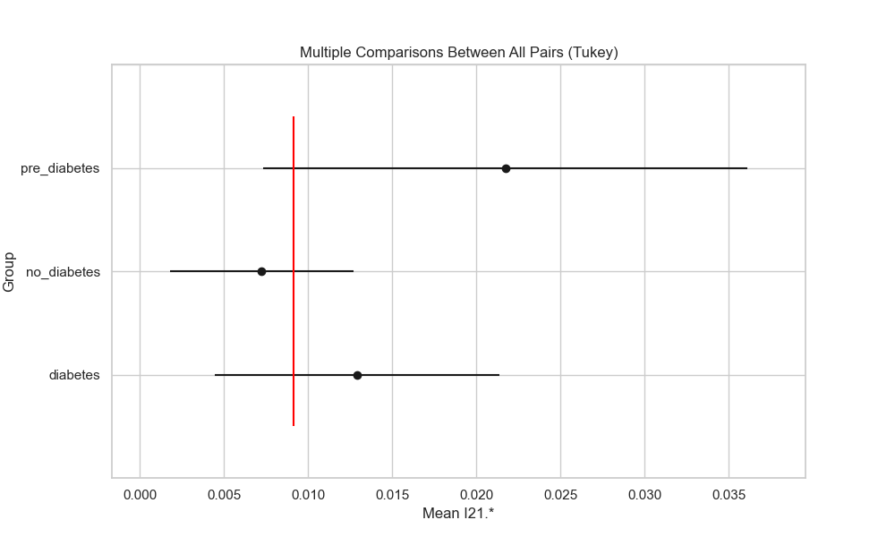

## plot_interaction_analysis

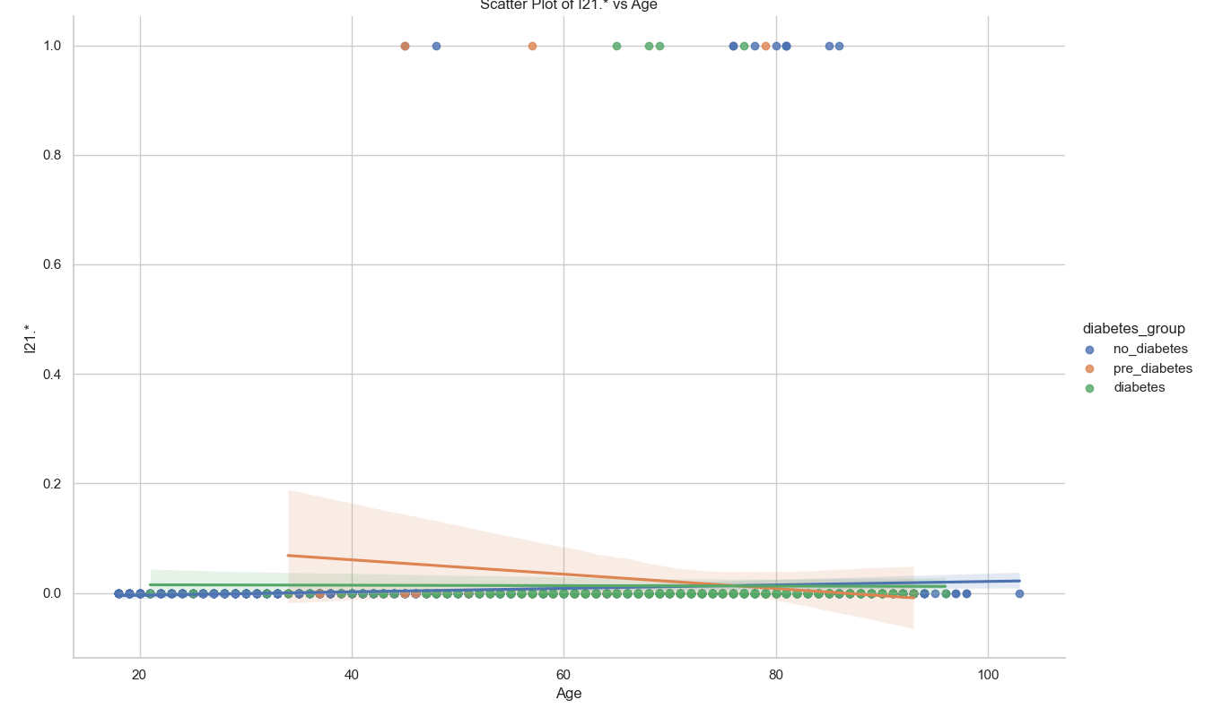

## visualize_chi_square_results

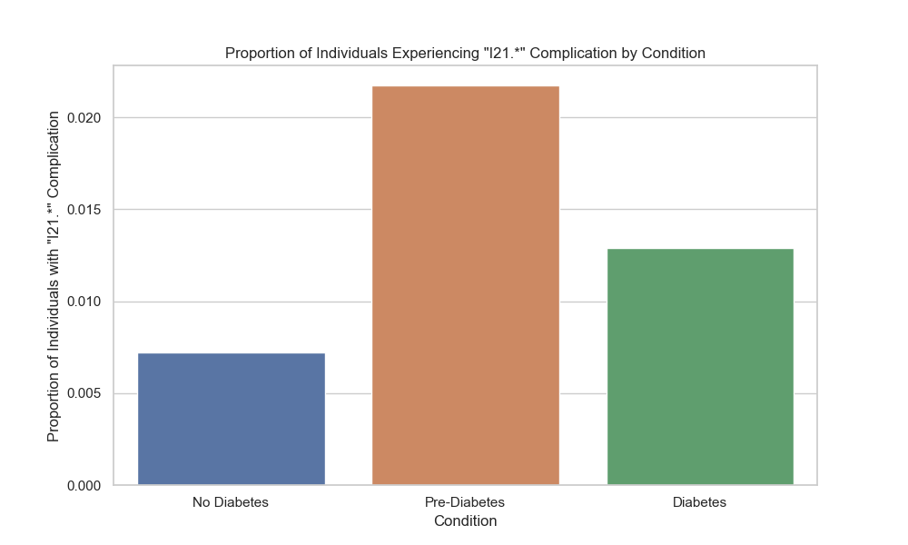

## visualize_relative_risk_results

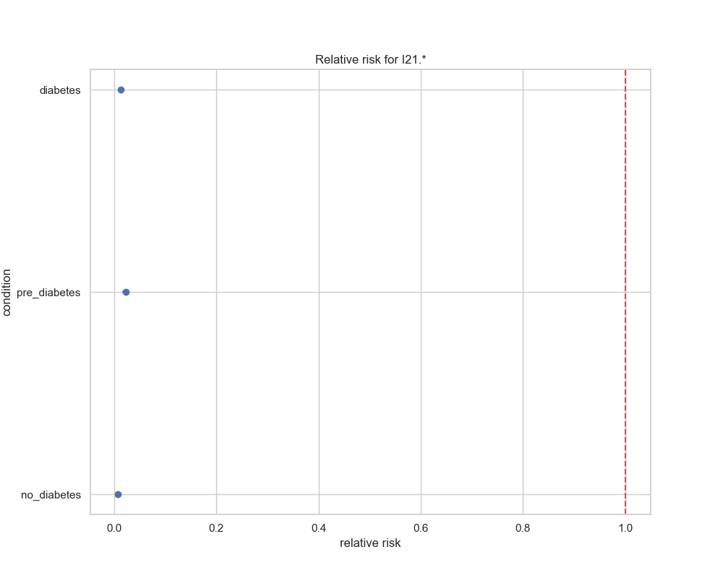

## visualize_odds_ratio_results

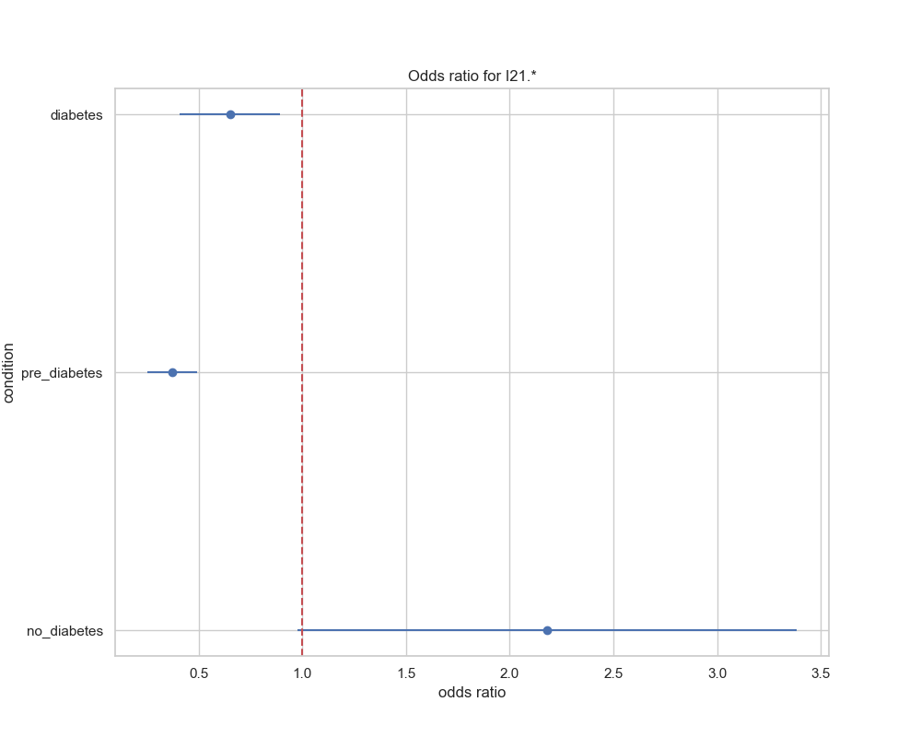

## visualize_relative_risk_by_age_results

