## one_way_anova

(86.5721391611755, 9.259718233695341e-37)

## t_test

t_statistic p_value  
pre_diabetes vs no_diabetes 12.757937 1.258457e-35  
diabetes vs no_diabetes 6.245474 5.241195e-10

## tukey_hsd

Multiple Comparison of Means - Tukey HSD, FWER=0.05   
==============================================================  
 group1 group2 meandiff p-adj lower upper reject  
--------------------------------------------------------------  
 diabetes no_diabetes -0.1505 0.0 -0.2082 -0.0928 True  
 diabetes pre_diabetes 0.2813 0.0 0.1865 0.3761 True  
no_diabetes pre_diabetes 0.4318 0.0 0.3494 0.5142 True  
--------------------------------------------------------------

## covariance_analysis

sum_sq df F PR(>F)  
C(no_diabetes) 14.630002 1.0 95.540816 4.569106e-22  
C(pre_diabetes) 14.434538 1.0 94.264342 8.452236e-22  
C(diabetes) 0.093749 1.0 0.612224 4.340459e-01  
Age 5.915543 1.0 38.631290 6.234122e-10  
Residual 300.897095 1965.0 NaN NaN

## interaction_analysis

sum_sq df F PR(>F)  
C(no_diabetes) 2.599886 1.0 16.972527 3.949902e-05  
C(pre_diabetes) 4.805437 1.0 31.370771 2.431906e-08  
C(diabetes) 0.093749 1.0 0.612009 4.341265e-01  
Age 5.915543 1.0 38.617746 6.277311e-10  
C(diabetes):Age 0.047658 1.0 0.311122 5.770561e-01  
Residual 300.849437 1964.0 NaN NaN

## interaction_analysis2

dfn dfd F PR(>F)  
diabetes 1.0 1827.0 118.820373 7.539529e-27  
pre_diabetes 1.0 1837.0 16.887620 4.140445e-05

## chi_square_test

condition chi2 p_value dof  
0 no_diabetes 113.410717 1.754044e-26 1  
1 pre_diabetes 122.580339 1.722955e-28 1  
2 diabetes 19.558994 9.754045e-06 1

## relative_risk_analysis

condition relative_risk ci p_value  
0 no_diabetes 0.193878 0.169180 2.080494e-123  
1 pre_diabetes 1.464286 1.042473 1.390660e-02  
2 diabetes 0.455399 0.358201 6.745662e-11

## odds_ratio_analysis

condition odds_ratio ci p_value  
0 no_diabetes 3.432205 2.994986 2.827400e-24  
1 pre_diabetes 0.157987 0.112476 1.023375e-23  
2 diabetes 0.543190 0.427255 1.643965e-05

## relative_risk_by_age

age_group condition relative_risk p_value confidence_interval  
6 18-40 No Diabetes 1.333333 5.584261e-01 0.906793  
7 18-40 Pre-Diabetes inf 1.000000e+00 NaN  
8 18-40 Diabetes 0.495575 4.343373e-01 0.059663  
3 40-60 No Diabetes 2.855407 1.089806e-04 2.221443  
4 40-60 Pre-Diabetes 0.145989 1.232623e-06 0.070910  
5 40-60 Diabetes 0.777846 4.636832e-01 0.410198  
0 60+ No Diabetes 2.688042 3.795673e-12 2.240085  
1 60+ Pre-Diabetes 0.201637 4.108963e-14 0.135992  
2 60+ Diabetes 0.712401 3.582389e-02 0.547667

## visualize_tukey_results

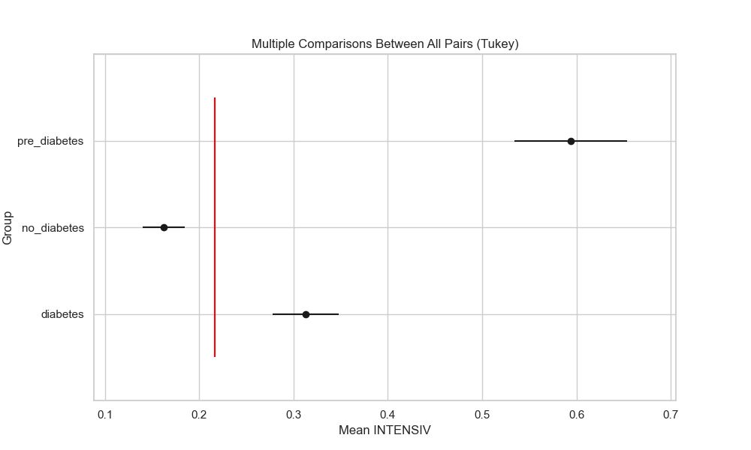

## plot_interaction_analysis

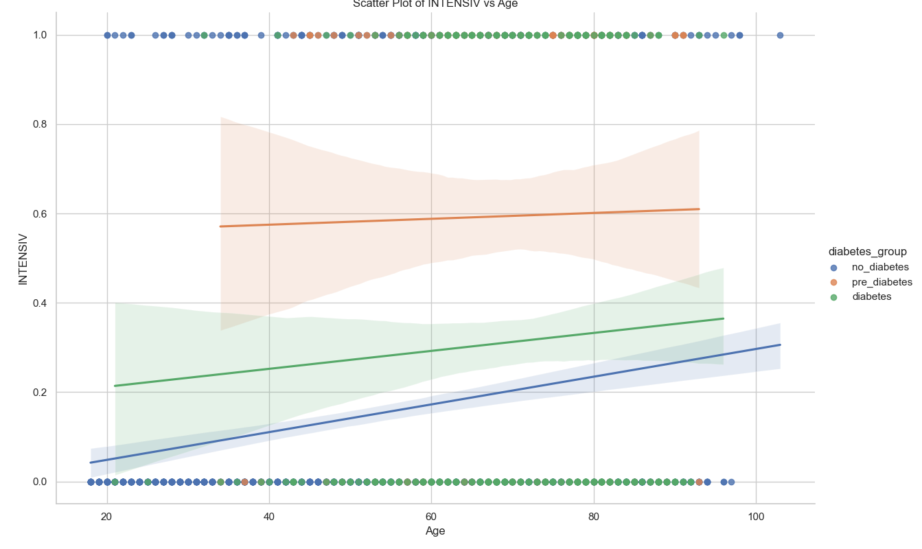

## visualize_chi_square_results

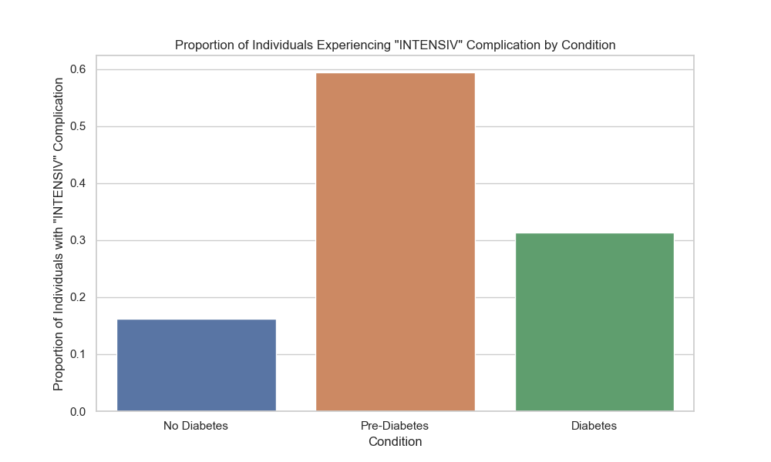

## visualize_relative_risk_results

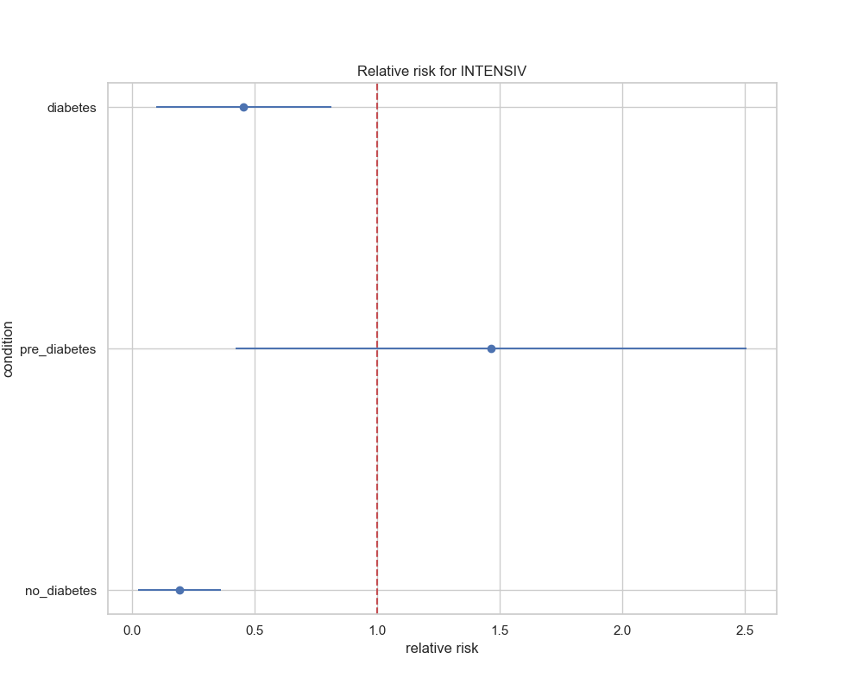

## visualize_odds_ratio_results

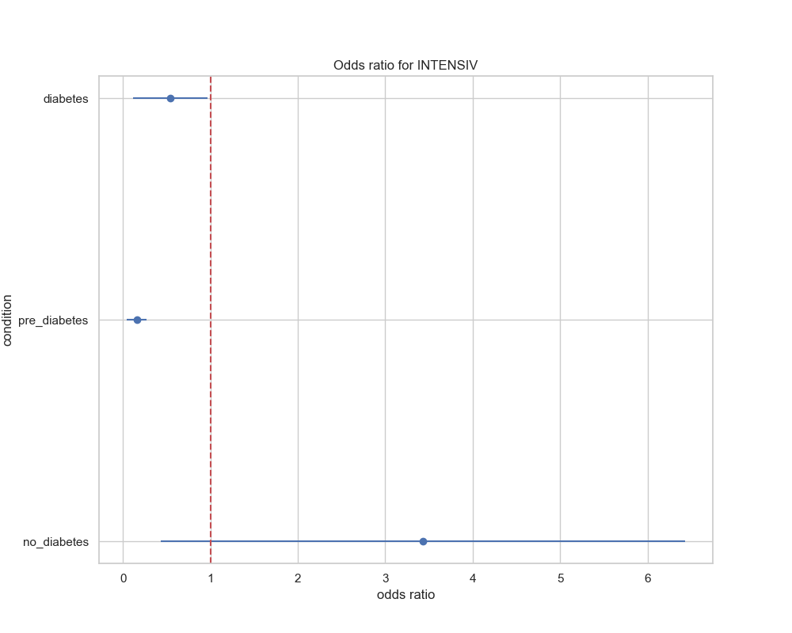

## visualize_relative_risk_by_age_results

