## one_way_anova

(6.971915634681189, 0.0009612194624364825)

## t_test

t_statistic p_value  
pre_diabetes vs no_diabetes 1.960218 0.050138  
diabetes vs no_diabetes 3.412616 0.000657

## tukey_hsd

Multiple Comparison of Means - Tukey HSD, FWER=0.05   
===============================================================  
 group1 group2 meandiff p-adj lower upper reject  
---------------------------------------------------------------  
 diabetes no_diabetes -2.1231 0.0018 -3.5758 -0.6705 True  
 diabetes pre_diabetes -0.4649 0.8912 -2.8503 1.9206 False  
no_diabetes pre_diabetes 1.6582 0.1457 -0.4141 3.7306 False  
---------------------------------------------------------------

## covariance_analysis

sum_sq df F PR(>F)  
C(no_diabetes) 1369.748629 1.0 13.958758 1.921967e-04  
C(pre_diabetes) 1090.330705 1.0 11.111281 8.739724e-04  
C(diabetes) 2555.044820 1.0 26.037808 3.670537e-07  
Age 1365.798990 1.0 13.918508 1.963265e-04  
Residual 192822.030289 1965.0 NaN NaN

## interaction_analysis

sum_sq df F PR(>F)  
C(no_diabetes) 67.434382 1.0 0.686978 4.072948e-01  
C(pre_diabetes) 254.953155 1.0 2.597299 1.072067e-01  
C(diabetes) 2555.044820 1.0 26.029157 3.686976e-07  
Age 1365.798990 1.0 13.913884 1.968095e-04  
C(diabetes):Age 34.070902 1.0 0.347092 5.558314e-01  
Residual 192787.959387 1964.0 NaN NaN

## interaction_analysis2

dfn dfd F PR(>F)  
diabetes 1.0 1827.0 0.533876 0.465075  
pre_diabetes 1.0 1837.0 2.156656 0.142125

## chi_square_test

condition chi2 p_value dof  
0 no_diabetes 88.129727 0.016262 62  
1 pre_diabetes 72.794754 0.164202 62  
2 diabetes 76.744911 0.098440 62

## relative_risk_analysis

condition relative_risk ci p_value  
0 no_diabetes 1.013636 0.841389 0.443329  
1 pre_diabetes 1.222222 0.506481 0.327631  
2 diabetes 1.576923 0.964744 0.034624

## odds_ratio_analysis

condition odds_ratio ci p_value  
0 no_diabetes 1.562437 1.412080 0.000041  
1 pre_diabetes 0.559216 0.397725 0.001377  
2 diabetes 0.735729 0.588608 0.015501

## relative_risk_by_age

age_group condition relative_risk p_value confidence_interval  
6 18-40 No Diabetes 0.893462 1.000000 0.717395  
7 18-40 Pre-Diabetes 0.956175 1.000000 0.086703  
8 18-40 Diabetes 1.199597 1.000000 0.232739  
3 40-60 No Diabetes 1.744865 0.023910 1.453073  
4 40-60 Pre-Diabetes 0.275778 0.002005 0.122781  
5 40-60 Diabetes 0.893918 0.775392 0.526506  
0 60+ No Diabetes 1.184561 0.212791 1.020048  
1 60+ Pre-Diabetes 0.831081 0.409930 0.564656  
2 60+ Diabetes 0.889526 0.466115 0.692559

## visualize_tukey_results

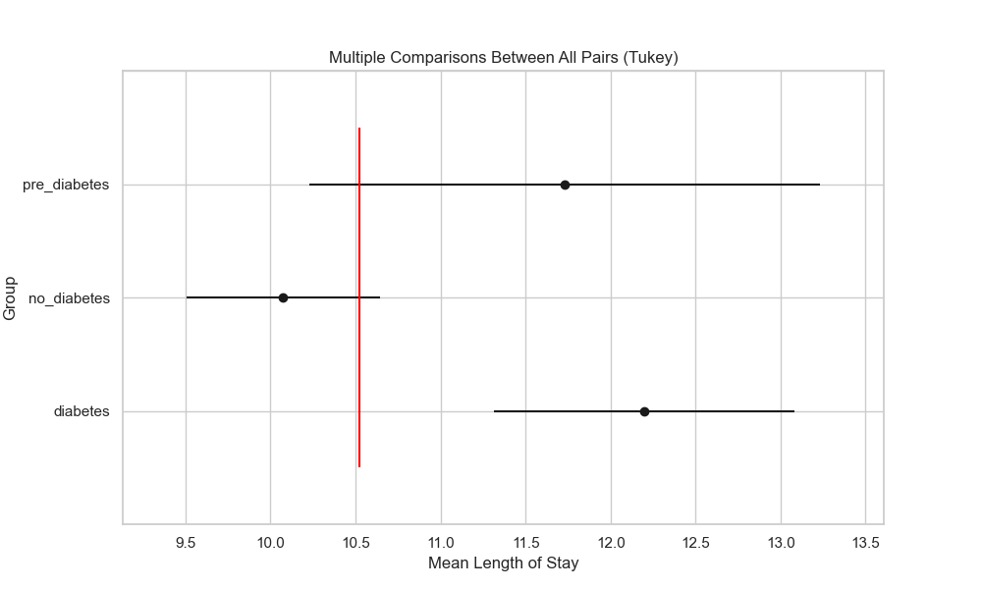

## plot_interaction_analysis

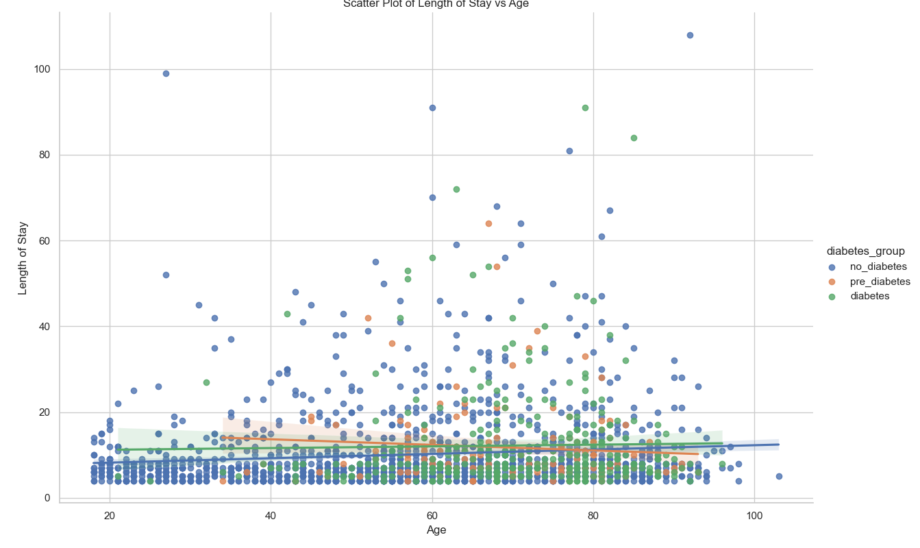

## visualize_chi_square_results

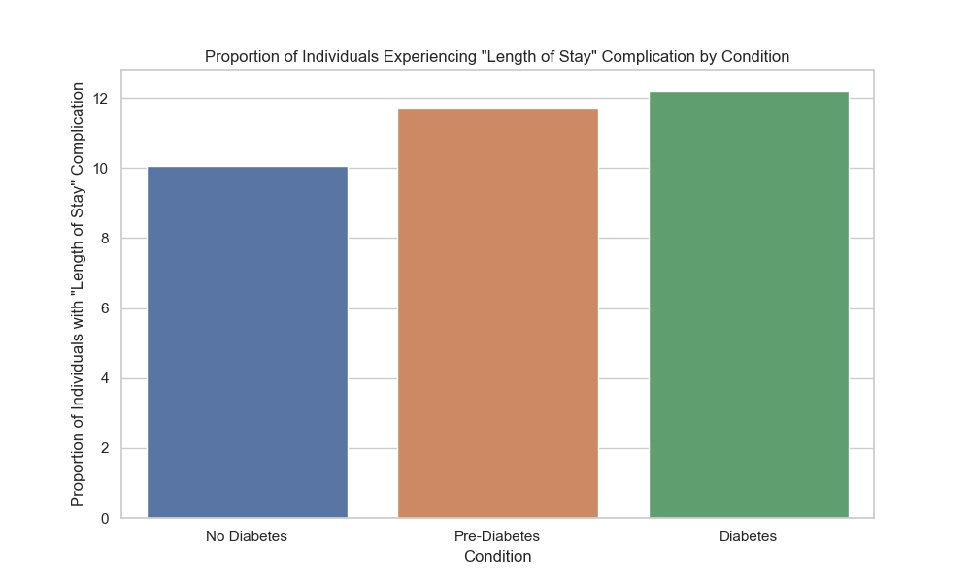

## visualize_relative_risk_results

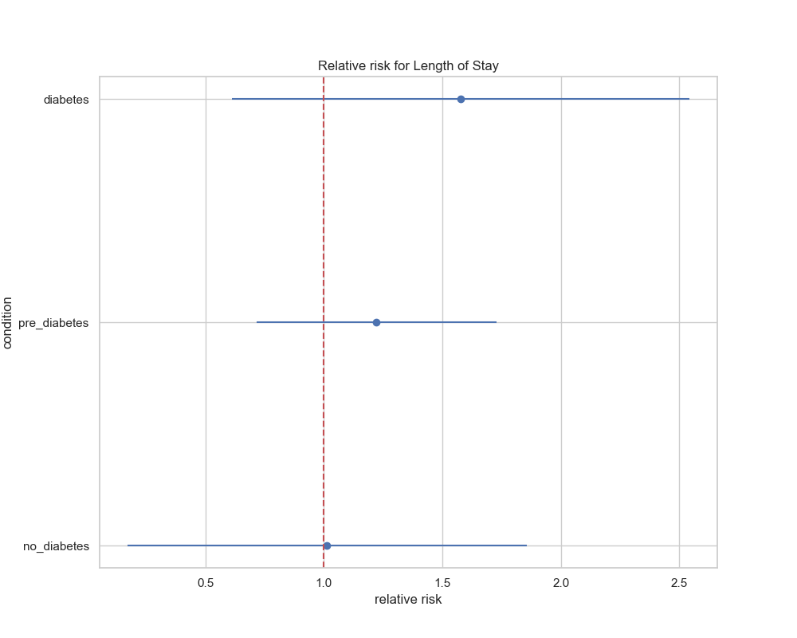

## visualize_odds_ratio_results

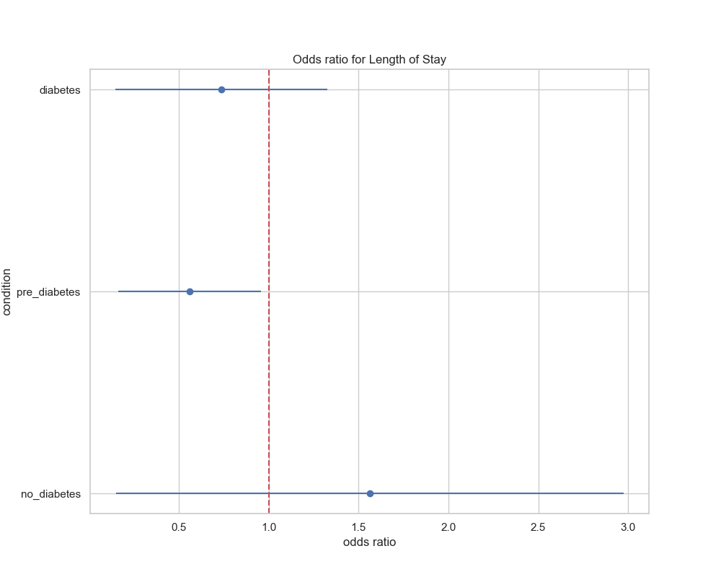

## visualize_relative_risk_by_age_results

