## one_way_anova

(1.0900729620782101, 0.336395070684971)

## t_test

t_statistic p_value  
pre_diabetes vs no_diabetes -1.044784 0.296275  
diabetes vs no_diabetes 0.923357 0.355943

## tukey_hsd

Multiple Comparison of Means - Tukey HSD, FWER=0.05   
==============================================================  
 group1 group2 meandiff p-adj lower upper reject  
--------------------------------------------------------------  
 diabetes no_diabetes -0.0126 0.617 -0.0443 0.019 False  
 diabetes pre_diabetes -0.0323 0.3114 -0.0843 0.0197 False  
no_diabetes pre_diabetes -0.0197 0.5631 -0.0648 0.0255 False  
--------------------------------------------------------------

## covariance_analysis

sum_sq df F PR(>F)  
C(no_diabetes) 0.085044 1.0 1.818201 0.177683  
C(pre_diabetes) 0.058845 1.0 1.258067 0.262154  
C(diabetes) 0.074727 1.0 1.597633 0.206389  
Age 0.208630 1.0 4.460388 0.034816  
Residual 91.910649 1965.0 NaN NaN

## interaction_analysis

sum_sq df F PR(>F)  
C(no_diabetes) 0.020477 1.0 0.437921 0.508205  
C(pre_diabetes) 0.130993 1.0 2.801348 0.094344  
C(diabetes) 0.074727 1.0 1.598083 0.206325  
Age 0.208630 1.0 4.461645 0.034790  
C(diabetes):Age 0.072646 1.0 1.553568 0.212758  
Residual 91.838003 1964.0 NaN NaN

## interaction_analysis2

dfn dfd F PR(>F)  
diabetes 1.0 1827.0 1.663787 0.197256  
pre_diabetes 1.0 1837.0 0.313942 0.575340

## chi_square_test

condition chi2 p_value dof  
0 no_diabetes 0.011403 0.914960 1  
1 pre_diabetes 0.878889 0.348506 1  
2 diabetes 0.851915 0.356011 1

## relative_risk_analysis

condition relative_risk ci p_value  
0 no_diabetes 0.051140 0.040487 1.169488e-137  
1 pre_diabetes 0.029851 0.011042 2.249332e-12  
2 diabetes 0.065292 0.041049 4.955976e-31

## odds_ratio_analysis

condition odds_ratio ci p_value  
0 no_diabetes 1.058219 0.837774 0.804386  
1 pre_diabetes 1.792578 0.663089 0.311747  
2 diabetes 0.755618 0.475060 0.315589

## relative_risk_by_age

age_group condition relative_risk p_value confidence_interval  
6 18-40 No Diabetes 0.000000 1.000000 0.000000  
7 18-40 Pre-Diabetes inf 1.000000 NaN  
8 18-40 Diabetes inf 1.000000 NaN  
3 40-60 No Diabetes 1.348861 0.605873 0.901570  
4 40-60 Pre-Diabetes inf 0.401026 NaN  
5 40-60 Diabetes 0.430731 0.110808 0.184520  
0 60+ No Diabetes 0.798418 0.479169 0.582301  
1 60+ Pre-Diabetes 1.545918 0.506545 0.569167  
2 60+ Diabetes 1.087515 0.875009 0.622175

## visualize_tukey_results

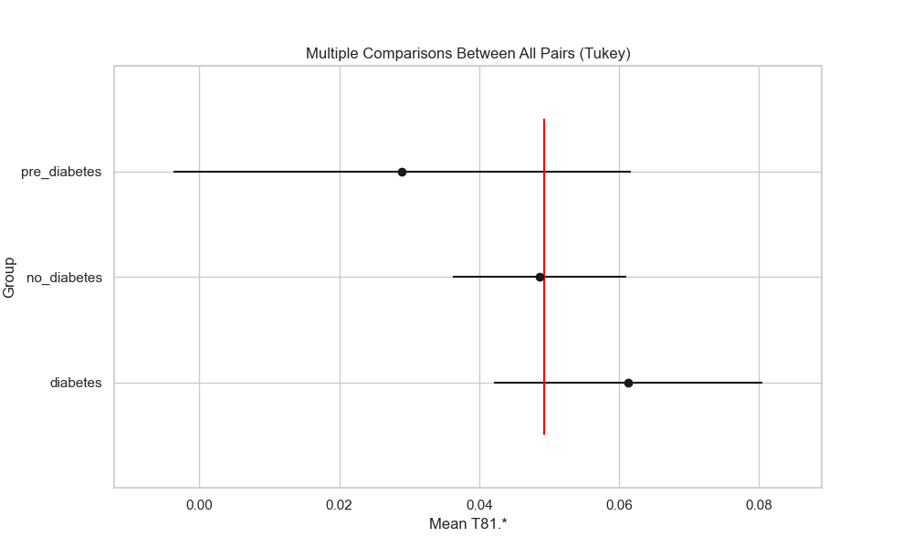

## plot_interaction_analysis

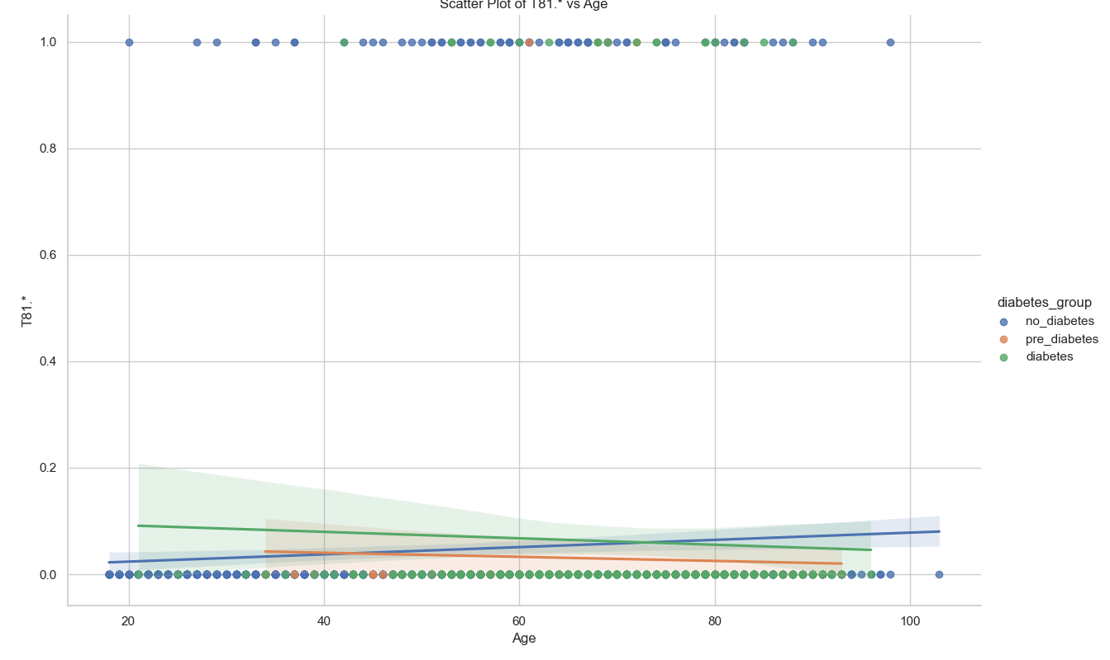

## visualize_chi_square_results

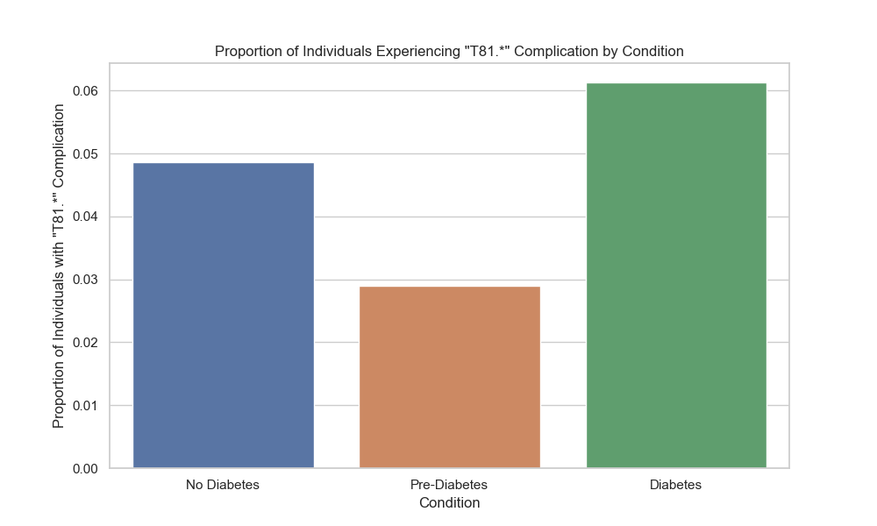

## visualize_relative_risk_results

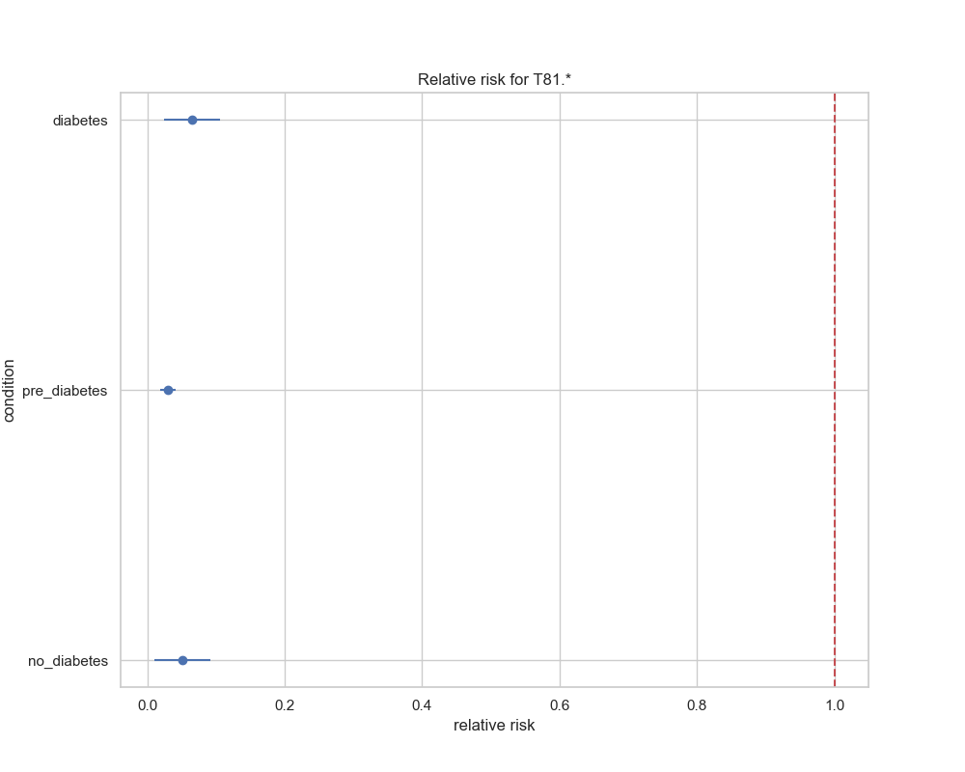

## visualize_odds_ratio_results

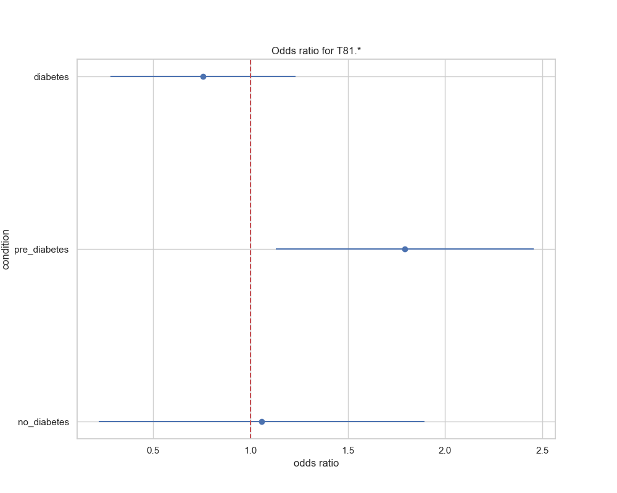

## visualize_relative_risk_by_age_results

