GATE 0 - PROJECT SYNOPSIS
Themes 1-5 | System / Tool / Engine based Mini Projects

Expected length: about 4 pages + cover page
Team No. | 11
Theme No. | Network system and tools
Project Title | DNS resolver and caching server
Guide Name | Mr.Pavankumar s
Team Members | 1.Vageesh Mathad  2. Mehak Sayed Yusuf  3. Joel Biju  4. Ishani

Student Preparation Instruction
This synopsis is intended to demonstrate the team's own understanding of the proposed project. Students should study the project, discuss within the team, consult relevant textbooks/technical resources, and prepare the content in their own words. AI tools shall not be used to generate the contents of this document.
At Gate 0, do NOT finalize: detailed functional/non-functional requirements, architecture/modules, algorithms/data structures, APIs, technology stack, alternate designs, detailed KPIs or test cases.

1. Background & Motivation
Briefly describe the proposed system/tool/engine, its purpose, broad functionalities/computational capabilities, and why developing it is technically meaningful as a Mini Project. Highlight opportunities to apply and integrate foundational Computer Science concepts.
DNS (Domain Name System) is a fundamental network service that translates domain names into their corresponding IP addresses, allowing clients to locate network services using human-readable domain names.
A DNS Resolver receives DNS queries from clients and performs domain-name resolution when a valid result is not already available. Repeated queries for the same domain may result in repeated external DNS resolution, additional network communication, and increased response time.
The proposed DNS Resolver and Caching Server provides a controlled system for studying DNS query handling, domain-name resolution, caching of valid resolution results, and response behaviour. Valid DNS results can be temporarily stored and reused for subsequent requests while they remain valid.
The project is technically meaningful as a Network System and Tools mini project because it integrates Computer Networks concepts such as DNS, client-server communication, request-response interaction and UDP communication with supporting concepts from Operating Systems, Design and Analysis of Algorithms, and Database Management Systems. It provides an opportunity to understand how DNS resolution and caching interact during repeated queries while keeping the scope suitable for a 3-credit academic mini project.

2. Project Objectives
State 3-5 broad engineering objectives. Describe what the team intends to develop or study. Do not prematurely prescribe architecture, algorithms, data structures, APIs or implementation mechanisms.
- To develop a functional DNS resolver capable of processing client DNS queries and providing appropriate responses.
- To develop DNS caching functionality for storing and reusing valid domain-resolution information for subsequent requests.
- To study the impact of caching on DNS response time, resolution efficiency, and reduction of repeated resolution requests.
- To handle different DNS query conditions, including repeated, invalid, and unsuccessful DNS requests.
- To evaluate the overall performance of the proposed system based on DNS query handling, caching effectiveness, and response efficiency.

3. Foundation Course Integration
Identify at least three foundational courses that are expected to contribute meaningful technical depth. Mention only broad concepts/areas at this stage.
Sl. No. | Foundation Course | Broad Concepts / Areas Expected to be Applied | Role
1 | Computer Networks | Client-server communication  Network communication  Request-response model  DNS query and response  UDP communication  DNS resolution | Dominant
2 | Operating System Principles and Programming | System-level programming • Request handling • Resource management • Handling multiple DNS requests | Supporting
3 | Design and Analysis of Algorithms (DAA) | Efficient data organization  Searching and lookup  Time and space considerations  Performance analysis  Cache effectiveness | Supporting
4 | Database Management Systems (DBMS) | Data storage  Data retrieval  Data organization  Consistency of cached information | Supporting

4. Conceptual Workflow / System View
Draw one high-level block/workflow diagram showing the broad functional flow or major interactions in the proposed artefact. 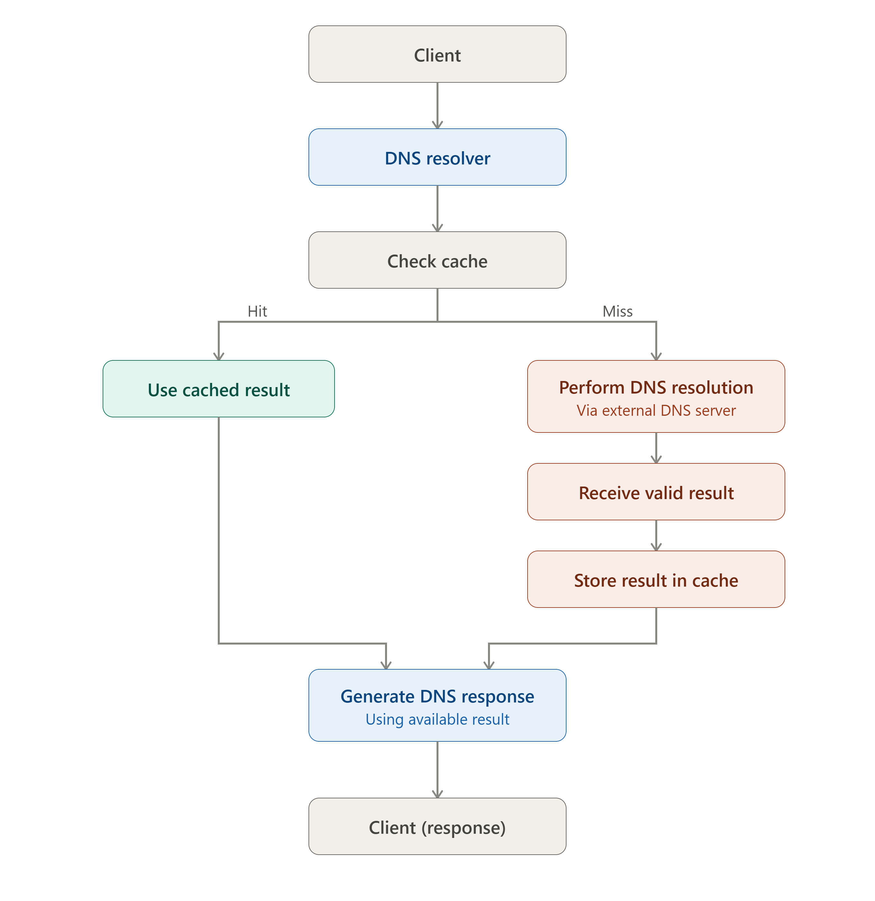
SCOPE & FEASIBILITY
Gate 0 - Themes 1-5
5. Broad Project Scope
Define the tentative technical boundary of the project. Detailed requirements will be derived later in S1.
5.1 Broadly In Scope
# | Broad In-Scope Item
1
  DNS Resolver: Development of a DNS resolver that accepts DNS queries from clients and performs domain-name resolution.
2 | DNS Caching Server: Development of caching functionality to temporarily store and reuse valid DNS resolution results for subsequent queries.
3 | DNS Monitoring and Performance Evaluation: Observation of DNS query activity and evaluation of resolution and caching behaviour using measures such as response time and cache effectiveness.

5.2 Out of Scope
# | Out-of-Scope Item | Reason
1 |  | Designing for global-scale traffic, distributed deployment, and enterprise-level availability
  Large-scale distributed DNS infrastructure
2 | Advanced DNS security and threat detection | Security analysis and threat detection are beyond the core objective of DNS resolution and caching and would substantially increase the project scope.
3 | Authoritative DNS services and domain hosting | The project focuses on DNS resolution and caching rather than hosting and managing authoritative domain records.

6. Feasibility & Constraints
Briefly assess whether the proposed scope is achievable as a 3-credit Mini Project. Identify required resources, prerequisite knowledge and major constraints. Existing libraries/tools may support peripheral functionality but should not completely hide the core mechanisms students are expected to design, implement and study.
Feasibility within 3-credit scope | Focusing on core DNS resolution, caching, query handling, and performance evaluation rather than large-scale DNS infrastructure or advanced security features.
Required computing / resources | Standard laptops/computers, network/Internet connectivity, and a suitable development and testing environment.
Prerequisite knowledge | Computer Networks, programming fundamentals, Operating System concepts and Design and Analysis of Algorithms (DAA).
Major constraints / limitations | Complexity of DNS query and response handling; variability of DNS responses and cache validity; and the need for reliable testing under different network and query conditions.
Use of existing libraries / tools | Existing libraries and tools may be used for supporting DNS communication, testing, debugging, and other peripheral functionalities. The team will independently design and implement the core DNS resolution and caching mechanisms to ensure meaningful understanding and application of networking concepts.
Overall feasibility | Feasible
INITIAL PROJECT RISKS & FACULTY REVIEW
Gate 0 - Themes 1-5

7. Initial Project Risks
Identify 2-3 major risks that may affect completion of the project and briefly state how the team plans to address them. These are initial risks and may be revised as the project evolves.
Sl. No. | Possible Risk | How will you address it?
1 | Incorrect DNS query/response handling | Study DNS message and resolution behaviour carefully and test the resolver with different domain queries and response conditions.
2 | Cache inconsistency or incorrect cached responses | Define and test cache validity, including cache hits, misses, and expiration, to ensure that only valid information is reused.
3 | Poor performance under multiple DNS requests | Test the system with different query loads and evaluate response time and caching effectiveness, then refine the implementation based on the results.
. Gate 0 - Faculty Review
☐ Technical motivation and objectives are clear.
☐ At least three foundation courses show potential for meaningful technical depth.
☐ Conceptual workflow/system view clearly communicates the proposed artefact.
☐ Broad scope is appropriate for a 3-credit Mini Project.
☐ Core mechanisms can be designed/implemented rather than fully hidden by ready-made tools.
☐ Feasibility, constraints and initial risks are reasonably identified.
Decision: ☐ Approved ☐ Approved with Modifications ☐ Resubmit
Faculty Remarks:
________________________________________________________________________________
________________________________________________________________________________
________________________________________________________________________________
Guide Signature: ____________________________ Date: __________________

