**A Project Report on**

**AUTOMATIC ATTENDANCE TRACING USING IMAGE PROCESSING IN PYTHON**

**Submitted in partial fulfillment of the requirements for the award of the Degree of**

**Bachelor of Technology**

**in**

**Electronics and Communication Engineering**

**By**

**P. MEHAR SRINIVAS CHOWDARI 19A91A0437**

**R. SURESH 19A91A0442**

**N. ADITHYA 19A91A0431**

## Under the Esteemed Supervision of

## Mr. A. Kondababu M.Tech., (Ph.D).

## Associate Professor



**Department of Electronics and Communication Engineering**

**ADITYA ENGINEERING COLLEGE**

**(An Autonomous Institution)**

(Approved by AICTE, New Delhi, Affiliated to JNTUK Kakinada, Accredited by NAAC with ‘A’ Grade)

Aditya Nagar, ADB Road, Surampalem

**2019 – 2023**

**ADITYA ENGINEERING COLLEGE**

**(An Autonomous Institution)**

(Approved by AICTE, New Delhi, Affiliated to JNTUK Kakinada, Accredited by NAAC with ‘A’ Grade)

Aditya Nagar, ADB Road, Surampalem

**2019 – 2023**

**Department of Electronics and Communication Engineering**



**CERTIFICATE**

This is to certify that the thesis entitled “**Automatic Attendance Tracing using Image Processing in Python”** is being submitted by

**P. MEHAR SRINIVAS CHOWDARI 19A91A0437**

**R. SURESH 19A91A0442**

**N. ADITHYA 19A91A0431**

in partial fulfillment of the requirements for the award of degree of B**.Tech** in Electronics and Communication Engineering from **Jawaharlal Nehru Technological University Kakinada** is a record of bonafide work carried out by them at Aditya Engineering College.

The results embodied in this Project report have not been submitted to any other University or Institute for the award of any degree or diploma.

**PROJECT GUIDE HEAD OF THE DEPARTMENT**

**Mr. A. Kondababu M.Tech., (Ph.D). Dr. N. Radha M.Tech., Ph.D.**

**Associate Professor Professor & HOD**

**ACKNOWLEDGEMENT**

We take great pleasure to express our deep sense of gratitude to our project guide **Mr. A. Kondababu,** Associate Professor, for his valuable guidance during the course of our project work.

We would like to thank **Dr. N. Radha** Head of the Department of Electronics and Communication Engineering for her encouragement.

We would like to express our heart-felt thanks to **Dr. M. Sreenevasa Reddy,** Principal, Aditya Engineering College, Surampalem for providing all the facilities for our project.

Our utmost thanks to all the Faculty members and Non Teaching Staff of the Department of Electronics and Communication Engineering for their support throughout our project work.

Our Family Members and Friends receive our deepest gratitude and love for their support throughout our academic year.

**P. MEHAR SRINIVAS CHOWDARI 19A91A0437**

**R. SURESH 19A91A0442**

**N. ADITHYA 19A91A0431**

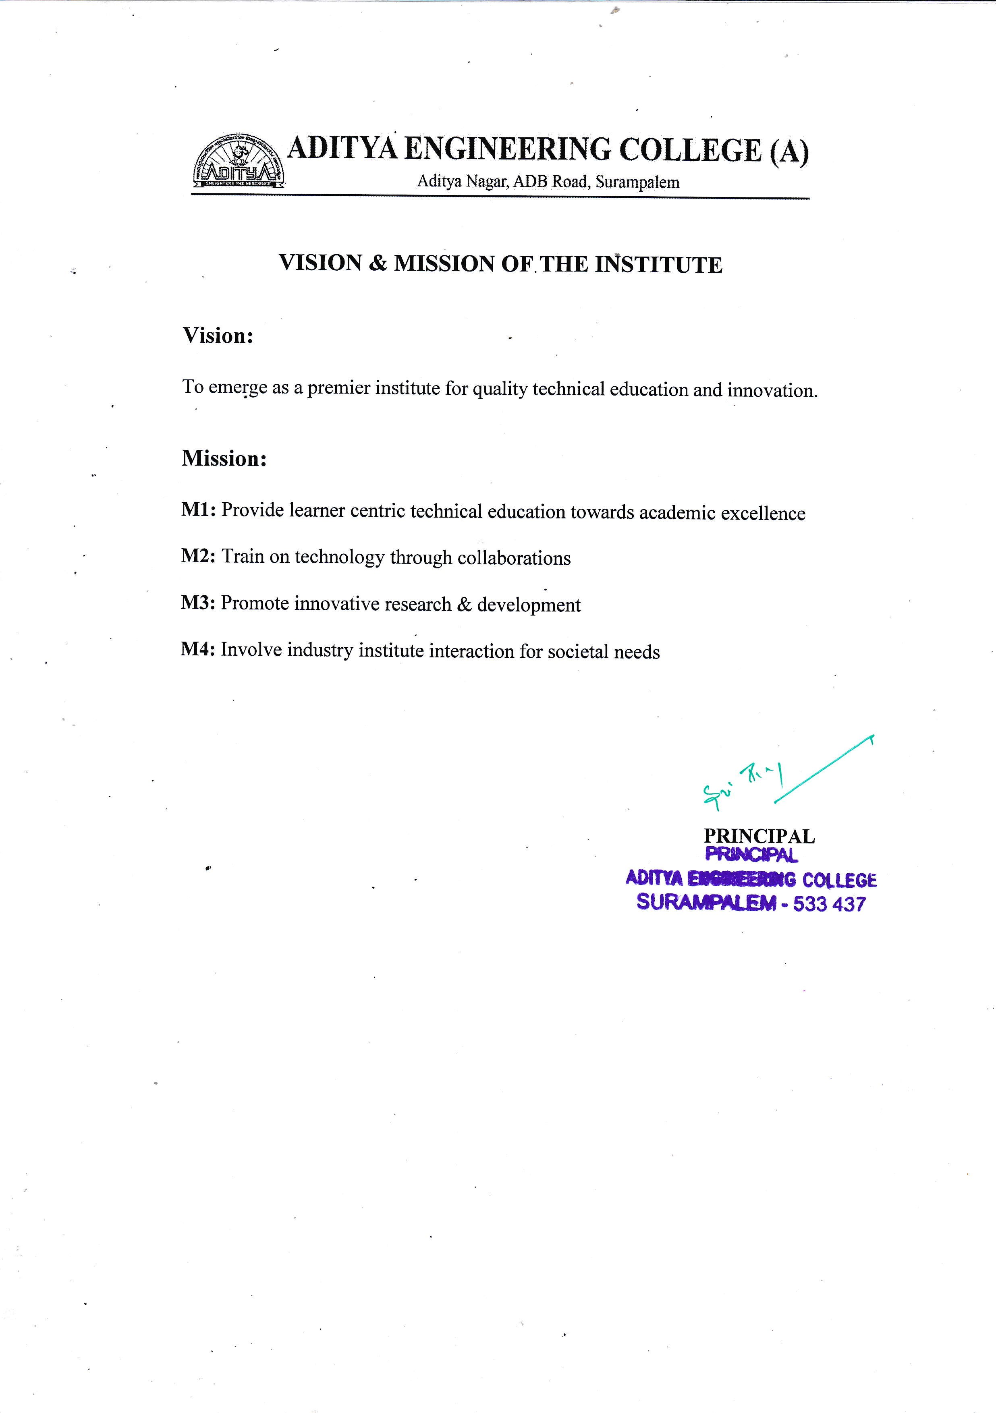

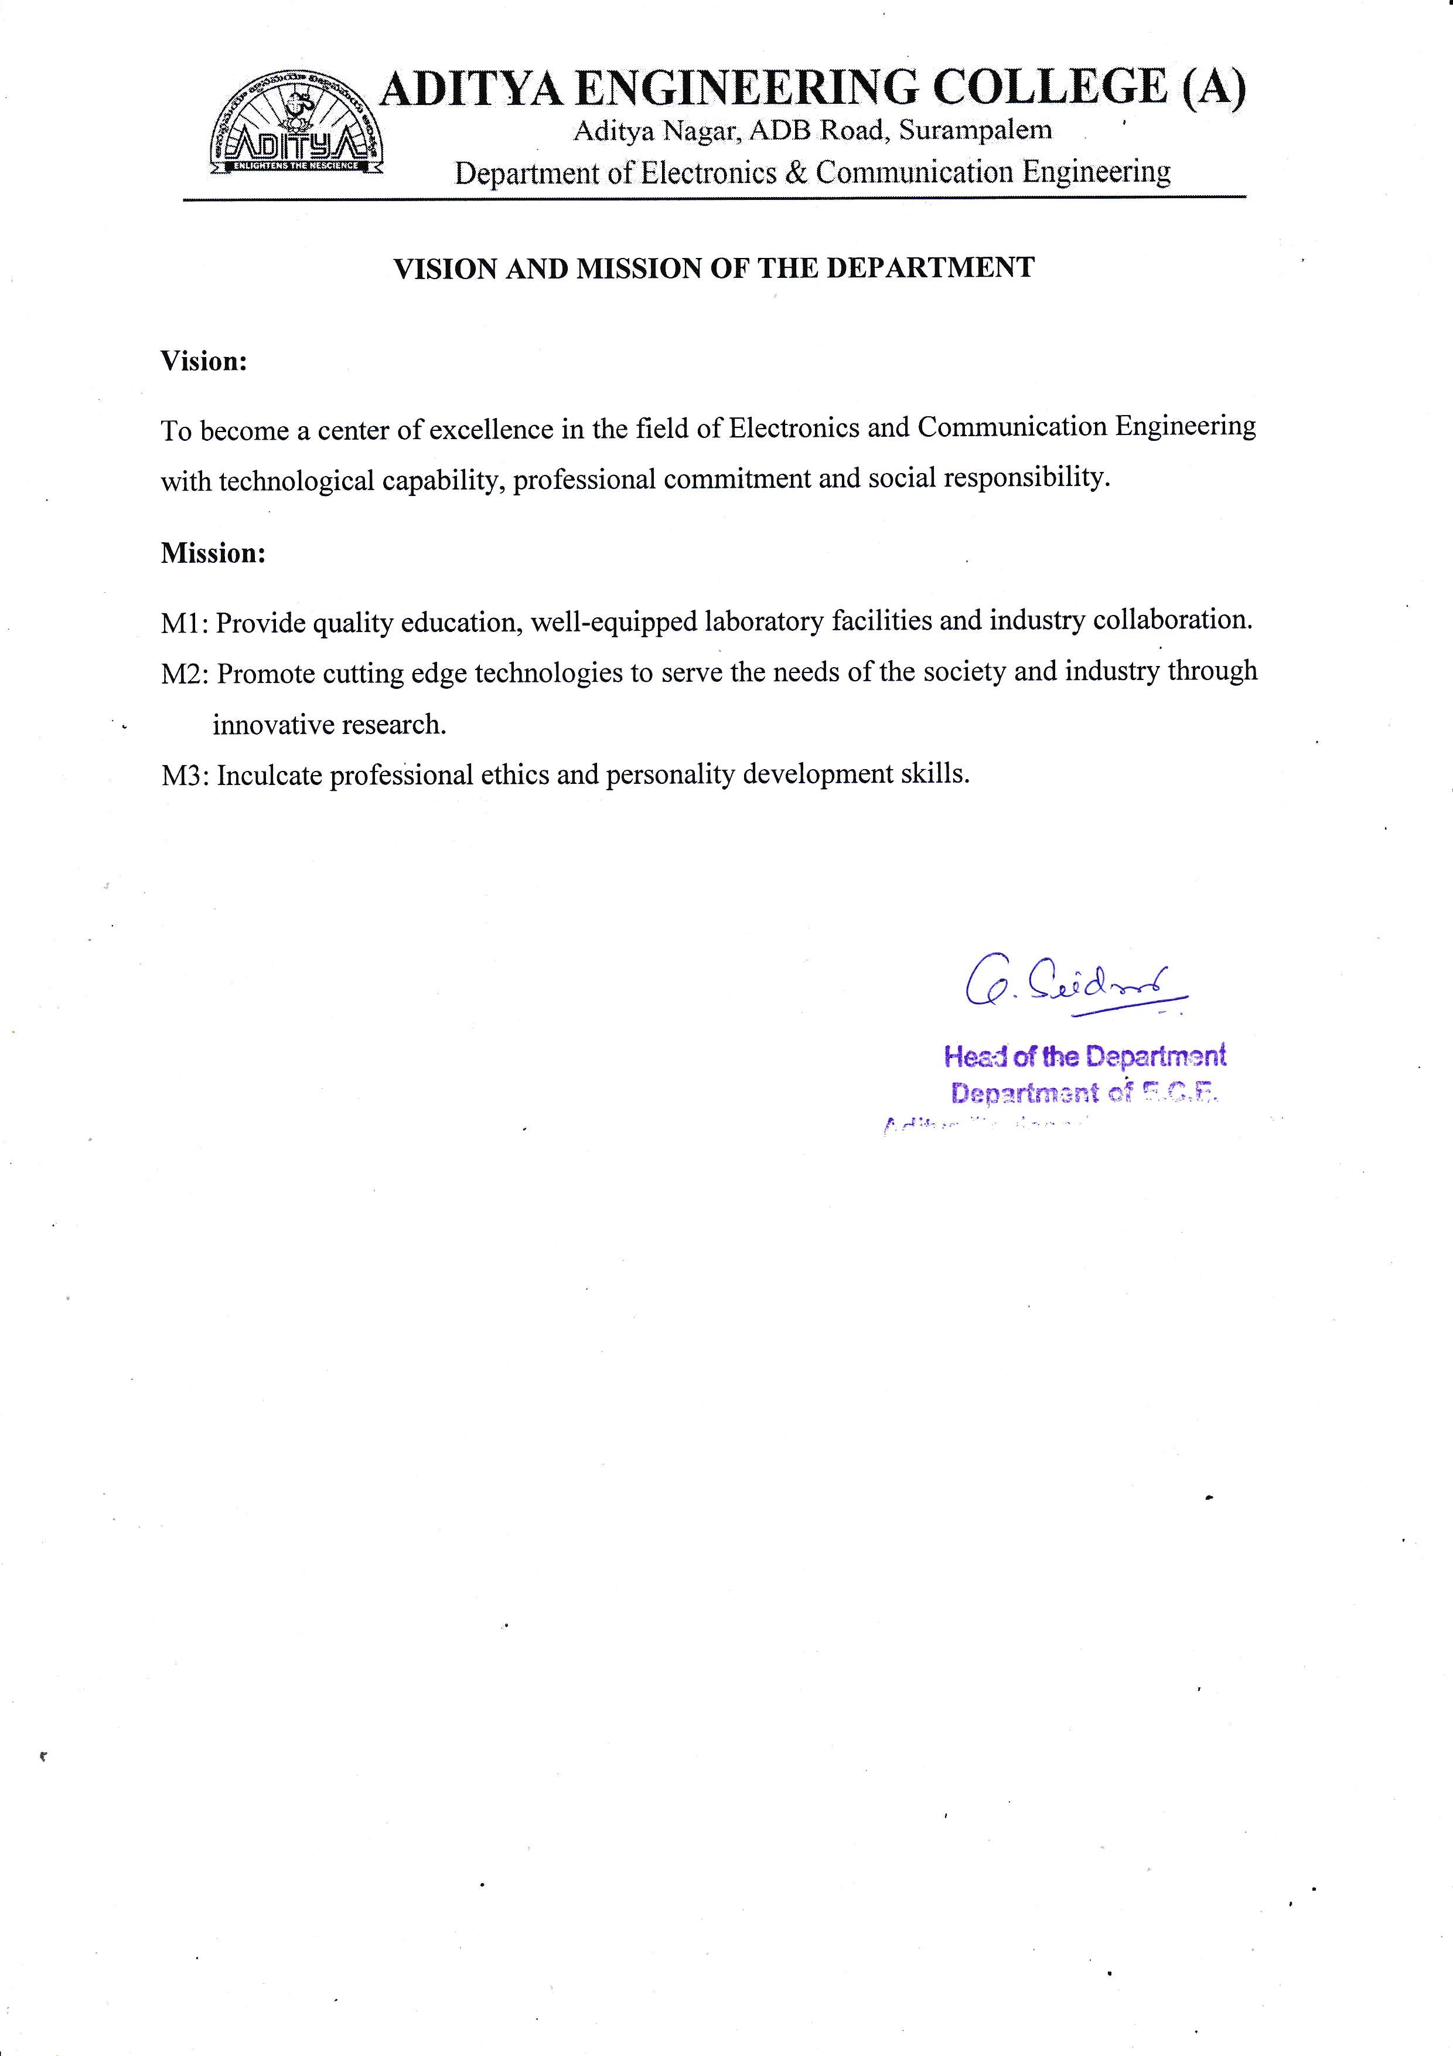

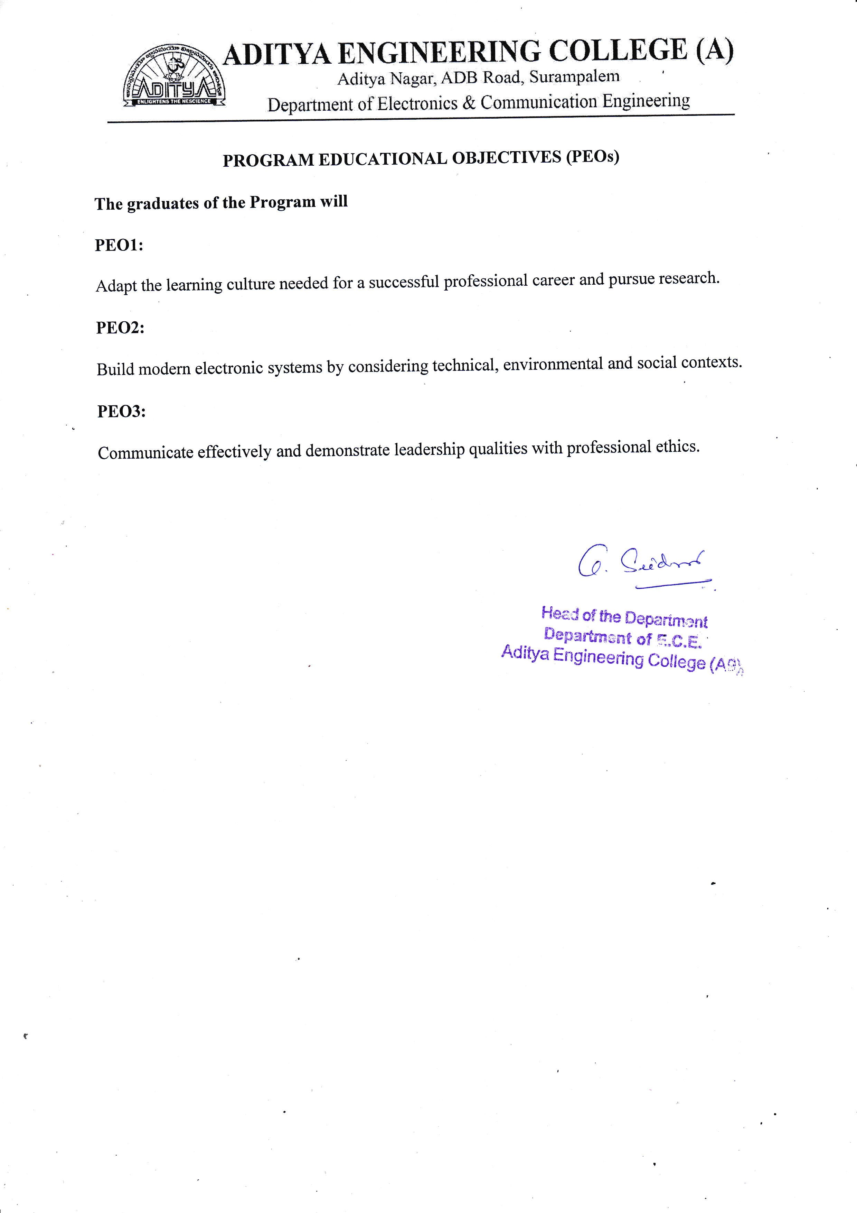

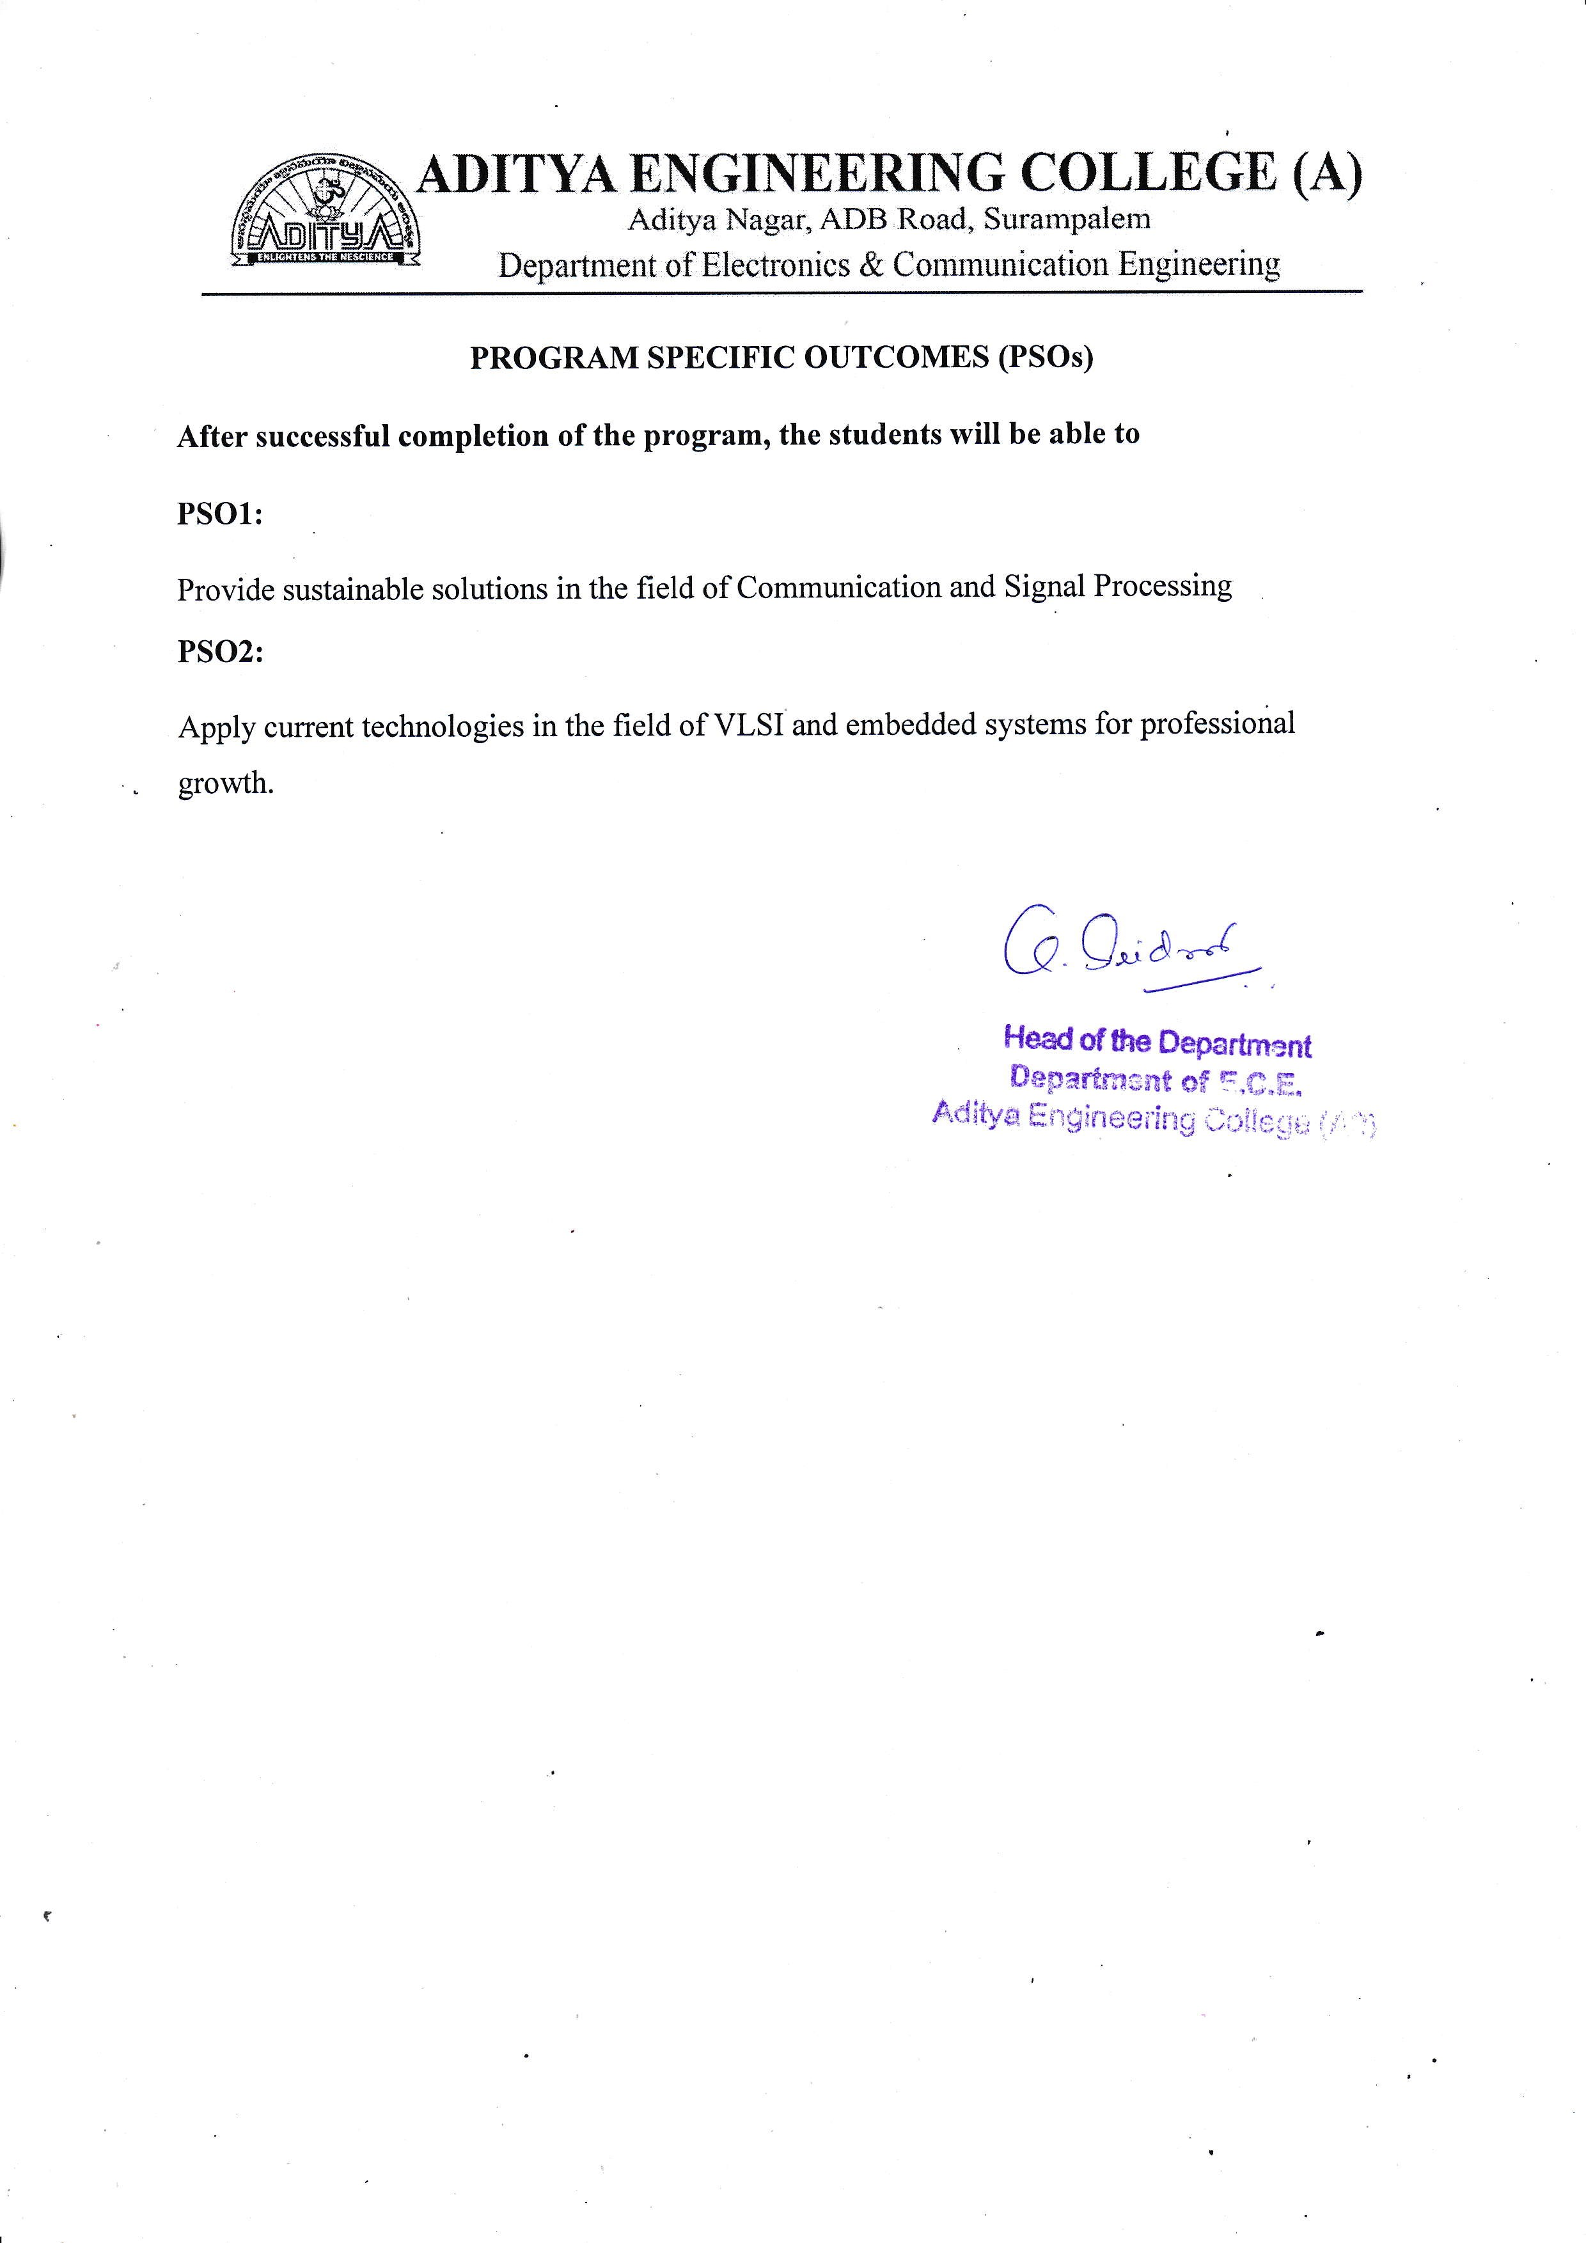

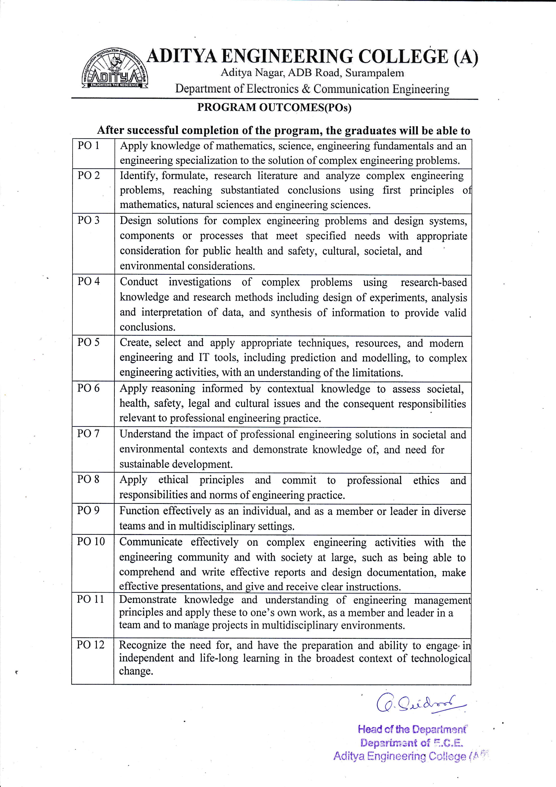

**LIST OF CONTENTS**

**CONTENTS PAGE NO**

**LIST OF FIGURES i**

**LIST OF TABLES ii**

**ABSTRACT iii**

**CHAPTER - 1. INTRODUCTION 1 – 17**

1.1Image 1

1.2 Image Processing 3

1.2.1 Components of Image Processing 3

1.2.2 Fundamental Image Processing Steps 5

1.2.3 Applications of Image Processing 7

1.2.4 Benefits of Image Processing 8

1.3 Introduction to Python 9

1.3.1 Python Features 9

1.3.2 Applications of Python 11

1.3.3 Python Architecture and Working 11

1.3.4 Python Constructs 12

1.4 Image Processing in Python 12

1.4.1 Libraries involved in Python 13

**CHAPTER - 2. LITERATURE SURVEY 18 – 32**

2.1 Research Papers 18

2.2 Face Recognition Techniques 23

2.2.1 Appearance based approaches 23

2.2.2 Feature based approaches 28

**CHAPTER - 3. FACE RECOGNITION 33 – 49**

3.1 Face Detection 33

3.1.1 Face detection methods 34

3.1.2 Working of Face Detection 37

3.2 Face Recognition 40

3.2.1 Face Detection Vs Face Recognition 40

3.2.2 Working of Face Recognition 41

3.2.3 Techniques for Face Recognition 42

3.2.4 Use Cases and Applications 46

**CHAPTER - 4. PROPOSED METHODOLOGY 50 – 53**

4.1 Introduction 50

4.2 Working of KNN 50

4.2.1 KNN for Face Recognition 52

4.3 KNN Algorithm Training 52

4.4 Prediction 53

04.5 Trained Algorithm Working 53

**CHAPTER - 5. RESULTS 54 – 56**

**CHAPTER - 6. CONCLUSION AND FUTURE SCOPE 57**

**REFERENCES 58**

**LIST OF FIGURES PAGE NO**

Fig 2.1: Feature vectors are derived using Eigen faces 23

Fig 2.2: Example of Six Classes Using LDA 25

Fig 2.3: Snapshot of ORL Database 26

Fig 2.4: Snapshot of cropped Yale database 27

Fig 2.5: Geometrical feature used by Brunelli and Poggio 29

Fig 2.6: Left to Right HMM for face recognition 29

Fig 2.7: Image is split into shape and shape normalized texture 30

Fig 3.1: Different types of Face Detection Methods 34

Fig:3.2: Template Matching 35

Fig 3.3: Converting RGB image to Grayscale 38

Fig 3.4: Haar-like features for face detection 38

Fig 3.5: Haar-like features on face 39

Fig:3.6: Successfully detect the face in an image 39

Fig 3.7: Face detection vs. face recognition 41

Fig 3.8: 3D model of a human face 44

Fig 3.9: Thermal Image of a Human face 45

Fig 4.1: Workflow of Algorithm 50

Fig 4.2: Basic steps in KNN. 51

Fig 5.1: Database Folder 54

Fig 5.2: Images of students from database 54

Fig 5.3 Testing Image – 1 55

Fig 5.4 Testing Image – 2 56

Fig 5.5 Testing Image – 3 57

Fig 5.6 Testing Image – 4 58

Fig 5.7: Attendance in excel sheet 59

**LIST OF TABLES PAGE NO**

Table 2.1: ORL Result 27

Table 2.2: Yale Result 28

**ABSTRACT**

There are different prevailing methods to capture person's presence like biometrics to take attendance which is a time-consuming process then why going with biometrics or manual attendance while we have a better alternative using image processing. In the human body, the face is the most crucial factor in identifying each person as it contains many vital details.

In this Project,

The group image is captured first and then from the group image individual faces are identified using face-recognition module and the recognition of faces is done by using KNN(k-nearest neighbours) Algorithm. The capturing of image is continued till the class ends. The attendance will be posted at the end of the class after identification of each and every person. The database can be updated yearly to yield more accurate results.

Automatic Attendance Tracing(AAT) marks individual attendance, if the captured image matches the image in the database i.e., if both images are identical. The proposed algorithm reduces effort and captures day-to-day actions of managing each student and also makes it simple to mark the presence.