**A Project Report on**

**AUTOMATIC ATTENDANCE TRACING USING IMAGE PROCESSING IN PYTHON**

**Submitted in partial fulfillment of the requirements for the award of the Degree of**

**Bachelor of Technology**

**in**

**Electronics and Communication Engineering**

**By**

**P. MEHAR SRINIVAS CHOWDARI 19A91A0437**

**R. SURESH 19A91A0442**

**N. ADITHYA 19A91A0431**

## Under the Esteemed Supervision of

## Mrs. Bondada Savithri M.Tech

## Assistant Professor



**Department of Electronics and Communication Engineering**

**ADITYA ENGINEERING COLLEGE**

**(An Autonomous Institution)**

(Approved by AICTE, New Delhi, Affiliated to JNTUK Kakinada, Accredited by NAAC with ‘A’ Grade)

Aditya Nagar, ADB Road, Surampalem

**2019 – 2023**

**ADITYA ENGINEERING COLLEGE**

**(An Autonomous Institution)**

(Approved by AICTE, New Delhi, Affiliated to JNTUK Kakinada, Accredited by NAAC with ‘A’ Grade)

Aditya Nagar, ADB Road, Surampalem

**2019 – 2023**

**Department of Electronics and Communication Engineering**



**CERTIFICATE**

This is to certify that the thesis entitled “**Automatic Attendance Tracing using Image Processing in Python”** is being submitted by

**P. MEHAR SRINIVAS CHOWDARI 19A91A0437**

**R. SURESH 19A91A0442**

**N. ADITHYA 19A91A0431**

in partial fulfillment of the requirements for the award of degree of B**.Tech** in Electronics and Communication Engineering from **Jawaharlal Nehru Technological University Kakinada** is a record of bonafide work carried out by them at Aditya Engineering College.

The results embodied in this Project report have not been submitted to any other University or Institute for the award of any degree or diploma.

**PROJECT GUIDE HEAD OF THE DEPARTMENT**

**(Mrs Bondada Savithri) (Dr. N. Radha)**

**EXTERNAL EXAMINIER**

**ACKNOWLEDGEMENT**

We take great pleasure to express our deep sense of gratitude to our project guide **Mrs. Bondada Savithri,** Associate Professor, for his valuable guidance during the course of our project work.

We would like to thank **Dr. N. Radha** Head of the Department of Electronics and Communication Engineering for her encouragement.

We would like to express our heart-felt thanks to **Dr. M. Sreenevasa Reddy,** Principal, Aditya Engineering College, Surampalem for providing all the facilities for our project.

Our utmost thanks to all the Faculty members and Non Teaching Staff of the Department of Electronics and Communication Engineering for their support throughout our project work.

Our Family Members and Friends receive our deepest gratitude and love for their support throughout our academic year.

**P. MEHAR SRINIVAS CHOWDARI 19A91A0437**

**R. SURESH 19A91A0442**

**N. ADITHYA 19A91A0431**

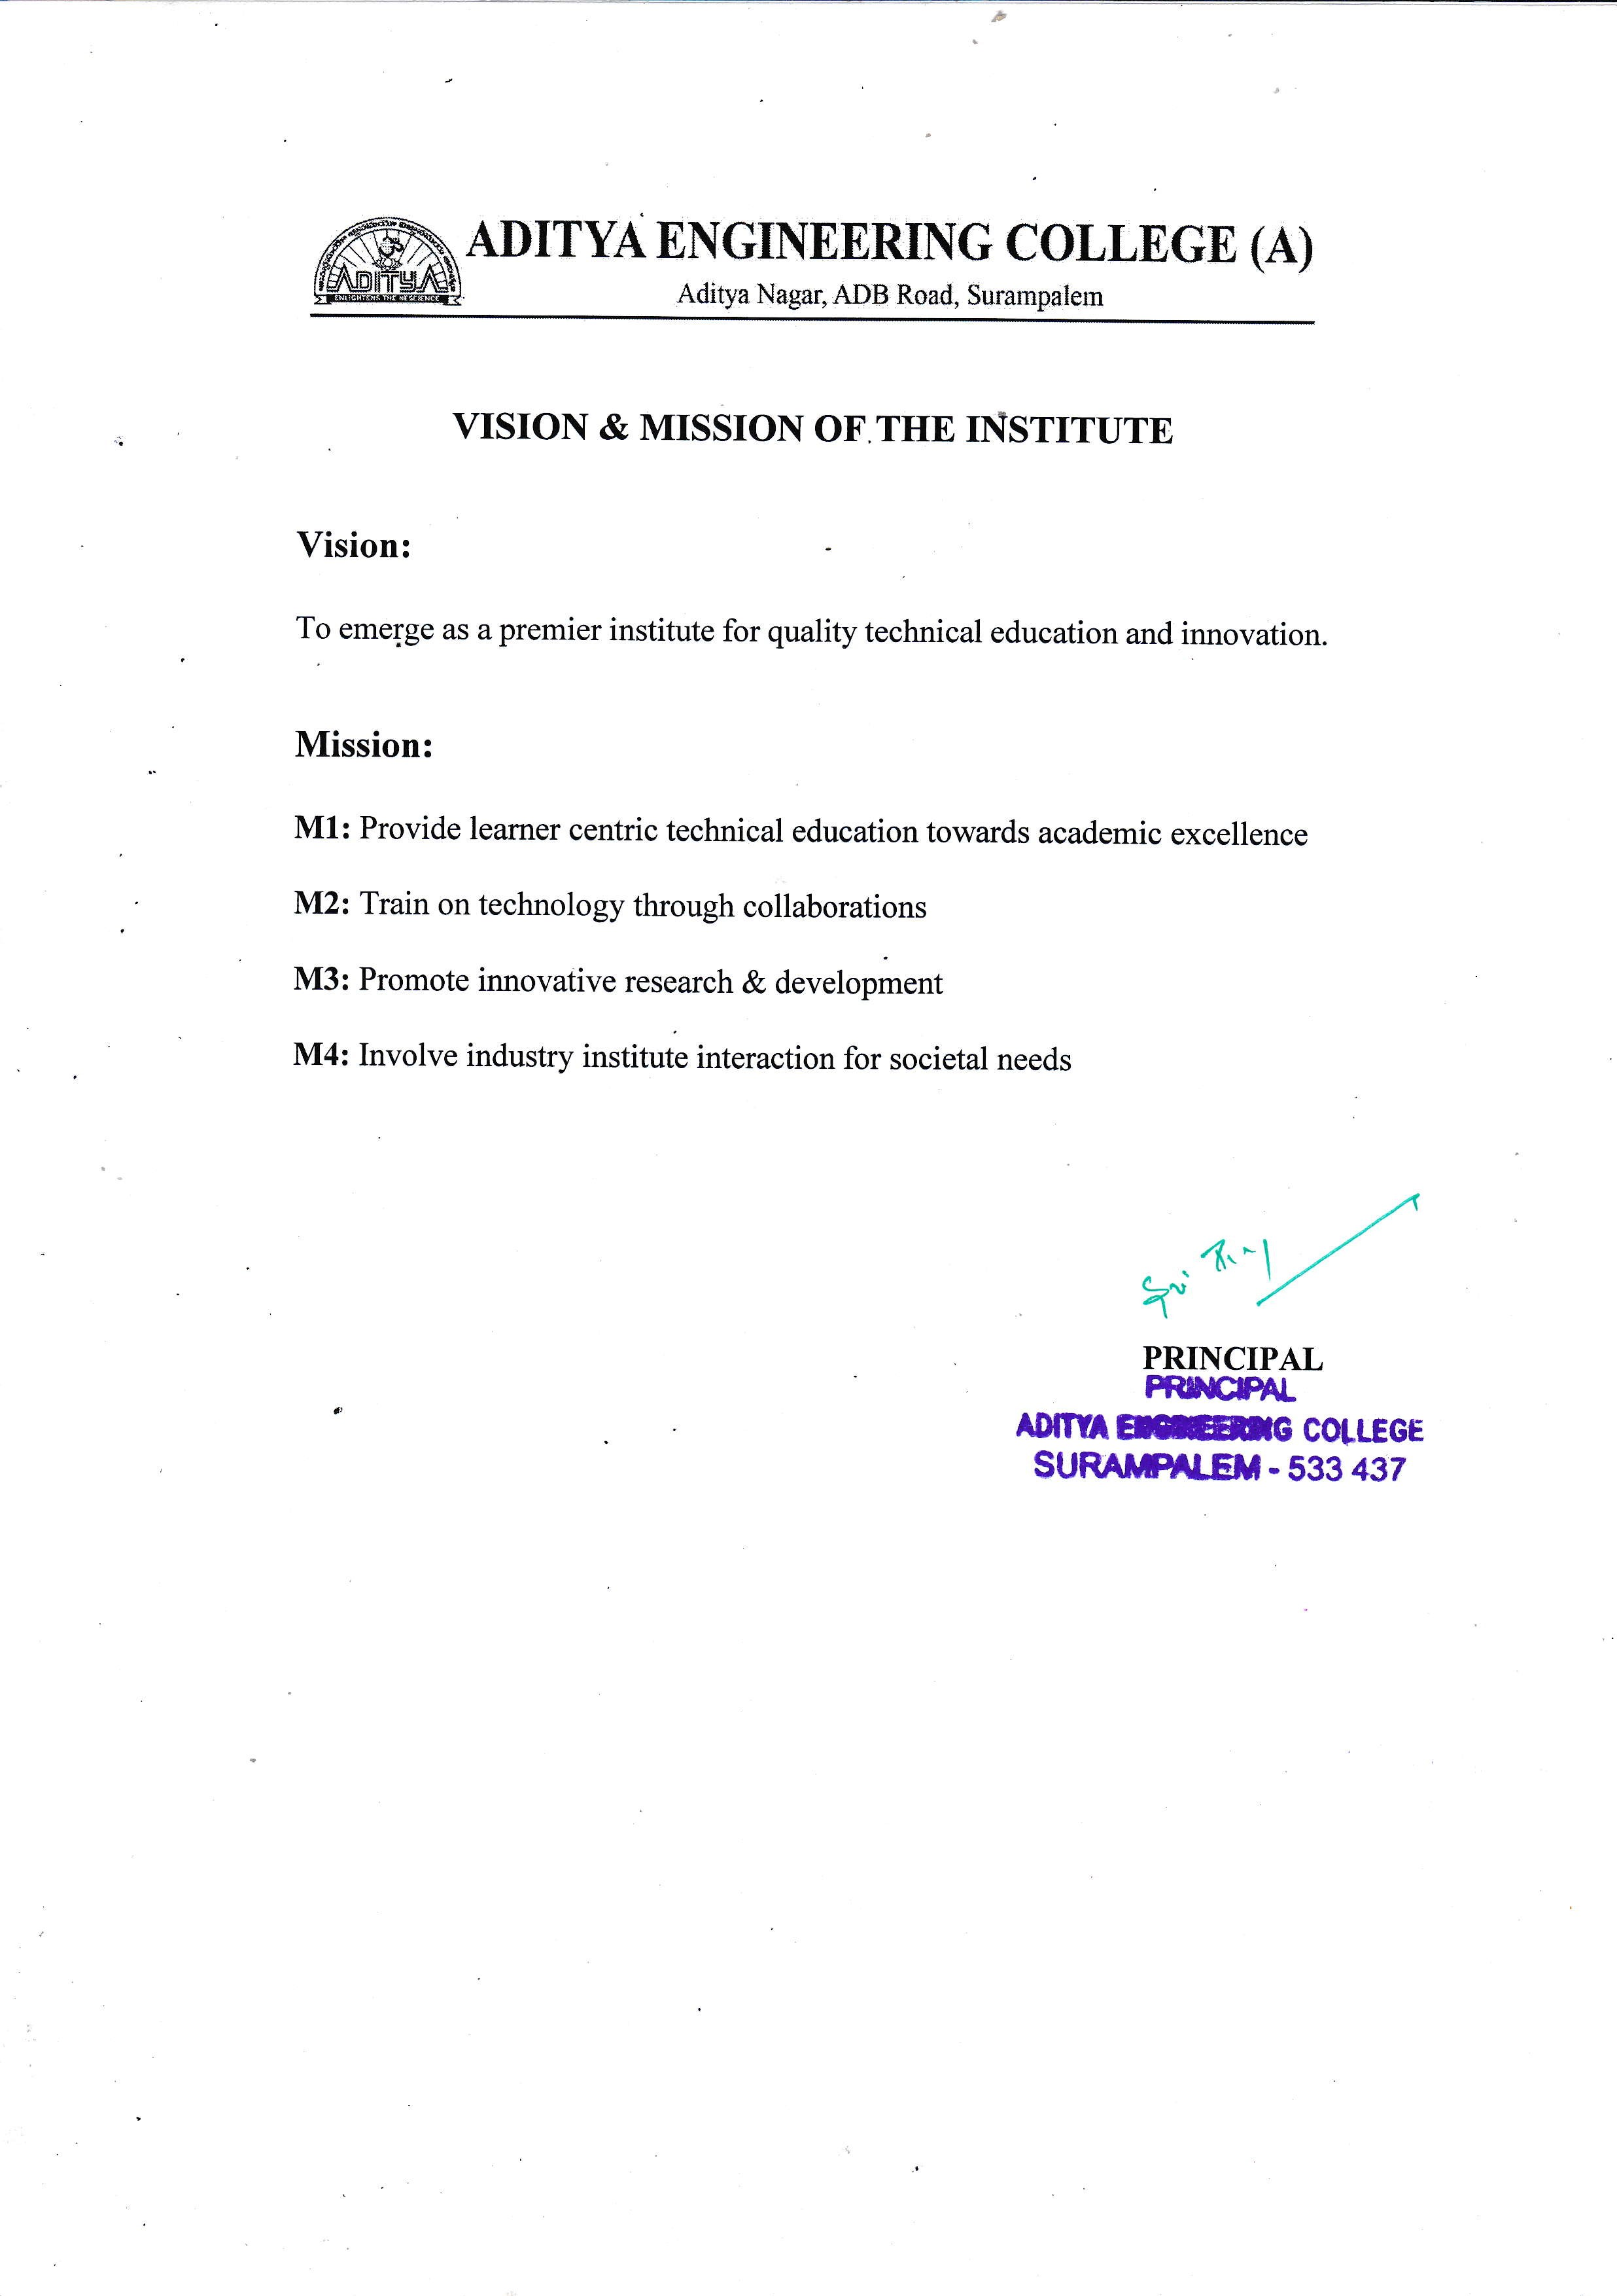

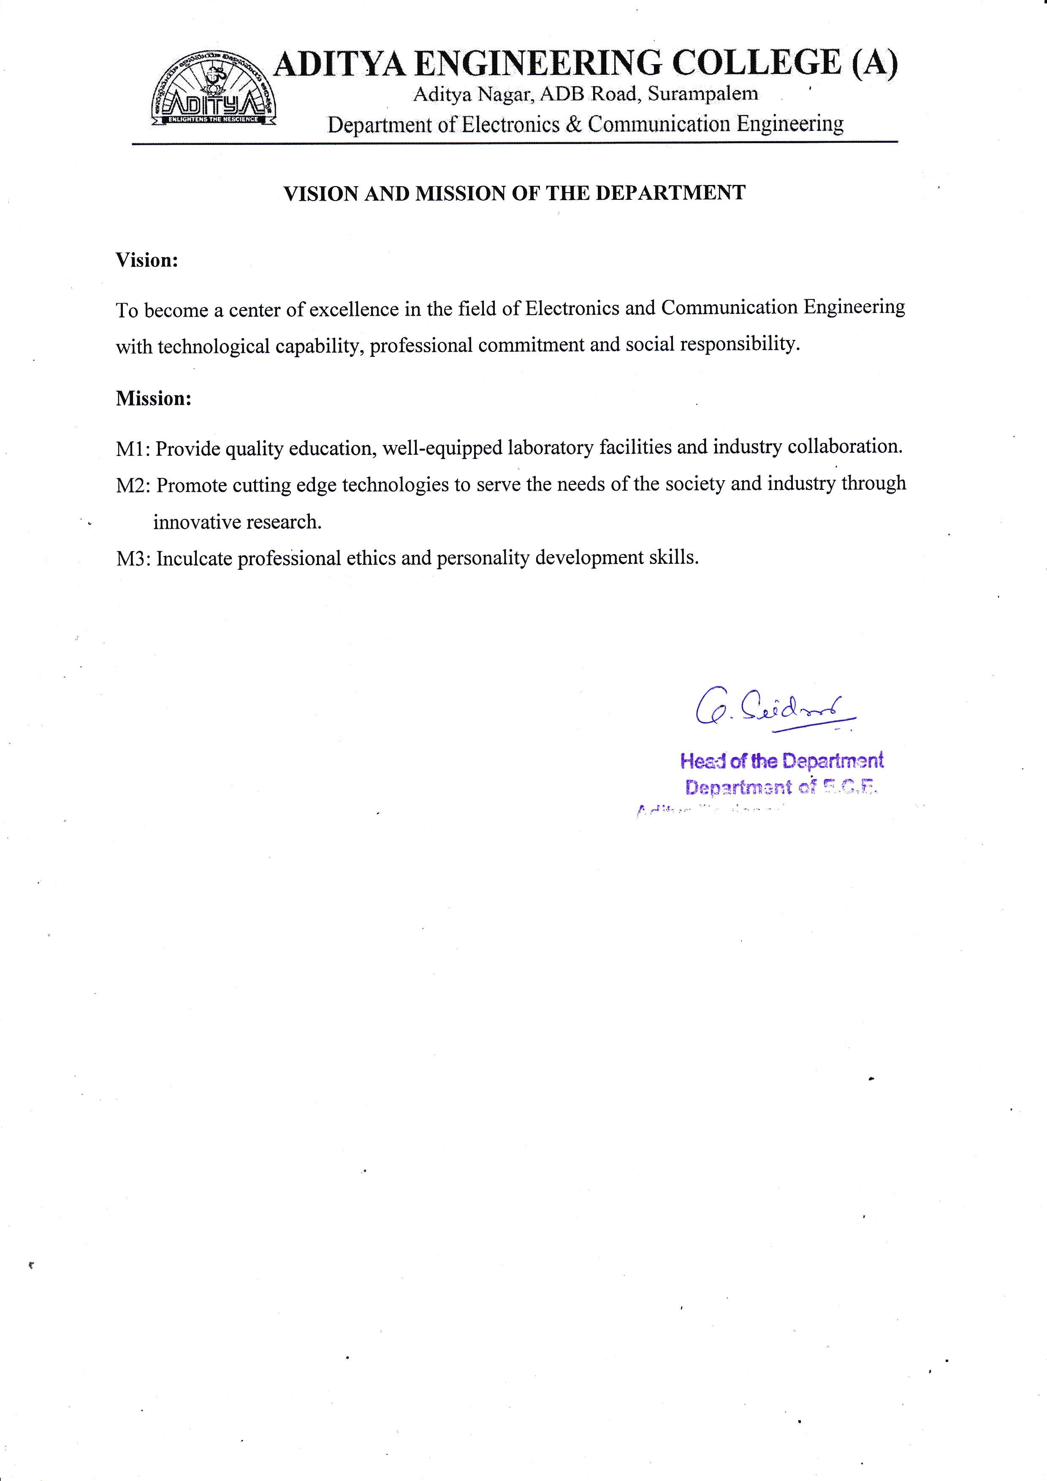

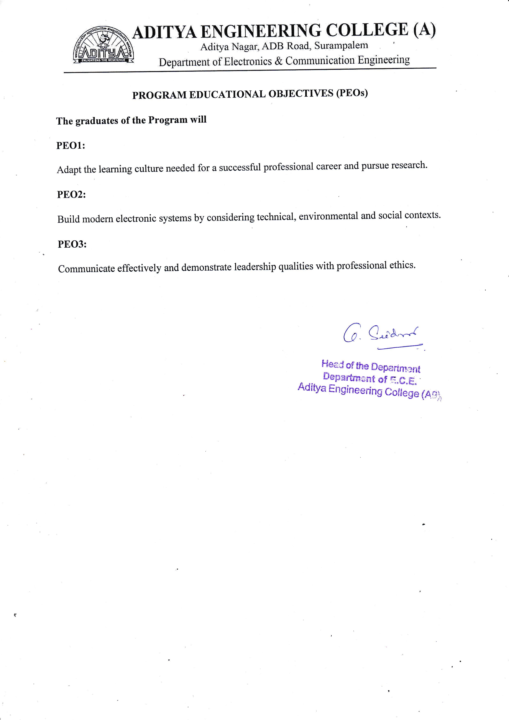

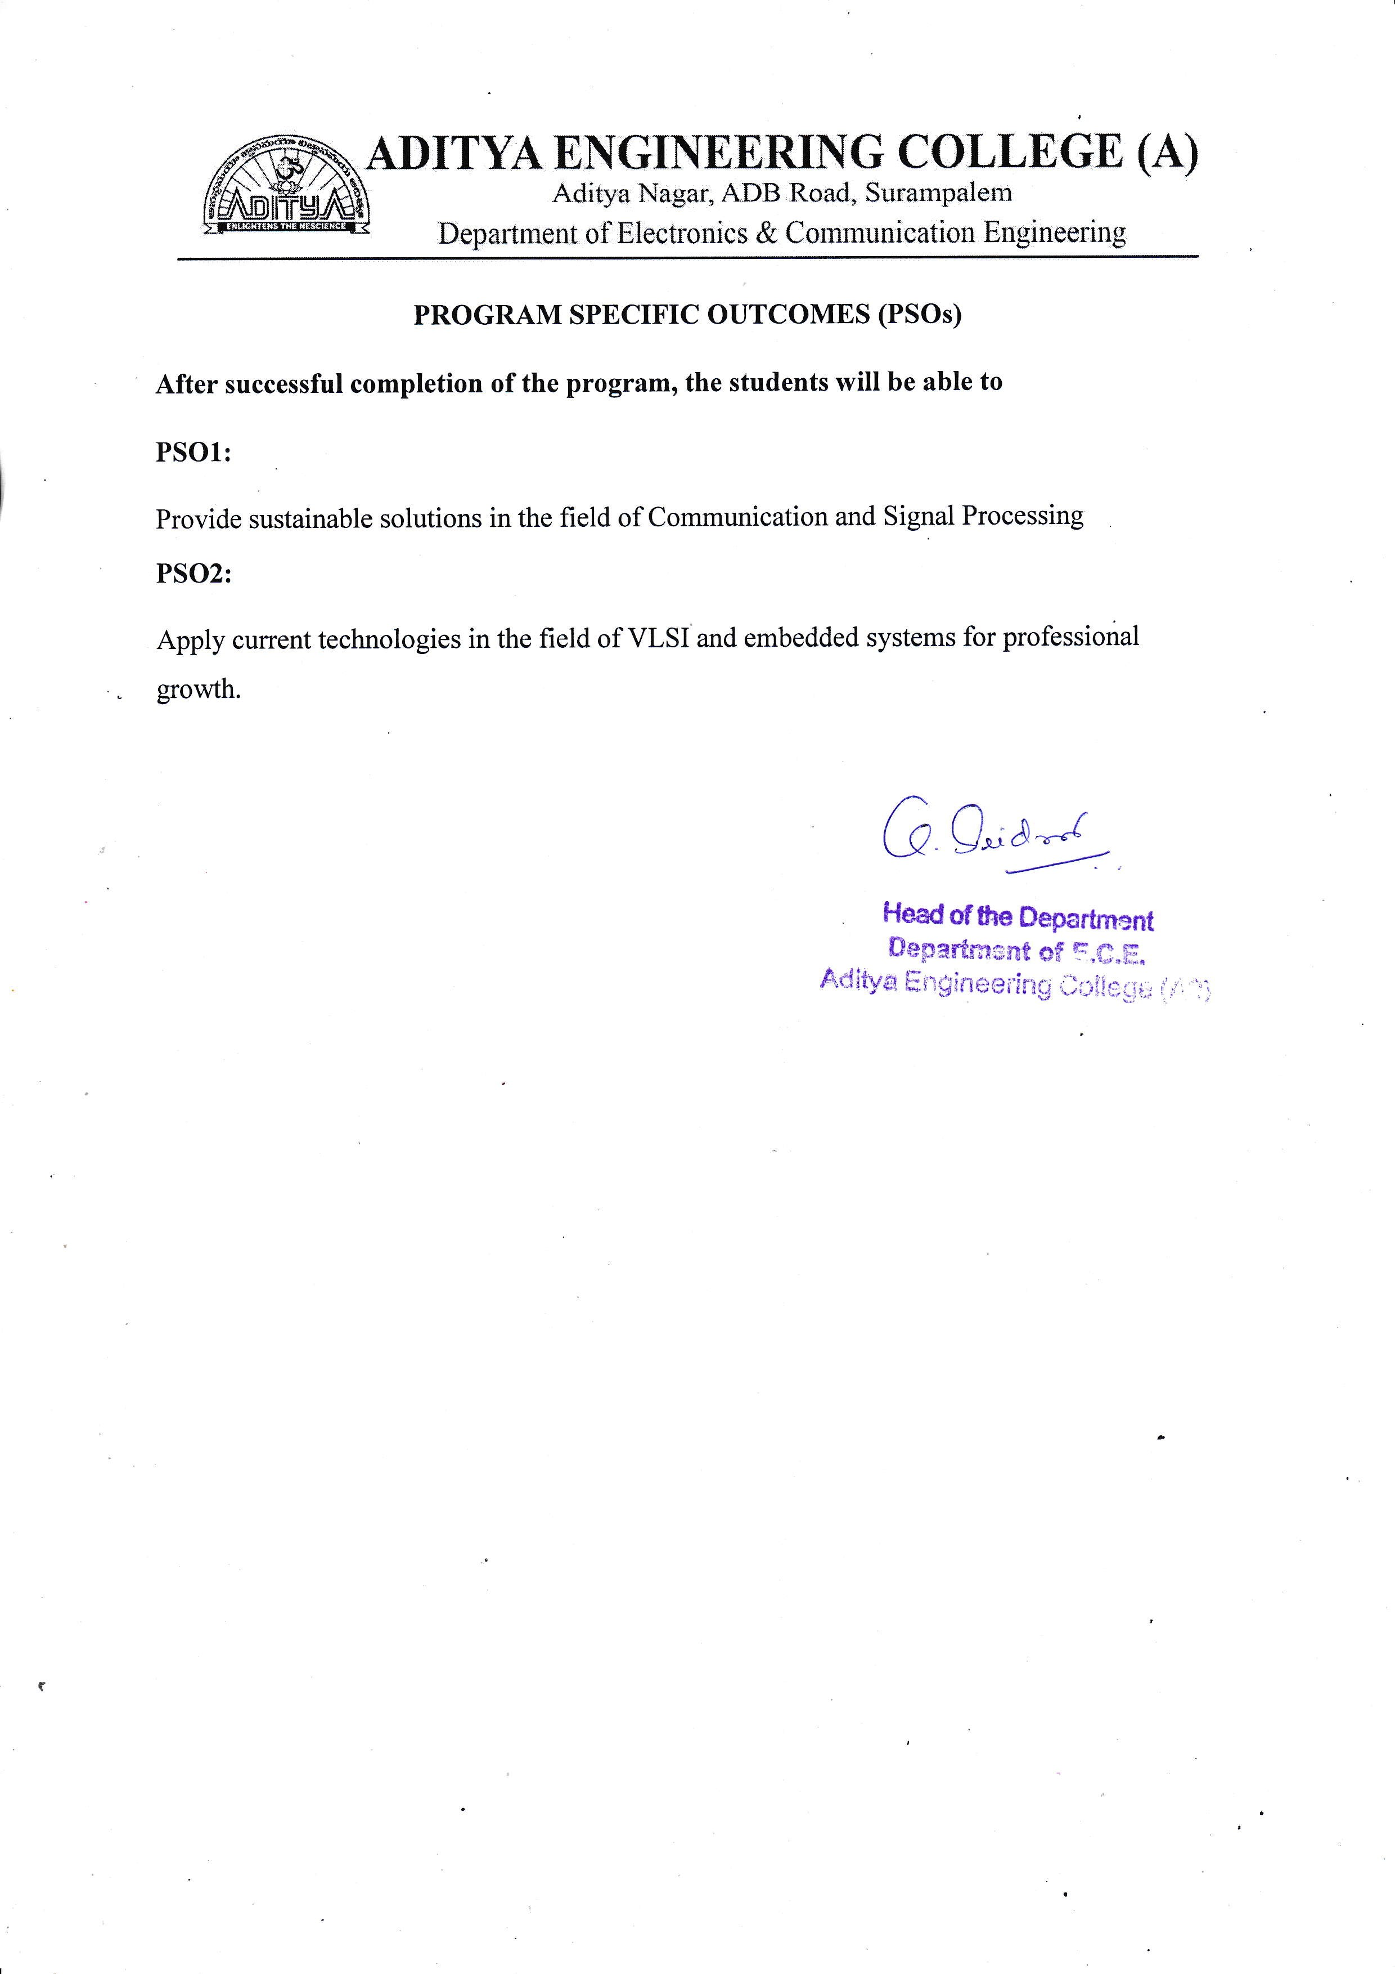

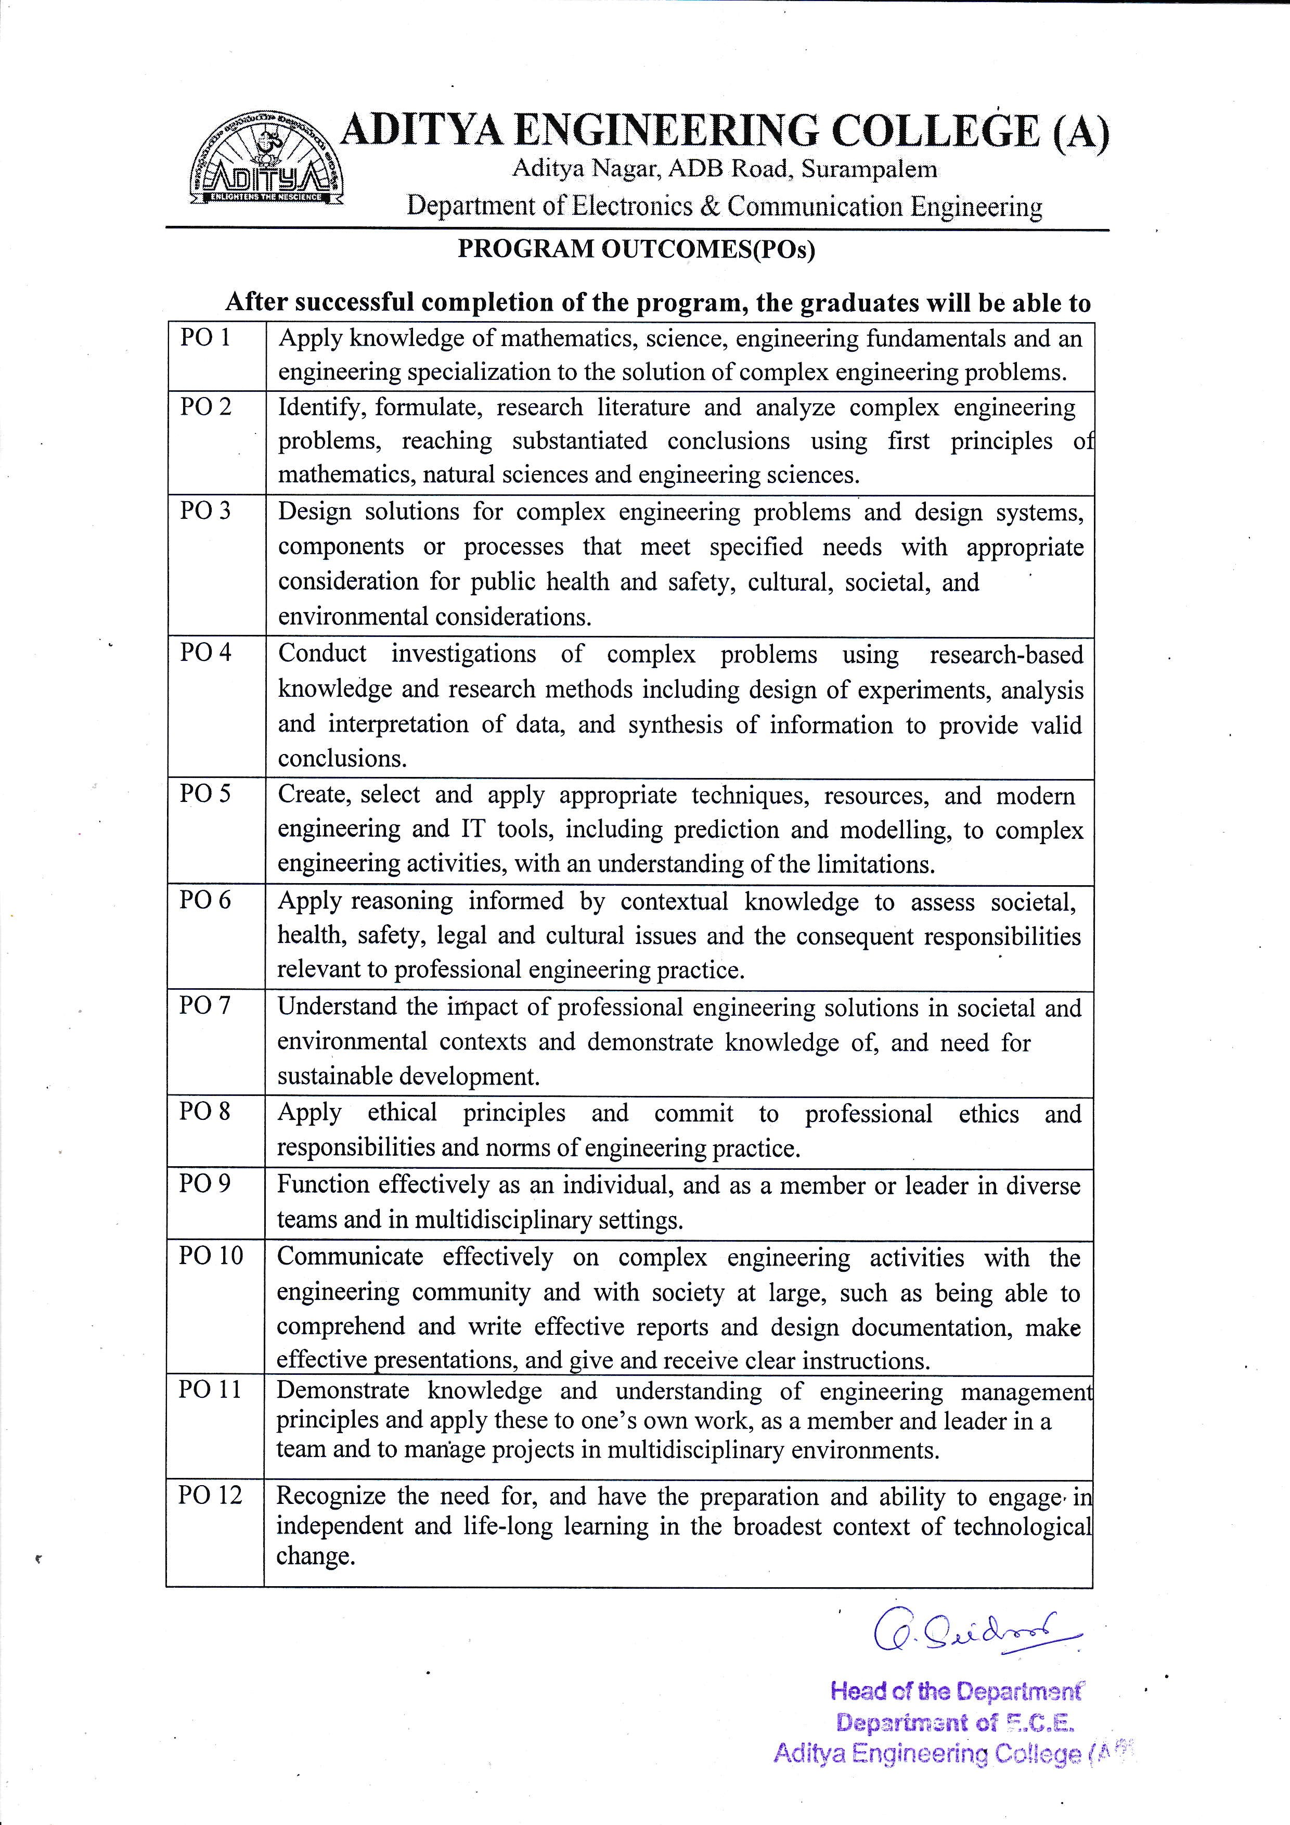

**COURSE OUTCOMES**

**PROJECT PART 1**

Regulation: AR19 L T P C

Course Code: 191EC7P04 0 0 4 2

|  |  |
| --- | --- |
| CO1 | Identify a real life / engineering problem |
| CO2 | Perform extensive investigation with prior knowledge |
| CO3 | Interpret problem formulation and solution through critical thinking |
| CO4 | Develop the work plan, schedule and estimate the cost |
| CO5 | Identify the resources required to initiate project work |

**PROJECT PART 2**

Regulation :AR19 L T P C

Course Code: 191EC8P05 0 0 14 7

|  |  |
| --- | --- |
| CO6 | Apply the domain knowledge to arrive at a framework to solve the problem |
| CO7 | Design solution using research-based knowledge and modern tools and interpret the results |
| CO8 | Assess the obtained solution in the context of engineering framework addressing the societal and environmental concerns adhering to professional ethics |
| CO9 | Demonstrate communication skills effectively to work as a team, for guide interaction and presentations. |
| CO10 | Prepare technical documentation/reports with effective written communication skills |

**CO-PO MAPPING**

|  |  |  |  |  |  |  |  |  |  |  |  |  |  |  |  |
| --- | --- | --- | --- | --- | --- | --- | --- | --- | --- | --- | --- | --- | --- | --- | --- |
| **PROJECT PART-I 191CS7P04** | | | | | | | | | | | | | | | |
| **CO/PO** | **PO1** | **PO2** | **PO3** | **PO4** | **PO5** | **PO6** | **PO7** | **PO8** | **PO9** | **PO10** | **PO11** | **PO12** | **PSO1** | **PSO2** |  |
| **CO1** | 2 | 3 |  |  |  |  |  |  | 2 |  |  | 1 | 2 |  |  |
| **CO2** | 1 | 2 | 2 | 2 |  |  |  |  | 2 |  |  | 1 | 2 |  |  |
| **CO3** | 1 |  | 3 | 2 | 1 | 2 | 1 |  | 2 |  |  | 1 | 2 |  |  |
| **CO4** | 1 | 1 |  |  |  |  |  |  | 2 | 1 | 3 | 1 | 2 |  |  |
| **CO5** | 1 | 1 | 1 |  | 2 |  |  |  | 1 |  | 3 | 1 | 2 |  |  |
| **PROJECT PART-II 191CS8P05** | | | | | | | | | | | | | | | |
| **CO/PO** | **PO1** | **PO2** | **PO3** | **PO4** | **PO5** | **PO6** | **PO7** | **PO8** | **PO9** | **PO10** | **PO11** | **PO12** | **PSO1** | **PSO2** |  |
| **CO6** | 3 | 2 | 2 | 2 | 1 |  |  |  | 2 |  | 2 | 3 | 2 |  |  |
| **CO7** | 1 | 2 | 2 |  | 3 | 1 | 1 |  | 2 | 2 | 2 | 2 | 2 |  |  |
| **CO8** | 1 | 1 | 1 | 2 |  | 3 | 3 | 2 | 2 |  | 2 | 2 | 2 |  |  |
| **CO9** | 2 | 1 | 2 | 1 |  |  |  |  | 3 | 3 | 2 | 2 | 2 |  |  |
| **CO10** | 1 | 1 | 1 | 1 | 1 | 1 |  | 3 | 1 | 2 | 1 | 1 | 2 |  |  |

Academic Year: 2022-23

Project Title: **Automatic Attendance Tracing Using Image Processing in Python**

Type of Project: **Application Oriented/Design Oriented/Research Oriented**

Project Guide: Mrs. Bondada Savithri

Project Team: P. Mehar Srinivas Chowdari (19A91A0437)

R. Suresh (19A91A0442)

N. Adithya (19A91A0431)

**ABSTRACT**

There are different prevailing methods to capture person's presence like biometrics to take attendance which is a time-consuming process then why going with biometrics or manual attendance while we have a better alternative using image processing. In the human body, the face is the most crucial factor in identifying each person as it contains many vital details.

In this Project,

The group image is captured first and then from the group image individual faces are identified using face-recognition module and the recognition of faces is done by using KNN(k-nearest neighbours) Algorithm. The capturing of image is continued till the class ends. The attendance will be posted at the end of the class after identification of each and every person. The database can be updated yearly to yield more accurate results.

Automatic Attendance Tracing(AAT) marks individual attendance, if the captured image matches the image in the database i.e., if both images are identical. The proposed algorithm reduces effort and captures day-to-day actions of managing each student and also makes it simple to mark the presence.

**Signature of the Team members**

**LIST OF CONTENTS**

**CONTENTS PAGE NO**

**LIST OF FIGURES i**

**LIST OF TABLES ii**

**CHAPTER - 1. INTRODUCTION 1 – 7**

1.1 Different Types of Attendance Tracing Systems 1

1.2 Problem Statement 4

1.3 Thesis overview 7

**CHAPTER – 2 BACKGROUND 8 - 24**

2.1Image 8

2.2 Image Processing 10

2.2.1 Components of Image Processing 10

2.2.2 Fundamental Image Processing Steps 12

2.2.3 Applications of Image Processing 14

2.2.4 Benefits of Image Processing 15

2.3 Introduction to Python 16

2.3.1 Python Features 16

2.3.2 Applications of Python 18

2.3.3 Python Architecture and Working 18

2.3.4 Python Constructs 19

2.4 Image Processing in Python 19

2.4.1 Libraries involved in Python 20

**CHAPTER - 3. LITERATURE SURVEY 25 – 39**

3.1 Research Papers 25

3.2 Face Recognition Techniques 30

3.2.1 Appearance based approaches 30

3.2.2 Feature based approaches 35

**CHAPTER - 4. FACE RECOGNITION 40 – 56**

4.1 Face Detection 40

4.1.1 Face detection methods 41

4.1.2 Working of Face Detection 44

4.2 Face Recognition 47

4.2.1 Face Detection Vs Face Recognition 47

4.2.2 Working of Face Recognition 48

4.2.3 Techniques for Face Recognition 49

4.2.4 Use Cases and Applications 53

**CHAPTER - 5. PROPOSED METHODOLOGY 57 – 60**

5.1 Introduction 57

5.2 Working of KNN 58

5.2.1 KNN for Face Recognition 59

5.3 KNN Algorithm Training 59

5.4 Prediction 60

5.5 Trained Algorithm Working 60

**CHAPTER - 5. RESULTS 61 – 66**

**CHAPTER - 7. CONCLUSION AND FUTURE SCOPE 67**

**REFERENCES 68**