BACK END WEB DEVELOPMENT

***A Summer Internship Report submitted in partialful fillment of the requirements for the award of degree of***

**BACHELOR OF TECHNOLOGY**

**In**

**ELECTRONICS & COMMUNICATION ENGINEERING**

**Submitted By:**

1. **V. V. L. Swathi Durga**

**21MH1A04B9**



**Department of Electronics and Communication Engineering**

# ADITYACOLLEGE OF ENGINEERING

**Approved by AICTE, Permanently affiliated to JNTUK & Accredited by NAAC & NBA**

**Recognized by UGC under the sections 2(f)and12(B) of the UGC act 1956 Aditya Nagar, ADB Road –Surampalem, 533437,Kakinada Dist,A.P.,**

**ADITYA COLLEGE OF ENGINEERING**

**Approved by AICTE, Permanently Affiliated to JNTUK & Accredited by NAAC & NBA**

**Recognized by UGC under the sections 2(f) and 12(B) of the UGC act 1956 Aditya Nagar, ADB Road - Surampalem – 533437, Kakinada.Dist.,A.P.,**

Department Of Electroni**c**s and Commucation Engineering



**CERTIFICATE**

This is to certify that the Internship report entitled *“BACKEND DEVELOPMENT”*is being submitted by

**R.V.V.L. Swathi Durga (21MH1A04B9)**

In partial fulfillment of the requirements for award of the B.Tech degree in Electronics and Communication Engineering for the academic year

2023-24

**Internship Coordinators Head of the department**

**Mr.M Sudheer Kumar Reddy Mrs. CH JANAKI DEVI, M.Tech.,(Ph.D.)**

Assistant Professor Associate Professor

**Mr. K Chandra Sekhar** Department of ECE Sr. Assistant Professor

Department of ECE

**DECLARATION**

I, hereby declare that the entitled internship **“BACKEND WEB DEVELOPMENT”** is a genuine work. This work has been submitted to the **ADITYA COLLEGE OF ENGINEERING,** Surampalem, in partial fulfillment of the **B.Tech** degree**.** I further declare that this project work has not been submitted in full or part of the award of any degree of this or any other educational institutions.

**By**

R.V.V.L. Swathi Durga

21MH1A04B9

# CERTIFICATE OF INTERNSHIP

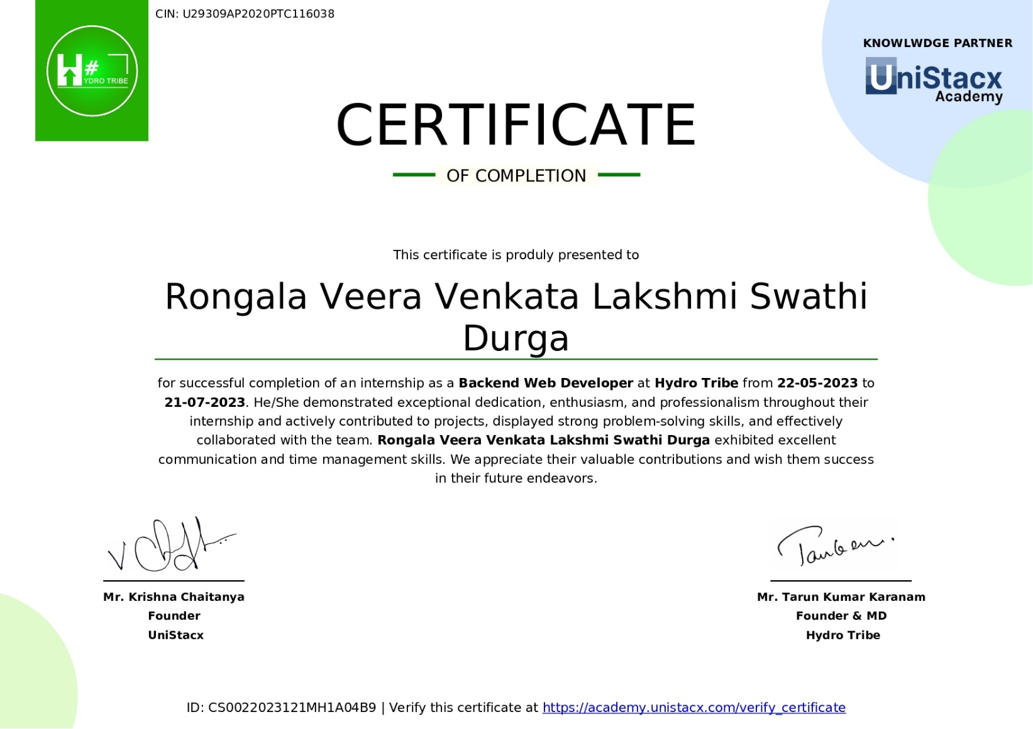



### VISION AND MISSION OF INSTITUTE

**Vision:**

To induce higher planes of learning by imparting technical education with

* International standards
* Applied research
* Creative Ability
* Value based instruction and to emerge as a premiere institute.

Mission:

Achieving academic excellence by providing globally acceptable technical Education by forecasting technology through

* Innovative Research and development
* Industry Institute Interaction
* Empowered Manpower

PEOS OF DEPT

PEO 1: Enrich individuals & acquire skills in the fields of ECE,software & firmware to Produce high impact and futuristic solutions.

PEO 2: Facilitate learning in the core field of Electronics and Communication Engineer

-ing ,research & innovation to have progressive careers

PEO 3: Inculcate professional and ethical attitude,team spirit,leadership qualities and eff

-ective communication skills to make them aware of their social responsibilities.

PEO 4: Utilize modern equipment and programming tools to solve real-life multi-discipli

-nary problems.

PROGRAM OUTCOMES

1. Engineering Knowledge: Apply the knowledge mathematics, science, engineering specialization to the solution of complex engineering problems.
2. Problems Analysis: identify, formulate, research literature and analyze complex engineering problems reaching substantiated conclusions using first principles of mathematics, natural sciences, and engineering sciences.
3. Design/Development of Solutions: Design solutions for complex engineering problems and design system components or processes that meet the specified needs with appropriate consideration for the public health and safety and the cult

-ural, societal, and environmental considerations.

1. Conduct Investigations of Complex Problems: Use research-based knowledge and research methods including design of experiments, analysis and Interpretation of data, and synthesis of the information to provide valid conclusions.
2. Modern Tool Usage: Create, select, and apply appropriate techniques, resources, and modern engineering and IT tools including prediction and modelling to complex engineering activities with an understanding of the limitations.
3. The Engineer and Society: Apply resoning informed by the contectual knowledge to assess societal, health, safety, legal and cultural issues, and the consequent responsibilities relevant to the professional engineering practice.
4. Environmental and Sustainability: Understand the impact of the professional engineering solutions in societal and environmental contexts, and demonstrate of, and need for sustainable development.

## PROGRAM OUTCOMES

1. Ethics: Apply ethical ptinciples and commit to professional ethics and responsiblities and norms of the engineering practice.
2. Individual and Teamwork: Function effectivety on complex engineering activities, an

-d as a member or leader in diverse teams, and an in multidisciplinary settings.

1. Communication: Communicate effectively on complex engineering activities with th

-e engineering community and with society at large, such as beng able to comprehen

-d and write effective reports and design documentation, make effective presentations , Give and receive clear instructions.

1. Project Management and Finace: Demostrate knowledge and understanding of the engineering and management principles and apply these to one’s own work, as a mem

-ber and leader in a team, to manage projects and in multi-disciplinary enviroments.

1. Life-Long Learning: Recognize the need for and have the preparation and ability to en

-gage in independent and life-long learning in the broadest contest of technological cha

-nge.

## VISION AND MISSION OF THE DEPT

#### Vision:

* + To be a center of excellence and renowned for Electronics & Communication Engineering education and research.

#### Mission:

* Enlighten the graduates in the basic concepts underlying the principles of analog and digital electronics, communication systems and adavances technologies.
* Provide state of the art infrastructure and research facilities.
* Oraganizing industrial programs and social activities in collaboration with industries, NSS to disseminate knowledge.

## PROGRAM SPECIFIC OUTCOMES OF DEPT

* PSO 1:

Apply concepts in Electronics & Communication Engineering to design

and implement systems in the areas related to Communication, image processing, VLSI, Antennas and Embedded Systems.

* PSO 2:

Demonstrate proficiency in utilization of software and hardware tools

Related to Electronics and Communication Technologies, while acquiring soft

Skills like persistence, proper judgement through projects and industrial interactions.

# ACKNOWLEDGEMENT

First, I would like to thank the Director of Organization, HYDRO TRIBE, Hyderabad for giving me the opportunity to do an internship within the organization. I also would like all the people that worked with me in HYDRO TRIBE, Hyderabad, with their patience and openness they created an enjoyable working environment.

We owe our sincere gratitude to **Dr.A. RAMESH, Principal** for providing a great support and for giving us the opportunity of doing the internship.

Our deepest thanks to **MS. CH. JANAKI DEVI, Associate Professor & Head of the Department,** for inspiring us all the way and for arranging all the facilities and resources needed for our internship.

We wish to thank **Mr. M Sudheer Kumar Reddy, Assistant Professor & Mr. K Chandra Sekhar, Sr.Assistant Professor** in ECE for their support and suggestions during our internship course work.

.

# Abstract

This report encapsulates the comprehensive experiences and learning acquired during my Front End web development internship at Hydro Tribe. Over the course of 22-5-2023 to 21-7-2023, I at the opportunity to contribute to various web development projects,gaining practical insights into the field. The primary objectives of this internship were to apply and expand my knowledge in front-end web development, collaborate within a professional team,and address real-world challenges in web development.There port begins with an introduction to the company and its role in the web development industry. It discusses the organizational structure, key projects, and technologies utilized within the company. This section provides context for the subsequent discussion of my specific roles and responsibilities during the internship.A substantial portion of the report is dedicated to detailing the technical aspects of my work. It covers my involvement in front-end development, including the use of HTML,CSS, and JavaScript to create visually appealing and responsive user interfaces. I discuss the challenges faced and solutions devised while working on the sea spects of web development.Finally, the report concludes with a reflection on the overall impact of the internship on my personal and professional growth, emphasizing the skills and knowledge gained that will contribute to my future career in web development.

# Learning Objectives/Internship Objectives

* + Internships are generally thought of to be reserved for college students looking to gain experience in a particular field. However,a wide array of people can benefit from Training Internships in order to receive real world experience and develop their skills.
  + An objective for this position should emphasize the skills youal ready possess in the area and your interest in learning more
  + Internships are utilized in a number of different career fields,includingarchitecture,engineering,healthcare,econ omics,advertisingandmany more.
  + Some internships are used to allow individual stoper form scientific research while others are specifically designed to allow people to gain first-hand experience working.
  + Utilizing internships is a great way to build your resume and develop skills that can be emphasized in your resume for future jobs. When you are applying for a Training Internship, make sure to highlight any special skills or talents that can make you stand a part from the rest of the applicants so that you have an improved chance of landing the position.

**WEEKLYINTERNSHIPACTIVITIES(WEEK1)**

|  |  |  |
| --- | --- | --- |
| **DATE** | **DAY** | **NAMEOF THETOPIC/MODULECOMPLETED** |
| 22/5/23 | Monday | Introduction to Python, installation and setup |
| 23/5/23 | Tuesday | Variables, data types and operators |
| 24/5/23 | Wednesday | Control flow and loops |
| 25/5/23 | Thursday | Functions and modules |
| 26/5/23 | Friday | File handling and Exception handling |
| 27/5/23 | Saturday | Review and practice Exercises |

**WEEKLYINTERNSHIPACTIVITIES(WEEK2)**

|  |  |  |
| --- | --- | --- |
| **DATE** | **DAY** | **NAMEOFTHETOPIC/MODULE COMPLETED** |
| 29/5/23 | Monday | Introduction to OOPS Concept |
| 30/5/23 | Tuesday | Inheritance and Polymorphism |
| 31/5/23 | Wednesday | Encapsulation and abstraction |
| 1/6/23 | Thursday | Advanced OOPS Concepts |
| 2/6/23 | Friday | Working with modules and packages |
| 3/6/23 | Saturday | Review and practice Exercises |

**WEEKLYINTENSHIPACTIVITIES(WEEK3)**

|  |  |  |
| --- | --- | --- |
| **DATE** | **DAY** | **NAMEOFTHETOPIC/MODULECOMPLETED** |
| 5/6/23 | Monday | Introduction to Django |
| 6/6/23 | Tuesday | Django project structure and configuration |
| 7/6/23 | Wednesday | Creating Modules and database migrations |
| 8/6/23 | Thursday | Django admin interface and CRUD operations |
| 9/6/23 | Friday | URL routing, views and templates |
| 10/6/23 | Saturday | Review and practice exercises |

**WEEKLYINTENSHIPACTIVITIES(WEEK4)**

|  |  |  |
| --- | --- | --- |
| **DATE** | **DAY** | **NAMEOFTHETOPIC/MODULECOMPLETED** |
| 12/6/23 | Monday | Working with forms and form validation |
| 13/6/23 | Tuesday | User authentication and authorization |
| 14/6/23 | Wednesday | Working with static files and media files |
| 15/6/23 | Thursday | Handling sessions and cookies |
| 16/6/23 | Friday | Development considerations and best practices |
| 17/6/23 | Saturday | Review and practice exercises |

**INDEX**

|  |  |  |
| --- | --- | --- |
| **S.NO** | **CONTENTS** | **PAGENO** |
| 1 | Executive summary | 1 |
| 2 | Introduction to WebDevelopment | 2 |
| 3 | Company overview | 3 |
| 4 | Training | 4 |
| 5 | Applications of WebDevelopment | 5 |
| 6 | Web designing Tool: BootStrap | 6 |
| 7 | Advantages and Disadvantages of WebDevelopment | 7-9 |
| 8 | Challenges faced | 10 |
| 9 | Code | 11-13 |
| 10 | Website designing | 14 |
| 11 | Photos of website | 15-16 |
| 12 | Conclusion | 17 |

# Executive summary

This report is about my 8 weeks internship program with Hydro Tribe. In this comprehensive report, I have discussed every major aspect of the company which I observed and perceived during my internship program.

During my internship program,I have learned and mainly worked on WebDevelopment. All the details have been discussed in detail. All the policies and procedures of the company have be end iscussed in detail.

The main purpose of the internship is to learn by working in practical environment and to apply the knowledge acquired during the studies in real world scenario to tackle the problems using the knowledge and skill learned during the academic process.

# Introduction to WebDevelopment

Web development is the process of creating websites and web applications for the internet. I ten compasses a wide range of tasks and skills, from designing the user interface to coding the back- end functionality that makes a website or web application work. In this introduction to web development, we'll cover the fundamental aspects and technologies involved in building web- based projects.

1. **Front-end Development:** Front-end development focuses on the user interface and user experience of a website or web application. Key aspects include:
   * **HTML(Hypertext Markup Language):**HTML isused to structure the content of a webpage. It defines the elements like headings,paragraphs, images,links,andmore.
   * **CSS(Cascading Style Sheets):**CSS isused for styling HTML elements,making them visually appealing.It controls layout,fonts,colors,and responsive design.
   * **JavaScript:**JavaScript is a versatile scripting language that adds interactivity to webpages.It can be used for animations,form validation, and more.
2. **Full-Stack Development:** Full-stack developers are proficient in both front- end and back- end development.They can build entire web applications from start to finish.
3. **Web Development Frameworks and Libraries:** Frameworks and libraries simplify web development by providing pre-built components and tools. Examples include React, Angular,Vue.js(frontend),and Express.js,Ruby on Rails,and Django(back end).
4. **Version Control:** Version control systems like Git are essential for tracking changes incode,collaborating with other developers,and managing project versions.
5. **Web Hosting and Deployment:** To make a website or web app accessible online, you need web hosting. Platforms like AWS, Heroku, Netlify, and GitHub Pages provide hosting solutions.Deployment in volves configuring servers and uploading code.
6. **Responsive Web Design:** Ensuring your web application looks and works well on various devices and screen sizes is crucial. Responsive design techniques and

media queries help achieve this.

1. **Web Security:** Web developers must be aware of security best practices to protect against common threats like cross-site scripting(XSS), SQL injection,and data breaches.
2. **Testing and Debugging:** Thorough testing and debugging a reessential to ensure your web application functions correctly.Tools like browser developer consoles and testing frame work said in this process.
3. **Continuous Learning:** Web development is a constantly evolving field. Developers need to stay updated with new technologies, best practices, and trends.

#### Environment Setup:

Setting up a development environment involves configuring the tools and software required for coding and testing. This typically includes:

* Installing a code editor (e.g., Visual Studio Code, Sublime Text).
* Setting up a version control system (e.g., Git).
* Installing and configuring a web server (e.g., Apache, Nginx) for backend development.
* Installing runtime environments (e.g., Node.js for JavaScript).
* Configuring databases (e.g., MySQL, MongoDB).
* Installing necessary dependencies and libraries.

#### Introduction to HTML:

HTML (Hypertext Markup Language) is the standard markup language used to create web pages. It provides the structure and content of a webpage through a system of tags. HTML tags define elements such as headings, paragraphs, links, images, and forms, enabling the browser to render the page correctly.

○ Basic HTML structure:

An HTML document typically has the following structure: ```html

<!DOCTYPE html>

<html>

<head>

<title>Page Title</title>

</head>

<body>

<h1>This is a Heading</h1>

<p>This is a paragraph</p>

<a href=”https:/[www.example.com](http://www.example.com/)”>Vist Example.com</a></body>

</html> Introduction to CSS:

CSS (Cascading Style Sheets) is a stylesheet language used to control the presentation and layout of web pages. It defines how HTML elements should be displayed, including aspects like colors, fonts, spacing, and positioning.

Basic CSS syntax:

CSS rules consist of a selector (identifies the HTML element) and a declaration block (specifies the styling). Here's an example:

```css

/* CSS comment */ h1

{ color: blue; fontsize: 24px;

} p { color:

green; margin-top:

10px;

} ```

These are the fundamental concepts and responsibilities associated with frontend develop ment and full-stack development, along with setting up the development environment and introductions to HTML and CSS. These are foundational knowledge areas for

web developers.

○ HTML Elements:

HTML (Hypertext Markup Language) elements are the building blocks of a web page. They define the structure and content of a page, such as headings, paragraphs, lists, links, and more.Elements are enclosed in angle brackets (<>) and typically come in pairs, with an opening tag and a closing tag.

○ HTML Attributes:

HTML attributes provide additional information about an HTML element. They are specified within the opening tag of an element and modify the element's behavior or appearance. For example, the "href" attribute in an anchor (link) element defines the URL to which the link points.

○ HTML Forms:

HTML forms are used to collect user input on a web page. They consist of various form elements like text fields, radio buttons, checkboxes, and buttons. When a user submits a form, the data is sent to a server for processing, often used in applications like user registr

-ation and online surveys.

HTML Tables:

HTML tables are used to organize and display data in a tabular format. They consist of rows and columns created using the <table>,<tr>(table row),<th>(table header), and<td>(table data) elements. Tables are commonly used for displaying information like schedules, data comparisons, or product listings.

○ HTML Lists:

HTML lists are used to create ordered lists (<ol>), unordered lists (<ul>), and definition lists (<dl>). Ordered lists have numbered items, unordered lists have bulleted items, and definition lists have terms and their corresponding definitions. Lists are useful for organizing and presenting information in a structured manner.

○ HTML Images:

HTML allows you to embed images on web pages using the **Error! Filename not specified.** element. You specify the image source using the "src" attribute and can set attributes like "alt" for alternative text (useful for accessibility) and "width" and "height" for size control.

Images enhance the visual appeal and content of a webpage.

○ HTML Links:

HTML links, created with the <a> (anchor) element, are used to navigate between web pages or resources. You define the link destination using the "href" attribute. Links are essential for creating navigation menus, connecting to external websites, or enabling users to move within a website.

○ HTML Layout:

HTML provides various elements and techniques for structuring the layout of a web page. This includes elements like <header> ,<nav> ,<main> ,<section> ,<article>, and <footer>, which help define the semantic structure of a webpage. Additionally, CSS (Cascading Style Sheets) is often used to control the visual layout, positioning, and styling of HTML elements, allowing for the creation of responsive and visually appealing designs.

These HTML concepts are foundational for web development and are used to create the struct

-ure, content, and interactivity of web pages. Understanding and mastering these elements is crucial for web developers and designers.

CSS Selectors:

CSS (Cascading Style Sheets) selectors are patterns used to select and style HTML elements on a web page. They define which elements should receive specific styling rules. Common selectors include:

* Element selectors (e.g., p for paragraphs).
* Class selectors (e.g., .button for elements with a specific class).
* ID selectors (e.g., #header for elements with a specific ID). - Attribute selectors (e.g., [type="text"] for elements with a certain attribute).

○ CSS Properties:

CSS properties are attributes that control the visual presentation and behavior of HTML elements. Examples of CSS properties include "color" for text color, "font-size" for text size, "margin" for spacing, and "background-color" for background color. Developers can use CSS properties to customize the appearance of web page elements.

○ Box Model:

The CSS box model defines how elements are rendered on a web page. It consists of four part s:content, padding, border, and margin. The content area holds the actual content, while padd

-ing adds space around the content, the border surrounds the padding, and the margin creates space outside the border. Understanding the box model is crucial for layout and spacing control.

○ CSS Layout:

CSS layout techniques control how elements are positioned and flow within the web page. Developers can use properties like "display," "position," and "float" to control layout. Modern CSS layout techniques, such as CSS Grid and Flexbox, have made it easier to create complex and responsive layouts.

○ CSS Grid:

CSS Grid is a layout system that allows developers to create two-dimensional grid layouts for web pages. It enables precise control over rows and columns, making it ideal for complex layouts. Grid layout is responsive by default and simplifies the creation of grid-based designs.

○ CSS Flexbox:

CSS Flexbox, short for Flexible Box Layout, is a one-dimensional layout system that focuses on the alignment and distribution of elements along a single axis. It is particularly useful for creating flexible and responsive layouts, such as navigation menus, card grids, and centering

elements within containers. Introduction to JavaScript:

JavaScript is a versatile and widely used programming language primarily used for web deve

-lopment. It allows developers to add interactivity, manipulate the DOM (Document Object Model), and create dynamic web applications. JavaScript is executed in web browsers and Can also be used on the server- side with technologies like Node.js.

○ Variables:

Variables in JavaScript are used to store and manage data. They act as containers for values, such as numbers, strings, or objects. Variables are declared using keywords like `var`, `let`, or`const`, and they can change (for `var` and `let`) or remain constant (for `const`) during the program's execution.

○ Data Types:

JavaScript supports several data types, including:

* Primitive Types: These include numbers, strings, booleans, null, undefined, and symbols (added in newer versions of JavaScript).
* Reference Types: These include objects, arrays, functions, and more. Objects are versatile

data structures that can hold key-value pairs.

○ Operators:

JavaScript provides various operators to perform operations on data, including: - Arithmetic Operators: Addition (+), subtraction (-), multiplication (*), division (/), and more. – Compari

-son Operator: Equal (==), not equal (!=), greater than (>), less than (<)

○ Control Structures:

JavaScript uses control structures to manage the flow of a program. Key control structures include: - Conditional Statements: `if`, `else if`, `else`, and the ternary operator (`? :`) for ma

-king decisions based on conditions.

* Loops: `for`,`while`, and `do...while` loops for repetitive tasks and iterating over data.
* Switch Statement: Used for multiple conditional branches.
* Functions: Defining and calling functions to encapsulate reusable blocks of code.
* Error Handling: Using `try`,`catch`, and `finally` for handling and managing exceptions.

JavaScript's combination of variables, data types, operators, and control structures makes it a powerful language for creating interactive and dynamic web applications. Understanding these fundamental concepts is essential for JavaScript developer.

THEORITICAL ANALYSIS:

* Block diagram

Diagrammatic overview of the project.



JAVASCRIPT

CSS

APPLICATION

HTML

Hardware / Software:

A code editor (such as Visual Studio Code, Sublime Text, or Atom)

* A web browser
* An internet connection
* HTML, CSS or Bootstrap, and JavaScript knowledge Software Folder Structure:
* index.html
* style.css
* script.js
* running.html
* index.html: The main HTML file that contains the structure of the webpage.
* style.css: The CSS file that defines the styles for the user interface.
* script.js: The JavaScript file that handles data and all functions that are used in projects and updates the UI.

# Company overview

Hydro Tribe, one of the fast-growing companies, Web Designing and all the Digital Solutions to the corporate world and Nation. We are having years of experience in Gardening and landscaping with in-depth expertise in providing end-to-end solutions. We work on diverse projects.

It is providing its services through store And its main branch is in prathipadu.

**Our Vision**

We dream of a world where food is free of poisonous chemicals,where everyone has access to clean food and air.We dream of anations parkling with a massive tribe of home farmers.

**Our Mission**

We provide A to Z assistance in growing easy to maintain food gardens and air pockets using context apt technology and services

# TRAINING

In these 4 weeks of the training,they have provided us the training in Web Development using different tools.

They have provided us with the training of several technologies like:

* + CSS
  + HTML
  + JAVASCRIPT

**CSS:** Cascading Style Sheets, commonly referred to as CSS, is a fundamental technology used in web development to control the presentation and layout of web pages. It allows developers to define the visual styling, positioning, and formatting of HTML elements with in a webpage. CSS plays a crucial role in creating visually appealing and user-friendly websites.

**HTML:** HTML, or Hypertext Markup Language, is the standard markup language used to create and structure content on the World Wide Web. It serves as the backbone of web pages,defining the structure and hierarchy of elements, which are then rendered by web browsers.HTML uses a system of tags to describe the meaning and purpose of each element within a web document.

**JAVASCRIPT:** JavaScript is a high-level, versatile, and widely used programming language that is primarily known for its role in web development. It allows developers to add interactivity, manipulate web page content, and create dynamic user experiences in web applications. JavaScript is supported by all modern web browsers, making it an essential language for front-end and, increasingly, back-end web development.

### APPLICATIONS OF WEB DEVELOPMENT

Web development is a broad field with numerous applications, ranging from building simple personal web sites to creating complex web applications for businesses and organizations.Here are some common applications of web development:

* + - **Personal Websites and Blogs:** Many individuals use web development to create personal websites or blogs to share their thoughts, hobbies, and experience swith others.
    - **E-commerce Websites:**Online stores area significant part of web development.They allow businesses to sell products and services to customers over the internet.Examples include Amazon, eBay,and Shopify stores.
    - **Social Media Platforms:** Social media websites like Facebook, Twitter and Linked In rely heavily on web development to provide features like user profiles, news feeds,and messaging.
    - **Content Management Systems (CMS):** CMS platforms like Word Press,Joomla, and Drupal simplify website creation and management, making itaccessibletoindividualsandorganizationswithoutextensivecodin gknowledge.
    - **Web Applications:** These are interactive, dynamic websites that perform specific functions. Examples include email services like Gmail, cloud storage like Drop box,and productivity tools like Google Docs.
    - **Online Learning Platforms:** Educational institutions and e- learning companies use web development to create platforms for delivering courses, quizzes, and resources to learners. Examples include Courser a and X.
    - **Booking and Reservation Systems:** Travel agencies, hotels, and restaurants often use web development to implement booking and reservation systems, allowing customers to book services or tables online.
    - **Financial Services:** Banks and financial institutions provide online banking, investment, and trading platforms, which rely on web development to ensure secure and user-friendly experiences.
    - Firstly, it serves as an excellent platform for online shoe retail, where customers can conveniently browse and purchase shoes.
    - Additionally, the same infrastructure can be extended to fashion and apparel retail, enabling sellers to list a broader range of products like clothing and accessories.
    - The solution can also be adapted to function as a multi-vendor marketplace, allowing various shoe sellers and brands to create their own stores within the platform.
    - This fosters a diverse collection of shoes and increases customer choices. Furthermore, it can support custom shoe design and personalization, empowering customers to create unique, personalized shoes, while sellers fulfill these custom orders.
    - For sports enthusiasts, the web application can be specialized to cater to athletic and sports shoes, providing a comprehensive range

# WEB DESIGNING TOOL: BOOTSTRAP

Bootstrap is a popular front-end framework for web development that simplifies the process of designing and building responsive, mobile-friendly websites and web applications. It provides a collection of pre-designed CSS and JavaScript components that you can use to create a polished and consistent user interface. Here's a brief overview of Bootstrap:

\*\***Key Features of Bootstraps**:**

1. **Responsive Grid System**: Bootstrap includes a responsive grid system that makes it easy to create layouts that adapt to different screen sizes, from desktops to mobile devices.
2. **Pre-Designed UI Components**: Bootstrap offers a wide range of pre-styled UI components like navigation bars, buttons, forms, alerts, modals, carousels, and more. These components save time and effort in designing and coding.
3. **Sass Support**: You can customize and extend Bootstrap using Sass, a popular CSS preprocessor, to tail or the frame work to your specific design needs.
4. **Cross-Browser Compatibility:** Bootstrap is designed to work consistently across different web browsers, reducing the need for extensive br**owser-specific CSS and** JavaScript.
5. **JavaScript Plugins**: It comes with a set of JavaScript plugins, like dropdowns, tooltips, and modals, that enhance the functionality of your web pages.
6. **Theming and Customization**: You can create your own custom themes b**y** modifying Bootstrap variables and styles to match your project's brand and design guide lines.

**ADVANTAGES AND DISADVANTAGES OF WEBDEVELOPMENT**

**ADVANTAGES:**

Webdevelopment offers numerous advantages for individuals, businesses, and organizations. Here are some key advantages of web development:

* + **Global Reach:** Websites and web applications can be accessed from any where in the world with an internet connection, allowing businesses to reach a global audience and expand their customer base.
  + **Cost-Effective:** Compared to traditional brick-and-mortar businesses, establishing an online presence through web development is often morecost-effective. Maintenance and updates are also typically more affordable than physical infrastructure.
  + **Accessibility:** The web allows people with disabilities to access information and services, thanks to web development practices that prioritize accessibility standard sand compliance with guide lines like WCAG(Web Content Accessibility Guidelines).
  + **Scalability:** Web applications and websites can easily scale to accommodate increased traffic and user demand. This scalability is crucial for businesses experiencing growth.
  + **Ease of Updates:** Web content can be updated quickly and easily, ensuring that information is always current. This is especially beneficial for news sites, blogs, and businesses with changing product catalogs.
  + **Reduced Marketing Costs:** Online marketing through web development techniques such as SEO(Search Engine Optimization) and content marketing can be cost-effective and provide a high ROI(Return on Investment).
  + **Interactivity:** Web development allows for the creation of interactive and engaging user experiences, enhancing user engagement and satisfaction.
  + **Analytics and Data Collection:** Websites and web applications can collect valuable data about user behavior, preferences, and demo graphics, which can be used for informed decision-making and marketing strategies.
  + **E-commerce Opportunities:** Web development enables businesses to sell products and services online, opening up new revenue streams and expand in market reach.
  + **Automation:** Web development can integrate automation tools and scripts to streamline business processes, improve efficiency, and reduce manual labor.
  + **Cross-Platform Compatibility:** Responsive web design ensures that

websites and applications function seamlessly on various devices and screen sizes, including desktops, tablets, and smartphones.

* + **Instant Availability:** Once deployed, web applications and websites are instantly available to users, eliminating the need for physical distribution or installation.
  + **Content Delivery:** Content delivery networks (CDNs) can be used to optimize the speed and performance of websites, ensuring a faster and more reliable user experience.
  + **Customer Support:** Websites can provide customer support through chatbots, FAQs, and contact forms, improving customer service and satisfaction.
  + **Security:** While web security is a concern, web development also offers the advantage of implementing robust security measures to protect data and user information.
  + **Community and Social Engagement:** Web development facilitates the creation of online communities and social platforms, allowing people to connect, share in formation, and collaborate.
  + **Flexibility and Customization:** Webdevelopment allows for highly customizable solutions tailored to specific business needs and goals.
  + **Innovation:** The ever-evolving field of web development leads to continuous innovation and the development to new technologies and features.
  + **Environmental Impact:** Conducting business online can have a smaller environmental footprint compared to physical operations, as it reduces the need for paper, transportation, and energy consumption.
  + **Competitive Advantage:** Having a well-designed and functional web site or web application can provide a competitive advantage in today's digital landscape.
  + First and foremost, the web application becomes platform- independent, allowing users to access it from various devices with web browsers. Whether customers are using desktops, laptops, tablets, or smartphones, they can seamlessly browse and shop for shoes on the platform.
  + This broad accessibility enhances the potential reach of the application and accommodates a diverse audience.
  + Additionally, HTML and CSS support various media formats, which is vital for an Ecommerce Shoe Store. High-quality images and multimedia content can be seamlessly integrated into the platform to showcase the shoes effectively.

These advantages highlight the importance of web development in modern b us s i n e s s a n d communication.However,it'simportanttonotethatsuccessfulwebdevelopmentalsor equirescaref ul planning, strategy, and on going maintenance to realize these benefits fully.

### DISADVANTAGES:

While web development offers numerous advantages, it also comes with its fair share of disadvantages and challenges. Here are some of the common disadvantages associated with web development:

* + **Complexity:** Web development can be complex, especially for large and feature- rich websites or applications. Managing code, databases, and server configurations can become intricate and require significant expertise.
  + **Security Concerns:** The internet is rife with security threats, including hacking, data breaches, and malware. Web developers must continually update and secure their sites to protect against these risks.
  + **Browser Compatibility:** Ensuring that websites and applications work correctly across various web browsers can be challenging, a search browser may interpret code differently .
  + **Performance Issues:** Slow-loading websites and applications can frustrate users and lead to high bounce rates. Optimizing performance for different devices and internet connections is essential but can be time-consuming.
  + **Maintenance and Updates:** Websites and web applications require ongoing maintenance, updates, and bug fixes to remain functional and secure. Neglecting these tasks can lead to issues and vulnerabilities.
  + **Costs:** Developing and maintaining a website or web application can be costly, particularly for businesses that require advanced features or custom solutions. Hosting, domain registration, and software licenses add to the expenses.
  + **Limited Offline Access:** Unlike native mobile apps, web apps require an internet connection to function. This limitation can be a drawback for users in areas with unreliable or no internet access.
  + **Limited Control Over User Experience:** Web developers have less control over the user experience compared to native apps, which can result in variations in performance and functionality across different devices and browsers.
  + **Dependence on Third-Party Services:** Many websites and web apps

rely on third- party services for features such as payment processing, social media integration, and analytics. If these services experienced owntime or changes, it can affect the functionality of the site.

* + **Data Privacy Concerns:** Collecting and handling user data on the web can raise privacy concerns and legal compliance issues, such as GDPR in Europe or CCPA in California. Web developers must be mindful of data protection regulations.
  + **Scalability Challenges:** Scaling a website or web application to handle increased traffic can be complex and may require infrastructure changes and load balancing.
  + **Competition and Saturation:** The web is highly competitive, and many niches are saturated with existing websites and applications. It can be challenging to stand out and attract users in such environments.
  + **Technical Limitations:** Certain features and functionalities are better suited for native applications rather than web apps, such as complex 3D graphics, access to hard ware sensors, and offline data storage.
  + **SEO Challenges:** While the web offers SEO(Search Engine Optimization) opportunities, it can also be challenging to rank well in search engine results due to competition and ever-changing algorithms.
  + **Downtime and Reliability:** Websites and web applications may experience downtime due to server issues, maintenance, or other factors affecting user access and trust.
  + **Learning Curve:** Staying up to date with the rapidly evolving web technologies and frameworks can be demanding, requiring continuous learning and skill development.
  + One significant concern is security. JavaScript, being a client-side language, can expose the application to potential security risks, such as cross-site scripting (XSS) attacks.
  + To ensure data and user security, developers must implement robust security measures, validate user inputs, and sanitize data effectively.
  + Performance challenges can also arise from the extensive use of JavaScript.
  + The inclusion of multiple scripts or the execution of complex operations on the client-side can result in slower page loading times, particularly for users with limited processing power and slower internet connections. • Optimizing JavaScript code and limiting its usage can mitigate this issue

# CHALLENGES FACED

* + - At the beginning of internship, I faced difficulty in understanding the applications and different tools.
    - If aced difficulty in designing the website
    - If aced difficulty in managing college and internship timings.
    - If aced difficulty in understanding the advanced topics in designing
    - If aced difficulty in managing my classes
    - Even with these difficulties, I am able to complete the internship and it helps me in successful completion.

**CODE**

**<!DOCTYPEhtml>**

**<htmllang="en">**

**<head>**

**<metacharset="utf-8">**

**<metacontent="width=device-width,initial-scale=1.0"name="viewport">**

**<title>Portfolio</title>**

**<linkhref="assets/img/icon.png"rel="icon">**

**<linkhref="https://fonts.googleapis.com/css?family=Open+Sans:300,300i,400,400i,600,6 00i,700,700i|Krub:300,300i,400,400i,500,500i,600,600i,700,700i|Poppins:300,300i,400,400i,**

**50**

**0,500i,600,600i,700,700i"rel="stylesheet">**

**<linkhref="assets/vendor/aos/aos.css"rel="stylesheet">**

**<linkhref="assets/vendor/bootstrap/css/bootstrap.min.css"rel="stylesheet">**

**</head>**

**<body>**

**<headerid="header"class="fixed-top">**

**<divclass="containerd-flexalign-items-centerjustify-content-between">**

**<h1 class="logo"><a href="index.html"><imgsrc="assets/img/icon.png"alt=""></a></h1>**

**<navid="navbar"class="navbar">**

**<ul>**

**<li><a class="nav-link scrollto active"href="#heroassets/img/icon.png">Home</a></li>**

**<li><aclass="nav-linkscrollto"href="#about">About</a></li>**

**<li><aclass="nav-linkscrollto"href="#skill">Skills</a></li>**

**<li><aclass="nav-linkscrollto"href="#projects">Projects</a></li>**

**<li><aclass="nav-linkscrollto"href="#badges">Badges</a></li>**

**<li><aclass="nav-linkscrollto"href="#contact">Contact</a></li>**

**</ul>**

**<iclass="bibi-listmobile-nav-toggle"></i>**

**</nav>**

**</div>**

**</header>**

**<sectionid="hero"class="herod-flexalign-items-center">**

**<divclass="container">**

**<divclass="row"**

11

**</section>**

**<mainid="main">**

**<sectionid="about"class="about">**

**<divclass="container">**

**<divclass="rowno-gutters">**

**<divclass="contentcol-xl-5d-flexalign-items-stretch"data-aos="fade-right">**

**<divclass="content">**

**<h3>SATYA</h3>**

**<p>**

**Studing at ADITYA COLLEGE OF ENGINEERING**

**</p>**

**<p>Electronics And Communication Engineering</p>**

**<a href="#" class="about-btn">About <i class="bx bx-chevron- right"></i></a>**

**<p>Hello! I'm Satya. I am a passionate engineer who is hard working and passionate. I am seeking for challenging and dynamic position which helps me in enhancing my technical and analytical skills.**

**</p>**

**</div>**

**</div>**

**<div class="row">**

**<divclass="col-md-6icon-box"data-aos="fade-up"data-aos-delay="100">**

**<I class="bxbx-receipt"></i>**

**<h4>Education</h4>**

**<p>Bachelor of Technology in ECE</p>**

**<p>Aditya College Of Engineering, Surampalem, India</p>**

**<p><b>Graduation:</b>June20257.5(CGPA tillnow)</p>**

**</div>**

**</div>**

**</div>**

**</div>**

**</section>**

**<section id="Profiles"class="profiles">**

**<div class="container"data-aos="fade-up">**

**<div class="section-title">**

**<h2>Coding Profiles</h2>**

12

**</div>**

**<div class="icon"><iconify-icon icon="simple-icons:leetcode"></iconify- icon></div>**

**<h4class="title">Leet code</h4>**

**<a href="https://leetcode.com/profile/points" class="btn-get-started scrollto d- inline-flexalign-items-centerjustify-content-centeralign-self-center">**

**<!--=======Footer=======-->**

**<footerid="footer">**

**<div class="container centerr">**

**<div class="social-linkstext-centertext-md-rightpt-3pt-md-0">**

**<ahref="#"class="twitter"><iclass="bxbxl-twitter"></i></a>**

**<ahref="#"class="facebook"><iclass="bxbxl-facebook"></i></a>**

**<ahref="#"class="instagram"><iclass="bxbxl-instagram"></i></a>**

**<ahref="#"class="google-plus"><iclass="bxbxl-skype"></i></a>**

**<ahref="#"class="linkedin"><iclass="bxbxl-linkedin"></i></a>**

**</div>**

**</div>**

**</footer><!--EndFooter--**

**<!--VendorJS Files-->**

**<!--TemplateMainJS File-->**

**<scriptsrc="assets/js/main.js"></script>**

**<scriptsrc="https://ajax.googleapis.com/ajax/libs/jquery/2.1.1/jquery.min.js"></ script>**

**<script> functiontoggle(){**

**varblur=document.getElementById('blur'); blur.classList.toggle('active') varpopup=document.getElementById('popup'); popup.classList.toggle('active')**

**}**

**</script>**

**</body>**

**</html>**

13

# WEBAPPLICATIONDESIGNING

I have done the web Application called my portfolio. It helps in presenting my skills in a more better way and is helpful in showcasing my best skills. It also grabs the attention of the HR. It is used in best way Possible for showcasing the skills.

### PHOTOSFORWEBAPPLICATION

14

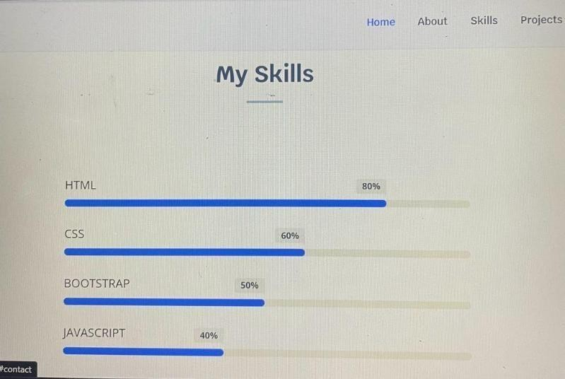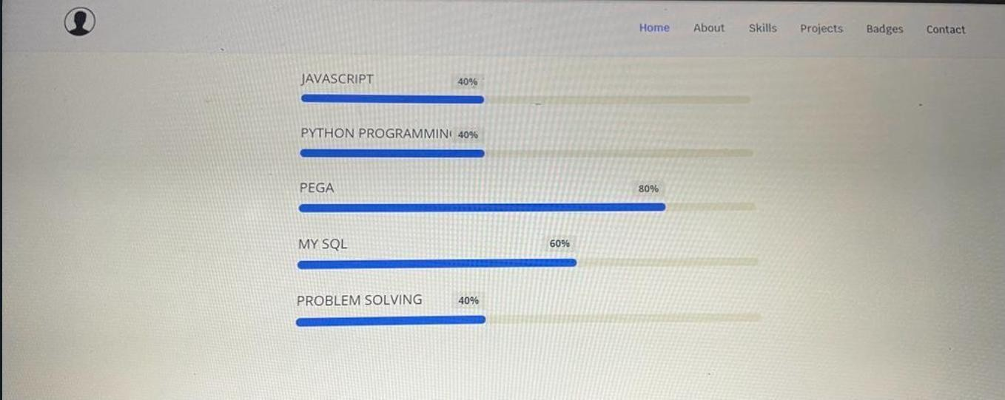

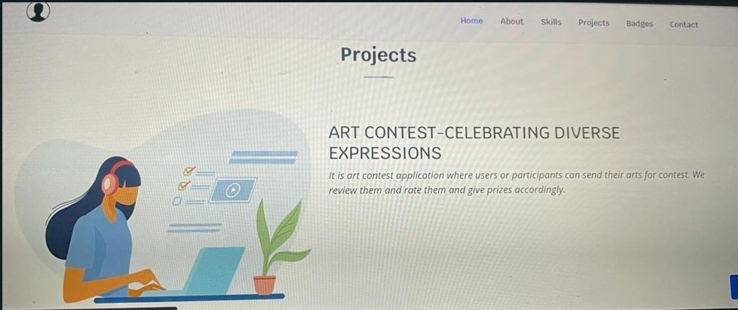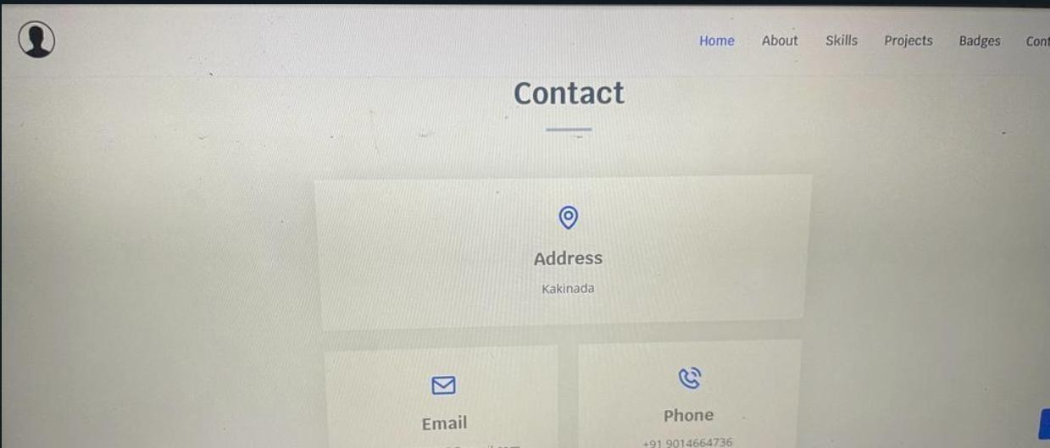

# CONCLUSION

Concluding an internship can be a significant milestone in one's professional development.Here's a summary or conclusion regarding the experience of completing an internship:

* + **Learning and Growth:** The internship provided an in valuable opportunity to learn and grow both personally and professionally. Through hands-on experience, I gained practical skills, expanded my knowledge, and developed deeper understanding of my chosen field.
* **Real-World Application:** The internship allowed me to apply classroom knowledge to real-world scenarios, bridging the gap between theory and practice. I encountered challenges and problem-solving opportunities that helped me develop a more practical perspective on the industry.
* **Skill Development:** Over the course of the internship, I had the chance to develop and refine a range of skills, including technical skills specific to the field, as well as soft skills like communication, teamwork, and time management.
* **Professional Network:** I had the privilege of working along side experienced professionals in the industry, which allowed me to build a valuable network of contacts. These connections can be instrumental in future career opportunities and collaborations.
* **Mentorship and Guidance:** I benefited from the mentorship and guidance of seasoned professionals who provided feedback, shared their expertise, and offered valuable in sights. This guidance was instrumental in my development.
* **Contributions to Projects:** Through out the internship, I actively contributed to meaningful projects, making at angible impact on the organization. These contributions not only added to my portfolio but also gave me a sense of accomplishment.
* **Adaptability:** The internship environment often presented dynamic challenges and changes, forcing me to adapt and think on my feet. This adaptability is a crucial skill that will serve me well in future endeavors.
* **Self-Reflection:** The internship allowed me to reflect on my career goals, interests, and strengths. It helped me gain clarity about my professional path and the direction I want to take in my career.
* **Resume Enhancement:** Completing this internship has added a valuable entry to my resume, demonstrating to future employers my commitment to continuous learning and professional development.
* **Gratitude:** I am grateful for the opportunity to be part of the organization and for the trust placed in me as an intern. I want to express my appreciation to the entire team for their support and mentor ship during this period.

17