Lambda function

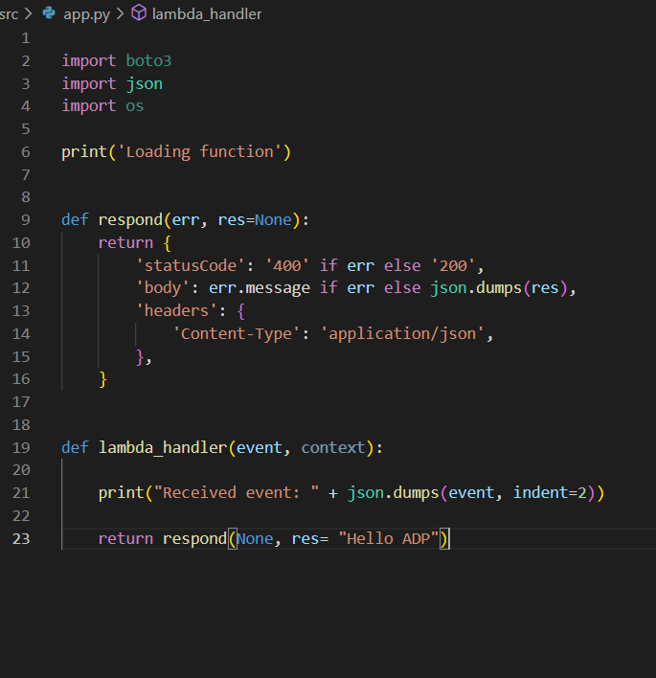

SAM template written

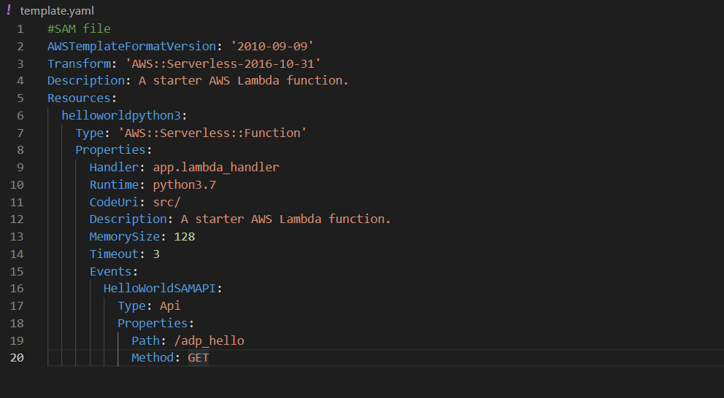

Genrated SAM template

aws cloudformation package --s3-bucket aws-sam-template-creation-adp --template-file template.yaml --output-template-file gen/template-generated.yaml

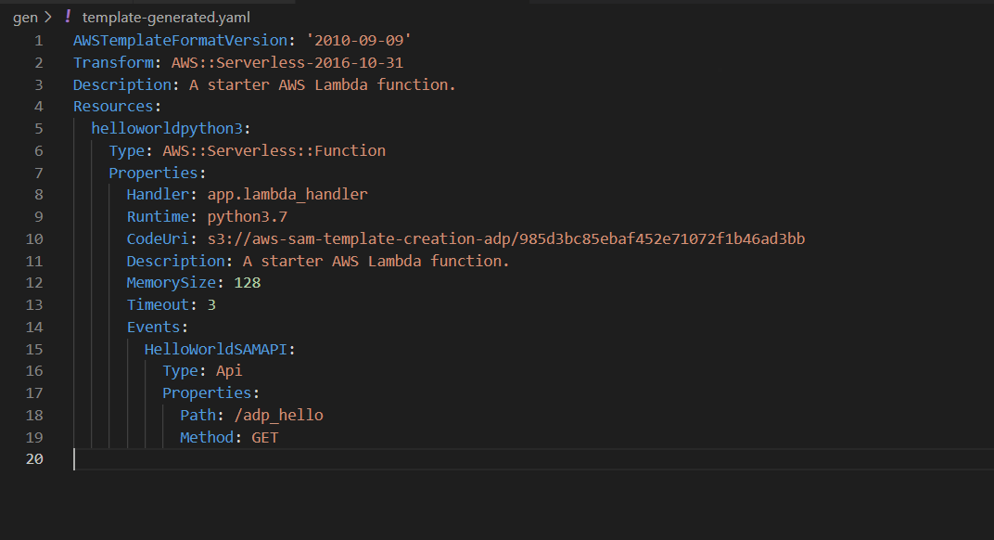

Commands used to

**CREATE BUCKET**

aws s3 mb s3://aws-sam-template-creation-adp

**PACKAGE CLOUD FORMATION**

**DEPLOY**

aws cloudformation deploy --capabilities CAPABILITY_IAM --template-file gen/template-generated.yaml --stack-name hello-sample

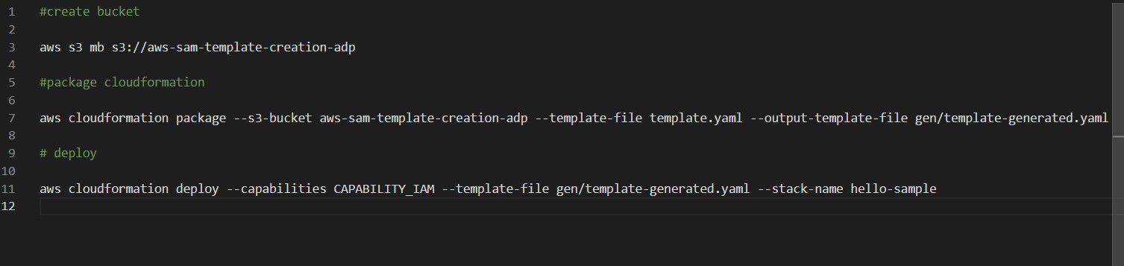

Response

