1.What are the two values of the Boolean data type? How do you write them?

Ans: True and False (0 and 1)

2. What are the three different types of Boolean operators?

3. Make a list of each Boolean operator's truth tables (i.e. every possible combination of Boolean values for the operator and what it evaluate ).

4. What are the values of the following expressions?

(5 > 4) and (3 == 5) : False

not (5 > 4) : False

(5 > 4) or (3 == 5) : True

not ((5 > 4) or (3 == 5)) : False

(True and True) and (True == False) : False

(not False) or (not True) : True

5. What are the six comparison operators?

6. How do you tell the difference between the equal to and assignment operators?Describe a condition and when you would use one.

Ans : the symbol itself indicate if its 1 equals to i.e assignment operator (=)

If its 2 equals to i.e equal operator (==)

A=10 #assignment operator

B=20

If A==B: #equal operator

Print(“True”)

Else:

Print(“false)

7. Identify the three blocks in this code:

spam = 0

if spam == 10:

Block 1

print('eggs')

if spam > 5:

Block 2

print('bacon')

else:

print('ham')

Block 3

print('spam')

print('spam')

8. Write code that prints Hello if 1 is stored in spam, prints Howdy if 2 is stored in spam, and prints Greetings! if anything else is stored in spam.

Ans:

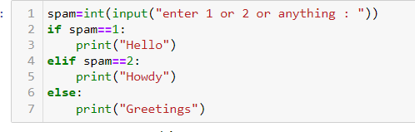

9.If your programme is stuck in an endless loop, what keys you’ll press?

10. How can you tell the difference between break and continue?

Ans:

* while running a loop, if the same value is repeating then we can skip this by using continue
* after certain value is reached , if I want to come out of the loop we use break

11. In a for loop, what is the difference between range(10), range(0, 10), and range(0, 10, 1)?

Ans: all these three are same, it prints from 0 to 9

12. Write a short program that prints the numbers 1 to 10 using a for loop. Then write an equivalent program that prints the numbers 1 to 10 using a while loop.

Ans :

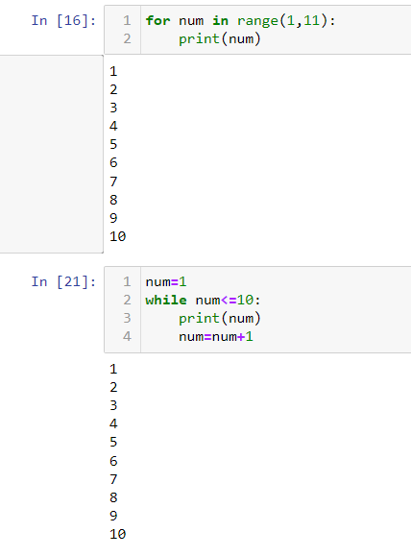

13. If you had a function named bacon() inside a module named spam, how would you call it after importing spam?

Ans:

Import spam

Spam.bacon()