DEEP LEARNING PROJECT REPORT
Rock, Paper, Scissors Image Classification
Using MobileNetV2 Transfer Learning

Submitted By | Abdullah Afzal
Roll No | SU92-BSCSM-F23-473
Class | BSCS-7B
Subject | Deep Learning
Submitted To | Dr. Munir Ahmad

Abstract
This project develops an image-classification system that recognizes hand gestures representing Rock, Paper, and Scissors. It uses transfer learning with MobileNetV2, a convolutional neural network originally trained on ImageNet. Images are resized to 160 × 160 pixels, augmented during training, and passed to a three-class softmax output layer. The model was trained for 8 epochs. The supplied training log reports a final training accuracy of 99.54% and validation accuracy of 99.31%. A Streamlit application is used to make predictions from uploaded images.

1. Introduction
Image classification is a deep-learning task in which a model assigns an image to one of several predefined categories. In this project, the categories are Rock, Paper, and Scissors. The system learns visual patterns in hand images and predicts the most likely gesture. This project demonstrates the practical use of convolutional neural networks, transfer learning, data augmentation, model evaluation, and application deployment.

2. Problem Statement
The goal is to build a computer-vision model that can classify an input hand image into one of three classes—Rock, Paper, or Scissors—with reliable validation performance, and to make the trained model accessible through a simple user interface.

3. Objectives
- Prepare and organize a labelled Rock-Paper-Scissors image dataset.
- Apply image resizing and training-time data augmentation.
- Use MobileNetV2 transfer learning to extract useful visual features.
- Train a three-class classification head and evaluate validation performance.
- Deploy the trained model through a Streamlit application.

4. Dataset
The project uses the Rock-Paper-Scissors dataset available on Kaggle (dataset identifier: drgfreeman/rockpaperscissors). The target classes are Rock, Paper, and Scissors. The notebook pipeline uses an 80/20 training-validation split, image size of 160 × 160 pixels, batch size of 32, and random seed 42. The exact image count per class is not stated in the supplied screenshots, so no class totals are assumed in this report.
Dataset source: Kaggle — drgfreeman/rockpaperscissors.

5. Data Preprocessing and Augmentation
Images are resized to 160 × 160 pixels and processed in batches. The training pipeline applies random horizontal flipping and a small random rotation (factor 0.05) to introduce variation and help reduce overfitting. A rescaling operation is used to map pixel values into the range expected by the model pipeline. The data pipeline also uses prefetching to improve input delivery during training.
- Input shape: 160 × 160 × 3 (RGB image).
- Batch size: 32.
- Training-validation split: 80% / 20%.
- Augmentation: RandomFlip and RandomRotation(0.05).
- Random seed: 42.

6. Model Architecture
MobileNetV2 is used as the feature-extraction backbone with ImageNet-pretrained weights. The base model is frozen during this training stage, so its weights are not updated. A Global Average Pooling layer converts the feature maps into a feature vector, followed by Dropout (0.3) and a Dense layer with 3 softmax outputs.
- Input: 160 × 160 × 3.
- Data augmentation: RandomFlip and RandomRotation.
- Preprocessing/rescaling layer.
- MobileNetV2 backbone with ImageNet weights (frozen).
- GlobalAveragePooling2D.
- Dropout: 0.3.
- Dense output: 3 neurons with softmax activation.
The architecture summary screenshot reports 2,261,827 total parameters and 3,843 trainable parameters. The remaining parameters belong to the frozen feature-extraction backbone and are not updated during training.
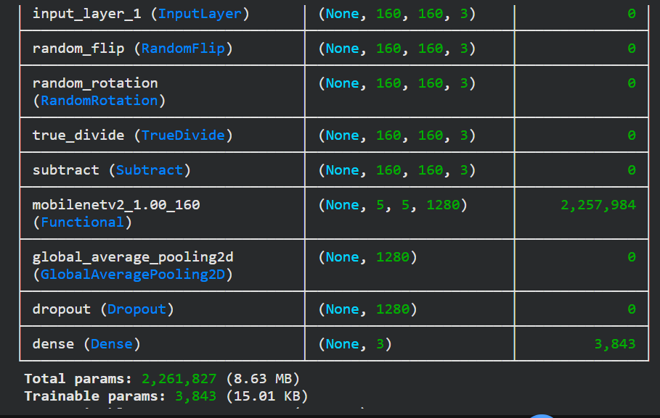
Figure 1. Model summary showing MobileNetV2 feature extraction and the three-class output layer.

7. Training Configuration
Setting | Value
Backbone | MobileNetV2
Pretrained weights | ImageNet
Trainable base model | Frozen
Optimizer | Adam
Learning rate | 0.001
Loss function | Sparse categorical crossentropy
Epochs | 8
Batch size | 32
Output classes | 3

8. Results and Performance
The supplied training log shows that the model converged quickly over 8 epochs. Validation accuracy remained high and reached 99.31% in the final two epochs. The final recorded training accuracy was 99.54%.
Metric | Recorded value
Epochs completed | 8
Final training accuracy | 99.54%
Final validation accuracy | 99.31%
Final training loss | 0.0195
Final validation loss | 0.0168
Best validation accuracy shown | 99.31% (Epochs 7 and 8)
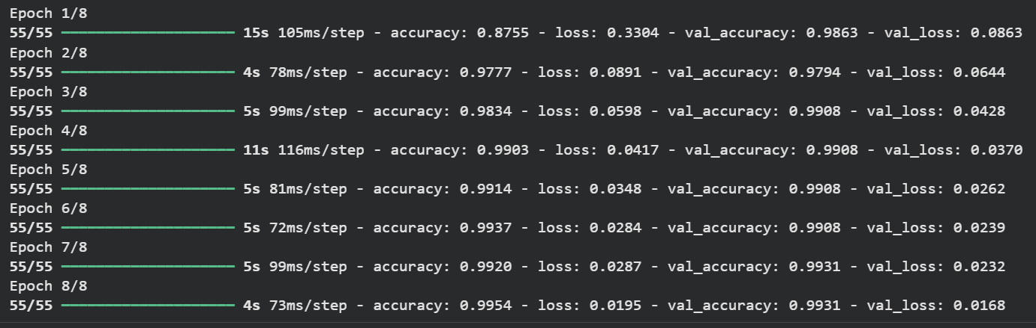
Figure 2. Training log for all 8 epochs.
These figures are the training and validation metrics displayed by the training process. They should not be described as independent test-set accuracy unless a separate test evaluation is performed.

9. Application Deployment
The trained model is integrated into a Streamlit application. The user can upload a hand image, and the application preprocesses the image to the model's expected input size before displaying the predicted class. During deployment debugging, an inference preprocessing mismatch was identified: preprocessing was being applied twice. Removing the duplicate app-side preprocessing corrected the prediction pipeline.
A deployed prediction should be interpreted as the model's classification, not as a guarantee that every possible camera image will be classified correctly. Performance can be affected by lighting, background, camera angle, hand position, and image quality.

10. Limitations
- The model is trained for only three gesture categories.
- The reported validation metrics do not replace evaluation on a separate, unseen test set.
- Changes in lighting, background, camera angle, and hand distance may affect predictions.
- The supplied screenshots do not include a confusion matrix or per-class precision and recall.

11. Future Improvements
- Evaluate the model on a separate test dataset containing unseen images.
- Generate a confusion matrix and class-wise precision, recall, and F1-score.
- Test images captured under different lighting and background conditions.
- Collect more varied training images to improve generalization.
- Add a confidence score and clearer user guidance in the Streamlit interface.

12. Conclusion
The project successfully demonstrates a three-class Rock-Paper-Scissors image classifier using MobileNetV2 transfer learning. With an input size of 160 × 160 pixels and an eight-epoch training run, the recorded final training accuracy was 99.54% and validation accuracy was 99.31%. The model was also integrated into a Streamlit application for interactive image prediction. The project provides practical experience in dataset preparation, augmentation, transfer learning, model training, evaluation, and deployment.

References
- Keras documentation, MobileNetV2: https://keras.io/api/applications/mobilenet/
- TensorFlow documentation: https://www.tensorflow.org/
- Kaggle dataset: drgfreeman/rockpaperscissors.
- Streamlit documentation: https://docs.streamlit.io/

