# Assignment: Functions & CTE

1. Problem Statement:
   1. Kindly run the attached SQL Script in a database.
   2. There should be multiple tables created.
   3. Create a function called fnTableCourses to return a table of all of the courses which start and finish between two specified dates. ( Hint: function should take two date parameters as start and end date and then should be matched with schedule table)



1. Problem Statement:
   1. Kindly run the attached SQL Script in a database.
   2. There should be multiple tables created.
   3. Create a function to provide the number of events on a particular day of a week as per below screenshot: 
      1. 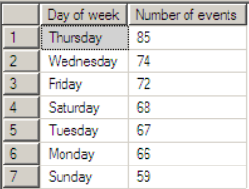
2. Problem Statement: USE CTE
   1. Kindly run the attached SQL Script in a database.
   2. There should be multiple tables created.
   3. **Get a list of all of the episodes written by authors with MP in their names.**
   4. **Get a list of the companions featuring in these episodes**

