SOC 2 Automated Compliance
Platform
Data Model and ER Design
The complete entity relationship design

Contents
1. Introduction
2. System overview
3. Module designs
4. The 360 degree linkage model
5. Design decisions and reasoning
6. Conventions and scheduled jobs
7. Points to confirm

1. Introduction

1.1 Purpose
This document presents the complete data model for the SOC 2 automated compliance platform: every module as an entity relationship diagram, the linkage model that connects the modules, and the reasoning behind each structural decision. It is the basis for the database design and migrations.

1.2 How to read the diagrams
- Each box is a table. Rows list the column type, the column name, and whether it is a primary key (PK) or foreign key (FK). Only the defining columns are shown; shared columns that exist on every table are listed once in Section 6.
- Lines between boxes are relationships. The notation on the line ends reads as one or many: a double bar means exactly one, and the crow foot with a circle means zero or many. For example, one tenant has many groups, and one control is proven by many evidence items.
- Labels on the lines name the relationship in plain words.

1.3 Three principles behind the model
- Frameworks are content, controls belong to the organisation. Framework requirements, the prebuilt control library, checks, and templates ship as read-only data. The organisation's records map onto them, so ISO 27001, GDPR, and HIPAA are added later by inserting content, never by changing the schema.
- Every operational row is tenant scoped. Every tenant owned table carries tenant_id, enforced on every query, so isolation between customer companies is structural rather than an afterthought. The provider plane tables (platform admins and the tenants register) sit above this and are the deliberate exception.
- Every ingestible record is born integration ready. Anything that could ever arrive from an outside system carries source, external_id, and synced_at from day one, so each future connector, including Vantagemdm, becomes a simple synchronisation against tables that already exist.

2. System overview
Controls are the hub of the model. Requirements justify them, evidence proves them, and every other module traces back to them. The diagram below shows the modules and the main relationships between them; each module is then detailed in Section 3.
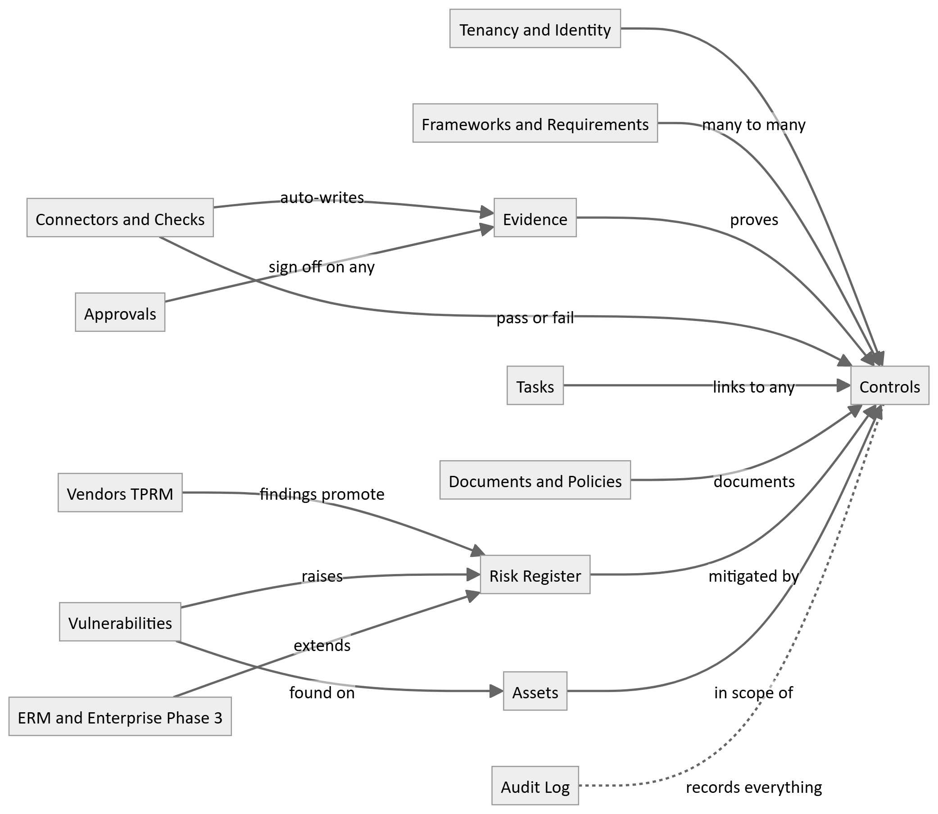

3. Module designs

3.1 Tenancy: the provider plane and the tenant plane
The platform has two planes. The provider plane internal admin panel or will be our signup page as we discussed over the call, where team registers and manages the customer companies. The tenant plane is the application each customer company uses, where their own users, controls, evidence, and everything else live. A tenant is one customer company. Every operational table in this document is scoped to one tenant by tenant_id; the provider plane sits above all tenants.
The provider plane: registering and branding a tenant
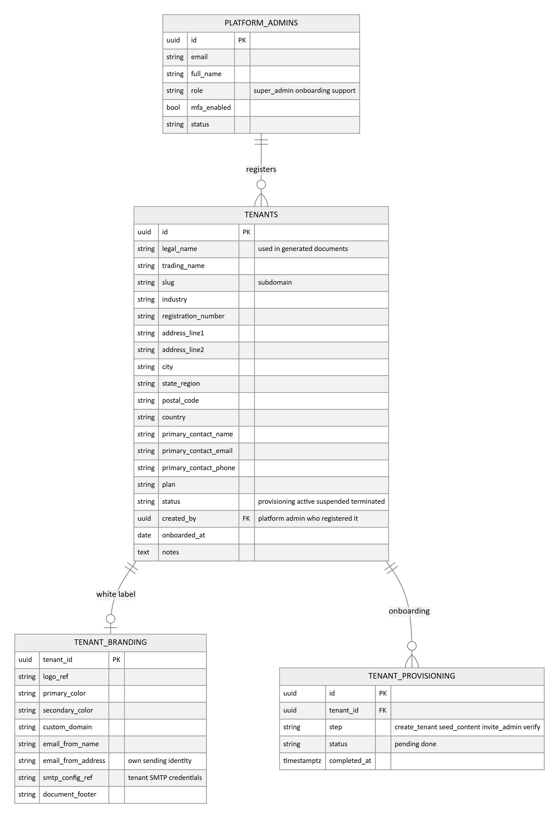
- The TENANTS record is the customer company. It holds the company profile captured at registration: legal and trading name, registration number, full address, industry, primary contact, plan, and status. These are the details that flow straight into generated documents, so a policy for a tenant already carries that tenant's legal name and address without anyone retyping them.
- TENANT_BRANDING is the white label layer: the tenant's logo, colours, and custom domain, plus their own email sending identity and SMTP credentials so notifications and acknowledgement emails come from the tenant, not from the platform, and a document footer for their exports.
- TENANT_PROVISIONING tracks the onboarding steps when a tenant is created: seed the content library, invite the tenant's first admin, verify. The tenant lifecycle status (provisioning, active, suspended, terminated) is managed from the provider panel.
The tenant plane: users, groups, roles, and permissions
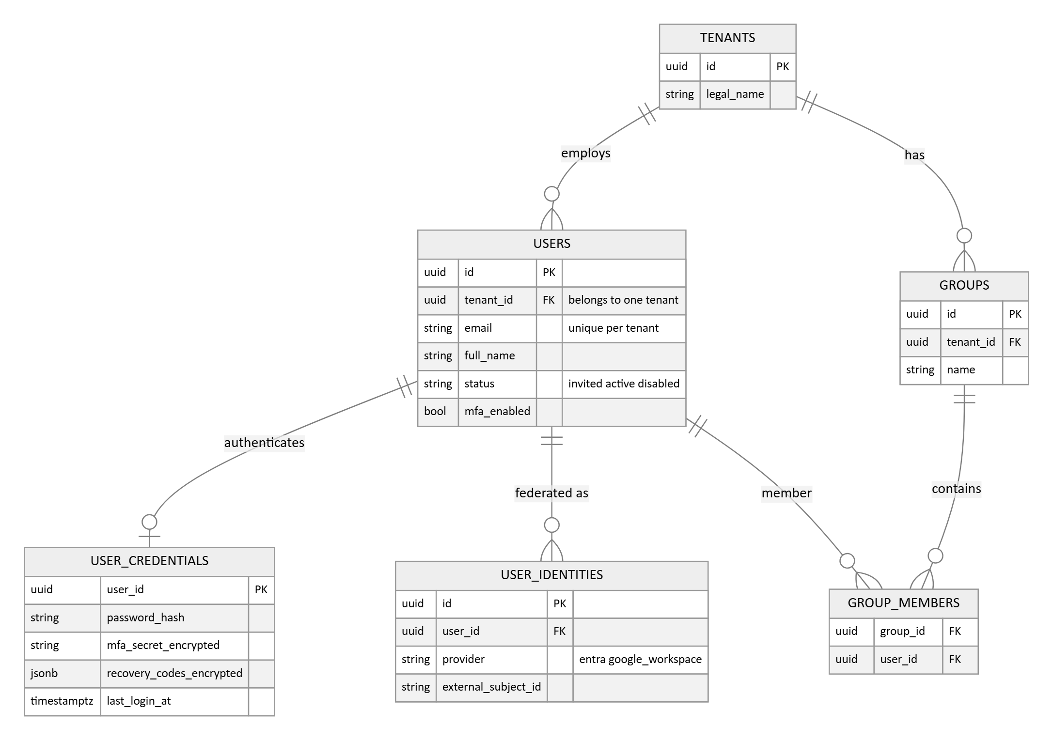
- A user is a global identity, not bound to one tenant. The USERS row is the person (email, unique globally, plus the link to their credentials and federated identities); it carries no tenant_id. Their relationship to an organisation is TENANT_MEMBERSHIPS, the many-to-many join recording which user belongs to which tenant and with which roles there. Every in-tenant reference to a person, an asset owner, a control owner, an approver, an assignee, is a foreign key to the membership, never to the user directly, so a person who works with two organisations is two memberships and nothing leaks across the tenant boundary. Phase 1 defaults to exactly one membership per user (signup creates one user and one membership); a global user, an auditor or consultant spanning several organisations, is the same schema with more than one membership, so enabling it later is a feature flag, not a rewrite.
- Credentials live in their own table: the password hash and MFA enrollment data (encrypted secret and recovery codes), one row per user, kept out of the hot users table. This is the native authentication provider used in Phase 1. It is one auth mechanism behind the identity seam, not the only possible one, so it can be left dormant per tenant once that tenant federates.
- USER_IDENTITIES is the federation seam, and it is provider-agnostic by design: it maps a platform user to an external identity by provider and subject (provider name, provider type such as OIDC or SAML, and the external subject id). The customer's external Keycloak-based solution, an in-house Keycloak we may build ourselves later, or a direct Entra ID, Okta, or Google Workspace connection are all just rows here. It is empty under native auth and populated when an identity provider is added. Adding or swapping a provider is additive, new rows plus a new auth provider registered behind the seam, and never a schema rewrite.
- Authentication is pluggable behind one identity seam. The user record is the platform's source of truth for who exists and is decoupled from how they authenticate, so native auth now and any identity provider later coexist without changing the model. This is what keeps a future move to our own Keycloak, or to the customer's, an extension rather than a rewrite.
- Members can be organised into groups within a tenant. Groups are tenant scoped and contain memberships, not global users, so group-based role assignment stays inside the tenant boundary.
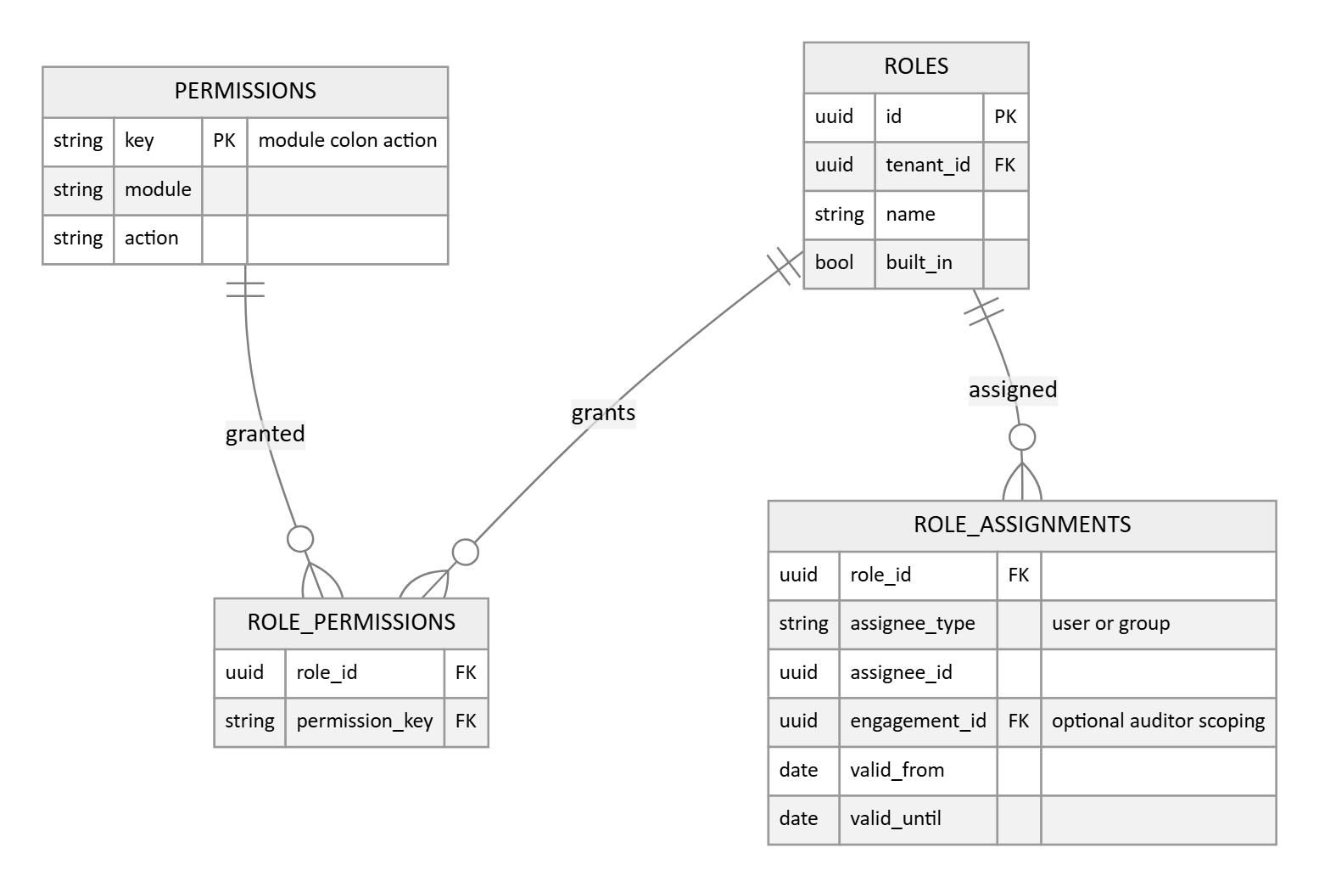
- Permissions are flat module and action keys, for example controls edit or evidence approve. Roles are named bundles of those keys, and a role can be assigned to a single user or to a whole group.
- Object scoped roles, the Control owner seeing only assigned controls and the Auditor seeing only the audit scope, are enforced in application logic by filtering on ownership and assignment columns on top of the flat permission check. The flat model alone does not deliver row level scoping, and implementers should not assume it does.
- Auditor access is time boxed and engagement scoped through the optional engagement_id, valid_from, and valid_until columns on role assignments: an auditor role assignment tied to an engagement grants read only access inside that engagement's window and expires with it.

3.2 Compliance core: the framework engine
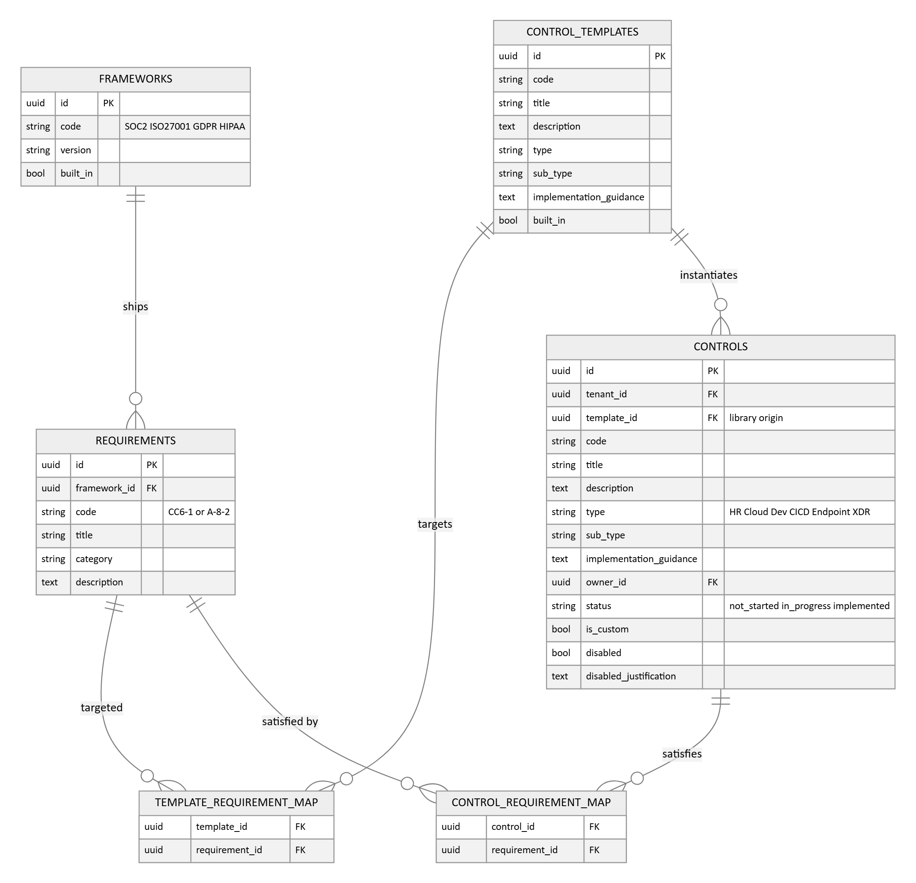
- Frameworks, requirements, and the prebuilt control library (CONTROL_TEMPLATES) carry no tenant_id: they are global, read-only content seeded by the platform. Everything the organisation edits lives in CONTROLS.
- Tenant creation instantiates the library: each control template becomes a tenant control carrying template_id, and the template's requirement mappings are copied into the tenant control's map. Shipped check mappings reference the stable template identity, which is how checks arrive already mapped to controls in every new tenant.
- One control satisfying requirements in several frameworks is one row in CONTROLS and several rows in the map. Evidence attached to that control automatically counts toward every mapped framework: collect once, satisfy many.
- Controls carry the requested Type and Sub-type columns, an implementation guidance text (inherited from the template, editable per tenant), owner, status, and disable with recorded justification. Custom controls are rows with no template_id.
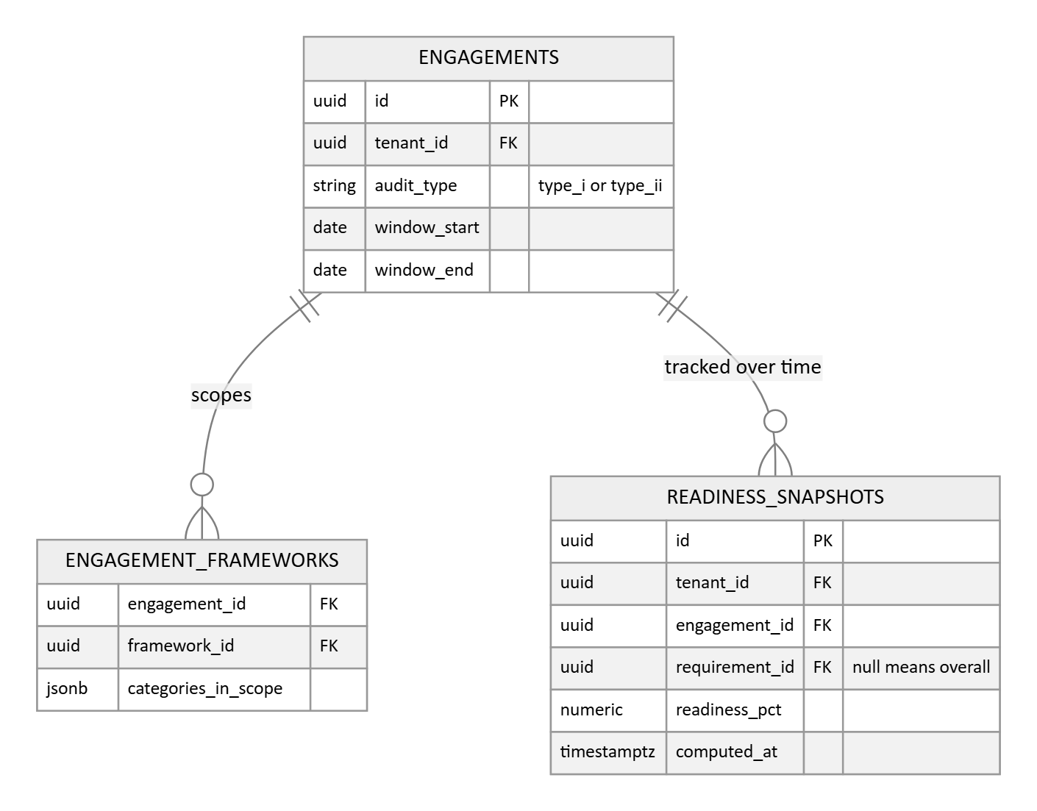
- The engagement records the audit type, Type I or Type II, the observation window, and which Trust Services categories are in scope per framework.
- READINESS_SNAPSHOTS makes the promised readiness tracked over time real: an append only table written on a schedule by the same job that refreshes evidence staleness, one row per engagement for the overall percentage and one per requirement for the per criterion trend. Live readiness is computed from the maps; history comes from here, because mappings and evidence mutate in place and past values could not otherwise be reconstructed.

3.3 Evidence
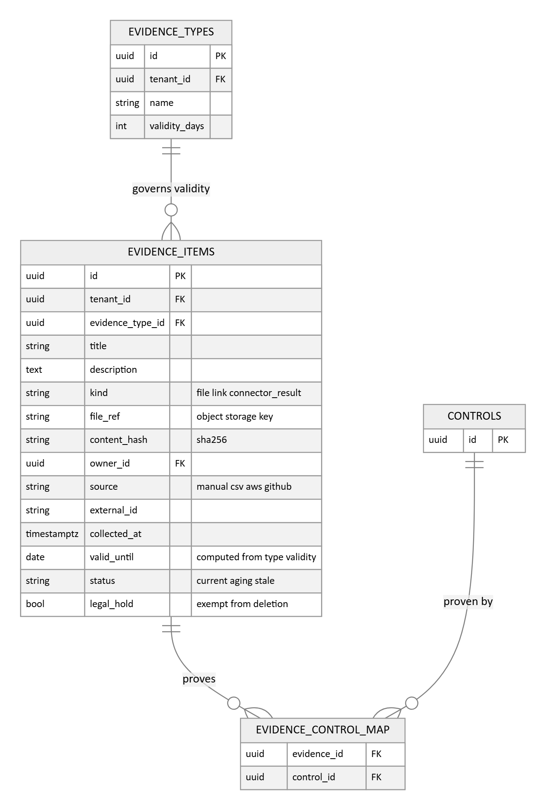
- The database stores metadata and an integrity hash. The file itself lives in object storage under file_ref, which keeps the database small, backups fast, and files servable through signed URLs.
- EVIDENCE_TYPES holds the per type validity period the requirements promise: valid_until is computed at capture from the item's type, staleness is derived from valid_until and cached in status by a scheduled job, and a renewal task is created automatically when an item goes stale.
- legal_hold exempts an item from retention deletion, which is the enforcement point for the data handling rule in Section 6.
- Evidence review, the approve or reject with recorded reviewer and time, is carried by the generic APPROVALS record in Section 3.11, not by a column here, so evidence, documents, controls, and risk acceptances all share one approval mechanism.
- Connector written evidence in Phase 2 uses this same table with kind set to connector_result. Automated and manual evidence are one concept: one renewal queue, one approval path, one audit surface.

3.4 Tasks and issues
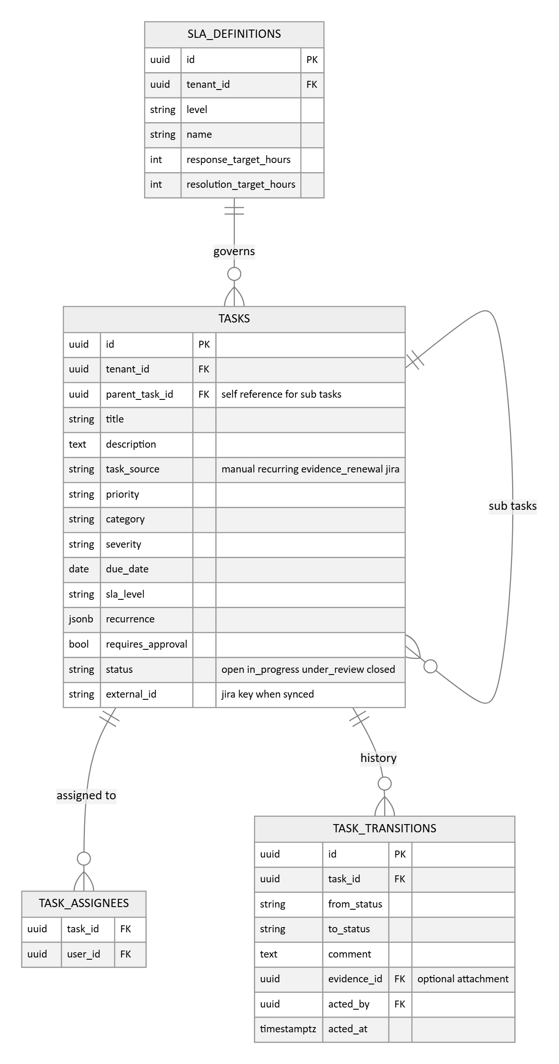
- task_transitions is append only and is the immutable task history: who, when, from which status to which, with a comment and an optional evidence attachment on every transition.
- SLA_DEFINITIONS gives each SLA level a meaning, response and resolution targets configurable per tenant, so the sla_level tag on a task resolves to real targets that can be evaluated and reported.
- Tasks connect to controls, policies, risks, evidence, assets, and vulnerabilities through the links table described in Section 3.11, rather than through a column per target type.
- The Jira loose coupling is carried by task_source and external_id: the Phase 2 connector synchronises by that pair, and standalone use is unaffected.

3.5 Documents and policies
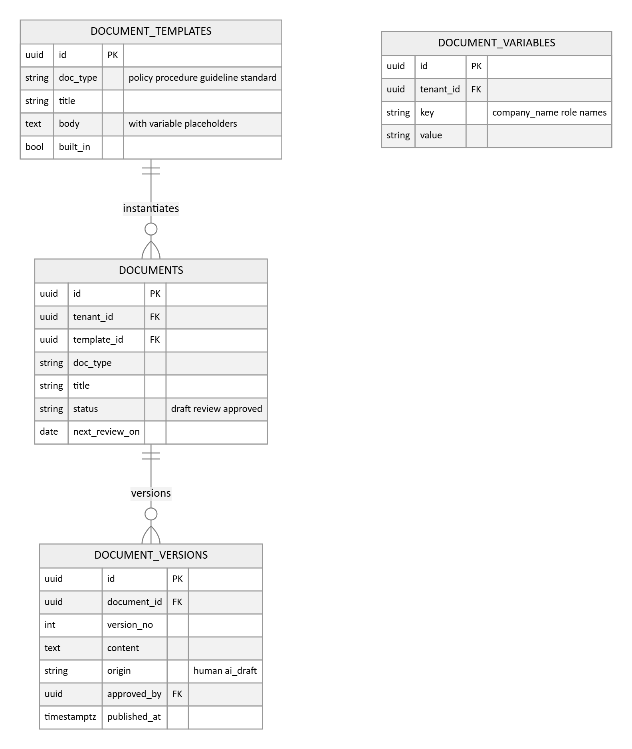
- Published versions are immutable rows. Editing creates the next version, and showing differences between versions comes directly from keeping full content per version.
- DOCUMENT_VARIABLES holds the tenant's reusable values, company name, role names, system names. Template bodies embed placeholders that are resolved from this table at render time, so a changed company name flows through every document.
- Phase 2 AI drafting writes versions with origin set to ai_draft. They pass through the same human review and approval gate as manual documents; there is no separate path for AI content.
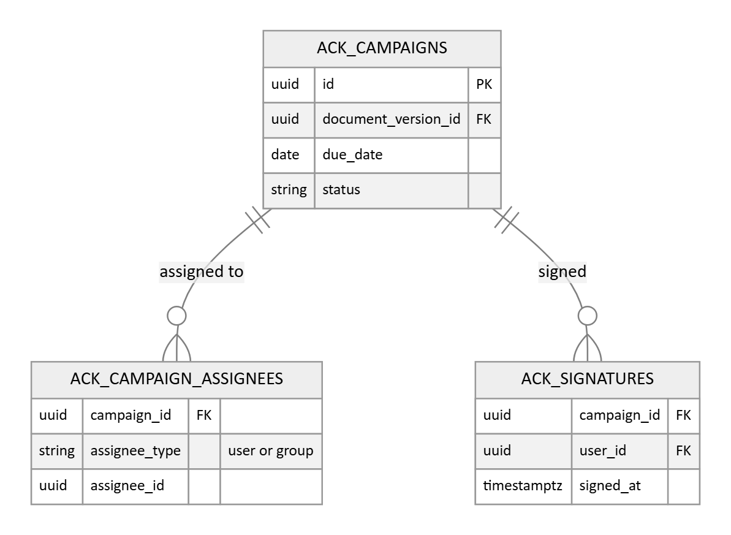
- Acknowledgement campaigns target a specific version, not the document, so the record that staff acknowledged version 3 survives version 4 being published.
- ACK_CAMPAIGN_ASSIGNEES records the assigned population, individual users or whole groups, which is what makes non signers computable: assignees resolved minus signatures received drives the reminder job and the completion percentage. Group membership is snapshot at campaign launch, so later joiners fall into the next campaign rather than retroactively appearing overdue.
- Completion exports as an evidence item, ready for the auditor.

3.6 Risk register
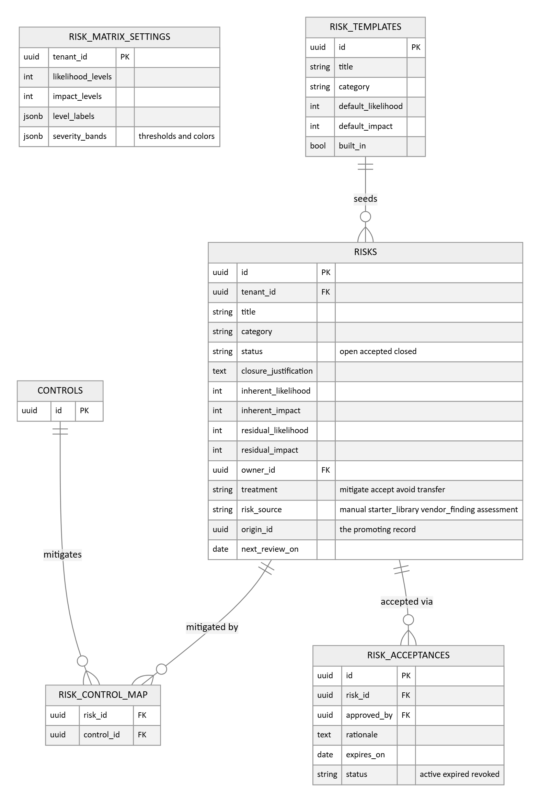
- The flow the module supports: identify and record the risk, score inherent likelihood and impact, link the controls that mitigate it, decide the treatment, record the residual score, and revisit on scheduled review dates.
- RISK_MATRIX_SETTINGS makes the matrix genuinely configurable per tenant: scale sizes, level labels, and the severity bands with their colors. Scoring bounds and the heatmap read from here rather than from hard coded values.
- RISK_TEMPLATES is the starter risk library, shipped as global content like the control library: instantiating it stamps risk_source as starter_library with origin_id pointing at the template, so seeded and hand raised risks stay distinguishable.
- Risks now carry an explicit status, open, accepted, or closed, with a closure justification. The scheduled job that expires acceptances flips the acceptance to expired and sets the risk back to open, which is the reopen the requirements promise.
- A risk with no linked control is found by querying the map, not by a stored flag, so the warning can never go stale.
- risk_source and origin_id exist now so the Phase 3 ERM module extends this table instead of replacing it; the ERM entities themselves are designed in Section 3.12.

3.7 Third party vendor risk
This module is designed to product grade, benchmarked against dedicated TPRM platforms (OneTrust, Prevalent, ProcessUnity, Venminder), security rating services (SecurityScorecard, BitSight, UpGuard), the vendor modules of Vanta and Drata, and the Shared Assessments SIG, CAIQ, and HECVAT questionnaire standards. It covers the full lifecycle: intake, tiering, due diligence, contracting, approval, continuous monitoring, reassessment, and offboarding.
Vendor register and engagements
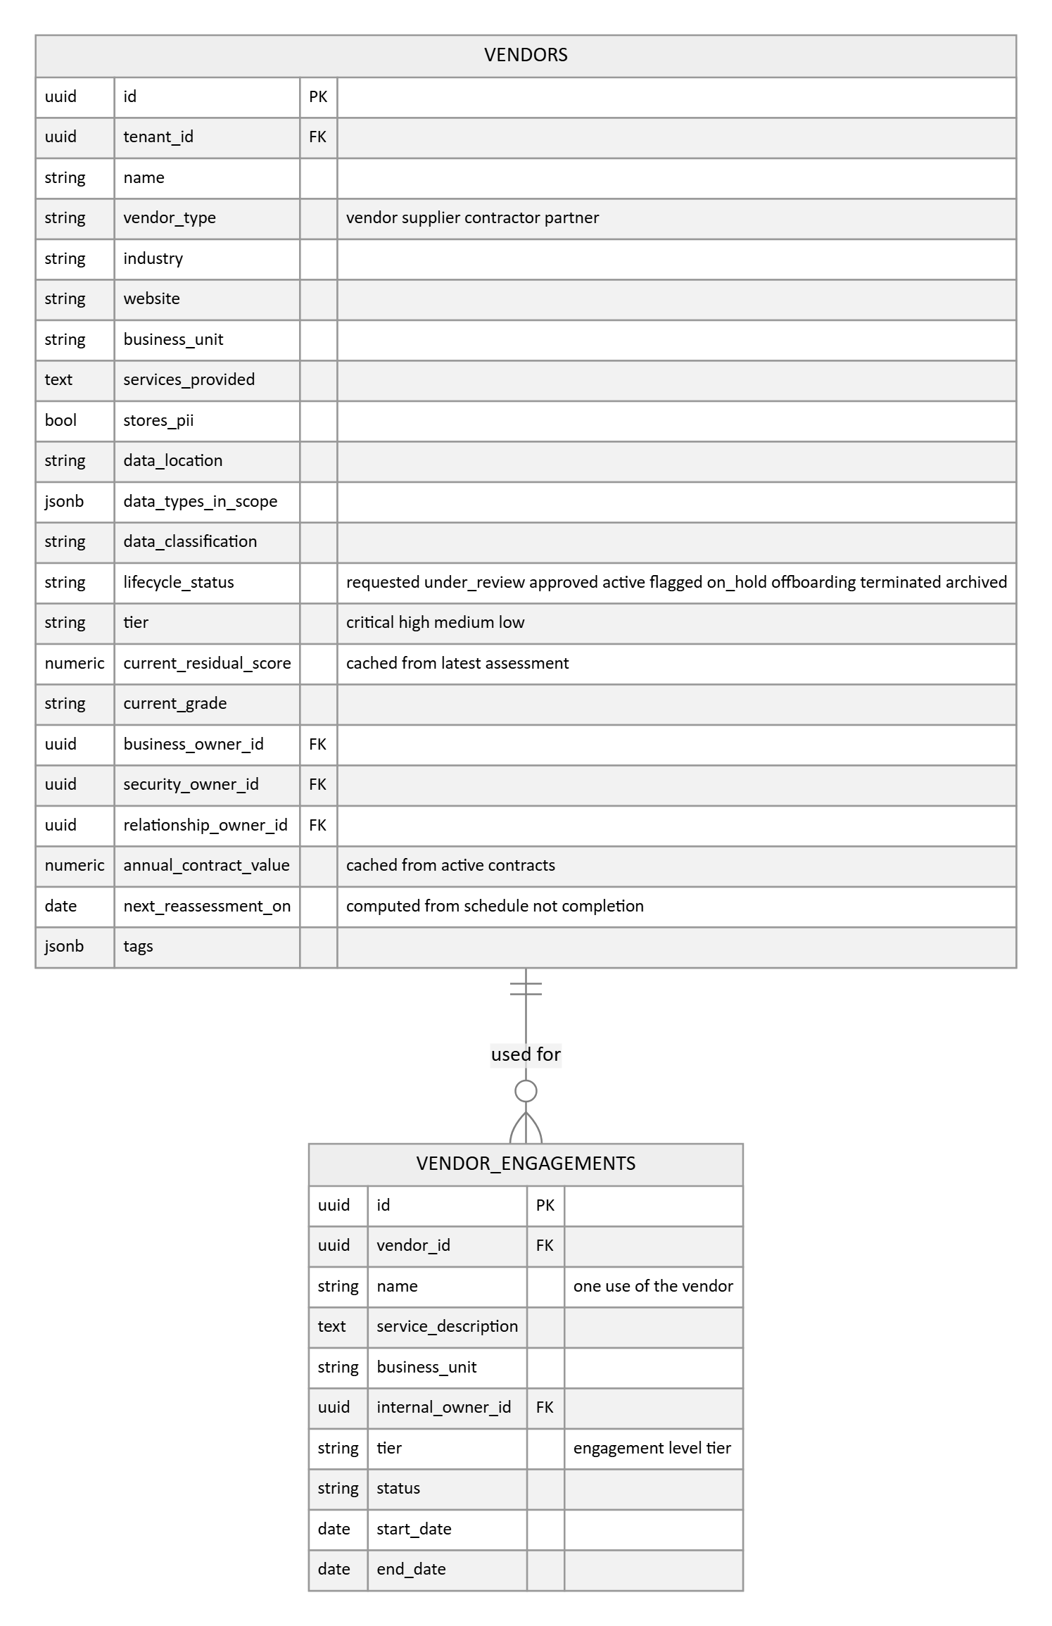
- The vendor record carries the full profile: firmographics, business unit, the services provided, whether it stores personal data and where, data types and classification, the three owners (business, security, and relationship), and a lifecycle status that doubles as the approval pipeline, from requested through active to terminated and archived.
- VENDOR_ENGAGEMENTS is the two level model that separates real TPRM products from checkbox features: the vendor is the organisation, an engagement is one use of it. The same vendor serving two departments with different data gets one vendor row and two engagements, each with its own tier, owner, assessments, and contract, so risk is scoped to the relationship rather than averaged across uses. Engagement references are optional throughout, a small organisation can ignore them entirely.
- current_residual_score and current_grade are cached from the latest scored assessment for portfolio ranking; history lives on the immutable assessments. Duplicate detection on save, matching name or website, is application logic over these columns.
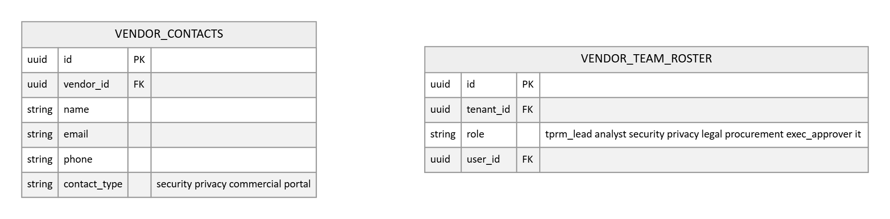
- VENDOR_CONTACTS carries the vendor side people, including the portal contacts who receive questionnaires. VENDOR_TEAM_ROSTER is the internal RACI backbone: the named roles, TPRM lead, analyst, security, privacy, legal, procurement, and executive approver, assigned once and resolved by every stage and approval, so required reviewers by tier resolve to real people.
Intake and discovery
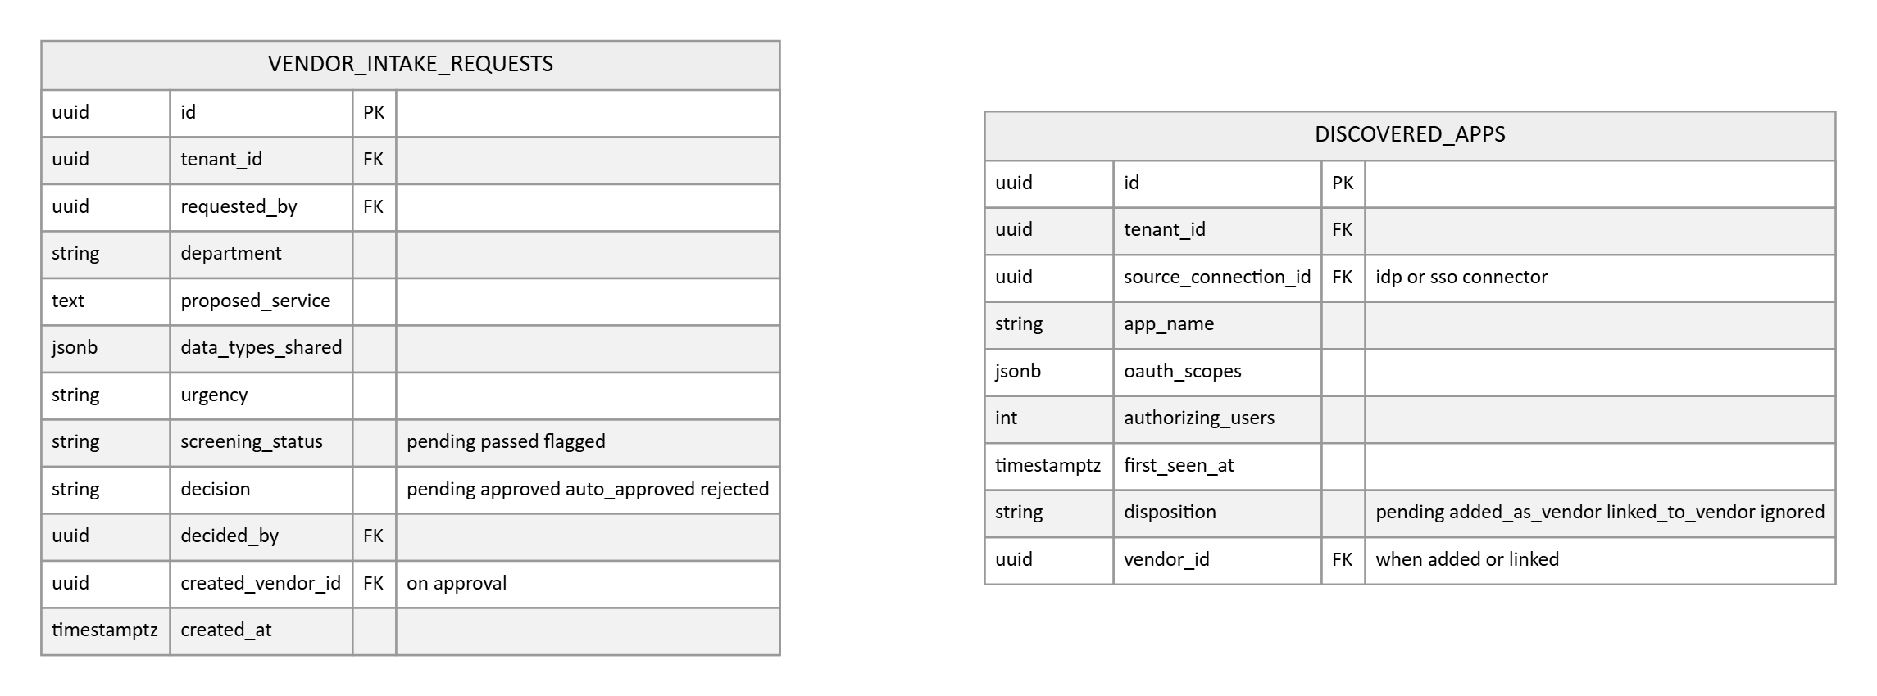
- VENDOR_INTAKE_REQUESTS is the front door: an employee requests a new vendor with the proposed service and the data to be shared, before any vendor record exists. Screening runs against the request, tiering rules can auto approve low risk asks, and approval creates the vendor with lineage back to the request.
- DISCOVERED_APPS is the shadow IT queue, and it free rides on connectors the platform already has: the identity connectors (Google Workspace, Okta, Microsoft 365) surface third party apps from OAuth grants and SSO assignments, each with its scopes, user count, and first seen date. Triage either creates a vendor, links to an existing one, or dismisses, so unmanaged vendors surface themselves.
Tiering and lifecycle
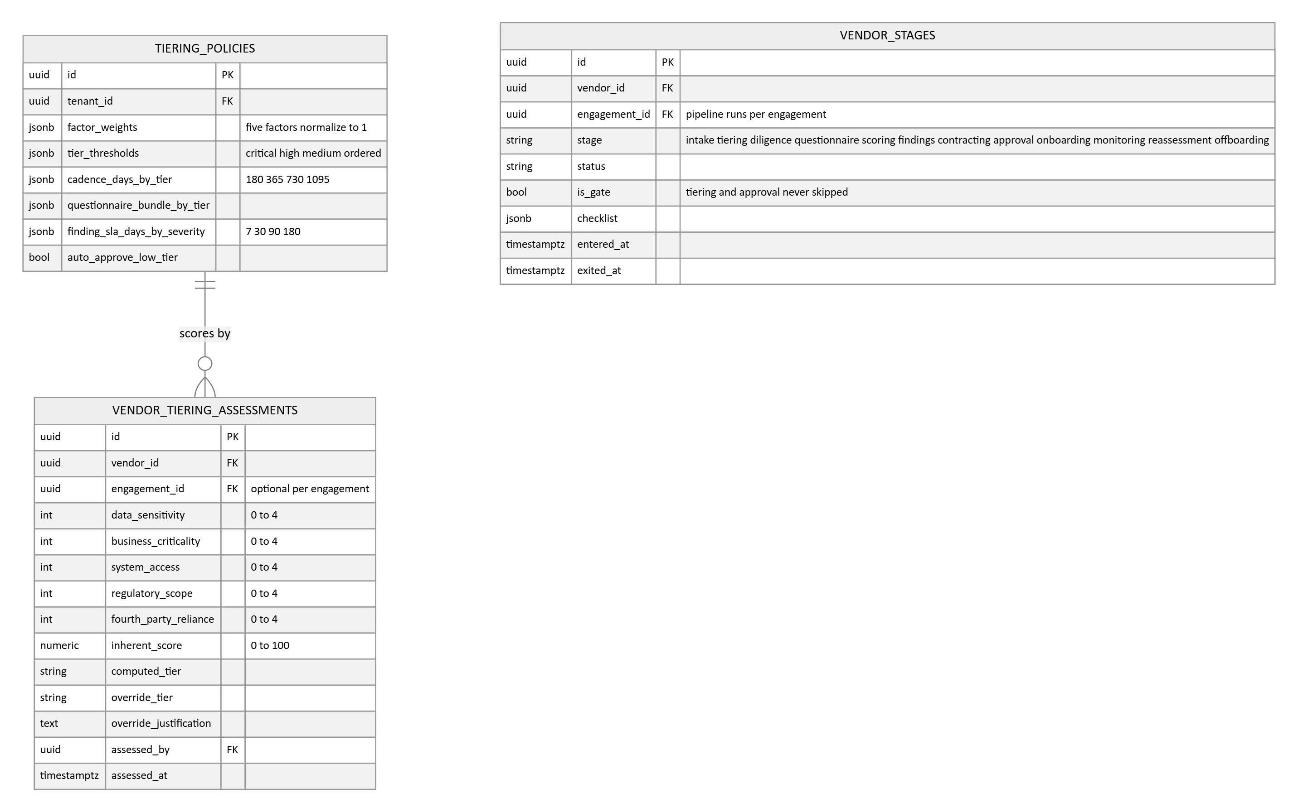
- TIERING_POLICIES is the proportionality engine, fully configurable per tenant: the five factor weights, the tier thresholds, the reassessment cadence per tier, the questionnaire bundle per tier, the finding SLA days per severity, and whether low tier requests auto approve. Weights are validated to normalize and thresholds to stay ordered.
- VENDOR_TIERING_ASSESSMENTS stores the five factor scores behind the tier, data sensitivity, business criticality, system access, regulatory scope, and fourth party reliance, the computed inherent score and tier, and any override with justification. Inherent and residual risk are deliberately separate fields with different jobs: inherent is scored before review and drives rigor; residual is the output of the completed review.
- The staged lifecycle is data, rows in vendor_stages, each stage carrying its checklist. Tier based stage skipping means inserting fewer rows; gates are rows flagged is_gate that require an approval record to exit and are never skipped. next_reassessment_on is computed from the cadence schedule, not from completion dates, so reviews cannot drift later each cycle.
Questionnaires and assessments
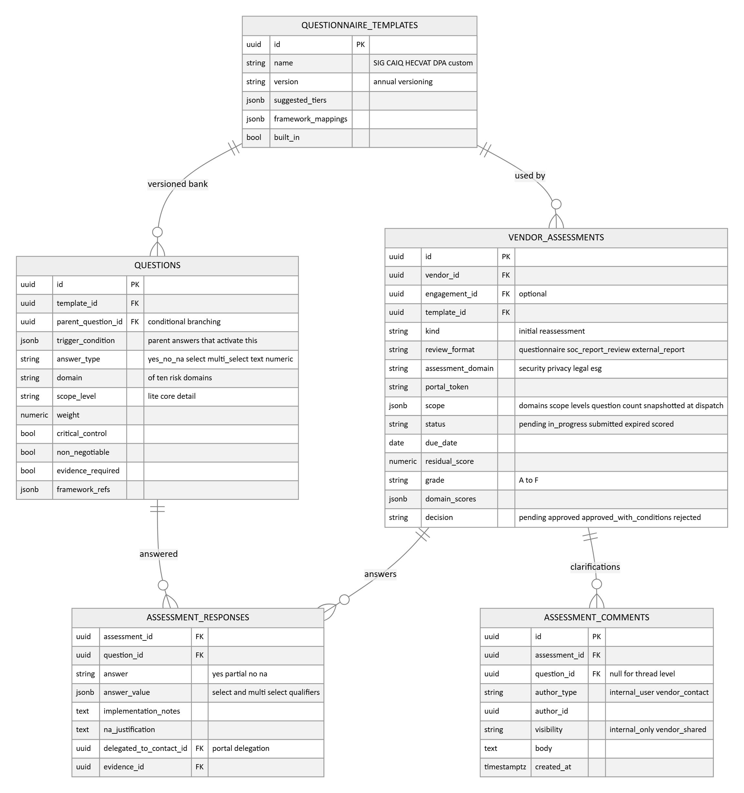
- Questionnaire standards ship as versioned question banks, SIG, CAIQ, and HECVAT are versioned annually, so every stored answer is pinned to its standard and version and survives the next revision. Questions carry a scope level (lite, core, detail), so tiering subsets one bank instead of duplicating templates, plus the branching parent reference, the domain, weights, and the critical control and non negotiable flags that gate approvals.
- Assessments carry the review format, because real due diligence is not always a questionnaire: a structured SOC report review or an externally completed report upload are first class formats. The assessment domain (security, privacy, legal) lets several parallel reviews run against one vendor without duplicating records.
- The portal token gives the vendor a self service link; responses support delegation to a named vendor contact, per answer implementation notes, a justification when answering not applicable, and attached evidence. Submitted assessments are immutable and store the scoring snapshot: residual score, grade, and the per domain breakdown.
Documents and structured report review
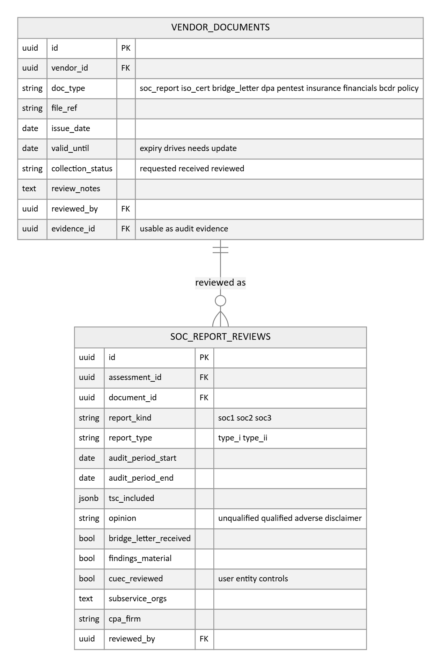
- VENDOR_DOCUMENTS is the typed artifact library per vendor: SOC reports, ISO certificates, bridge letters, DPAs, penetration test summaries, insurance certificates, financials, and continuity plans, each with issue and expiry dates and a collection workflow of requested, received, reviewed. Expiring documents surface in the renewal queue exactly like stale evidence, and a reviewed document can stand as audit evidence.
- SOC_REPORT_REVIEWS turns a vendor's SOC report from a PDF into queryable fields: report kind and type, audit period, criteria included, the auditor's opinion, bridge letter status, whether findings are material, and whether the complementary user entity controls were reviewed. This structured review is precisely the CC9.2 evidence an auditor asks for.
Contracts and service levels
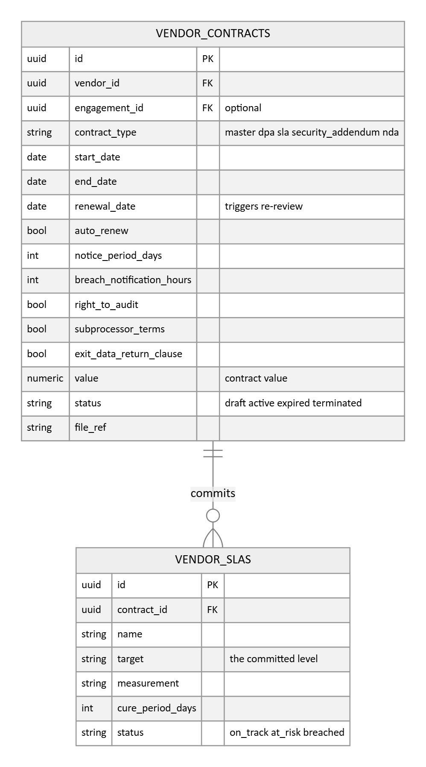
- Contracts are clause level objects, not attachments: type (master, DPA, SLA, security addendum), dates, renewal with notice period, and the security clauses that drive the program, breach notification window, right to audit, subprocessor terms, and exit data return. Contract renewal triggers a re review, and the offboarding checklist reads the exit clauses.
- VENDOR_SLAS holds the contract derived service commitments with cure periods; a breach raises a signal and can raise a finding, connecting contractual performance to the risk picture.
Continuous monitoring and signals
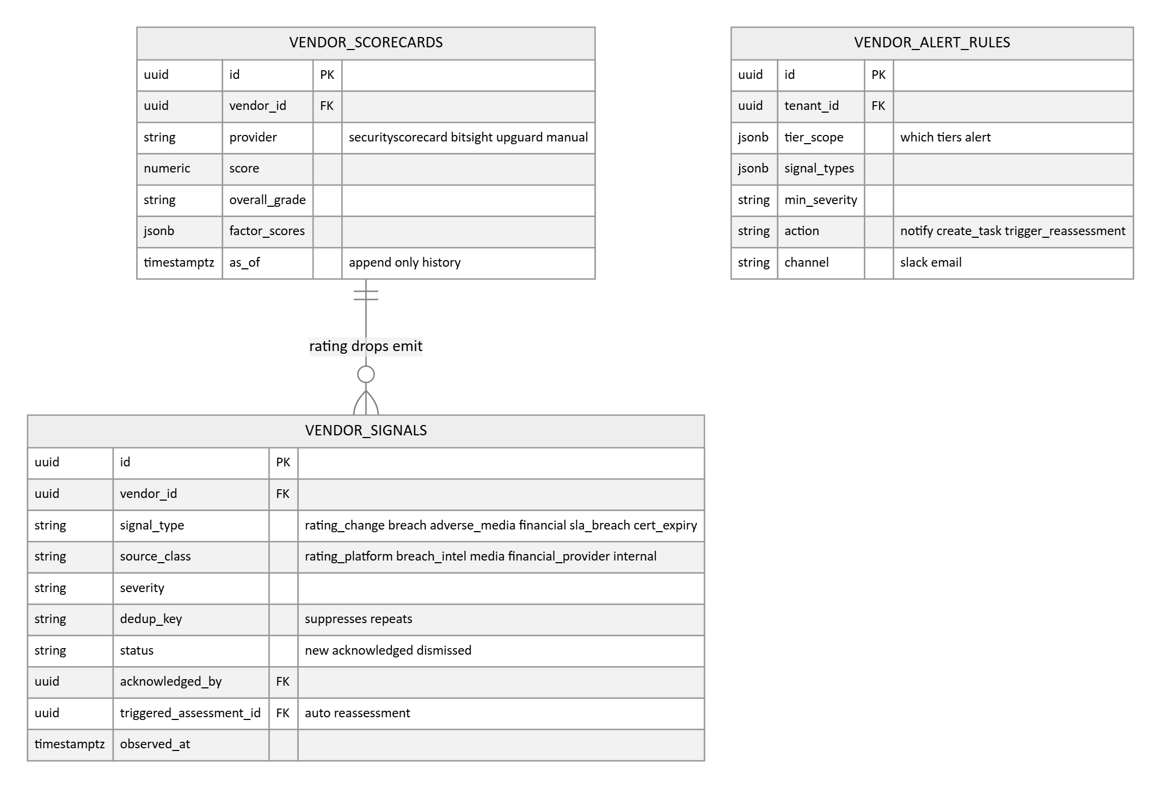
- VENDOR_SCORECARDS is the external security rating snapshot per provider, score, grade, and per factor breakdown, appended over time so the trend is visible. The connector seam covers SecurityScorecard, BitSight, and UpGuard, with manual entry until credentials are configured.
- VENDOR_SIGNALS is the normalized event stream, and the source class matters: rating platforms do not emit financial distress signals, and adverse media comes from separate providers, so each signal records its class. The dedup key suppresses repeats of the same underlying event, and a material signal can auto trigger a reassessment, recorded on the signal itself.
- VENDOR_ALERT_RULES scales alerting by tier: which signal types, at what severity, for which tiers, produce a notification, a task, or an automatic reassessment, so critical vendors are watched closely without alert noise from low tier ones.
Approvals, findings, fourth parties, and offboarding
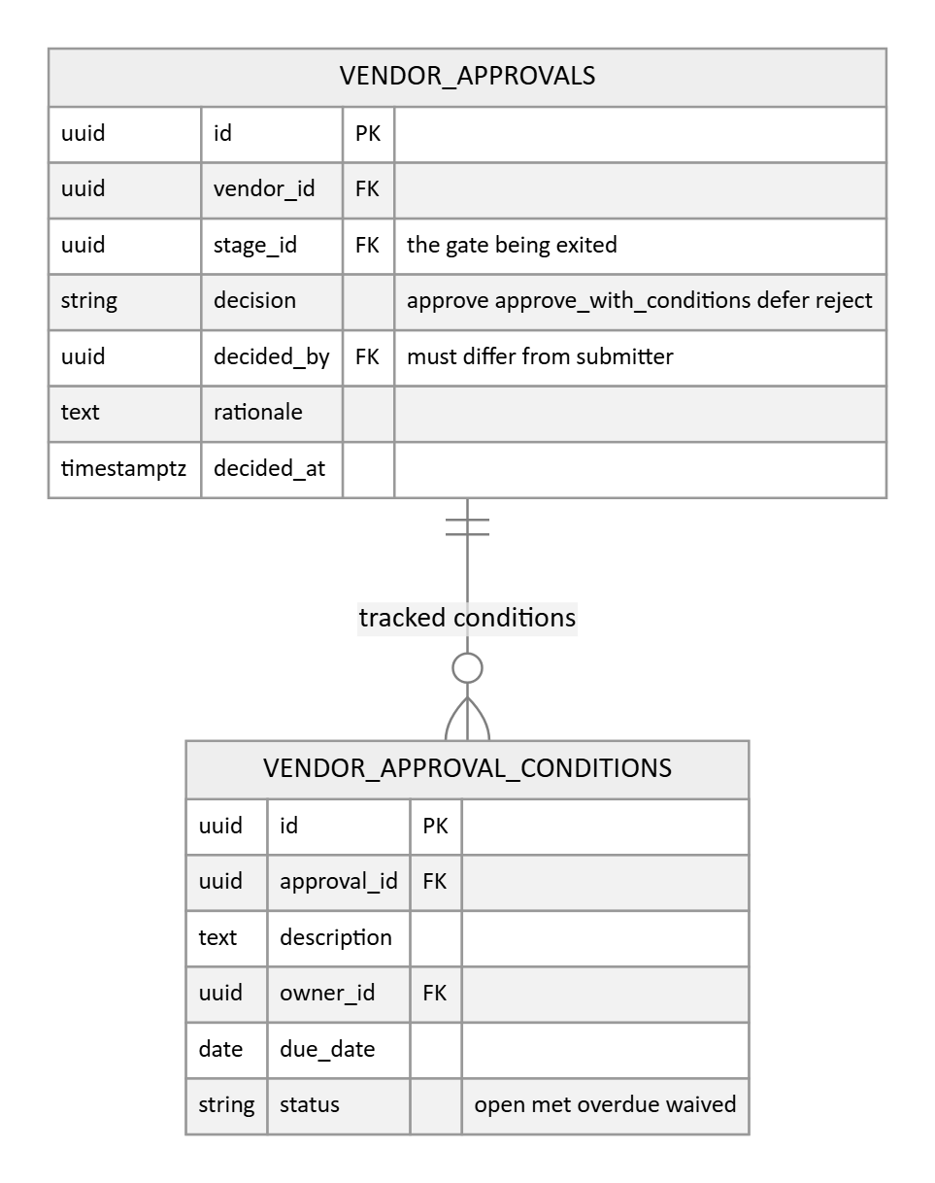
- VENDOR_APPROVALS is the gate record: the decision, approve, approve with conditions, defer, or reject, the approver, rationale, and time. Segregation of duties is enforced by requiring the decider to differ from the vendor's business owner and the stage submitter, and the check is recorded in the audit trail.
- Approve with conditions creates VENDOR_APPROVAL_CONDITIONS rows, each with an owner, due date, and status tracked to closure, so conditions are commitments with follow through rather than free text.
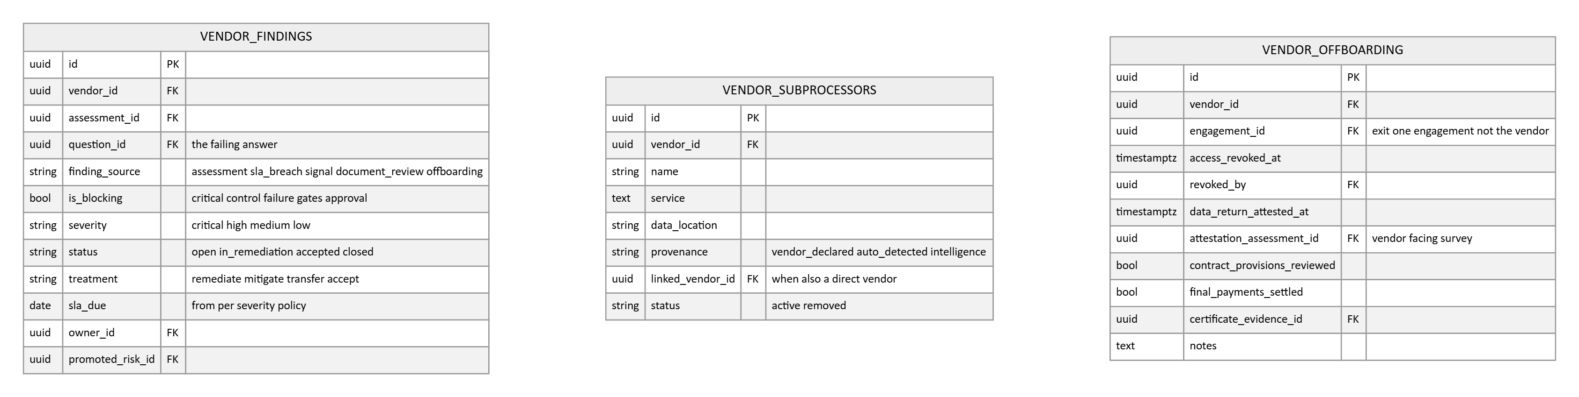
- Findings record their source, an assessment answer, an SLA breach, a monitoring signal, a document review, or offboarding, with per severity SLA due dates from the tiering policy, a treatment decision, and an owner. A no on a critical control question auto creates a finding flagged is_blocking, and an open blocking finding prevents the approval gate from passing regardless of the headline score. An onboarded vendor with an open critical finding is suspended until it clears. Findings promote into the risk register with lineage kept on both rows.
- VENDOR_SUBPROCESSORS is the fourth party graph: each downstream dependency records its provenance, vendor declared, auto detected, or intelligence derived, because provenance determines how much to trust it and what to verify. A subprocessor that is also a direct vendor links to its vendor record, which is how concentration risk, one provider underneath many vendors, becomes queryable.
- Offboarding is an evidenced exit, not a status flip: access revocation with who and when, a vendor facing attestation survey (data destroyed, access removed) recorded as an assessment, contract exit provisions reviewed, final payments settled, and a completion certificate stored as evidence. Terminated vendors are archived, never deleted.

3.8 Asset management
This module is designed to product grade, benchmarked against cyber asset inventory platforms (Axonius, JupiterOne, runZero) and CMDB practice (ServiceNow, ISO 27001 A.5.9). The core idea: one unified, deduplicated record per real asset, built non-destructively from every source that reports it, with policies, coverage gaps, and audit attestation on top.
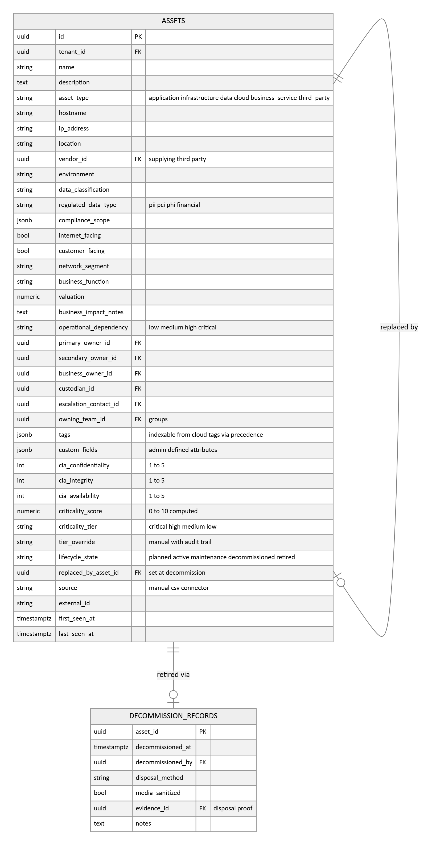
- The asset register carries the full field set: identity (description, hostname, IP, location, the supplying vendor as a link into the TPRM module), classification (data classification, regulated data type, compliance scope), exposure (internet facing, customer facing, network segment, business function), business context (valuation, business impact notes, operational dependency rating), and the complete ownership chain: primary and secondary owners, business owner, custodian, escalation contact, and the owning team as a group. Ownership on the asset is what everything else inherits: vulnerability instances, policy violations, and drift alerts all resolve their owner from here.
- criticality_score is computed from the CIA ratings with adjustments for exposure and data sensitivity, then stored; tier_override is kept separately so the record always shows both what the system derived and what a person chose. Business criticality belongs on service assets (asset_type business_service), and infrastructure inherits it through the dependency edges below, so a database supporting a critical service ranks as critical without anyone re-rating servers.
- Lifecycle transitions are enforced. Decommissioning auto closes the asset's open vulnerability instances, records the replacement in replaced_by_asset_id, and writes a DECOMMISSION_RECORD, the disposal method, whether media was sanitised, and the disposal evidence, because auditors test that retirement followed policy.
Multi source truth: raw records, merge, and precedence
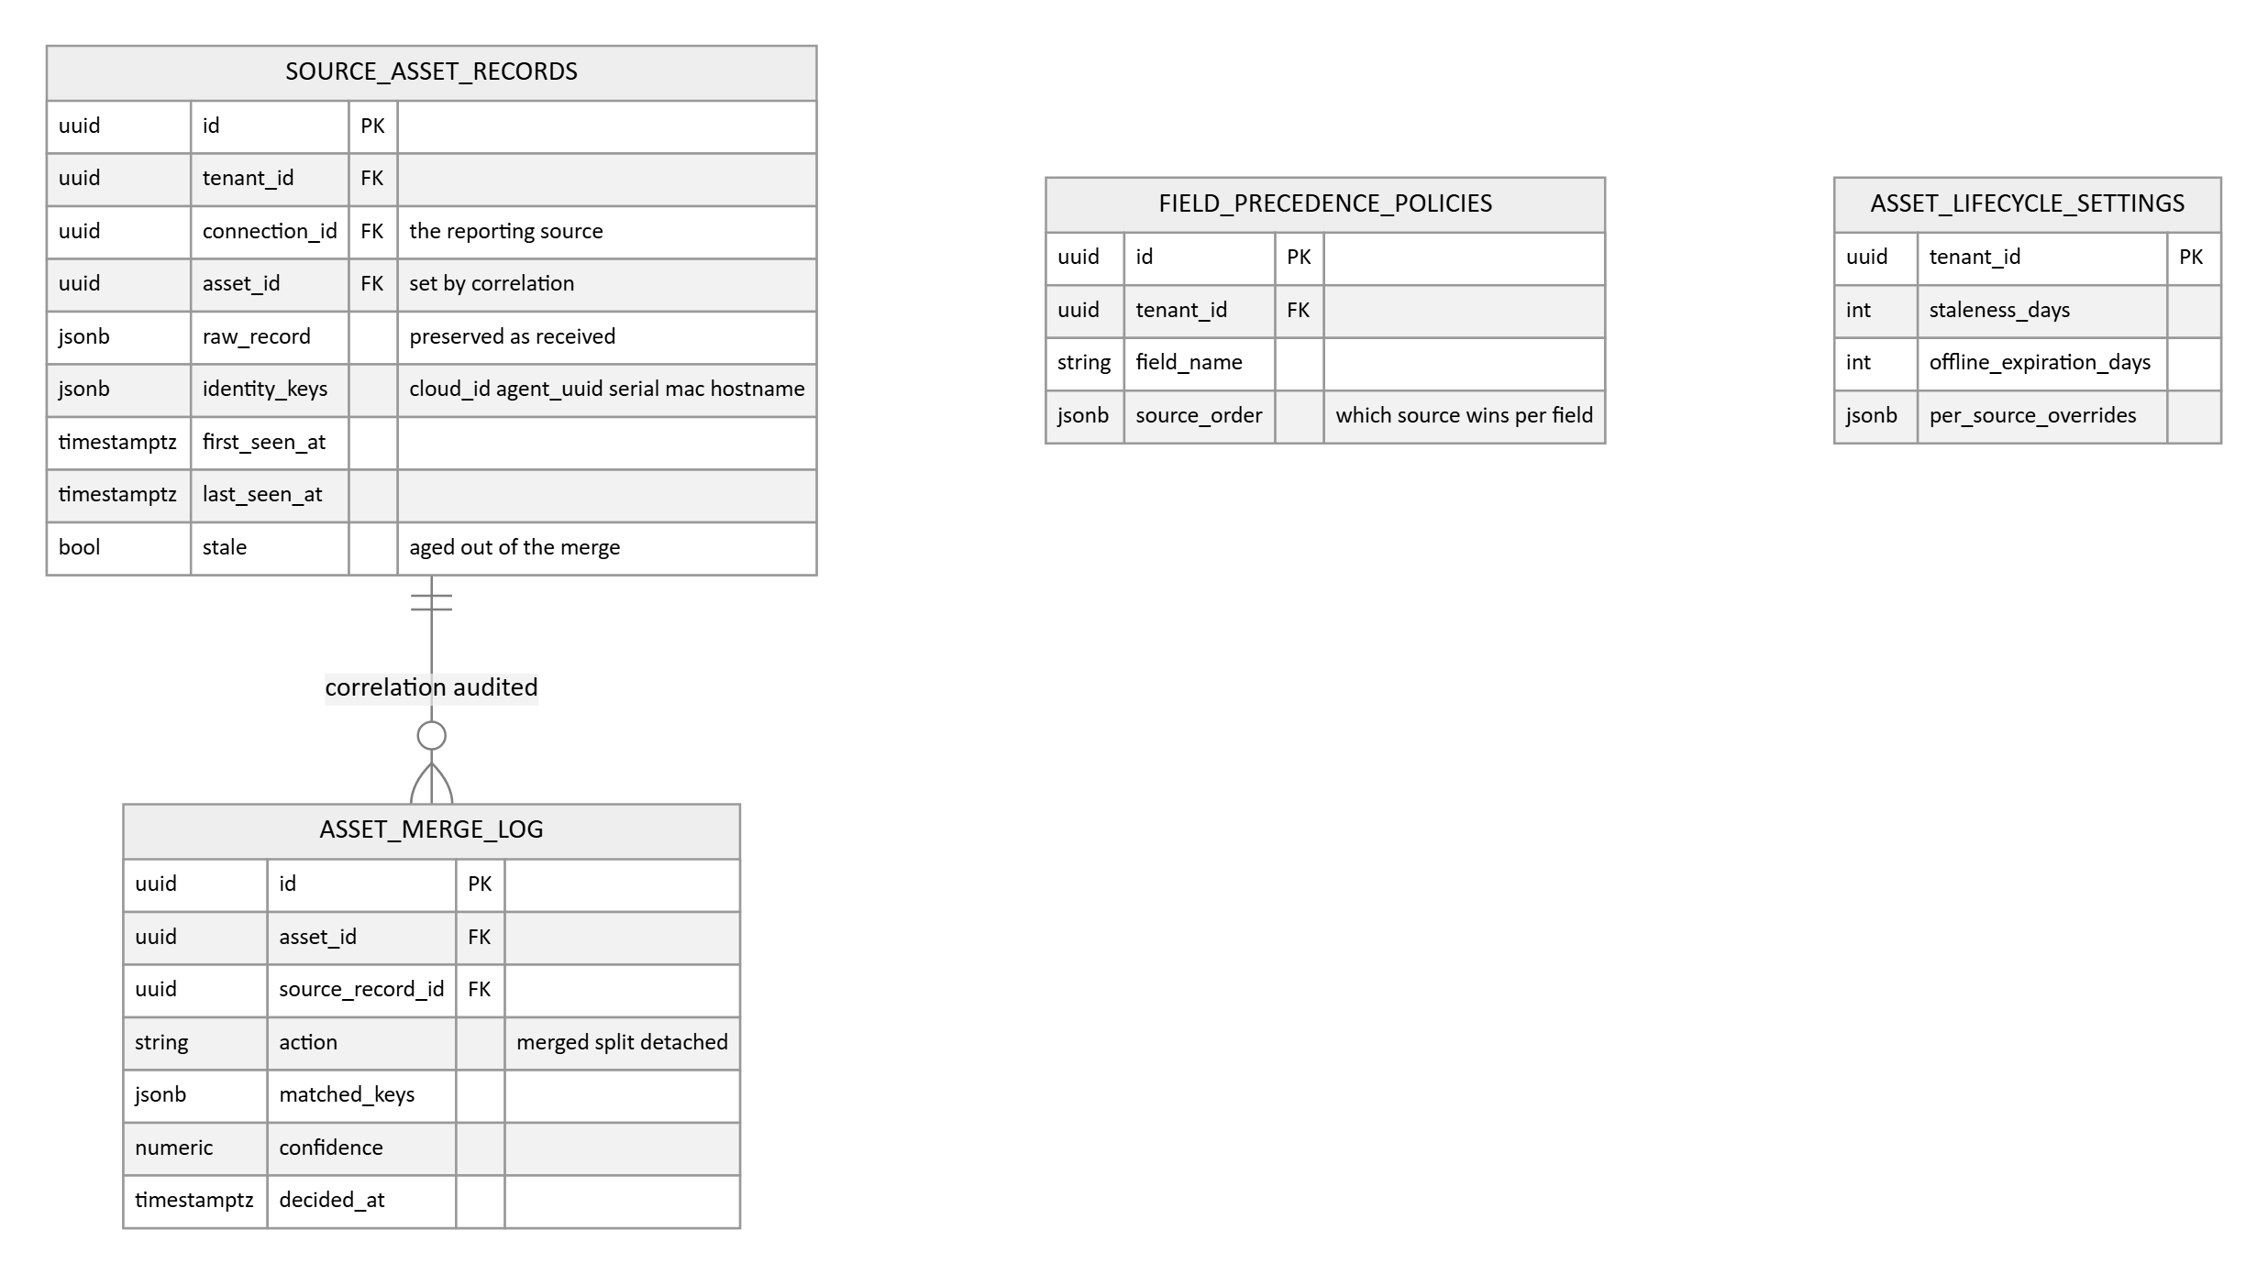
- Every connector sync writes SOURCE_ASSET_RECORDS, the raw per source view, preserved as received with its identity keys. Correlation matches on stable identifiers in strict order, cloud instance id, agent id, serial, MAC, then hostname, and deliberately distrusts IP addresses. The merge is non destructive: the unified asset is derived, the sources remain, and a wrong merge can be split.
- ASSET_MERGE_LOG records why records merged or split, the matched keys and confidence, so merged data stays debuggable. FIELD_PRECEDENCE_POLICIES decides per field which source wins, the MDM's hostname can beat the scanner's, while every source's value is retained.
- ASSET_LIFECYCLE_SETTINGS governs freshness: per source staleness ages one connector's contribution out of the merge without deleting the asset, and asset level offline expiration retires records nobody reports anymore. first and last seen exist at both source and asset level.
Relationships and software inventory
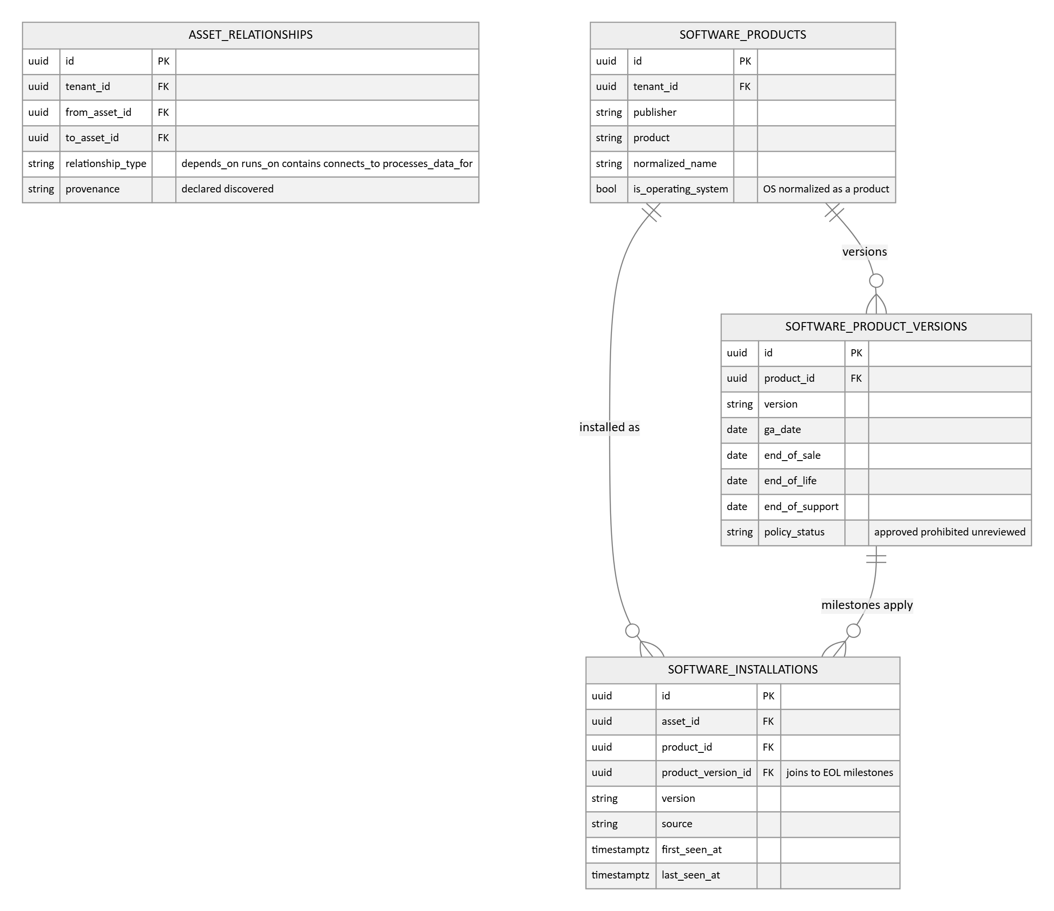
- ASSET_RELATIONSHIPS is the typed dependency graph: depends on, runs on, contains, connects to, processes data for, with provenance (declared by a person or discovered by a connector). The graph powers impact tracing, which service is hit if this host dies, and the criticality inheritance above.
- Software inventory is two levels: SOFTWARE_PRODUCTS is the normalized catalog (publisher, product) built from messy raw install strings, and SOFTWARE_INSTALLATIONS is one title on one asset with its version and sighting dates. Vulnerability matching joins against the normalized product, not the raw string.
Groups, policies, and coverage gaps
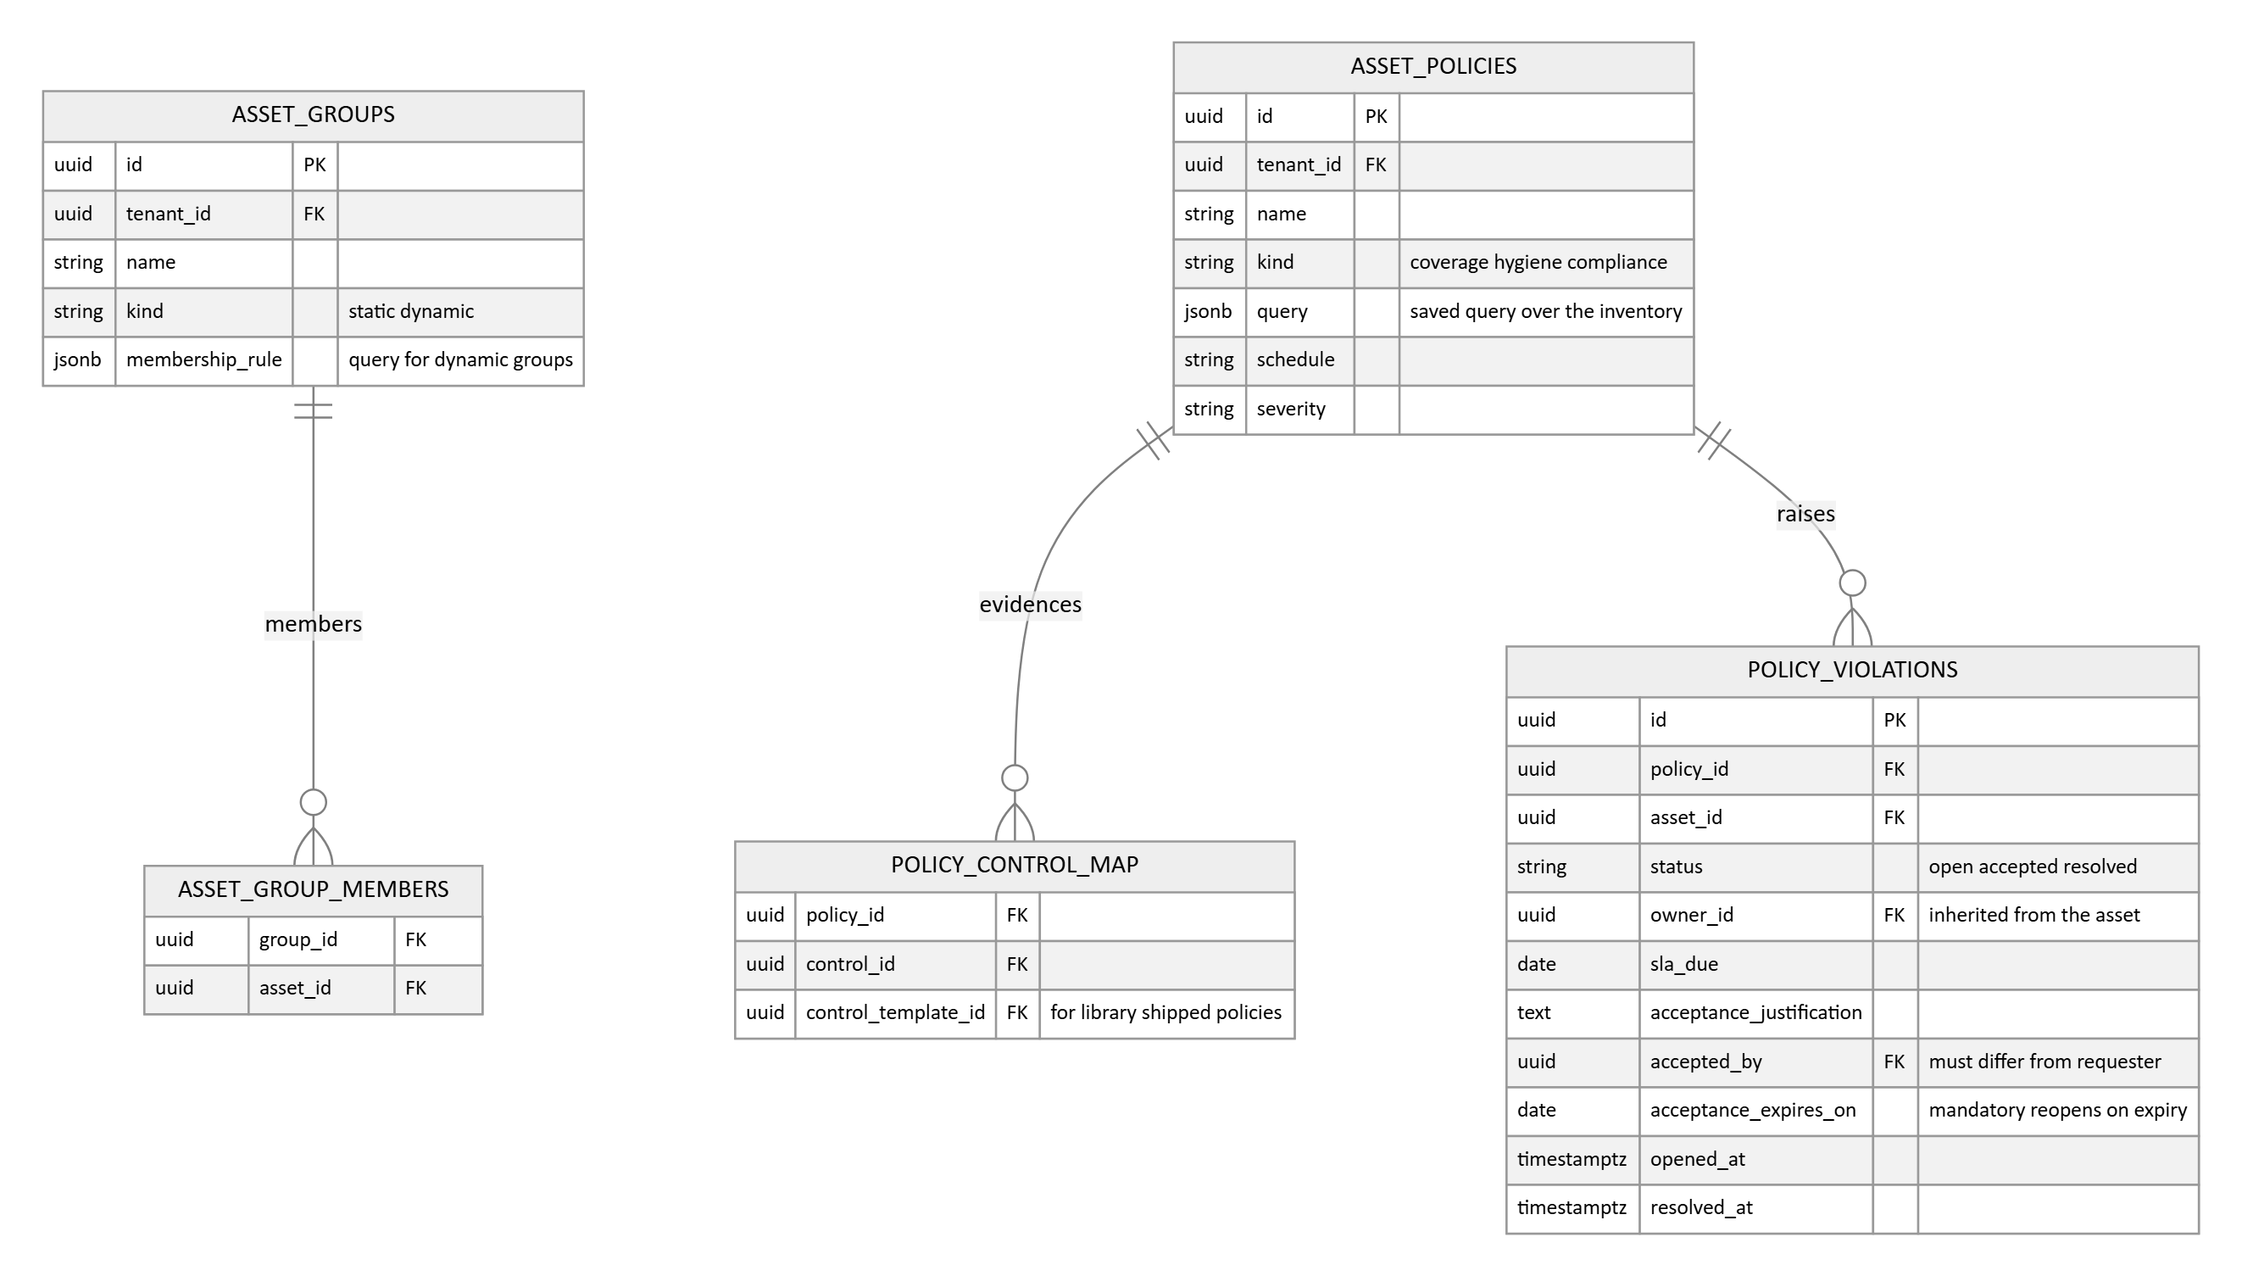
- ASSET_GROUPS segments the estate, statically or by a dynamic membership rule, and scopes dashboards, SLA policies, and ownership defaults.
- ASSET_POLICIES is the saved query engine, the primitive the research shows every real platform is built on: a named query over the unified inventory, evaluated on a schedule. Coverage gaps are just set subtraction as a policy, all workstations minus assets seen by the endpoint tool equals machines missing protection. Hygiene checks (no owner, no classification, no CIA rating) and compliance checks are the same primitive.
- A failing asset raises a POLICY_VIOLATION with an owner inherited from the asset and an SLA date, a workable finding rather than a dashboard number.
Inventory governance
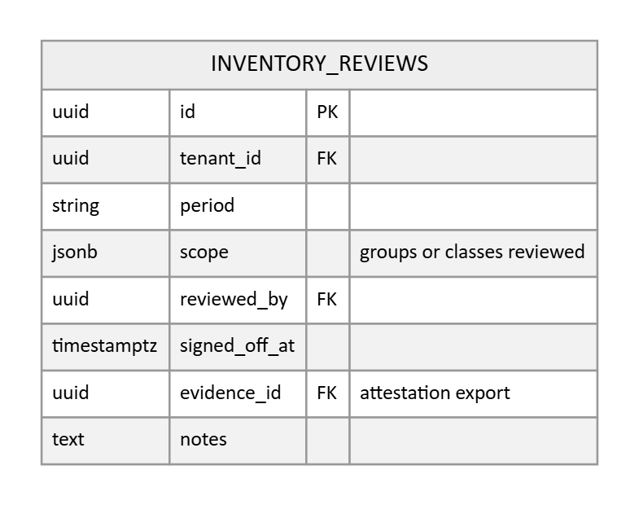
- INVENTORY_REVIEWS is the periodic attestation record, the owner signs off that the inventory scope was reviewed, with the export stored as evidence, which is what ISO 27001 A.5.9 and SOC 2 auditors ask of an asset inventory.

3.9 Vulnerability management
This module is designed to product grade, benchmarked against scanner platforms (Tenable, Qualys VMDR, Rapid7 InsightVM) and risk based VM aggregators (Nucleus, Vulcan, Brinqa). The core idea: separate the vulnerability definition from its per asset instances, keep an explicit state machine per instance, and orchestrate remediation around the fix rather than the finding.
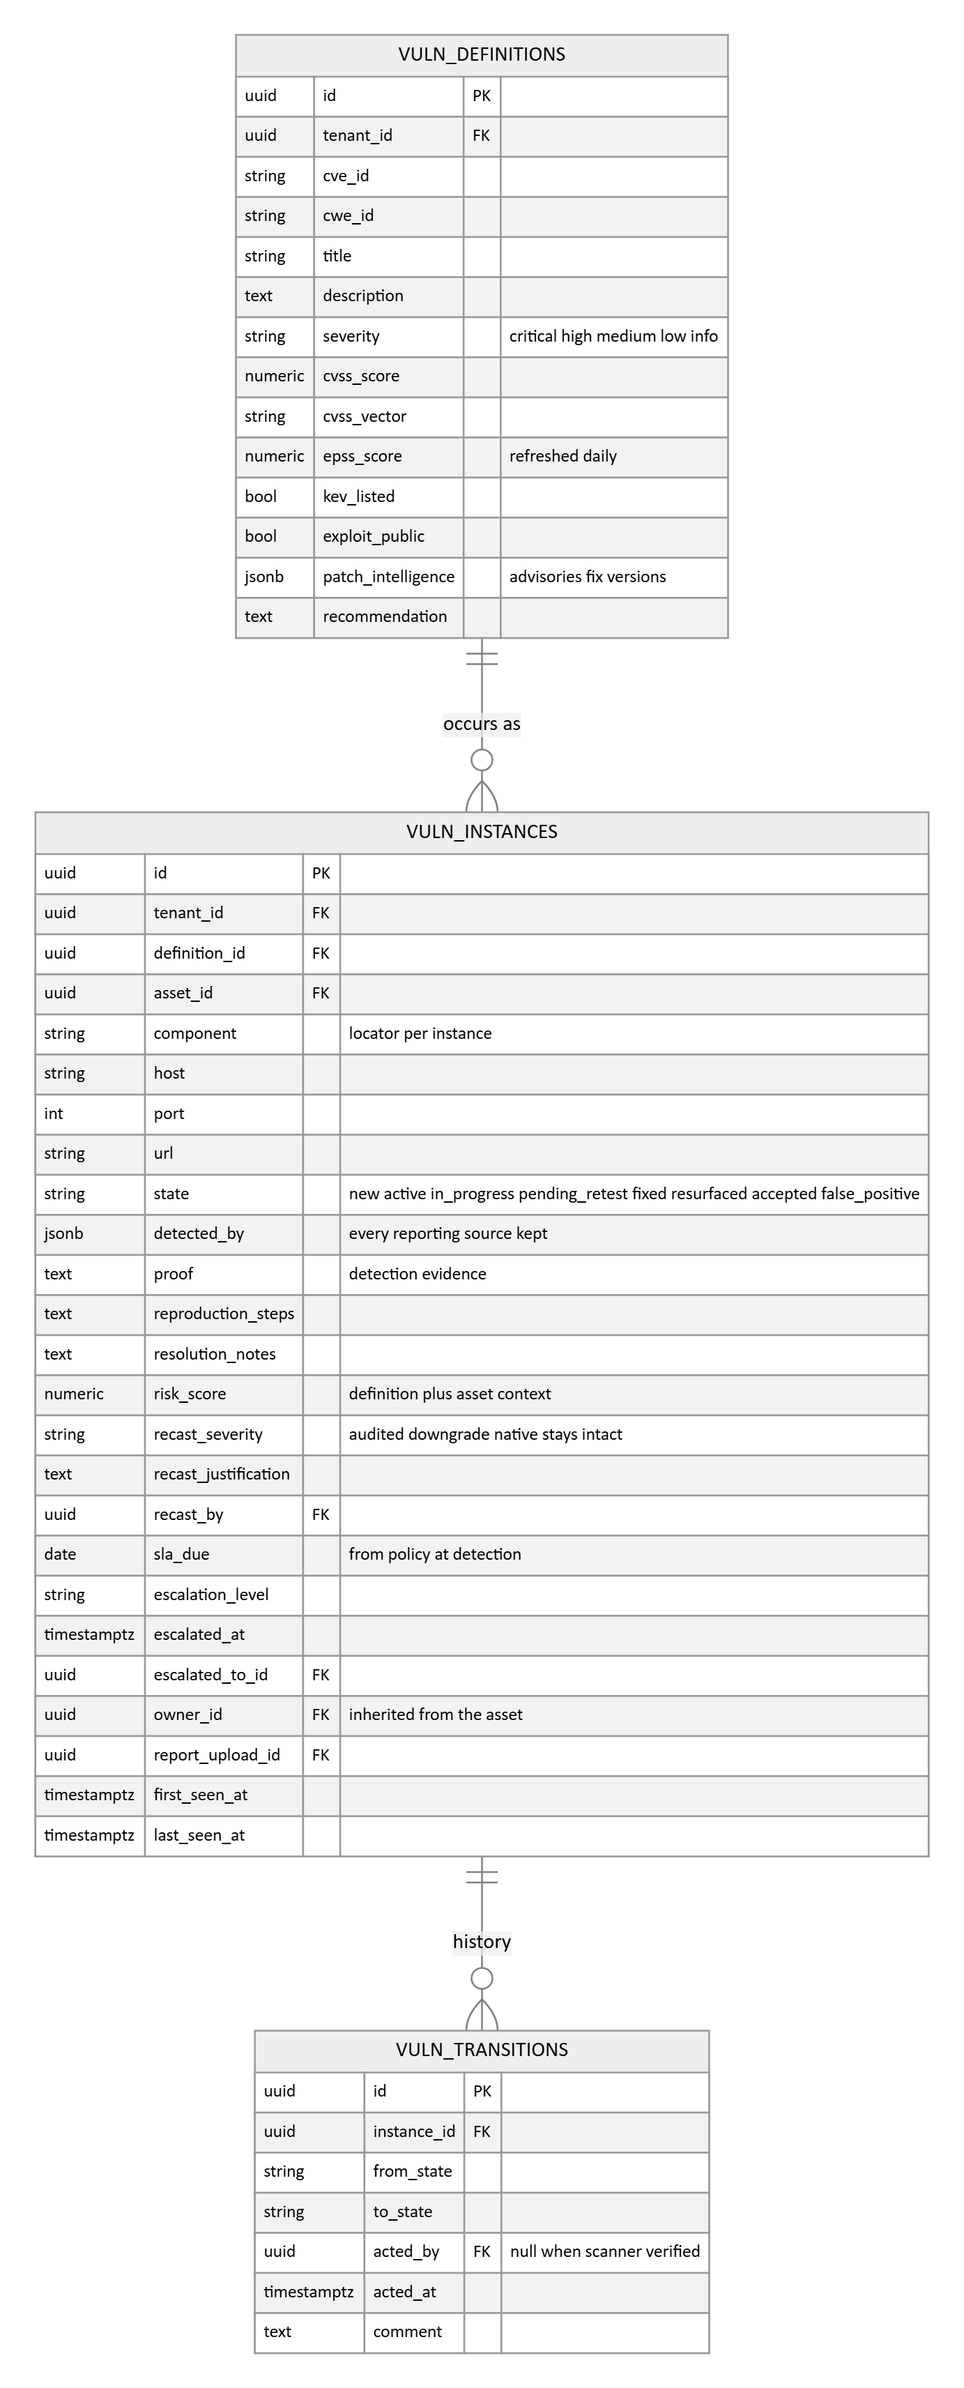
- VULN_DEFINITIONS is the asset independent description, one row per CVE or finding definition, carrying the CVSS score and vector, the enrichment set (EPSS refreshed daily, the KEV flag, public exploit indicator, vendor patch intelligence), and the recommendation. Enrichment lands once per definition and every instance inherits it, instead of being copied onto every row.
- VULN_INSTANCES is the unit of work: one occurrence of a definition on one asset at one locator (component, host, port, URL), because the same CVE on two assets, or two ports, is two pieces of work. Uniqueness is asset plus definition plus locator, which is also the dedup key when several scanners report the same issue: one instance survives, and detected_by keeps every reporting source.
- The state machine is explicit and stored: new, active, in progress, pending retest, fixed, resurfaced, accepted, false positive. Fixed is scanner verified or formally approved, never just asserted, and a definition that reappears on the same asset flips the old instance to resurfaced rather than opening a duplicate. VULN_TRANSITIONS records every step (a null actor means the scanner did it), which is where time to remediate and throughput reporting come from.
- risk_score blends the definition's severity and exploit intelligence with the asset's criticality and exposure, so an exploited, internet facing, critical asset instance outranks a higher CVSS score nobody is exploiting. Ownership is inherited from the asset at detection, so triage starts assigned.
Scoring, SLA, automation, and exceptions
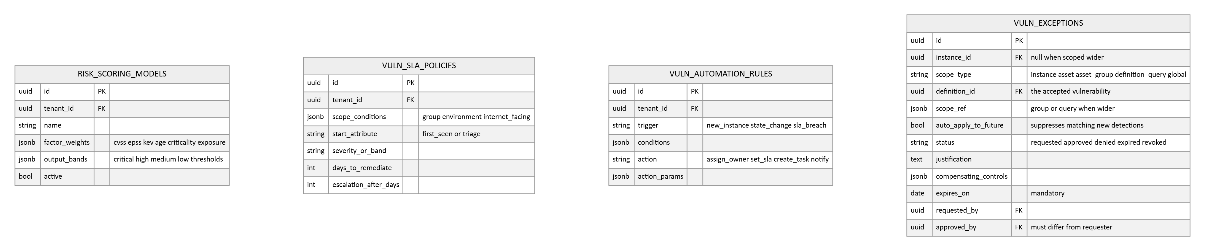
- RISK_SCORING_MODELS makes the scoring recipe configurable: named factors with weights and the output bands. Scores recompute when threat intelligence changes, not only at scan time, and accepted instances drop out of risk aggregates.
- VULN_SLA_POLICIES is a policy engine rather than one number per severity: scope conditions (group, environment, internet facing) select the policy, the start attribute anchors the clock, and escalation triggers record the level, time, and who was escalated to on the instance.
- VULN_AUTOMATION_RULES is trigger, condition, action: route ownership, set SLAs, open tasks, or notify when instances appear, change state, or breach SLA. The ERM workflow engine (Section 3.12) layers configurable multi step processes on top where a team wants its own flow.
- Exceptions are governed deviations: requested with justification and compensating controls, approved by someone other than the requester, with a mandatory expiry that automatically returns the instance to the queue. An accepted risk without an approval gate would fail audit scrutiny.
Remediation orchestration and report ingest
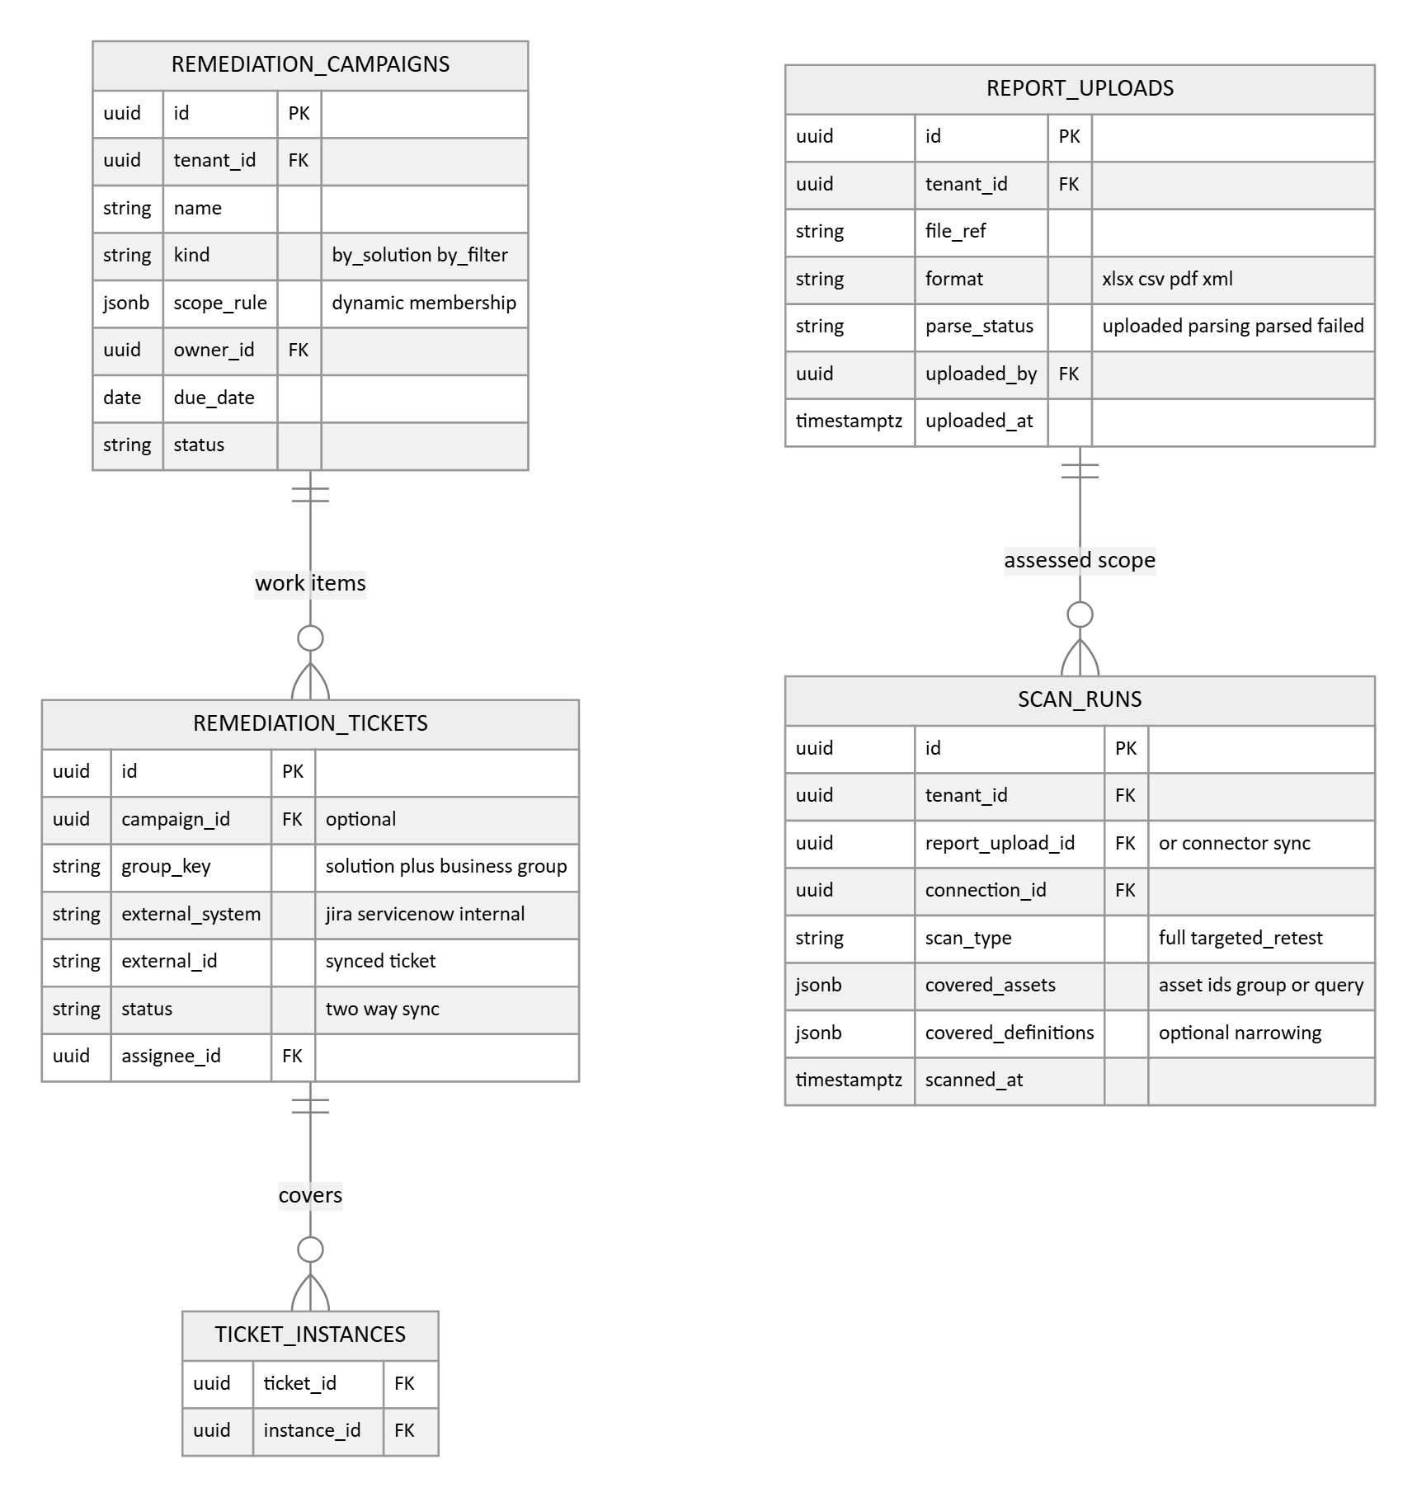
- Remediation groups by the fix, not the finding: one patch resolves many CVEs on many assets, so campaigns collect instances by solution or by a dynamic filter, and tickets consolidate on a group key (solution plus business group). Tickets sync two ways with Jira or ServiceNow through the connector framework, and completion is measured in resolved instances, with credit as each asset closes.
- REPORT_UPLOADS keeps the uploaded scan or test report itself, its format and parse status; every parsed instance references its source report, so the auditor can walk from a finding back to the report it came from, and a failed parse can be re-run.

3.10 Connectors, checks, and monitoring
Modeled now so Phase 1 can show connector placeholders; built in Phase 2.
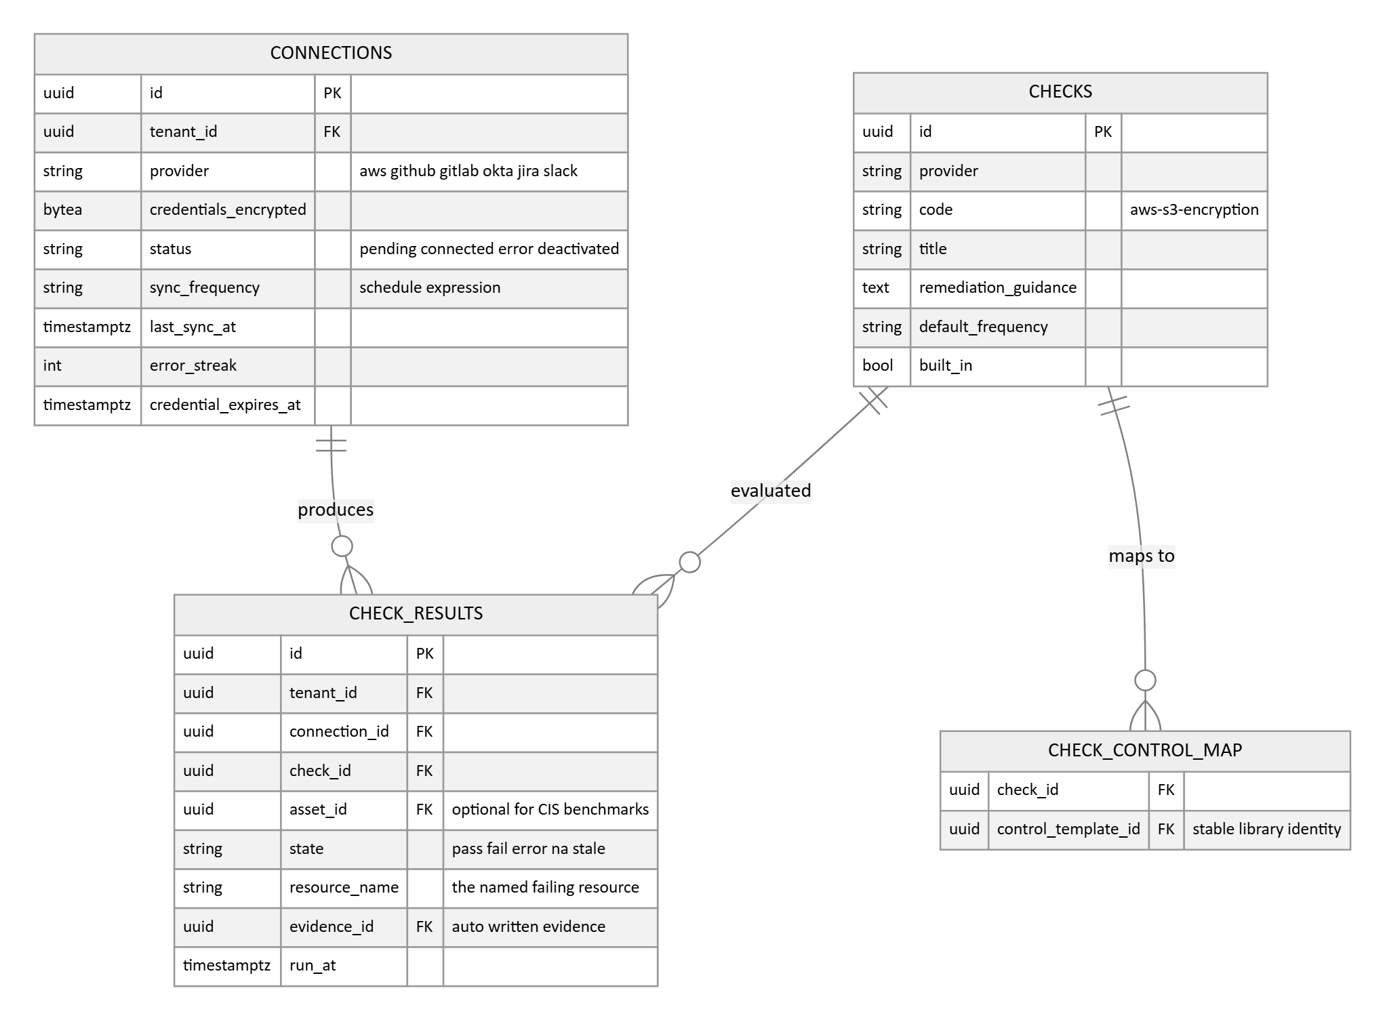
- Checks are global content, like requirements: shipped per provider, mapped to the stable control template identity, which resolves to the tenant's instantiated controls. A check activates only when its provider is connected and reads as not applicable otherwise.
- Schedule lives in data: a default frequency on the check and a per connection sync frequency, consumed by the scheduler. Checks also run when new evidence arrives.
- Every result can write an evidence row, and results can reference an asset, which is how the Phase 3 CIS hardening benchmarks ride this same engine: benchmark items ship as checks, results land per asset, and drift alerts resolve the asset's owner.
- Error is a first class state, never conflated with fail, so a broken credential cannot look like a failed control.
- check_results is the one high volume table in the system. It is append only and partitioned by month from day one; see Section 5.
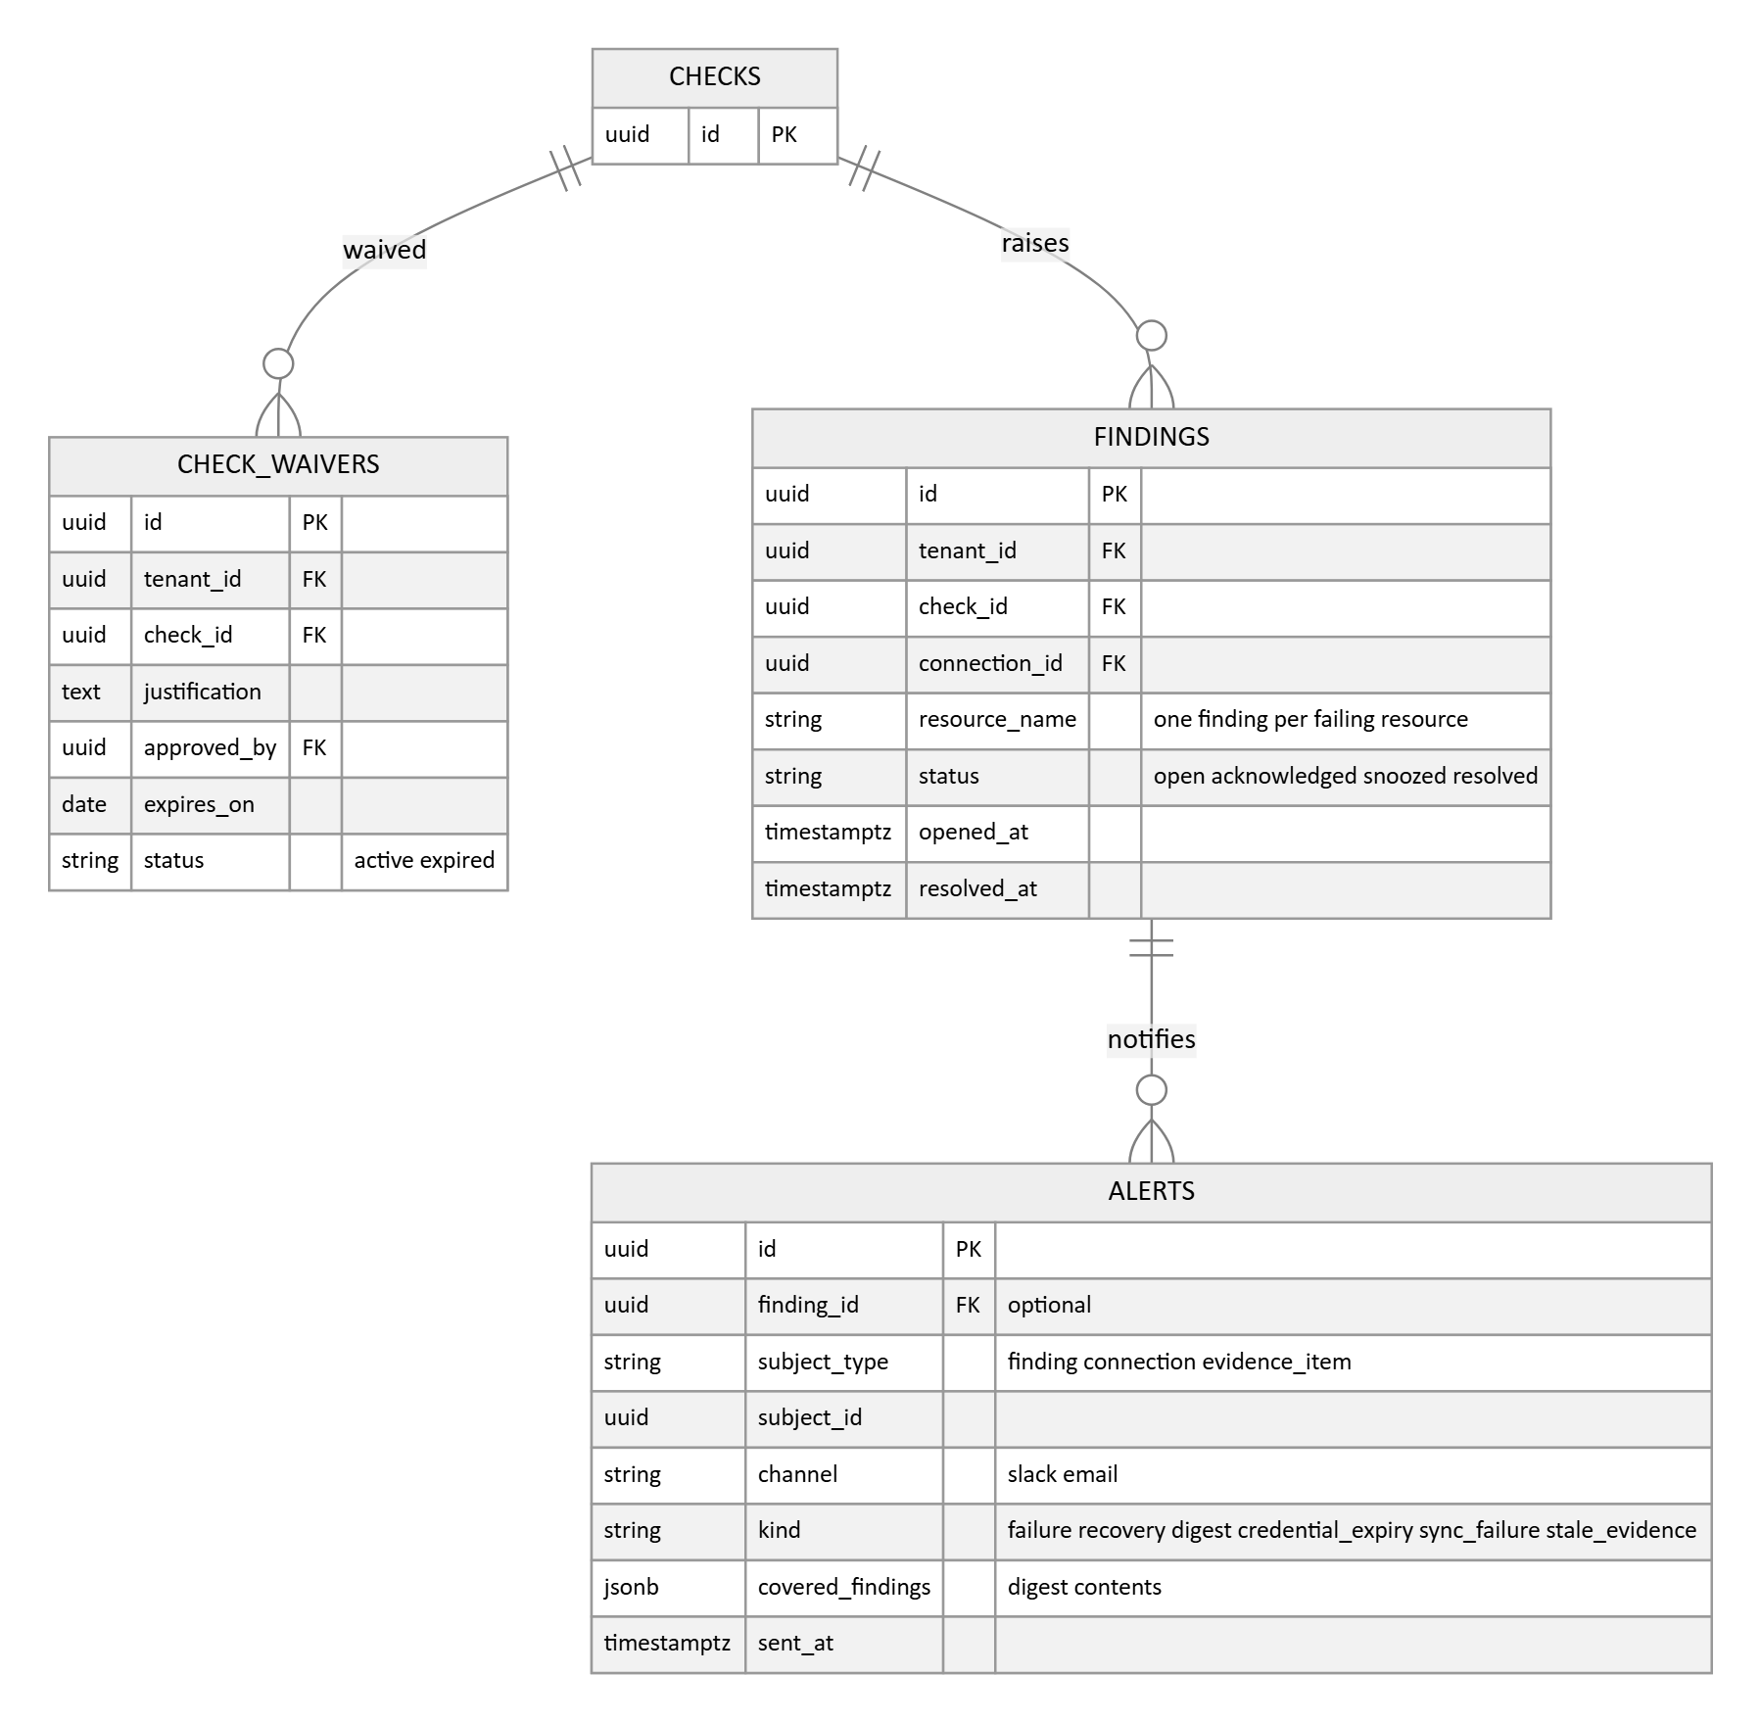
- Findings are opened per failing check, connection, and resource, so a check failing on three buckets raises three findings, each naming its resource, and each auto resolves when that resource next passes. The check runner performs the resolve; waiver expiry is handled by a scheduled job that flips the waiver to expired and reopens the finding.
- Alerts fire on state change only, a new failure or a recovery, with ongoing failures summarised in a periodic digest whose covered findings are recorded on the alert row.
- The separate operational stream the requirements promise, expired credentials, failed syncs, and stale evidence, uses the same table through subject_type and subject_id with its own kinds, no finding required.

3.11 Approvals, the linkage fabric, and the audit trail
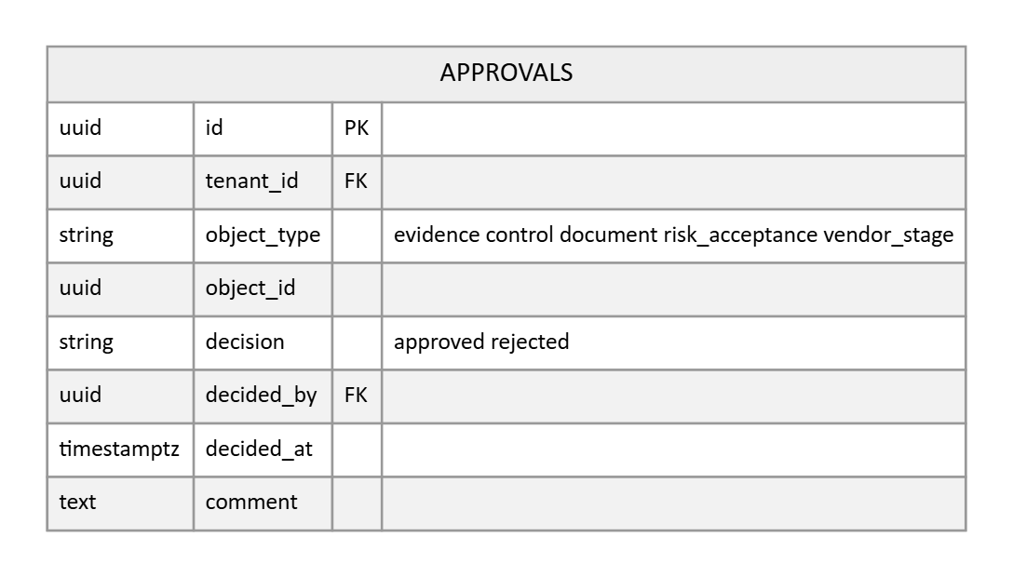
- APPROVALS is the single sign off record for the whole platform: evidence review, control sign off, document approval, risk acceptance sign off, and TPRM gate exits all write here, with the object reference, the decision, the decider, the time, and a comment. One mechanism, one queue of pending approvals, one audit surface, instead of per module approval columns.
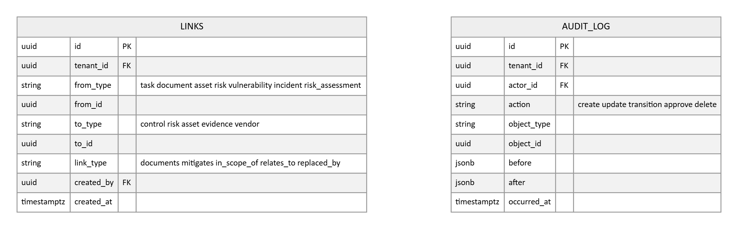
- links carries the long tail of the 360 degree model: task to anything, document to anything, asset to risk, vulnerability to evidence, incident to risk or asset. It is indexed in both directions, so the trace view can walk the graph either way.
- audit_log is append only, with no updates and no deletes, ever. The before and after snapshots give the full change record without touching the source tables.

3.12 Enterprise risk management (Phase 3, designed ahead)
The ERM module extends the Phase 1 risk register. It is designed now so nothing built earlier has to change when it arrives.
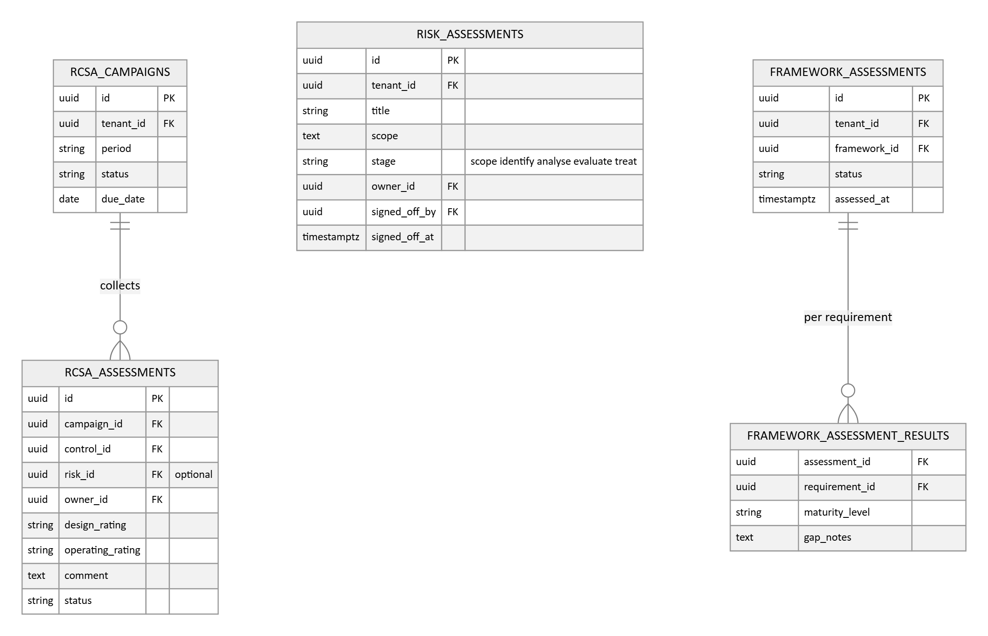
- RCSA campaigns schedule the periodic self assessment: each control and risk owner rates design and operating effectiveness, with comments, and the results roll up into the risk register and readiness reporting.
- RISK_ASSESSMENTS is the structured workflow that scopes, identifies, analyses, evaluates, and treats risks, with an owner and formal sign off; risks it raises land in the register with risk_source set to assessment and lineage through origin_id. Supporting evidence attaches to the assessment through the links table, the same fabric every other module uses.
- Framework assessments produce the gap and maturity result per requirement, feeding the roadmap for each new framework added to the engine.
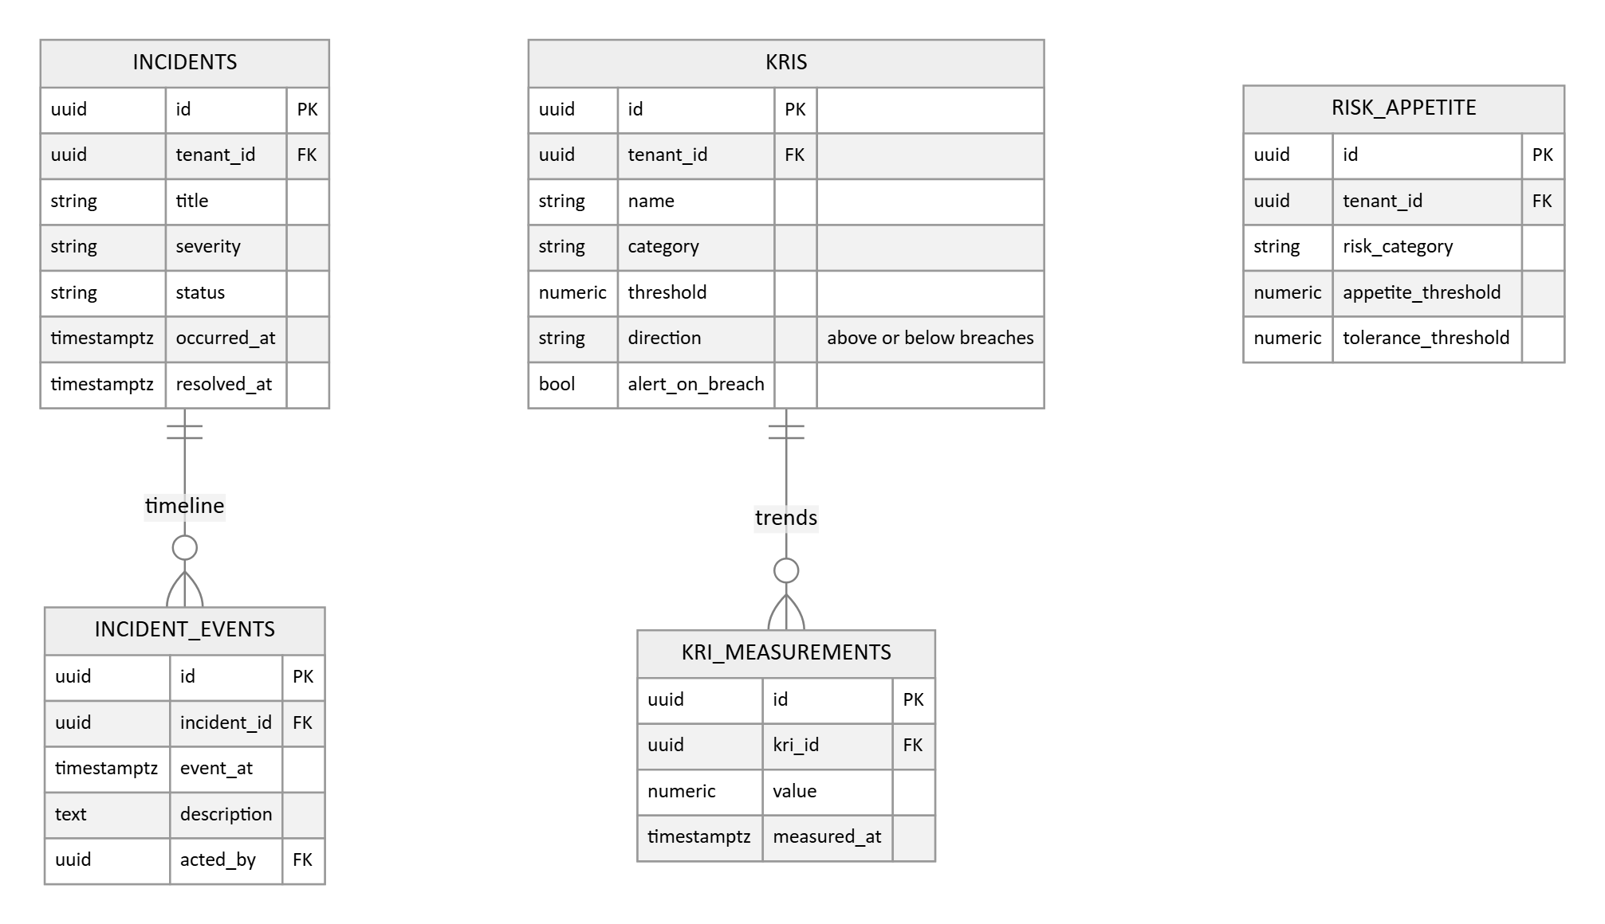
- Incidents carry severity, status, and a timestamped event timeline; they link to the risks and assets involved through the links table, and post incident mitigations are tasks tracked to closure.
- KRIs are defined with a threshold and direction, measured over time, and a threshold breach raises an alert through the standard alert stream.
- RISK_APPETITE holds the per category appetite and tolerance thresholds; any risk whose residual score exceeds its category's appetite is highlighted, a straight comparison at read time.
- AI powered mitigation proposals are drafts a person reviews, assigns, and tracks, the same human approval principle as document drafting.
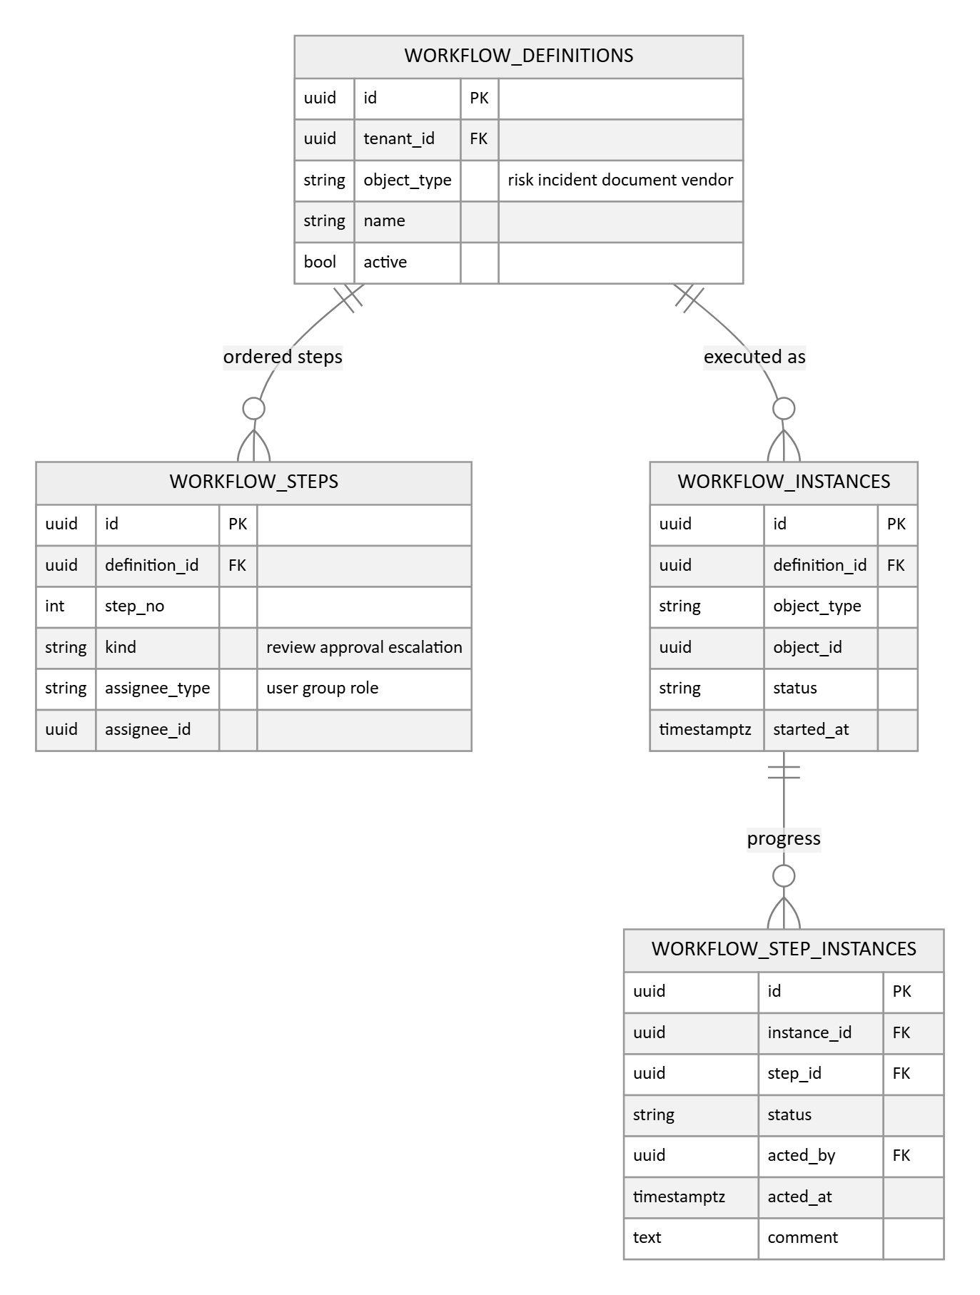
- The configurable workflow engine lets the organisation model its own review, approval, and escalation steps per object type: definitions hold the ordered steps, instances track execution per object, and every step action is recorded with who, when, and a comment.

3.13 Access reviews and single sign on (Phase 3, designed ahead)
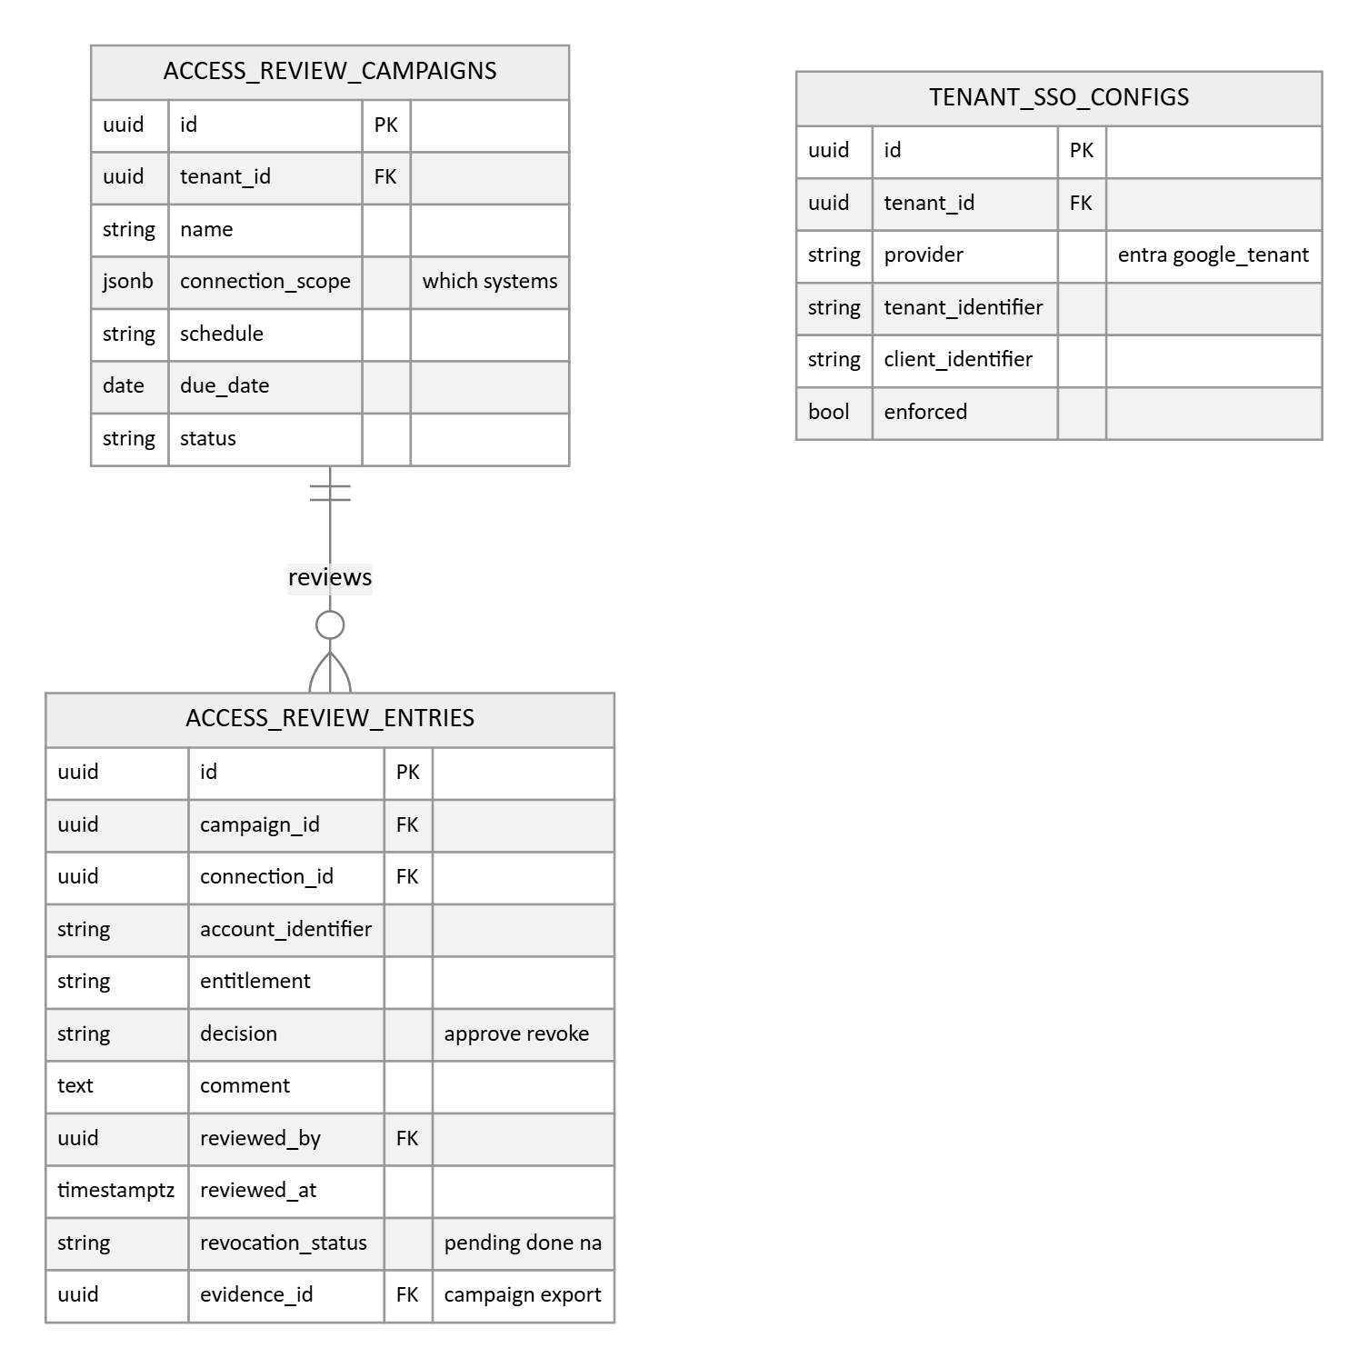
- Access review campaigns pull who has access from the connected systems into per entry rows: account, entitlement, and system. A reviewer approves or revokes each entry with a comment, revocations are tracked to completion, and the completed campaign exports as an evidence item, exactly the artifact an auditor asks for.
- WORKSPACE_SSO_CONFIGS holds the per tenant identity provider configuration for Azure AD / Entra ID and Google Workspace; user identities bind through the federated identity table in Section 3.1.

4. The 360 degree linkage model
Every connection promised in the requirements, and the mechanism that carries it. Frequently queried pairs get explicit join tables with enforced integrity. The flexible long tail rides the links table. One way promotions are direct foreign keys.
Relationship | Mechanism | Reasoning
Control and requirement | Explicit join table | The multi framework engine itself. The most queried join in the system; readiness is computed on it.
Control template and requirement | Explicit join table | Ships with the library; copied into the tenant map at instantiation.
Evidence and control | Explicit join table | Rendered on every dashboard and control page; needs enforced integrity and speed.
Risk and control | Explicit join table | Drives the flag for risks with no mitigating control and the readiness rollups.
Vulnerability definition and per asset instance | Direct foreign key | The three level model: enrichment lands on the definition once, work happens per instance with asset, locator, and state.
Vulnerability instance and asset | Direct foreign key | The instance IS the asset relationship, unique per asset, definition, and locator; walked when an asset is decommissioned.
Remediation ticket and instances | Explicit join table | Tickets consolidate many instances around one fix; completion is counted in resolved instances.
Software product and installation | Direct foreign key | Normalized catalog joined by vulnerability matching; installations carry per asset versions.
Asset relationships | Explicit self join | The typed dependency graph: impact tracing and criticality inheritance ride these edges.
Vendor and engagement | Direct foreign key | The two level TPRM model: risk scoped to one use of the vendor, not averaged across uses.
Check and control template | Explicit join table | Automated pass and fail rollup into readiness; shipped as content with the checks.
Vendor finding to risk | Direct foreign key | A one way promotion with lineage kept on both rows.
Vendor finding to assessment and question | Direct foreign key | Every finding traces to the answer that raised it; blocking findings gate approvals.
Check result to evidence | Direct foreign key | Each automated run lands one evidence record.
Check result to asset | Direct foreign key | Per asset benchmark results; drift alerts resolve the asset owner.
Questionnaire answer to evidence | Direct foreign key | A vendor answer can carry its proof.
Vulnerability to source report | Direct foreign key | Every parsed finding traces back to its uploaded report.
Asset to replacement asset | Direct foreign key | Set at decommission; the succession chain is queryable.
Approval to any object | Polymorphic record | One sign off mechanism for evidence, controls, documents, acceptances, and gates.
Task to any object | Polymorphic links table | Tasks attach to six or more object types; a column per type would rot.
Document to control, risk, or asset | Polymorphic links table | The same document links across modules; breadth matters more than heat.
Asset to risk, control, document, or evidence | Polymorphic links table | Scoping links that are browsed rather than computed; flexibility wins.
Vulnerability to evidence, incident to risk or asset, risk assessment to evidence | Polymorphic links table | Long tail traceability on the same fabric.

The trace that demonstrates the model end to end: vulnerability to asset, asset to risk, risk to control, control to policy and evidence. Four hops, all indexed.

5. Design decisions and reasoning

5.1 A three layer framework engine with a shipped control library
- Chosen: frameworks and requirements as shipped content, a prebuilt control template library mapped to them, and the organisation's controls instantiated from the library with a many to many requirement map.

5.2 A hybrid linkage model
- Chosen: explicit join tables for the hot pairs, one polymorphic links table for the long tail, and direct foreign keys for one way promotions.
- Alternative: all explicit, roughly a dozen join tables, or all polymorphic with no enforced integrity anywhere.
- Reasoning: all explicit explodes the table count and still cannot express task to anything. All polymorphic gives up referential integrity on exactly the joins the dashboards hammer. The hybrid puts rigor where the load is and flexibility where the breadth is.

5.3 Shared schema multi tenancy with row level security
- Chosen: one schema, tenant_id on every operational row, database row level security as a second wall keyed on tenant_id, and an automated isolation test that runs on every change. The provider plane (platform admins, the tenants register, branding, provisioning) is a small set of global tables above the tenant boundary.
- Alternative: a schema or database per tenant.
- Reasoning: per tenant schemas multiply migration, backup, and operations work by the number of tenants, which is a heavy burden for a small team. Shared schema with row level security gives strong isolation at single schema cost. The decision is revisited only if an enterprise customer contractually requires physical separation.

5.4 UUID primary keys
- Chosen: time ordered UUIDs, version 7, everywhere.
- Alternative: integer sequence keys, which are smaller and marginally faster.
- Reasoning: identifiers survive CSV import, cross system synchronisation, and merges without collision, which matters for an integration heavy platform. Version 7 is time ordered, so the classic index fragmentation argument against UUIDs no longer applies.

5.5 Evidence anchors to controls, not to requirements
- Chosen: evidence maps to controls; requirement coverage is derived through the control map.
- Alternative: map evidence directly to framework requirements.
- Reasoning: direct mapping means re-attaching every evidence item each time a framework is added. Anchored to controls, a new framework instantly inherits all previously collected evidence. This is the mechanism behind collect once, satisfy many.

5.6 Append only history
- Chosen: audit_log, task_transitions, vuln_transitions, check_results, readiness_snapshots, kri_measurements, and document_versions are insert only. No row in them is ever updated.
- Alternative: mutable rows with an updated timestamp, or database triggers writing shadow tables.
- Reasoning: immutability is a compliance feature this platform is selling, and append only writing is also the cheapest thing a database does. Storage growth is handled by partitioning the one hot table.

5.7 Integration fields on every ingestible table
- Chosen: source, external_id, and synced_at on every record that could arrive from an outside system, unique per tenant, source, and external identifier.
- Alternative: connector specific staging tables per provider.
- Reasoning: every future connector, including internal systems in Phase 3, becomes an idempotent synchronisation against tables that already exist. No migration is ever the integration migration.

5.8 Disable with justification, not delete
- Chosen: compliance objects, controls, risks, documents, and vendors, are disabled or closed with a recorded reason and an explicit status. Hard deletion exists only for drafts and tenant teardown.
- Alternative: soft delete flags everywhere, or free deletion.
- Reasoning: an auditor's first question about a missing control is who removed it and why. The disable record is the answer. Deleting history is the one thing a compliance platform must never do.

5.9 Partition the one hot table from day one
- Chosen: check_results is partitioned by month from the first migration. Every other table stays plain.
- Alternative: partition later when growth hurts, or partition many tables preemptively.
- Reasoning: daily checks multiplied by connectors, resources, and tenants compounds quickly, and repartitioning a live table is painful. Partitioning anything else now would be speculative complexity.

5.10 One generic approval record for the whole platform
- Chosen: a single APPROVALS table referencing any object, used by evidence review, control sign off, document approval, risk acceptance, and TPRM gates. TPRM keeps its own richer VENDOR_APPROVALS record because its decision set and tracked conditions go beyond approve or reject.
- Alternative: approval columns or tables per module.
- Reasoning: one mechanism gives one pending approvals queue, one recorded reviewer and time everywhere, and new approvable objects join by convention. The cost is a polymorphic reference, acceptable because approvals are written rarely and read by object.

5.11 Configuration lives in tables, not in code
- Chosen: the risk matrix, evidence type validity periods, task SLA definitions, vulnerability SLA and escalation policies, vendor tier cadence, and document variables are all per tenant rows.
- Alternative: hard coded defaults, or a single settings blob.
- Reasoning: the requirements say configurable, and configuration as typed rows is queryable, auditable through the same audit log, and enforceable with constraints. A settings blob hides structure and invites drift; hard coding contradicts the requirement outright.

5.12 Vendor and engagement, a two level TPRM model
- Chosen: the vendor is the organisation; an engagement is one use of it, with its own tier, owner, assessments, and contract. Engagement references are optional throughout.
- Alternative: a single vendor record carrying one tier and one risk level.
- Reasoning: the same vendor serving two departments with different data is two different risks, and every dedicated TPRM product models it that way. Averaging them loses exactly the information the tiering engine exists to produce. Optionality keeps the simple case simple.

5.13 Definition and instance, the three level vulnerability model
- Chosen: an asset independent definition (enrichment lands once), per asset instances as the stateful unit of work with an explicit stored state machine, and CVE level rollups for reporting.
- Alternative: one row per vulnerability with an asset map, and state reconstructed from scan diffs.
- Reasoning: every serious scanner and aggregator converges on this shape. Definition level enrichment avoids re-enriching thousands of rows; instance level state makes SLA clocks, resurfacing, and trend reporting tractable; and scanner verified closure, fixed only on re-detection absence, is what separates real remediation from asserted remediation.

5.14 Non destructive asset merge with preserved sources
- Chosen: raw per source records are stored alongside the unified asset, correlation is logged with keys and confidence, field precedence is per attribute configuration, and merges can be split.
- Alternative: overwrite one asset record with whichever source synced last.
- Reasoning: the unified inventory is only trustworthy if it is debuggable, and coverage gap detection, the strategic payoff of an inventory, only works when the sightings from every source are preserved. Last write wins destroys both. The cost is storage for source records, which is cheap and bounded by the lifecycle settings.

5.15 A provider plane above the tenant plane
- Chosen: platform admins, the tenants register, branding, and provisioning are global tables with no tenant_id; every other table is tenant scoped. Tenant users belong to exactly one tenant.
- Alternative: model the operator as just another tenant, or make users global and let them join many tenants.
- Reasoning: the product is sold one account per company and operated from an internal panel, so the operator and the customers are genuinely different populations with different tables and different logins. Global users joining many tenants would be a collaboration product, not a compliance platform, and would weaken isolation for no benefit. Keeping the two planes explicit also gives the tenant profile a natural home, so company details captured once at registration flow into every generated document.

6. Conventions and scheduled jobs
Conventions applied to every table
- id as a time ordered UUID primary key, with created_at and updated_at timestamps on every table.
- tenant_id on every tenant owned table, always the leading column of every composite index. The exceptions are the provider plane tables (platform admins, tenants, tenant branding, tenant provisioning) and the global content tables (frameworks, requirements, control templates, checks, questionnaire templates, document templates, and risk templates).
- Status fields are text with check constraints rather than database enums, so adding a state is a constraint change rather than a type migration.
- Files live in object storage. The database keeps the file reference and a content hash only. Retention is the audit period plus one year by default, and legal_hold exempts an item from deletion.
- Connector credentials and MFA secrets are encrypted at the application layer before they reach the database and are never written to logs.
Scheduled jobs the model depends on
- Evidence staleness refresh: recomputes status from valid_until and creates renewal tasks.
- Readiness snapshot writer: appends the overall and per requirement readiness rows.
- Acceptance and waiver expiry: flips expired risk acceptances and check waivers, reopening the risk or finding.
- Vulnerability SLA sweep: checks open items against the SLA policy, sets escalation, and sends the alerts.
- Vendor reassessment queue: compares next_reassessment_on against today and opens reassessments.
- Scheduled checks and connector syncs: run per the check and connection frequencies; the check runner resolves findings whose resource passes.
- Acknowledgement reminders: resolved assignees minus signatures drives reminder notifications until the campaign closes.
- Vendor monitoring: scorecard sync per provider, signal dedup and rule evaluation, and document expiry surfacing into the renewal queue.
- Asset hygiene: policy evaluation on schedule, per source staleness aging, offline expiration, and dynamic group membership refresh.
- Vulnerability enrichment: daily EPSS and KEV refresh on definitions, score recomputation, and the resurfacing check that reopens instances a scanner sees again.

7. Points to confirm
- Object storage target for evidence files, and any data residency constraints.
- Retention: the model defaults to the audit period plus one year, with a legal hold flag. Please confirm the period.
- Tenant registration fields: the TENANTS profile lists the company details we will capture at onboarding and reuse in documents.

