Assignment No: 03

Name: Mehboob Ali

Reg: 2021-uobs-431

In [31]:

*# from skimage import io, color*

**from** skimage.measure **import** label

**import** matplotlib.pyplot **as** plt

*# Load the image*

image **=** io.imread(r'H:\abc.png', as_gray**=True**)

*# Convert to binary image (thresholding)*

binary_image **=** image **>**0.5

*# Apply 4-connected component labeling*

labeled_image_4cc **=** label(binary_image, connectivity**=**1)

*# Display the results*

plt.figure(figsize**=**(10, 5))

plt.subplot(1, 2, 1)

plt.title('4-connected Labeling')

plt.imshow(labeled_image_4cc, cmap**=**'nipy_spectral') plt.axis('off')

plt.show()

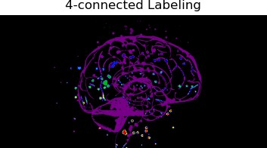

8-Connected Labeling

In [33]:

**from** skimage **import** io, color

**from** skimage.measure **import** label

**import** matplotlib.pyplot **as** plt

*# Load the image*

image **=** io.imread(r'H:\abc.png', as_gray**=True**)

*# Convert to binary image (thresholding)*

binary_image **=** image **>** 0.5

*# Apply 8-connected component labeling*

labeled_image_8cc **=** label(binary_image, connectivity**=**2)

*# Display the results*

plt.figure(figsize**=**(10, 5))

plt.subplot(1, 2, 2)

plt.title('8-connected Labeling')

plt.imshow(labeled_image_8cc, cmap**=**'nipy_spectral') plt.axis('off')

plt.show()

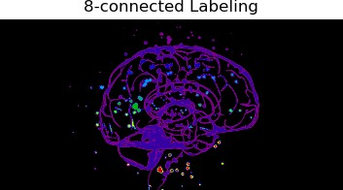

In [ ]: