**Upload multiple files into table and moved them into Archive folder from Source folder:**

**Folder Name:**

Source: To store csv files that we want to upload

Archive: moved files into this folder after upload

**File Name:** Employee01.txt, Employee02.txt

**Database:** Northwind

Table: Create table using

IF OBJECT_ID('dbo.Test_Employees', 'U') IS NOT NULL DROP TABLE dbo.Test_Employees

GO

CREATE TABLE [dbo].[Test_Employees](

[EmployeeID] [int] IDENTITY(1,1) NOT NULL,

[LastName] [nvarchar](20) NOT NULL,

[FirstName] [nvarchar](10) NOT NULL,

[Title] [nvarchar](30) NULL,

[BirthDate] [datetime] NULL,

[Address] [nvarchar](60) NULL,

[City] [nvarchar](15) NULL,

[Region] [nvarchar](15) NULL,

[PostalCode] [nvarchar](10) NULL,

[Country] [nvarchar](15) NULL

) ON [PRIMARY]

GO

**Connection String:**

File Connection: You need one connection to .txt files

Database Connection: You need one connection to link to database

**Variables:**

1. vSourceFolder (Data type: String): \\LAPTOP-E1J6KUU3\TechnicalExp\SSIS\Edge\Source

2. vArchiveFolder (Data type: String): \\LAPTOP-E1J6KUU3\TechnicalExp\SSIS\Edge\Archive

3. vFileName (Data type: String): Leave it blank

4. vFullArchivedPath (Data type: String): vArchiveFolder + vFileName

5. vSourceFullPath (Data type: String): vSourceFolder + vFileName

**Create Project:**

1. You can create new project and chose the name of your choice or you can add new Package into existing project “UploadFlatFileIntoTable” and called it “0001Edge_LoadFileandArchived”

2. Control Flow:

2.1 Add Execute SQL Task and add following script to create “Test_Employees” table into Northwind DB using Northwind Connection Manager

2.2 Add “Foreach Loop Container” and double Click on it.

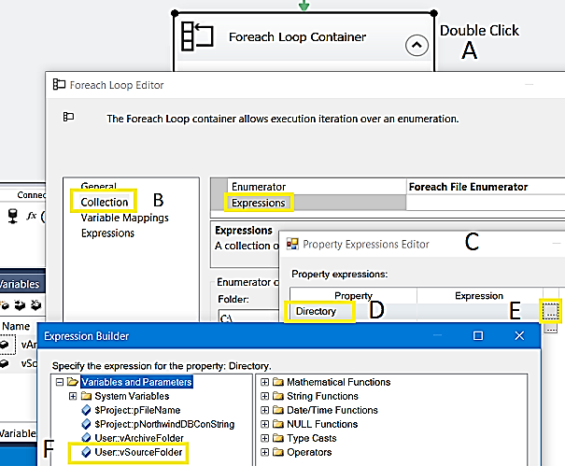

2.3 Add new variable vFileName and leave the file name blank

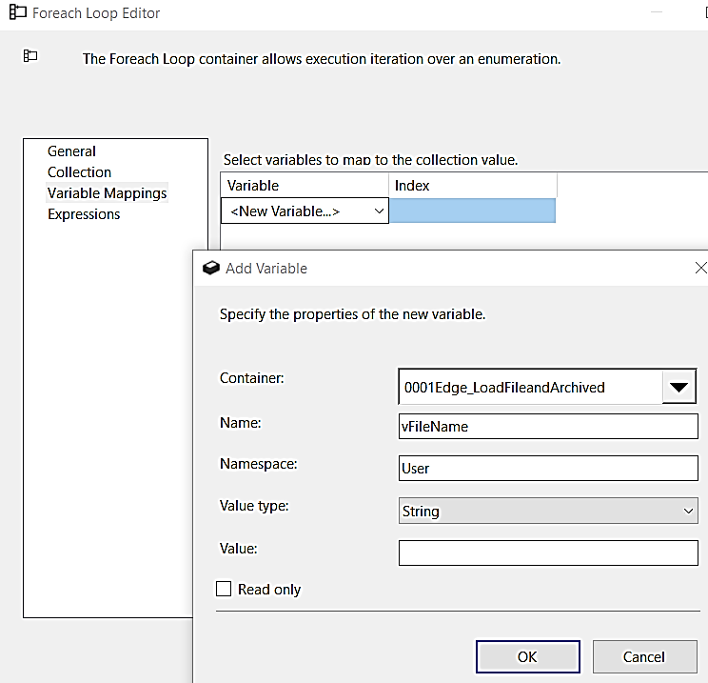

3. Add [Data Flow] task into Foreach Loop Container

3.1 Double Click on [Data Flow Task] and add [Flat File Source]

3.2 Create Flat file connection for Employee.txt files (01, 02), just pick one file for connection, If mapping error occurs than Right Click – Edit – Advance – Select data type for the column that show error

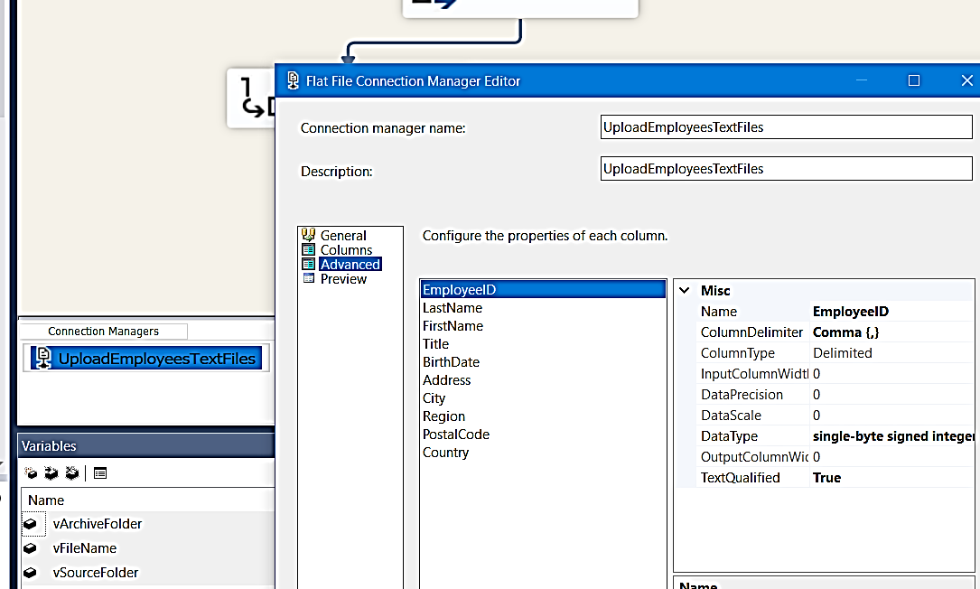

4. Add [OLE DB Destination] to upload data into Test_Employees table, for this you need Connection Manager to Northwind database, we already have one so we will use it.

5. If there is problem mapping data you have to go back 3.2

6. Right Click on Flat File Connection Manager – Properties – Select Expressions – connection String and use vSourceFolder+”\\”+vFileName to define full path with file name

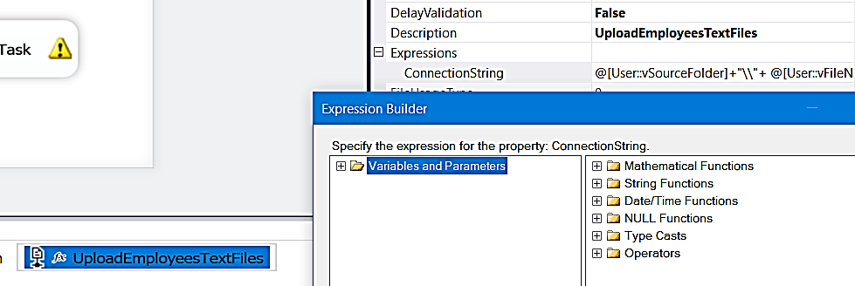

7. Package is ready you can run now – F6

8. Now its time to move source file into Archive folder, For this we need [File System Task] on Control Flow, Drag and Drop [File System Task] into [Foreach Loop Container]

8.1 Now Create two new variables for Source and Archive files, we want to add datetime with file name before move to Archive as:

a. vSourceFullPath = vSourceFolder + “\\” + vFileName

b. vArchiveFullPath = @[User::vArchiveFolder]+"\\"+ Replace(@[User::vFileName], ".txt", "")+"_"+ Replace(Replace(Replace(Substring((DT_STR, 50, 1252)getdate(), 1, 19), "-", ""), ":", ""), " ", "_")+".txt"

8.2 Setup [File System Task] as

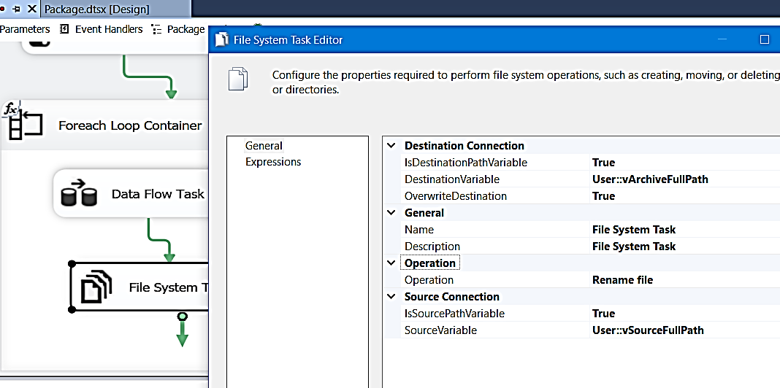

9. Files successfully moved from Source to Archive folder

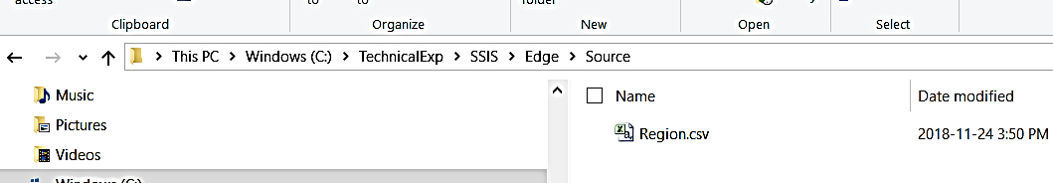

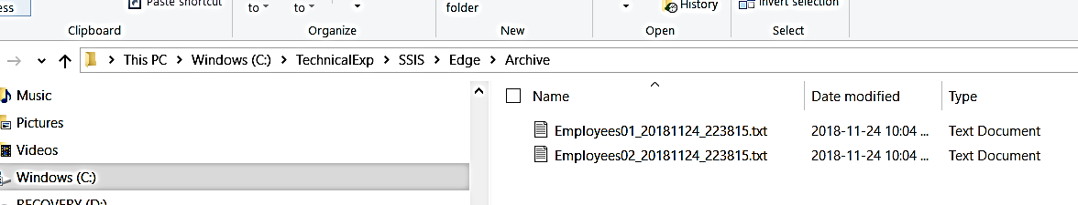

10. Create Zip File in Archive folder

Arguments: a –t7z ZipFileName FilesToMakeZip

Arguments: a –t7z “vArchiveFullPath.zip” “vArchiveFullPath” (you can omit –t7z, still works)

Working Directory

Note: Delete File is not working, I will try Script task